How to Install a DCEM PlugIn Module

DoubleClue Enterprise Management (DCEM) has a very modular architecture. DCEM can be extended easily with plugin-modules. Plug-In module can easily be installed to the default DCEM installation.

Here is the information:
- Every Plugin-Module is packed in a jar file, for example ShiftsModule-2.6.1.jar.
Please check the Module compatibliy with DCEM.
- To install the plugin, just copy the plugin jar to:
DCEM-Installation-directory/Plugins
- Stop DCEM.
  - For Linux execute “DCEM-Installation-directory /sh/stopDcemDaemon.sh“
  - For Windows: “DCEM-Installation-directory /bat/stopDcemService.bat“
- Start the DCEM Setup. This will check the database tables and will create the new module tables.
  - For Linux execute “DCEM-Installation-directory /sh/runSetup.sh“
  - For Windows: “DCEM-Installation-directory /bat/runSetup.bat“
- Alternatively, you can create the SQL-Tables manually. You will find the SQL scripts in the Module-JAR file. Open the jar with 7.zip and look at the directory “DB-Tables” for the SQL scripts.
- Stop Setup and restart DCEM.
- On multiple nodes scenario, you must restart DCEM on every node.
- In System Diagnostic, the Version of every Module is displayed.

Some information for developers:

To develop a plugin Module, add the project to the DcemApplications project.
! Do not add the module to maven pom.xml

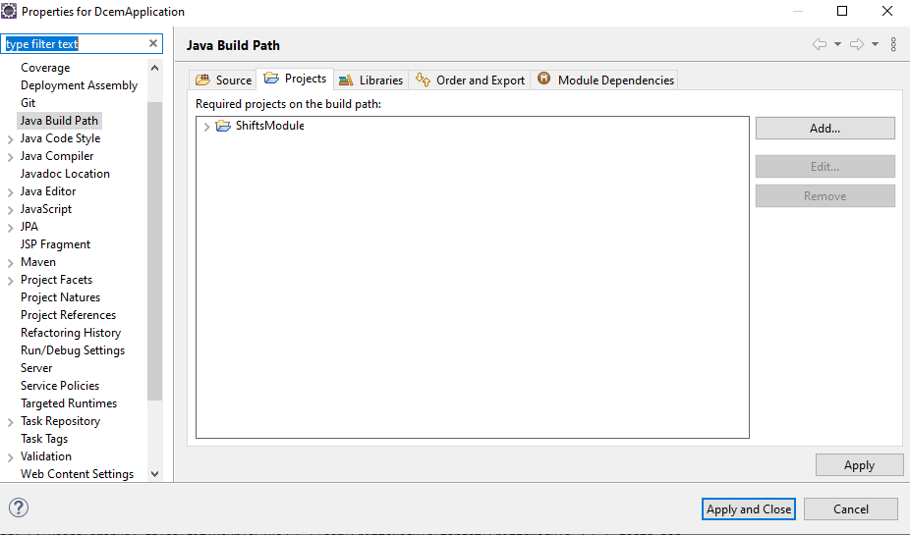

Create Tables for a Plugin-Module
To create the SQL Tables for a Plugin-Modules, you must execute the utility “CreateModuleTables” from DcemApplication\testsrc. It requires one program parameter, which is the name of the Plugin-Module. The utility will create all tables in the moduleDirecotry/resources/DB-Tables” respectively.

