Le Thi Phuong Thao

Student: 413707007

HW0310

**Question 3.01**

1. H0: β2 = 0 and H1: β2 >0
2. The test statistic is b2 = se(b2 ) ~ 6.09. If the null hypothesis is true t should > critical value at least 10% level t = 1.65
3. Under the alternative hypothesis the center of the t-distribution is pushed to the right.
4. We will reject the null hypothesis and accept the alternative if t ≥ 2.388 . We fail to reject the null hypothesis if t < 2.388
5. The calculated value of the test statistic is t= 6.09. We reject the null hypothesis that there is no relationship between the number of medals won and GDP and we accept the alternative that there is positive relationship between the number of medals won and GDP.

**Question 3.07**

1. Estimated intercept (alpha) = 11.51632
2. Sketch the estimated relationship. The estimated relationship between INCOME and BACHELOR is increasing at a constant rate.

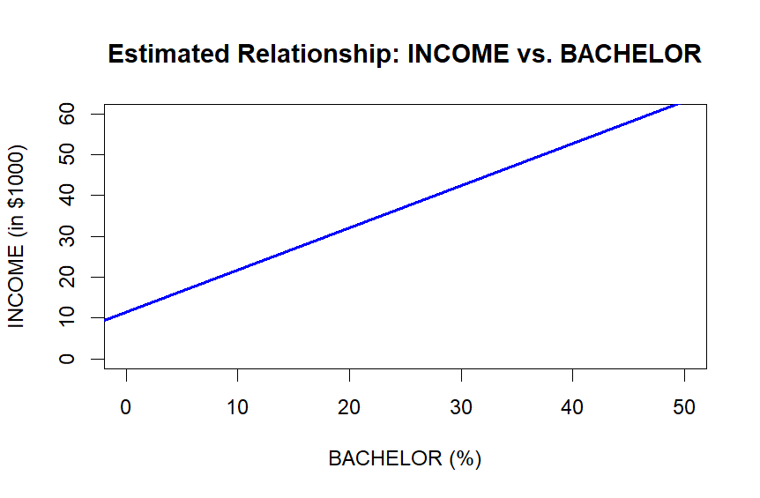

1. Standard Error of the slope coefficient = 0.09572093
2. t-statistic for testing intercept = 10 is: 0.567485
3. Plot

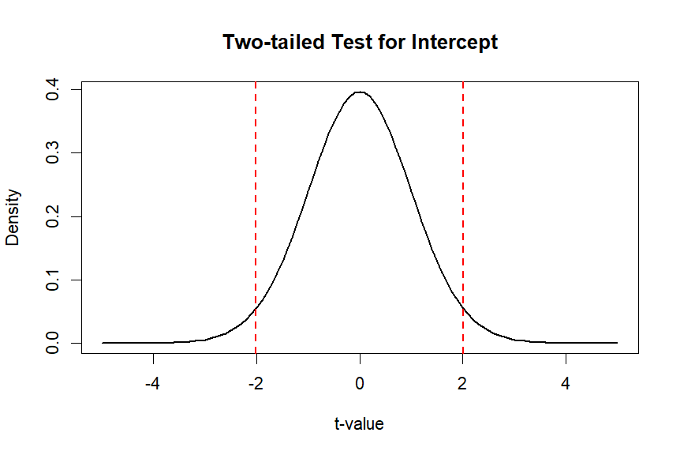

1. Answer

1. We fail to reject H0: beta = 1

**Question 3.17**

1. The calculated value of the t-statistic is t = 4.125 > t = 1.96 (5% significant), which falls in the rejection region, so we reject the null hypothesis and accept the alternative.
2. 95% CI for expected WAGE (rural) when EDUC = 16: [ 21.74 , 26.1]
3. 95% CI for expected WAGE (urban) when EDUC = 16: [ 27 , 30.2]
4. The calculated value of the t-statistic is t = −2.70, which falls in the rejection region.

**Question 3.19**

1. Plot

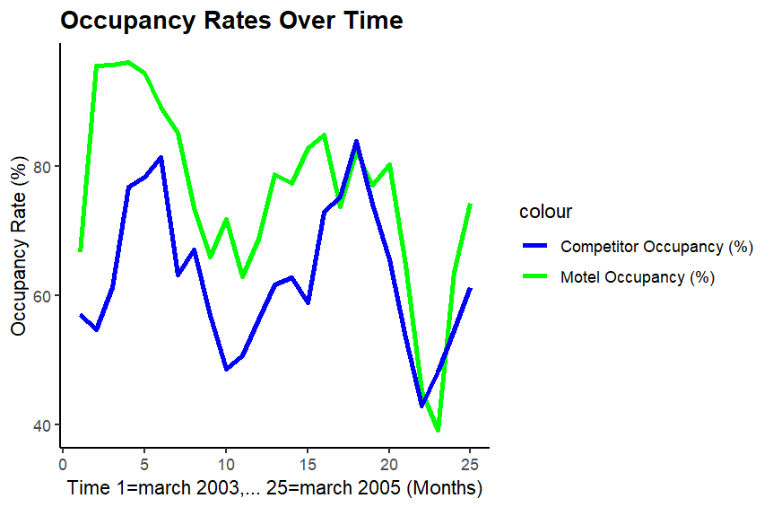

Estimate model:

95% CI for beta2 (slope): 0.4453 to 1.284

1. 90% CI for expected MOTEL_PCT when COMP_PCT = 70 : [ 77.382 , 86.467]
2. t = 4.27, this value is in the rejection region
3. t = −0.67 which is in the non-rejection region
4. For observations 17-23 all the residuals are negative but one.

