Student: Le Thi Phuong Thao (413707007)

HW0331

**Exercise 5.6**

**Exercise 5.31**

1. Answer:

Beta1- Bill’s expected commute time when he leaves Carnegie at 6:30AM and encounters no red lights and no trains is estimated to be 20.87 minutes.

Beta2- If Bill leaves later than 6:30AM, the increase in his expected traveling time is estimated to be 3.7 minutes for every 10 minutes that his departure time is later than 6:30AM (assuming the number of red lights and trains are constant).

Beta3- The expected increase in traveling time from each red light, with departure time and number of trains held constant, is estimated to be 1.52 minutes.

Beta4- The expected increase in traveling time from each train, with departure time and number of red lights held constant, is estimated to be 3.02 minutes.

1. Find 95% interval estimates for each of the coefficients

1. t = (b3-2)/se(b2) = -2.584 < -1.651. We conclude that the expected delay from each red light is less than 2 minutes
2. t = (b4-3)/se(b4) = 0.037 < 1.651 we cannot reject H0 that b4 is equal 3 minutes
3. t = (b3 – 1/3)/ se(b2) = 0.991 < 1.651. We cannot reject H0 that delaying departure time by 30 minutes increases expected travel time by at least 10 minutes
4. t = (beta4 – 3beta3)/ se(beta4 – 3 beta3) = -1.825027 < -1.651. We reject H0 = Beta4 > 3 beta3 that the expected delay from a train is less than three times the delay from a red light

1. H0 = beta1 + 30beta2 + 6beta3 +beta4 ≤ 45

t = (b1 + 30b2 + 6b3 + b4)/se(b1 + 30b2 + 6b3 + b4) = -1.725964 < 1.651 we cannot reject H0

1. H0 = beta1 + 30beta2 + 6beta3 +beta4 ≥ 45. If t > -1.651 we cannot reject H0, but t < -1.651, we reject H0 so Bill needs less than 4 5minutes to come to the meeting

**Exercise 5.33**

1. Result

All coefficient estimates are significantly different from zero at a 1% level of significance with the exception of that for EDUC^2 which is significant at a 12% significance level

1. Marginal effect | Educ = beta2 + 2beta3 + beta6*Expert

Its estimate is ME EDUC = 0.089539 + 0.002916*Educ - 0.001010*Expert

The marginal effect of education increases as the level of education increases, but decreases with the level of experience

1. Histogram

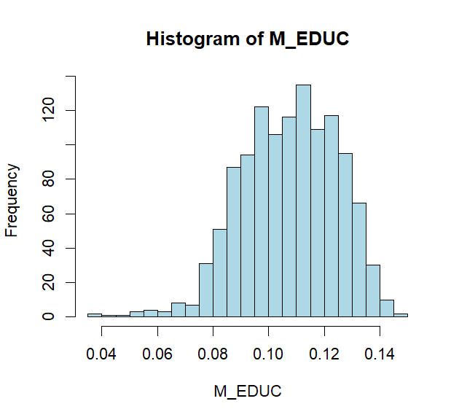

We observe that the marginal effects range from 0.036 to 0.148 with most of them concentrated between 0.085 and 0.13. The 5th , 50th (median) and 95th percentiles are, respectively

1. Marginal effect | Exper = beta4 + 2beta5*Exper + beta6*Educ

Its estimate is ME EXPER = 0.044879 - 0.000936Exper - 0.001010 Educ

The marginal effect of experience decreases as the level of education increases, and as the years of experience increases

1. Histogram

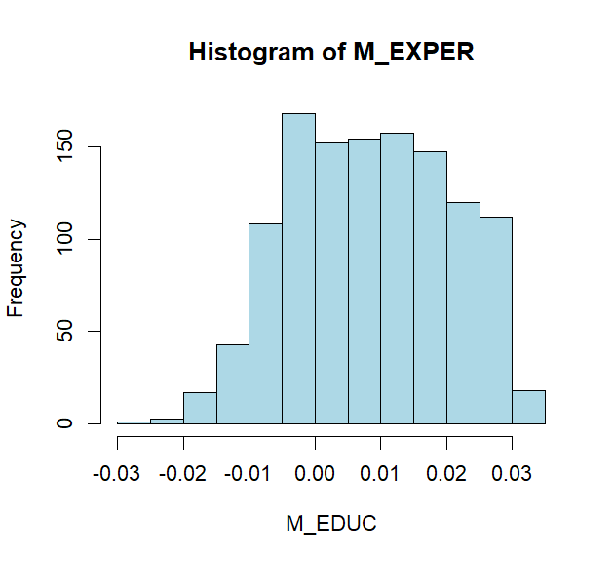

Although most of the marginal effects of experience are positive. Overall, the values range from -0.025 to 0.034. The 5th , 50th median and 95th percentiles are, respectivelyA black text with black text

1. H0: beta1 + 17beta2 + 289beta3 + 8beta4 + 64beta5 + 136beta6 ≤beta1 + 16beta2 + 256beta3 + 18beta4 + 324beta5 + 288beta6

Or H0​: β2​+33β3​−10β4​−260β5​−152β6 ​≤0

t = -1.669902 < t_cr = -1.6461 we cannot reject H0, there is insufficient evidence to conclude that David’s log-wage is greater

1. H0: -beta2 – 33beta3 +10beta4 +420beta5 + 144beta6 ≥ 0

t = -2.062365 < t_cr = -1.6461 we reject H0, there is evidence to conclude that David’s log-wage is greater. The difference in outcomes is attributable to diminishing returns to experience. Because Svetlana initially had 18 years of experience, her extra years of experience had a relatively small impact on her log-wage. Because David had only eight years of experience in the first instance, the extra eight years had a relatively large impact on his log-wage

1. Marginal effect | Exper = beta4 + 2beta5*Exper + beta6*Educ

Wendy = beta4 + 34beta5 + 12beta6

Jill = beta4 + 22beta5 + 16beta6

H0: beta4 + 34beta5 + 12beta6 = beta4 + 22beta5 + 16beta6 or 12beta5 – 4beta6 = 0

t = -1.027304 > t_cr = -1.96195 we cannot reject H0, there is insufficient evidence to conclude that the marginal effects from extra experience are different for Jill and Wendy

1. We assume that, as time goes on, Jill gains more experience, but no more education. Marginal effect | Exper = beta4 + 2beta5*Exper + beta6*Educ

Beta4 + 2beta5*Exper + 16beta6 - 11 < 0

It will be 19.667 more years before her marginal effect becomes negative

A 95% interval estimate for the number of years before her marginal effect become negative is [15.96, 23.40]