Student: Le Thi Phuong Thao

Student ID: 413707007

**Exercise 8.6**

**Exercise 8.16**

1. [-28.323, -135.330]

1. Plot

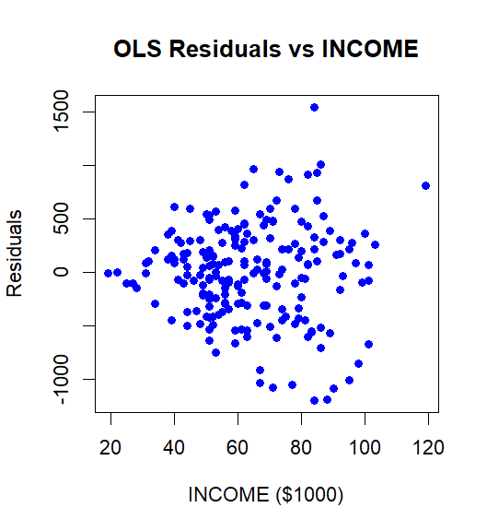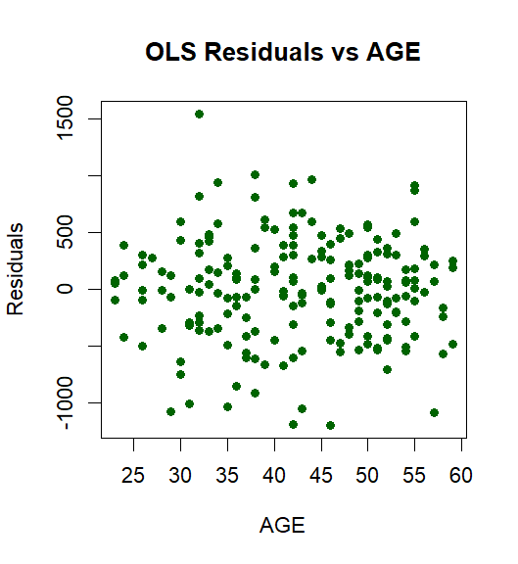

Heteroskedasticity is present

1. Test result

H0: variance of errors is constant for all observations.

H1: variance of errors differs between two subsets of the data (often increasing or decreasing in some regressor)

F value > F critical value. We conclude there are heteroskedastic errors at the 5% level

1. The point estimate is the same in both

There’s heteroskedasticity in your data, the robust interval is wider than the one in (a)

1. GLS and GLS robust

95% interval estimate for the effect of one more child on miles traveled [ -119.89, -33.72] and [ -121.41, -32.19] for robust se

The point estimate is larger than OLS ( -76.8 > -81.8)

**Exercise 8.18**

1. Hypothesis:

H0: σ^2 male=σ^2 female (homoskedasticity)

H1: σ^2 male#σ^2 female (heteroskedasticity)

Test Statistic (F): 0.9489479

Critical Region (5% significance level):  
F < 0.9453 or F > 1.0581  
We fail to reject the null hypothesis. There is no significant evidence of heteroskedasticity between males and females

1. Results

Case 1: Using only metro, female, and black as candidate variables

Hypothesis:

H0: Error variance is constant and unrelated to metro, female, or black.

H1: Error variance depends on at least one of metro, female, or black.

Test Statistic (NR²): 23.55681 > 11.34487 we reject H0

Case 2: Using all explanatory variables as candidate variables

H0: Error variance is constant and unrelated to all regressors.

H1: Error variance depends on at least one regressor.

Test Statistic (NR²): 109.4243 > 21.66599. We reject the null hypothesis, concluding that the model exhibits significant heteroskedasticity.

Although the Goldfeld–Quandt test in part (a) showed no evidence of unequal variances by gender, the NR² test results in part (b) reveal that heteroskedasticity is present in the model and may be related to other variables such as metro or black.  
Therefore, the evidence from this test complements and expands upon the findings in part (a)

1. White test result p value = 2.2 e^-16 < 0.01 so we conclude there is evidence of heteroskedastic
2. Result

Traditional OLS standard errors assume constant error variance (homoskedasticity). If this assumption is violated—for example, if wage variance changes with metro or experience—OLS standard errors can be biased, often underestimated. White's robust standard errors correct for heteroskedasticity by allowing error variance to vary. As a result, robust standard errors are usually larger, leading to wider confidence intervals. Wider intervals suggest that traditional standard errors may be overly optimistic, potentially causing overconfidence in the results

1. Result

OLS (White robust) does not assume an error variance structure and directly adjusts standard errors to address heteroskedasticity, making results more robust but potentially less efficient (wider confidence intervals).

FGLS assumes error variance can be modeled using metro and exper. If the assumption is correct, FGLS is more efficient (narrower confidence intervals); if incorrect, FGLS may perform poorly.

1. Result

For part (d), OLS (White robust) does not assume any variance structure and directly adjusts standard errors to handle heteroskedasticity, typically resulting in wider but more reliable confidence intervals.

FGLS (robust standard errors) may have narrower intervals than OLS (White robust) if the heteroskedasticity model is partially correct, but wider intervals than FGLS in part (e) since robust standard errors account for model errors.

1. Result

Choosing FGLS (White robust):

FGLS (White robust) has slightly smaller standard errors than OLS (White robust) leading to narrower confidence intervals and slightly higher efficiency.

Additionally, using White robust standard errors ensures that even if the heteroskedasticity model (metro and exper) is misspecified, the standard errors and confidence intervals remain reliable, avoiding the risk of FGLS (traditional standard errors) underestimating uncertainty