Student: Le Thi Phuong Thao – 413707007

**Exercise 10.18**

1. Answer



1. Answer

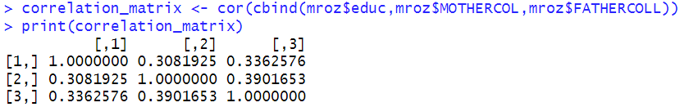

EDUC vs. MOTHERCOLL (r = 0.31): Children with more years of education tend somewhat to have mothers who also went past high school.

EDUC vs. FATHERCOLL (r = 0.34): A very similar pattern holds for fathers.

MOTHERCOLL vs. FATHERCOLL (r = 0.39): If one parent has some college, there’s a slightly higher chance the other does as well.

None of the correlations exceed 0.4, so there’s no strong collinearity among these three variables—just a modest positive relationship in each case.

They can be better IV than Mother_Educ and Father_educ if evidence suggests the main jump comes at “some college” (e.g., gains level off after 2 years); a 0/1 indicator will neatly capture that. If we only care about a policy threshold (e.g. whether parents went on for any post-secondary schooling), the dummy is more directly relevant. It often improves degrees of freedom and robustness if the continuous effect is very non-linear

1. Answer

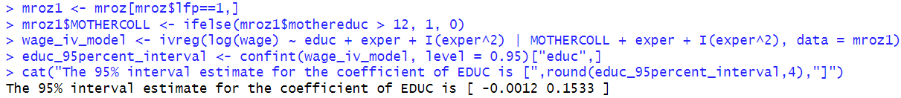

1. Answer: F-test statistic for the hypothesis that MOTHERCOLL has no effect on EDUC: 63.21602 > 10, we reject the null hypothesis that the IV is weak
2. 95% CI of the instrumental variables is [0.02752,0.1482], which is narrower than part c
3. F-test statistic for the joint significance of MOTHERCOLL and FATHERCOLL: 57.59666 > 10, we reject the hypothesis that IV is weak
4. We have one endogenous variable but two IV. We need to test the overidentification of IV. If all surplus moment conditions are valid, then NR2 ∼ Chi-square(L−B).

Sargan-Hansen statistic for the validity of the surplus instrument: 0.2375851 < Critical value 3.841459. We cannot reject H0 that the null of valid over‐identifying restrictions → the surplus instrument appears valid

**Exercise 10.20**

1. Summary for Microsoft stock

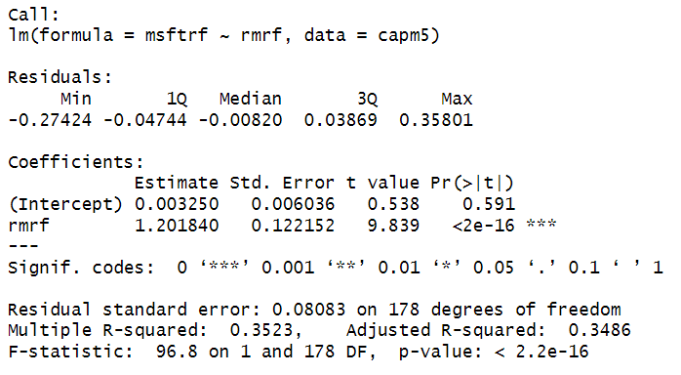

Beta = 1.2 and significant at 1%, Microsoft stock is about 20 % more volatile than the market portfolio

1. Answer

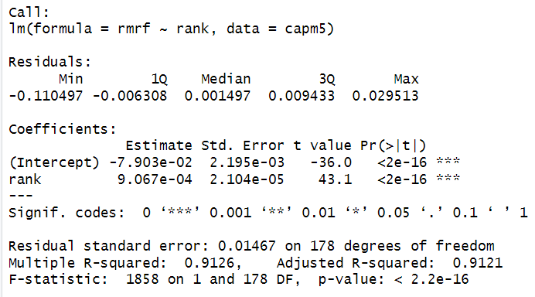

Rank can be a potential IV since it is not related to Microsoft stock but related to market beta. F value of 1st stage is 1858, indicating that Rank seems to be a strong IV

1. Answer

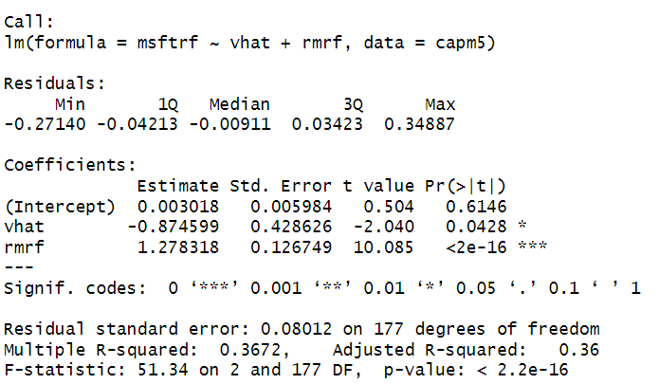

Hausman test indicates that at 1% level, we cannot reject H0: market return is exogenous

1. Answer

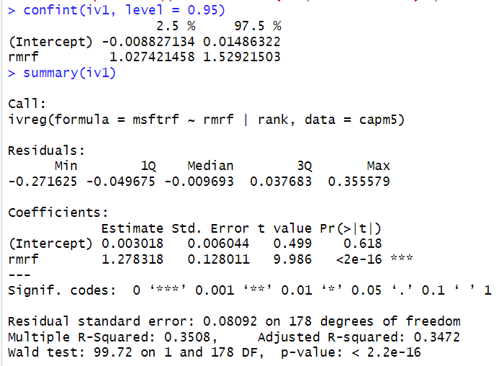

The coefficient of beta in IV regression (1.2783) is slightly larger than the original OLS one (1.2018), which is what we would expect. The 95% interval estimate is now [1.0274, 1.5292]

1. Answer

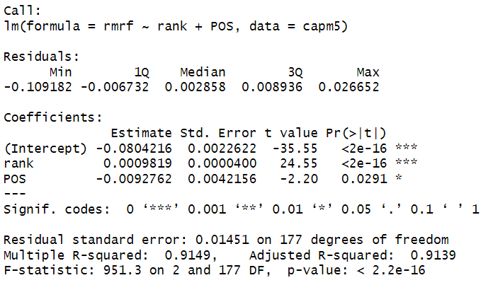

F-value is 951.3, so IV is not weak, RANK remains strongly significant, but POS is significant at the 5% level. If we accept a 5% test, we can conclude the IV are not weak.

1. Answer

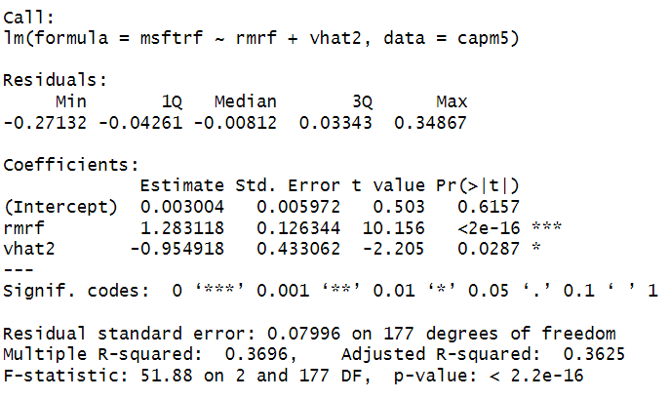

The hauman test indicates that at 1% level we cannot reject the null hypothesis that the market return is exogenous.

**Exercise 10.24**

1. Plot ehat IT with expert

When experience is low, the variation in the residuals appears to be larger. This indicates possible heteroskedasticity.

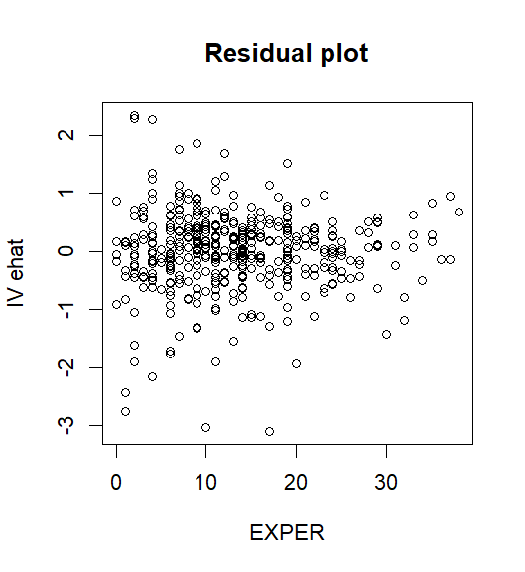

1. Answer

NR2 test statistics = 7.438552

p-value = 0.006384122

It indicates strong evidence of heteroskedasticity in the model

1. 95% CI for the coefficient of 'educ': [ -0.0003945456 , 0.1231878 ]

95% CI for the coefficient of 'educ' with robust SE: [ -0.004764123 , 0.1275574 ]