Le Thi Phuong Thao – 413707007

**Q11.1**

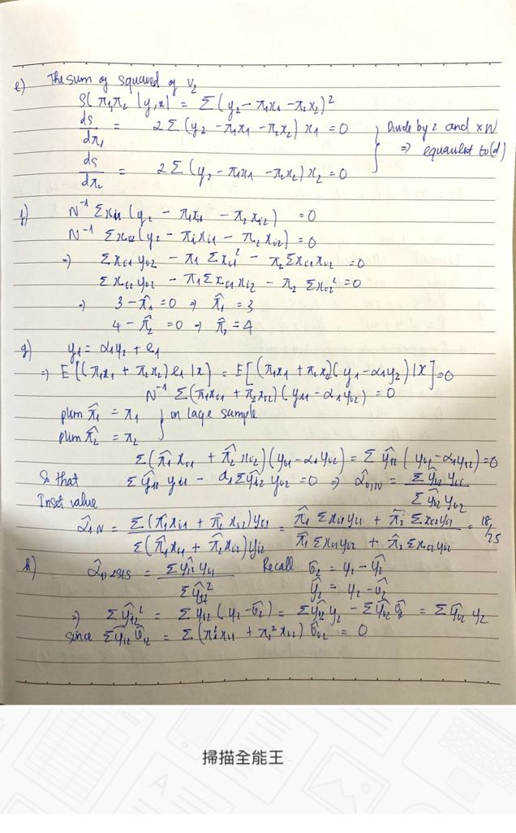

**Q11.16**

**Q11.17**

1. There are M = 8 equations requiring 7 omitted variables in each equation. There is a total of 16 variables in the system.

The consumption equation includes 6 variables and omits 10. The necessary condition is satisfied.

The investment equation includes 5 variables and omits 11. The necessary condition is satisfied.

The private sector wage equation includes 5 variables and omits 11. The necessary condition is satisfied.

1. The consumption equation has 2 RHS endogenous variables and excludes 5 exogenous variables.

The investment and private wage equations have 1 RHS endogenous variable and omit 5 exogenous variables

1. Answer



1. Answer



1. The coefficient estimates will be the same. The t-values will not be because the standard errors in part (d) are not correct 2SLS standard errors.