Le Thi Phuong Thao – 413707007

HW0512 (11.28, 11.30, 15.06)

**11.28**

a) original equations

Rewrite

Anticipated Signs of the Parameters for Demand Equation

1/α2 < 0 since α2 < 0

-α3/α2 > 0 since α3 > 0 and α2 <0

-α4/α2 > 0 since α4 > 0 and α2 <0

Anticipated Signs of the Parameters for Supply Equation

1/β2 > 0 since β2 > 0

-β3/β2 > 0 since β3 < 0 and β2 > 0

b) Answer

Signs are same as predicted

c) Answer

d) Answer

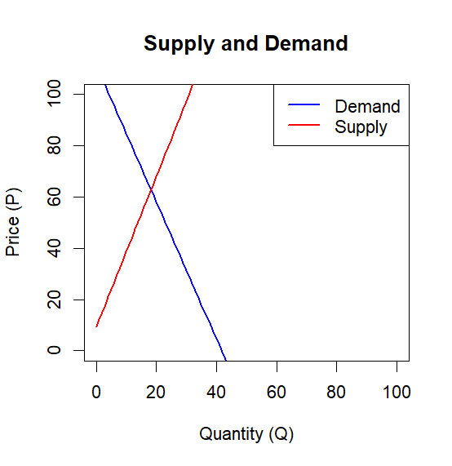

e) Answer

Difference in price predictions: 0.02719676

Difference in quantity predictions: -0.01018407

f) OLS results

*Are the OLS signs “correct”?*

Demand equation: the OLS slope on quantity q is positive (+0.15) even though theory (and 2SLS) says it should be negative. → Sign is wrong.

Supply equation: the OLS slope on q is positive—as theory predicts—so the sign is correct here.

*Are the OLS coefficients statistically different from zero?*

For demand, the q-slope is not significant (p ≈ 0.76); the intercept is not significant either.

Only the shift variables ps and di pass the 5 % level.

For supply, all coefficients are highly significant (p < 0.001)

Quantity and price are determined simultaneously in the market => endogenity

OLS can give the bias results, we prefer 2SLS to OLS

**11.30**

a) Answer

Current Profit (p, positive): Higher current profits lead to more net investment, reflecting that profits fund investments.

Lagged Profit (plag, positive): Past profits also boost current investment, showing a delayed investment response.

Lagged Capital Stock (klag, negative): Larger existing capital stock reduces current net investment, indicating firms slow investment when capital is already high.

b) Answer

p value > 0.1% so we cannot reject H0 that coeffificients are zero

c) Answer

V_hat (.resid) is significant at 1% level, so P is endogenous

d) Answer

And OLS

OLS suggests p is significant, but 2SLS shows it is not, indicating that OLS may be biased due to endogeneity. 2SLS provides more reliable inference in the presence of endogenous regressors

e) Answer

Coefficients are the same, t-value / standard error is different. T-value of 2SLS in part d is larger

f) Answer

H0: All instruments are exogenous (uncorrelated with the error term) ⇒ instruments are valid.

H1: At least one instrument is endogenous (correlated with the error) ⇒ instruments are invalid.

critical value = 9.487729

T*R^2 = 1.281519

If T*R^2>9.488, reject H0 so we cannot reject H0 => instruments are valid

**15.06**

(a) The OLS estimates differ very little for the 1987 and 1988 regressions. The differences are on the order of one standard error or less. The OLS models assume that all the population parameter values, including the intercept, for all individuals are identical. The underlying assumption is that there is no heterogeneity across individuals.

(b) In equation (XR15.6) we explicitly recognize the use of panel data, by adding both individual and time period identifying subscripts, *it*, to teach observable variable. Also the unobservable error components are specified, with one random error varying across individual and time, *eit*. This is the idiosyncratic error component. The other error component, *ui*, is time-invariant, and represents unobserved heterogeneity across individuals. It is assumed not to change over the period of the sample.

(c) All the fixed effects coefficient estimates seem substantially different. Constructing rough 95% interval estimates using the fixed effects model we find the intervals (-.0085, .1235), (-.0034, .001), (-.5777, -.0745) and (.0198, .1446) for *EXPER*, *EXPER2*, *SOUTH* and *UNION* respectively. The OLS estimates for the coefficient of *EXPER* does not fall within the fixed effects interval estimate, giving some content to the statement that the estimates show some difference. The other OLS estimates do fall within the interval estimates, suggesting that they are not “significantly” different.

(d) The *F-*statistic has numerator degrees of freedom *N* - 1= 716-1=715, because there are that many pairs of hypotheses such as β1*i* = β 1, *i*+1. The denominator degrees of freedom is *NT-N-(K-1)*=1432-716-4=712 . The number of individuals must be subtracted from the total because implicitly there are that many individual indicator variables in the model to account for individual differences even if they are not shown. Equivalently the within transformation uses *N* sample means in the calculations, each “costing” a degree of freedom. Here *K* = 5 is the number of parameters showing in equation (XR15.6). The 1% critical value using Statistical Table 5 is 1.0. Using computer software the critical value is 1.1904959. Using either we reject the null hypothesis that there are no individual differences because *F =* 11.68 is larger than the critical value (F.99,715,712)

(e) Following the within transformation the random error is $\tilde{e_{it}}=e_{it}-{\overline{ⅇ}}_{i}$. As discussed in Exercise 15.10 these transformed random errors are serially correlated when the idiosyncratic errors are uncorrelated. By using cluster robust standard errors we are allowing for heteroskedasticity in *eit* across individuals and time, and/or serial correlation across time in the *eit* .

In this example the ratios of the conventional to the robust standard errors are 1.0060976, 1.0, 0.50420842, and 0.85013624 for *EXPER*, *EXPER*2, *SOUTH* and *UNION* respectively. For the experience variables the robust standard errors are virtually identical to the conventional standard errors. For *SOUTH* the robust standard error is almost twice as large as the conventional one, and for *UNION* the robust error is 1.18 times as large as the conventional standard error.

(f) The random effects estimates for the coefficients of *EXPER* and *EXPER*2 are almost twice as large as the fixed effects estimates, 1.71 times and 1.92 times respectively. The random effects coefficient of *SOUTH* is 0.71 times the fixed effects estimate, and the random effects estimate for *UNION* is 1.25 times the fixed effects estimate.

The Hausman *t-*statistics are $=\frac{0.0575-0.0986}{{[0.033{}^{2}-0.022{}^{2}]}^{1/2}}$-1.67, 1.29, -0.77 and -1.06 respectively. Only the coefficient of *EXPER* shows any significant difference, and that at the 10% level. Thus the evidence of endogeneity is weak, and a strong argument against using the random effects estimator cannot be made based on these results. We conclude that the random effects estimator is appropriate in this example.

The results are based on the conventional fixed effects standard errors because the classic Hausman test is a contrast between the standard fixed effects estimator, which is consistent, and the random effects estimator, which is efficient under all its assumptions, including homoskedasticity and lack of serial correlation in the errors.