**Full name:** Nguyen Nhut Vu Truong

**Student ID:** 413707008

**Course:** Financial Econometrics

**HW0224**

**Question 1**

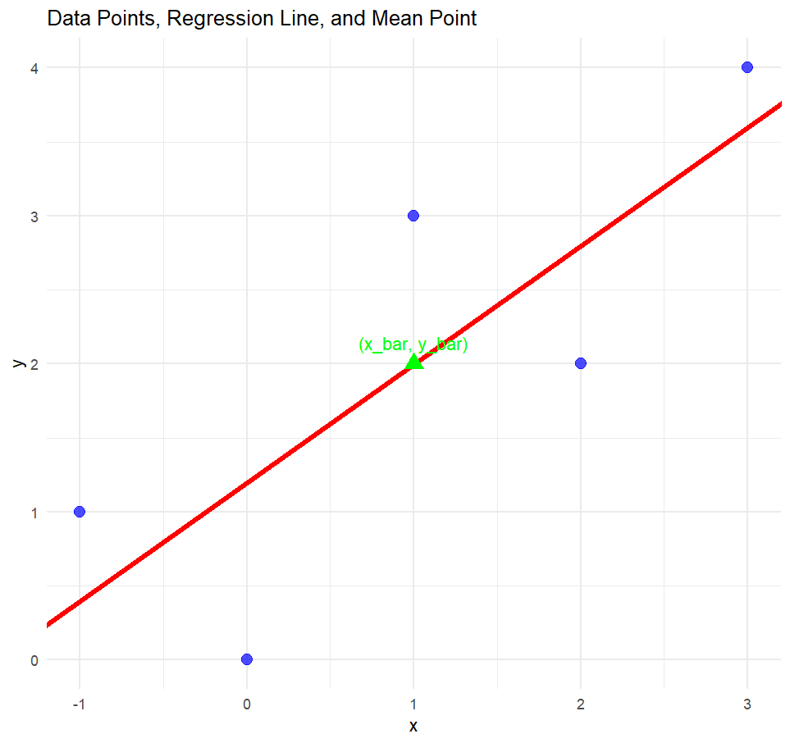

**Question 14**

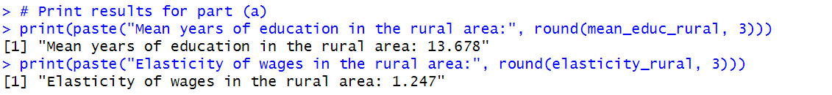

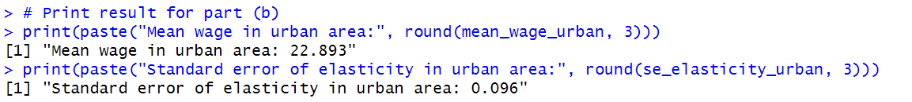

**Question 16**



The CAPM econometric model is a simple regression model because it expresses a dependent variable (excess return of security) as a linear function of a single independent variable (market risk premium), with an intercept, a slope coefficient, and an error term. This structure perfectly matches the standard simple regression framework discussed in the chapter, while providing parameters with meaningful financial interpretations.

b. Estimate the CAPM model for each firm, and comment on their estimated beta values.

c. The p-values of all alphas are larger than 0.1, which is insignificant.

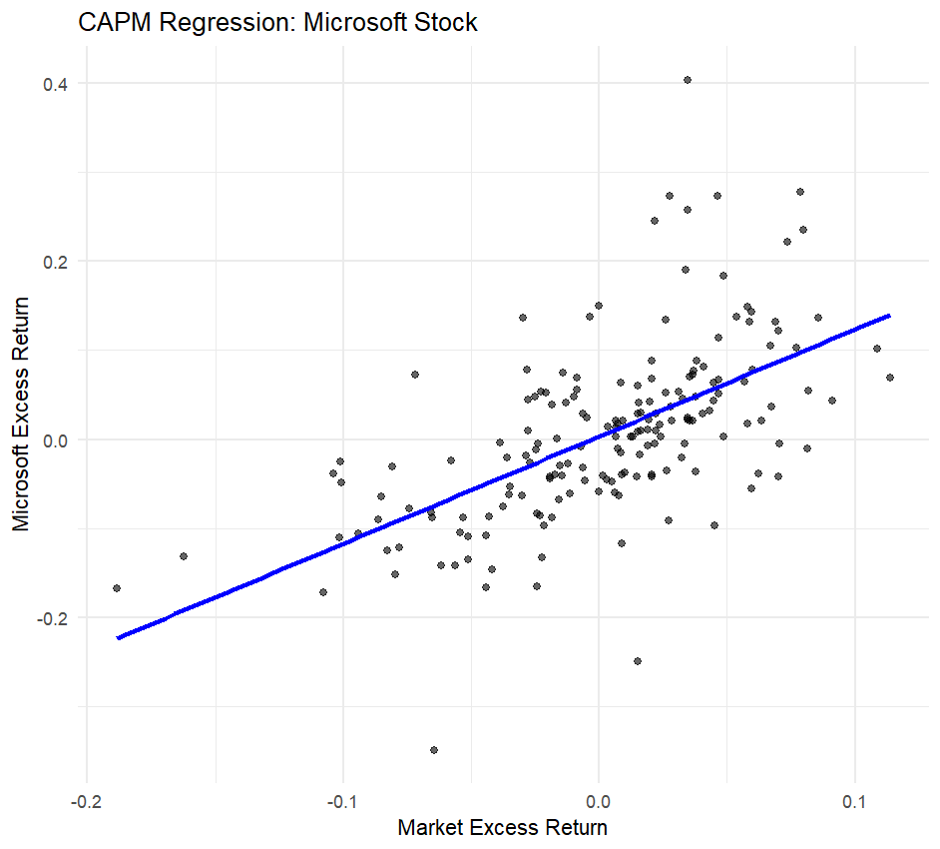

d. Beta values remain similar, it indicates that the intercept does not strongly influence the estimates.

