**Full name:** Nguyen Nhut Vu Truong

**Student ID:** 413707008

**Course:** Financial Econometrics

**HW0303**

**Question 17**

1. Code: Please check the corresponding R file.

2. Results:

a. Scatter plot of house price against house size created.

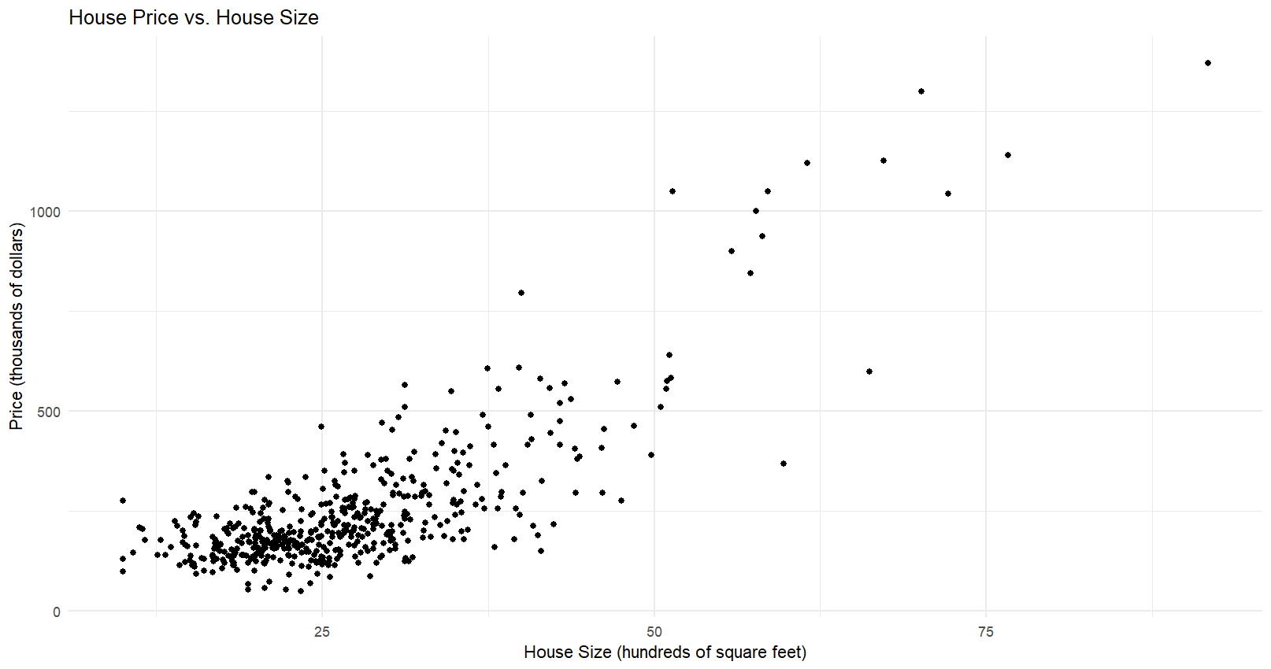

b. Linear Model: PRICE = -115.4236 + 13.40294 × SQFT

(se: 13.0882 and 0.4492, respectively)

We estimate that an additional 100 square feet of living area will increase the expected home price by $13,402.94 holding all else constant. The estimated intercept −115.4236 would imply that a house with zero square feet has an expected price of $−115,423.60.

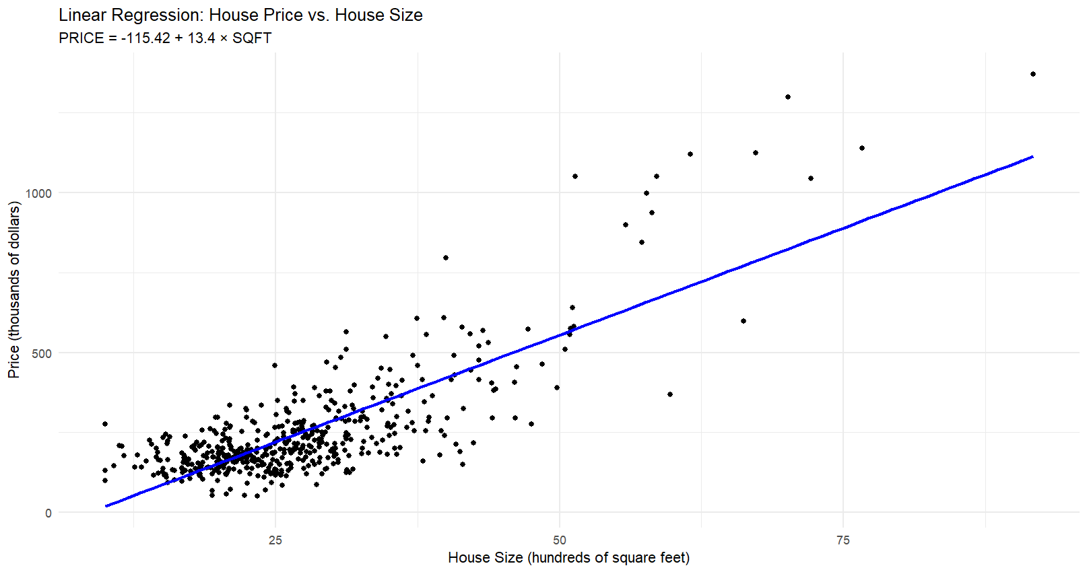

c. Quadratic Model: PRICE = 93.57 + 0.1845 × SQFT²

(se: 6.0722 and 0.00525, respectively)

We estimate that an additional 100 square feet of living area for a 2000 square foot home will increase the expected home price by $7,380.80 holding all else constant.

d. Quadratic model with tangent line at 2000 square feet plotted.

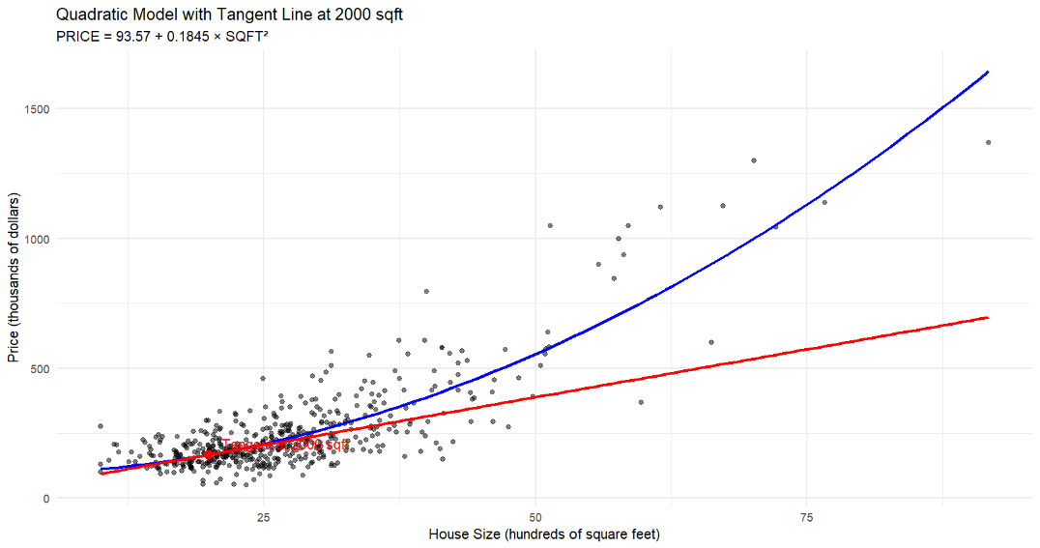

e. Elasticity at 2000 square feet: 0.882

   Interpretation: A 1% increase in house size at 2000 square feet results in approximately a 0.882% increase in house price.

f. Residual plots created for both models.

   Examining the residual plots for patterns: In both models, the residual patterns do not appear random. The variation in the residuals increases as SQFT increases, suggesting that the homoskedasticity assumption may be violated.

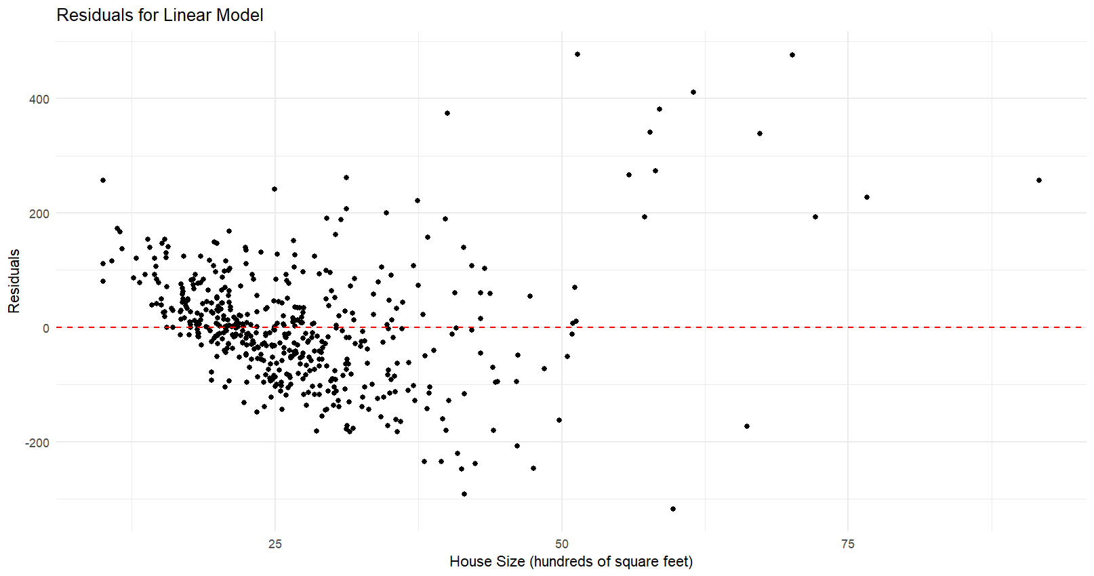

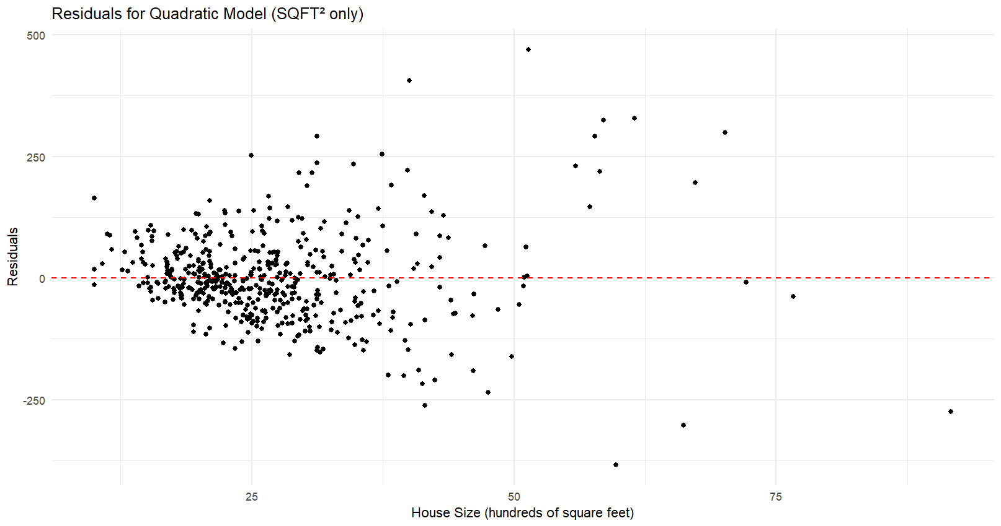

g. Sum of Squared Errors (SSE):

The sum of square residuals linear relationship is 5,262,846.9. The sum of square residuals for the quadratic relationship is 4,222,356.3. In this case the quadratic model has the lower SSE. The lower SSE means that the data values are closer to the fitted line for the quadratic model than for the linear model.

**Question 25**

a.

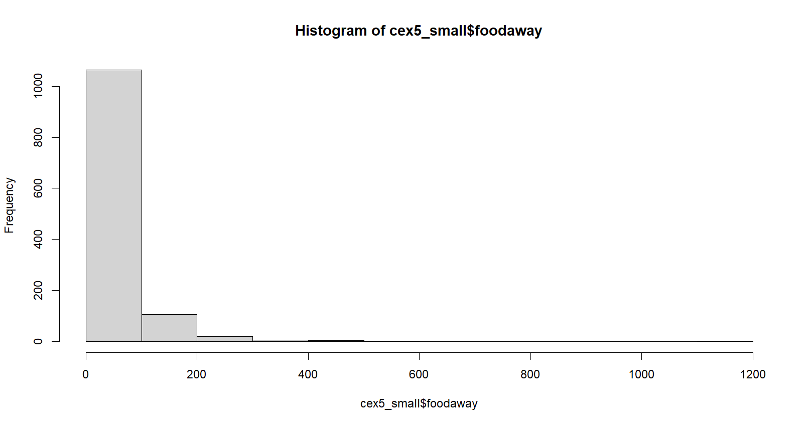

b.

c.

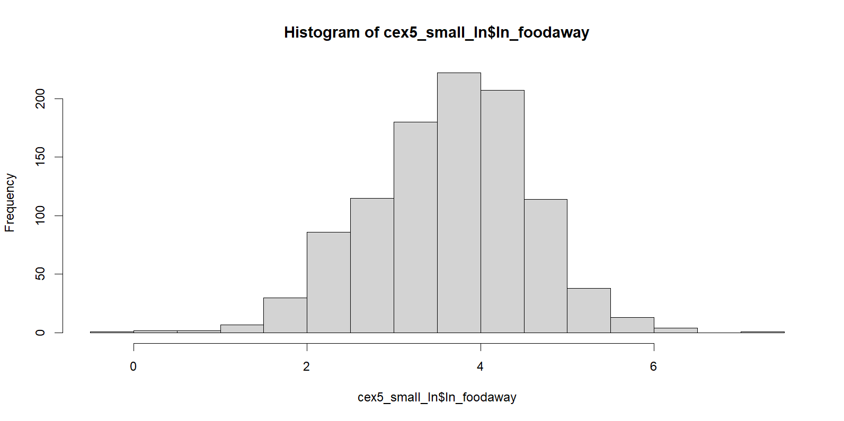

FOODAWAY and ln(FOODAWAY) have different numbers of observations because taking the natural logarithm requires FOODAWAY to be greater than zero. In the dataset, there are 178 observations (1200 - 1022) where FOODAWAY is zero, making it impossible to compute ln(FOODAWAY) for these cases.

d. The estimated model is

Interpreting the estimated slope: We estimate that each additional $100 household income increases food away expenditures per person of about 0.69%, other factors held constant.

e. The plot shows a slight positive association between ln(FOODAWAY) and INCOME.

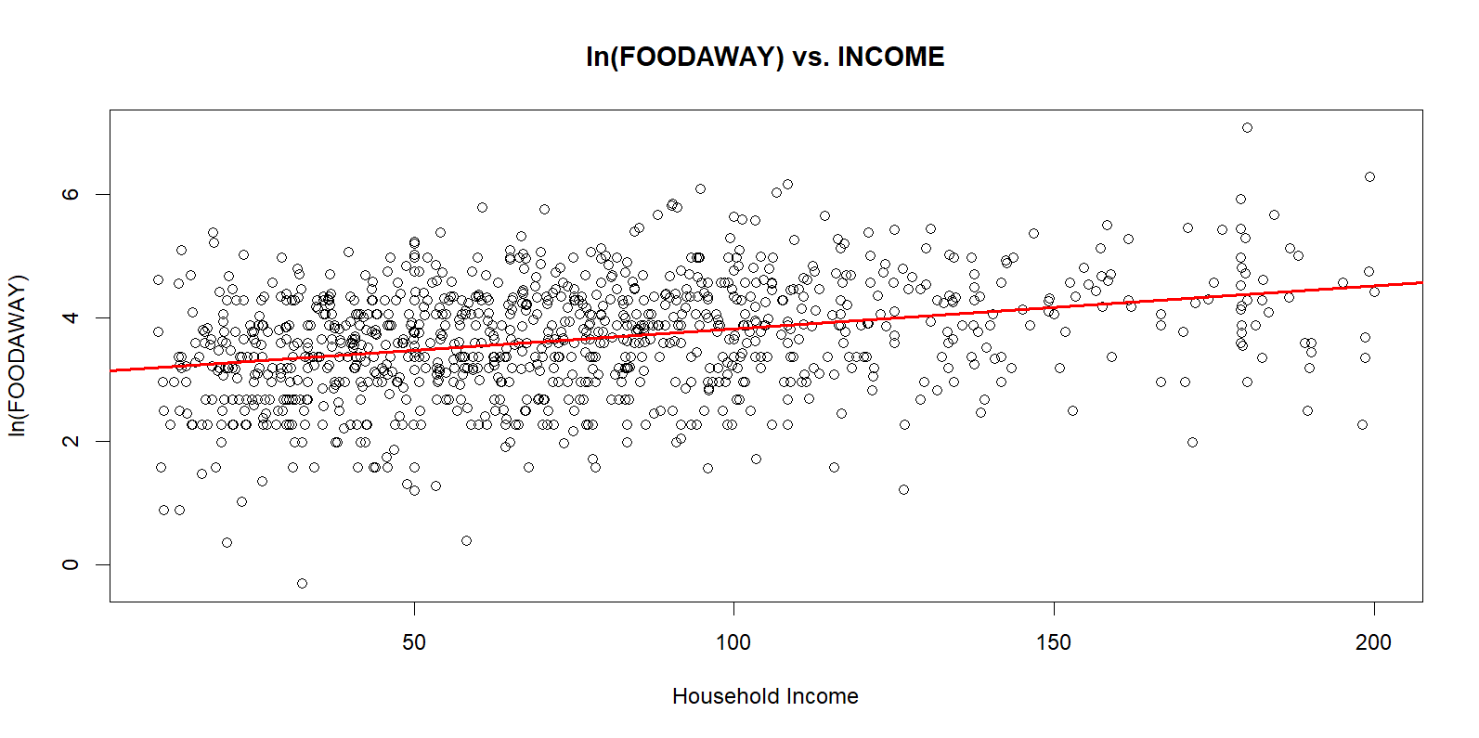

f. The OLS residuals do appear randomly distributed with no obvious patterns. There are fewer observations at higher incomes, so there is more “white space.”

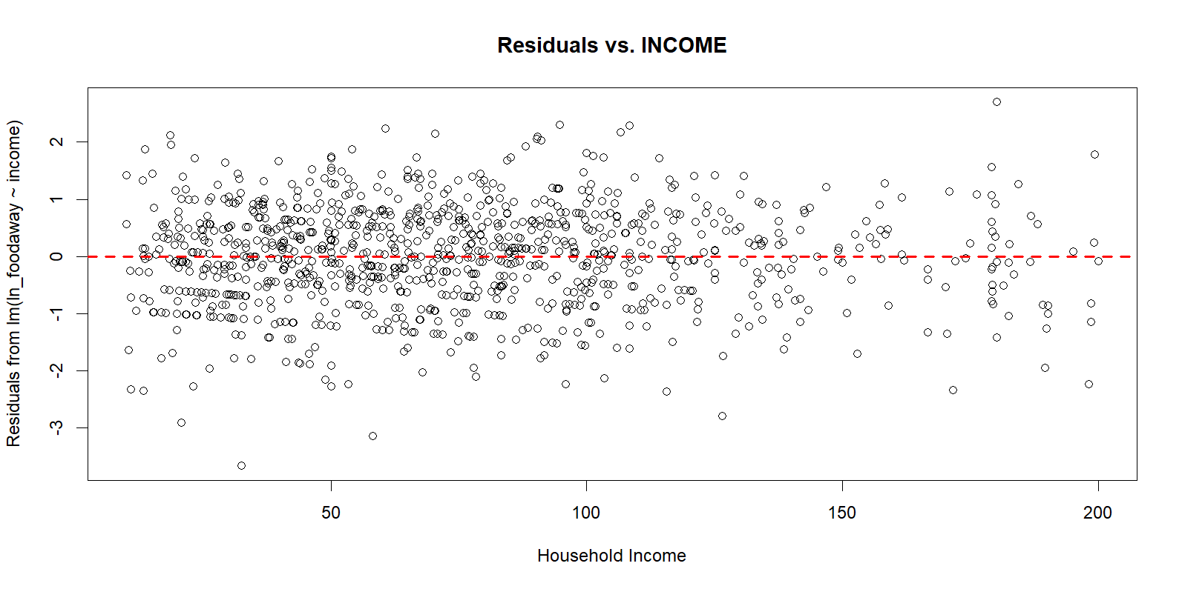

**Question 28**

a. The wage data exhibits a pronounced right skew, with most values clustering below $30 and a few extreme outliers pushing the maximum up to $221.10, as reflected by a median wage of around $19.30 and a mean of approximately $23.64.

In contrast, education levels are largely concentrated between 12 and 16 years, indicating a unimodal distribution centered on typical schooling durations, with very few observations at the lower and upper extremes.

These characteristics suggest that while the wages might benefit from a log transformation to account for their skewness in modeling, the education variable appears well-suited for standard analytical approaches.

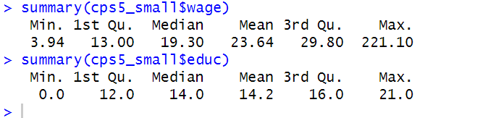

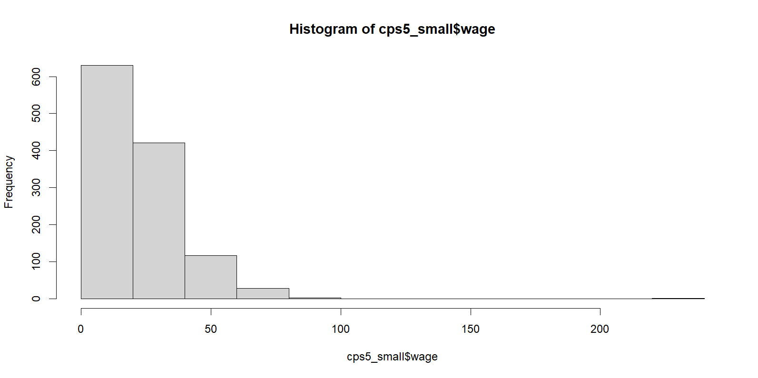

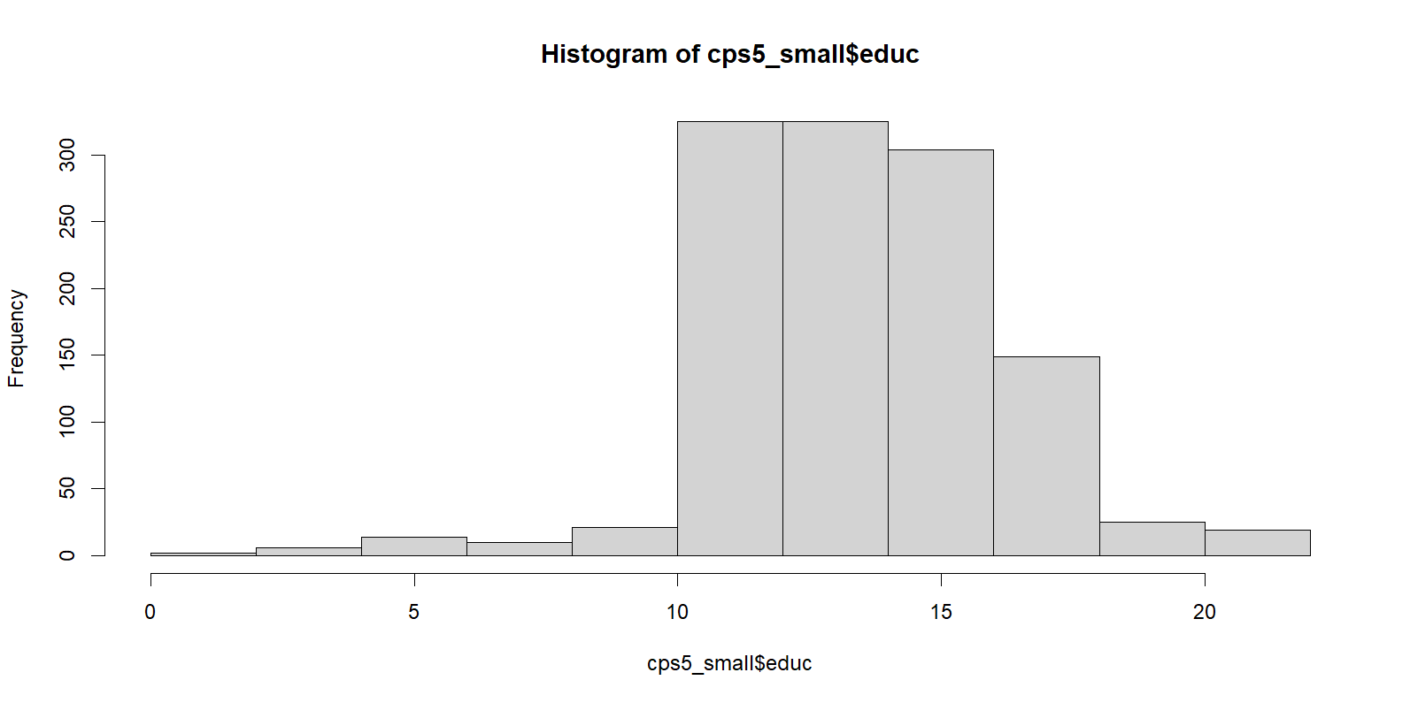

b. The estimated model is:

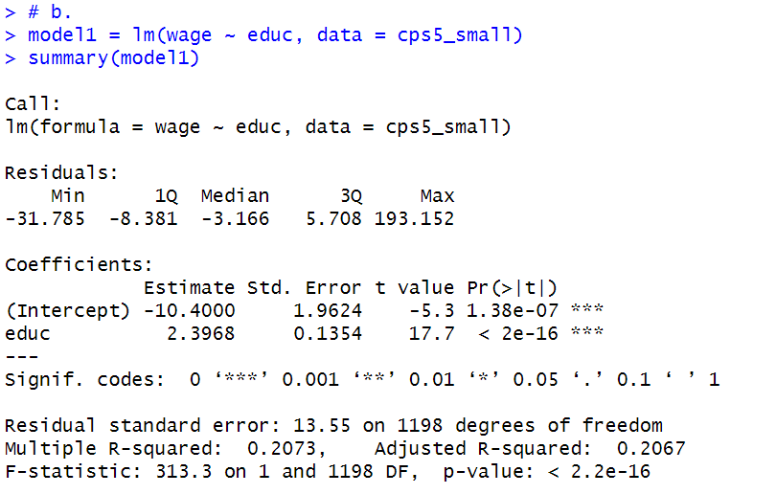

The model suggests that, for each additional year of education, the hourly wage is expected to rise by $2.3968, holding everything else constant. Regarding the intercept (-10.4000), this literally means that if someone had zero years of education (i.e., EDUC = 0), the model would predict a wage of -$10.40.

c. The residuals-versus-education plot does not exhibit a clear systematic pattern, such as a “U” shape, indicating that a linear specification in EDUC alone is not grossly violated.

The residuals are generally centered around zero, though a few high positive residuals (notably around EDUC = 15 and 20) suggest some individuals earn more than predicted. There is a slight increase in the spread of residuals at higher education levels, hinting at mild heteroskedasticity but not to an extreme degree.

The assumptions of strict exogeneity, linearity, and uncorrelated errors appear reasonably satisfied, and there is sufficient variation in EDUC. Overall, the residuals display a relatively random scatter around zero, which aligns with classical OLS assumptions (SR1–SR5) and suggests that the linear model is appropriate with no severe violations.

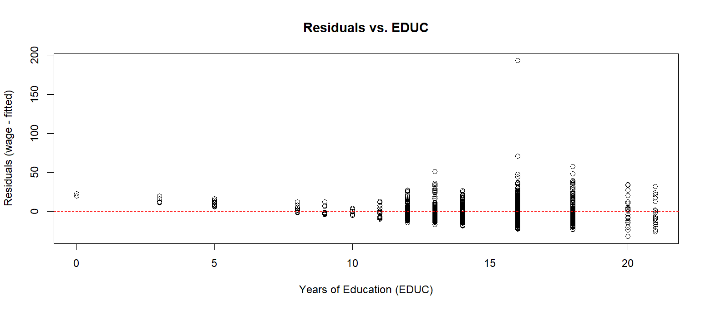

d. The findings highlight significant and positive returns to education across both gender and racial groups, with notable disparities. By gender, females experience a higher return per year of education ($2.66) than males ($2.38), with education explaining more wage variation for females (R² = 0.276). By race, whites have a higher return to education ($2.42) than blacks ($1.92), with blacks also exhibiting the lowest explanatory power (R² = 0.185), suggesting that other factors significantly influence their wages. All coefficients are statistically significant, reinforcing the positive impact of education on earnings.

These findings have several key implications. The higher returns for females suggest that education plays a stronger role in their wage determination, making it a crucial tool for improving women's economic mobility. The lower returns and explanatory power for blacks indicate that systemic barriers such as discrimination, job opportunities, or school quality differences may limit their wage gains from education. While education remains a key driver of wage growth, its varying impact suggests that it is not an equalizer across all groups. Structural inefficiencies in the labor market, including occupational segregation and hiring biases, may contribute to these disparities.

Policy interventions should focus on improving access to quality education for disadvantaged groups while addressing labor market barriers. Initiatives such as scholarships, mentorship programs, and diversity-focused hiring practices can help ensure that the benefits of education are equitably distributed. Ultimately, while education remains a valuable investment, structural inequalities must be addressed to maximize its role in reducing wage disparities and fostering economic mobility.

e. The estimated model is:

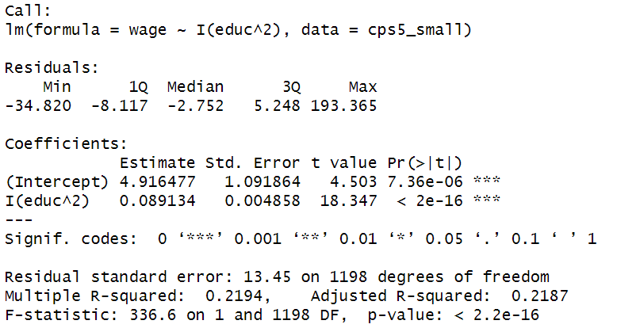

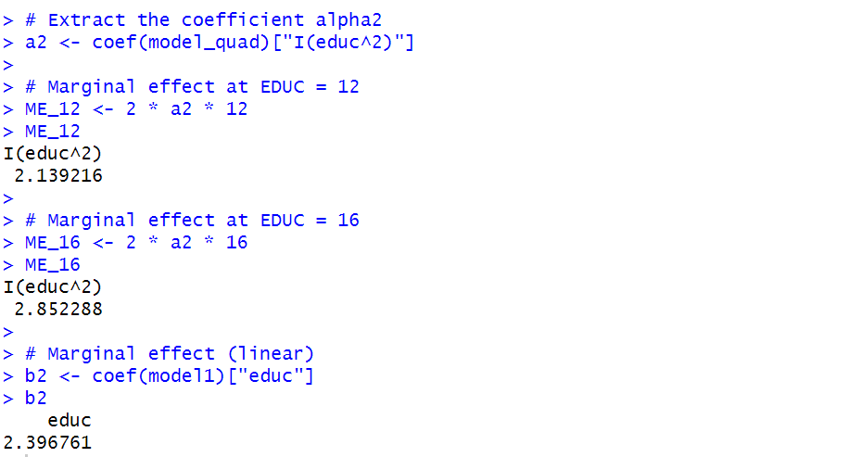

So, in the quadratic model, the return to education increases with additional schooling—someone moving from 12 to 13 years of education gains about $2.14/hour, while someone moving from 16 to 17 years gains around $2.85/hour.

For the linear model, its marginal effect is a constant 2.40 dollars/hour per extra year of education, regardless of whether you have any years of schooling.

**Key Insights:**

At 12 years: The quadratic model’s marginal effect (about $2.14) is slightly lower than the linear slope ($2.40).

At 16 years: The quadratic model’s marginal effect (about $2.85) is higher than the linear slope.

Thus, the quadratic specification implies returns to education grow as schooling increases, whereas the linear model forces a constant return at all education levels.

f. Linear: Adjusted R-squared = 0.2067

Quadratic: Adjusted R-squared = 0.2187

The quadratic model provides a slightly better fit than the linear model, as seen in both the plot and regression results:

1. Visually, it avoids the unrealistic negative wage predictions at low education levels and better captures the steeper wage growth for higher education (15–20 years).
2. Statistically, the quadratic model shows a marginally higher R2 and lower SSE, indicating it explains slightly more wage variation.
3. While the difference is not dramatic, the quadratic specification more flexibly accommodates increasing wage growth with education, rather than imposing a constant slope.

