**Full name:** Nguyen Nhut Vu Truong

**Student ID:** 413707008

**Course:** Financial Econometrics

**HW0310**

**Question 1**

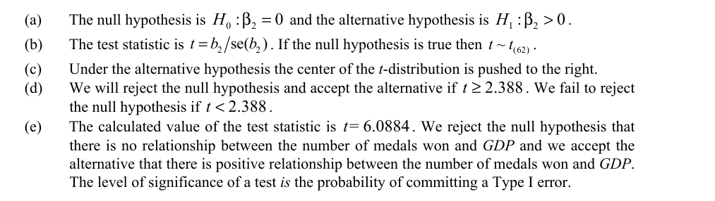

**Question 7**

The relationship between INCOME and BACHELOR is increasing at a constant rate.

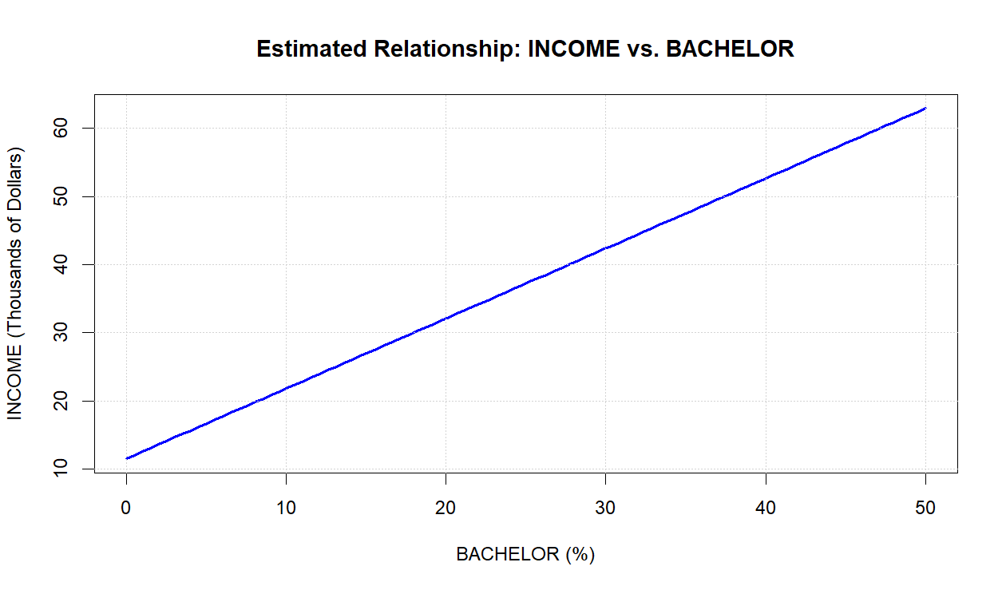

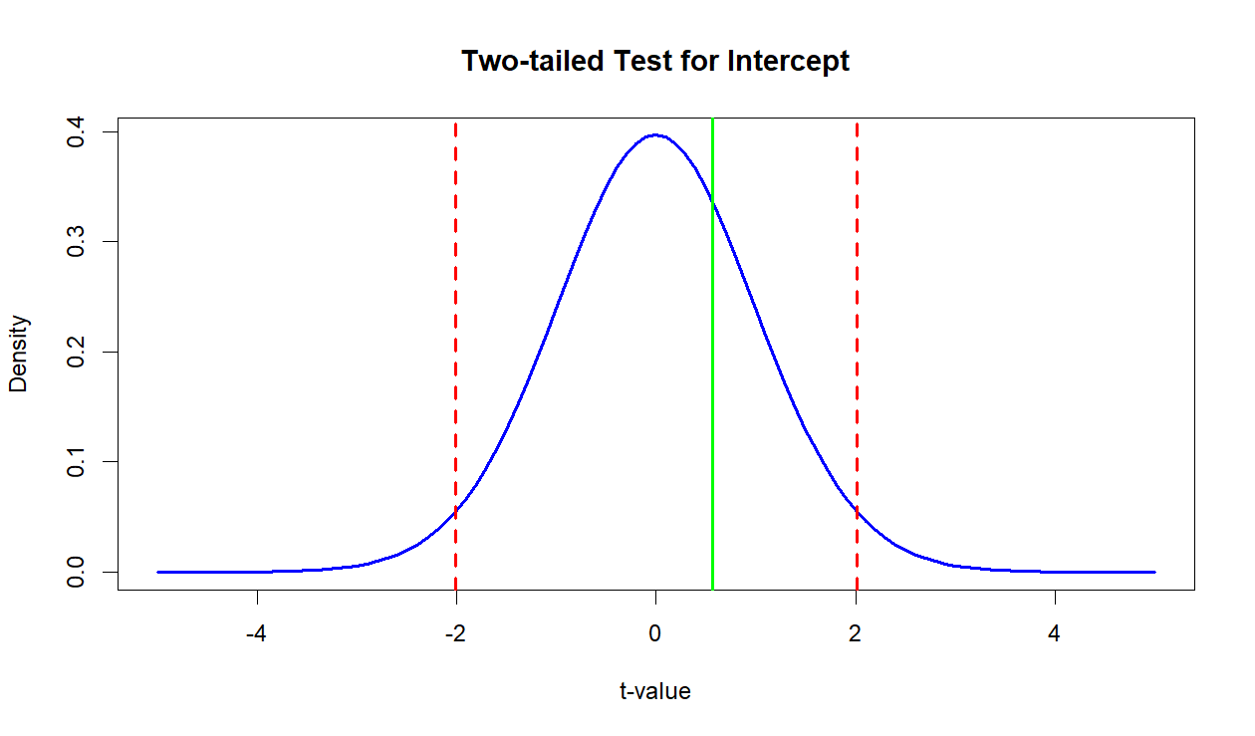

**Question 17**

**Question 19**

a. Yes, they tend to move together. Motel seems to have the higher occupancy rates.

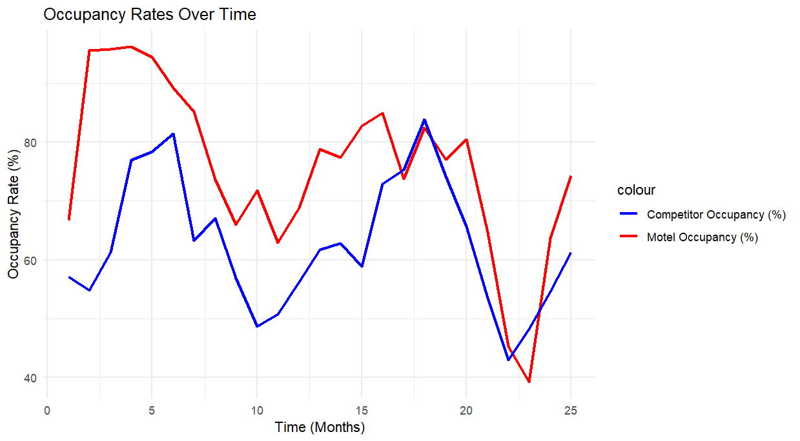

The estimate of the association between MOTEL_PCT and COMP_PCT is positive and statistically significant, but it is not estimated with high precision due to the moderately wide confidence interval and non-trivial standard error. If the interval were narrower, we could be more confident about the precise effect of COMP_PCT on MOTEL_PCT.

The residual plot indeed shows high variability both in the early time periods and toward the end. This suggests potential instability in the relationship between MOTEL_PCT and COMP_PCT over time.

For observations 17-23 all the residuals are negative but one.

