**Full name:** Nguyen Nhut Vu Truong

**Student ID:** 413707008

**Course:** Financial Econometrics

**HW0414**

**8.6**

a.

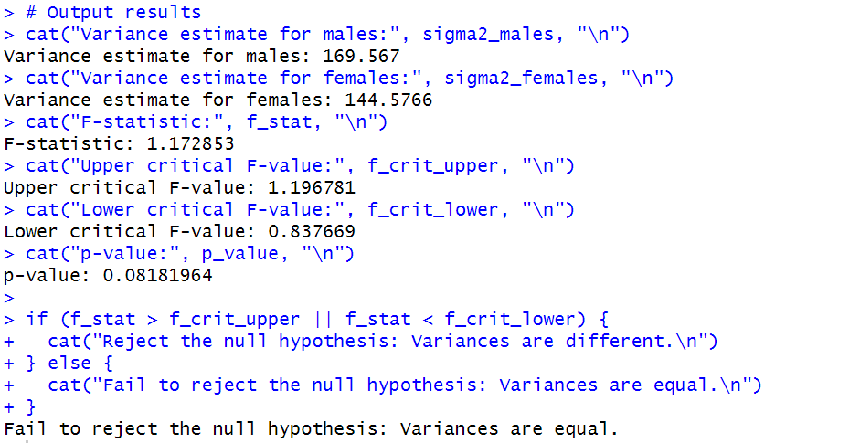

b.

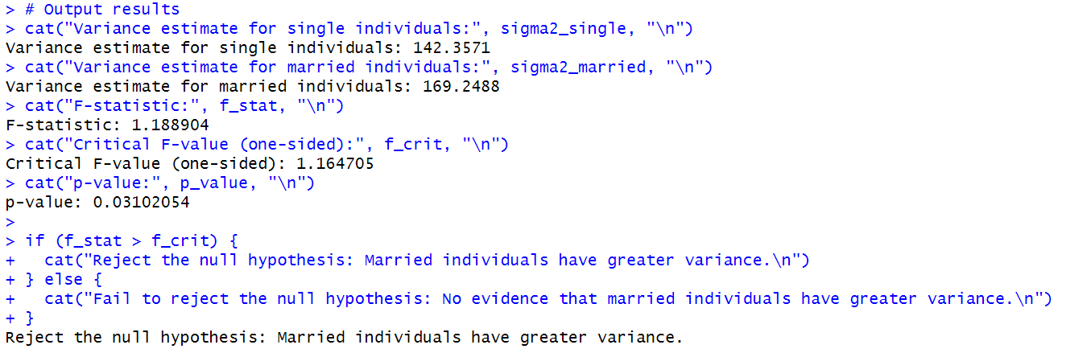

c.

Yes, the Breusch-Pagan test results do provide supporting evidence about the issue discussed in part (b) regarding different error variation between married and unmarried individuals. The combined results from both tests create a more complete picture:

1. The Goldfeld-Quandt test specifically shows that marital status is associated with different error variances, with married individuals having greater variance.
2. The Breusch-Pagan test confirms that heteroskedasticity exists in the overall model, which is consistent with and reinforces the specific finding about marital status.

Together, these results strengthen our confidence in the conclusion that married individuals have more variable wages than single individuals. The hypothesis that married individuals, potentially relying on spousal support, can seek wider employment types and thus have more variable wages is supported by both statistical tests.

For proper statistical inference in wage equation modeling, these findings suggest we should consider using heteroskedasticity-robust standard errors or weighted least squares estimation to account for the unequal variances across groups.

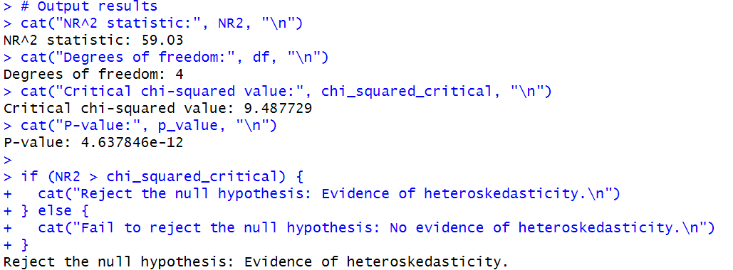

d.

The White test auxiliary regression includes:

1. **Original explanatory variables** (excluding constant):
   * EDUC, EXPER, METRO, FEMALE (4 terms)
2. **Squared terms** of each explanatory variable:
   * EDUC², EXPER², METRO², FEMALE² (4 terms)
3. **Cross-products** of all pairs of explanatory variables:
   * EDUC×EXPER, EDUC×METRO, EDUC×FEMALE
   * EXPER×METRO, EXPER×FEMALE
   * METRO×FEMALE
   * Total cross-products: 6 terms

**Total degrees of freedom** = 4 (original variables) + 4 (squared terms) + 6 (cross-products) = 14

The White test results provide strong evidence of heteroskedasticity in the wage equation model. This finding is consistent with our previous results:

1. The Goldfeld-Quandt test in part (b) found evidence that married individuals have greater wage variance than single individuals.
2. The Breusch-Pagan test in part (c) also detected heteroskedasticity in the model.

The White test result is particularly noteworthy because it's the most general of the three tests, capable of detecting various forms of heteroskedasticity without requiring specification of the potential source.

Given the presence of heteroskedasticity, standard OLS inference would be invalid. For proper statistical inference, we should consider:

1. Using heteroskedasticity-robust standard errors (White's standard errors)
2. Applying weighted least squares estimation
3. Transforming variables to stabilize variance

These approaches would ensure more reliable statistical inference when working with the wage equation model.

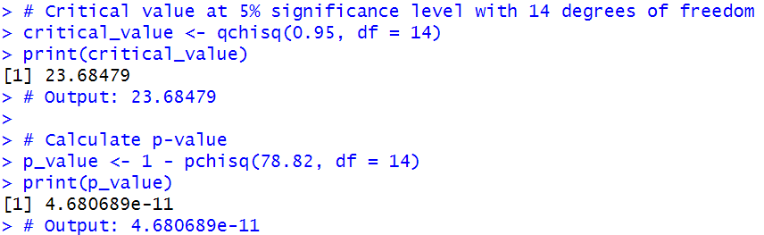

e.

**Coefficients with Narrower Interval Estimates:**

* **EXPER**: The robust standard error (0.029) is smaller than the usual standard error (0.031).
* **METRO**: The robust standard error (0.84) is substantially smaller than the usual standard error (1.05).
* **FEMALE**: The robust standard error (0.80) is slightly smaller than the usual standard error (0.81).

**Coefficients with Wider Interval Estimates:**

* **Intercept**: The robust standard error (2.50) is larger than the usual standard error (2.36).
* **EDUC**: The robust standard error (0.16) is larger than the usual standard error (0.14).

There is no inconsistency in these results. The differences between usual and robust standard errors reflect the nature of heteroskedasticity in the data. When heteroskedasticity exists, the usual OLS standard errors can be either underestimated or overestimated depending on how the error variance relates to the explanatory variables:

1. **For coefficients with wider robust intervals** (Intercept, EDUC): This suggests that the error variance is smaller for observations with extreme values of these variables than what would be expected under homoskedasticity. The usual standard errors underestimate the true sampling variability.
2. **For coefficients with narrower robust intervals** (EXPER, METRO, FEMALE): This suggests that the error variance is larger for observations with extreme values of these variables. The usual standard errors overestimate the true sampling variability.

These patterns align with our previous findings of heteroskedasticity in the model. The robust standard errors provide more reliable inference in the presence of heteroskedasticity by adjusting for the unequal error variances across observations.

f.

A t-value of approximately 1.0 means that the estimated effect of being married on wages is approximately one standard error away from zero. At conventional significance levels (typically requiring |t| > 1.96 for 5% significance), this coefficient would not be considered statistically significant.

This result is entirely compatible with our findings in part (b) regarding heteroskedasticity for several reasons:

1. **Effect on Mean vs. Effect on Variance**:
   * The t-value of the MARRIED coefficient tells us about the effect of marital status on the mean wage.
   * The heteroskedasticity tests in part (b) examined the effect of marital status on the variance of wages.
   * These are two distinct aspects of the relationship between marital status and wages.
2. **Statistical Compatibility**:
   * A variable can have no significant effect on the mean (low t-value) while simultaneously having a significant effect on the variance (heteroskedasticity).
   * Our earlier Goldfeld-Quandt test showed that the variance of wages for married individuals is significantly greater than for single individuals.
3. **Support for Original Hypothesis:**

* Our hypothesis in part (b) was that "married individuals, relying on spousal support, can seek wider employment types and hence holding all else equal should have more variable wages."
* The non-significant t-value for MARRIED coupled with the significant heteroskedasticity finding actually supports this hypothesis: marital status doesn't necessarily lead to higher or lower wages on average, but it does lead to more variable outcomes.

**Practical Explanation**

The findings suggest that being married doesn't systematically increase or decrease one's wage (hence the non-significant coefficient), but it does increase the variability of wages. This is consistent with the idea that married individuals might have more flexibility in their job choices due to spousal support, leading to more diverse employment outcomes and thus greater wage variability.

**Conclusion**

The analysis of robust standard errors reveals important insights about our wage equation model:

1. **Heteroskedasticity Effects**: The differences between usual and robust standard errors confirm the presence of heteroskedasticity, with some variables having wider confidence intervals and others having narrower intervals when robust methods are used.
2. **Marital Status Effects**: Marital status appears to have little effect on the average wage level (non-significant t-value) but a significant effect on wage variability (significant heteroskedasticity test). This perfectly aligns with our hypothesis that married individuals may have more diverse employment choices due to spousal support.
3. **Statistical Approach**: The use of robust standard errors is justified given the consistent evidence of heteroskedasticity across multiple tests (Goldfeld-Quandt, Breusch-Pagan, and White).

These findings highlight the importance of considering both the central tendency (mean) and dispersion (variance) when analyzing economic relationships, as variables may affect these aspects differently. The non-significant coefficient on MARRIED doesn't contradict but rather complements our finding of heteroskedasticity related to marital status.

**8.16**

a.

b.

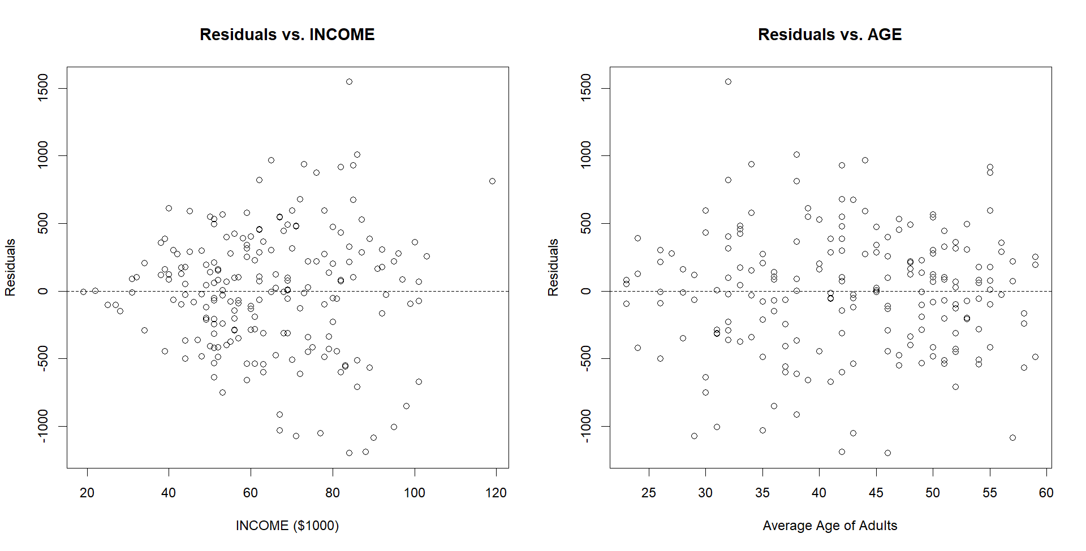

The **Residuals vs. AGE** plot shows **no obvious evidence** of heteroskedasticity. The variance of the residuals appears constant across different values of AGE.

The **Residuals vs. INCOME** plot also shows **no strong or clear visual evidence** of heteroskedasticity. While not perfectly uniform, there isn't a distinct fanning pattern that would strongly suggest non-constant variance related to INCOME.

c.

H₀: σ²2 = σ²1 (homoskedasticity)

H₁: σ²2 > σ²1 (heteroskedasticity related to income)

d.

Once we “robustify” our standard errors, we get a fatter confidence band around the estimate, which is what you’d expect if there’s any heteroskedasticity in the residuals.

e.

Both GLS intervals are narrower than their OLS counterparts (because GLS down‐weights the heteroskedasticity induced by INCOME).

The robust GLS CI (–121.41, –32.20) is slightly wider than the conventional GLS CI (–119.90, –33.72), but still appreciably tighter than the OLS robust CI (–139.32, –24.33).

In every case the interval stays strictly below zero, so we still conclude a statistically significant negative effect of an additional child on miles traveled.

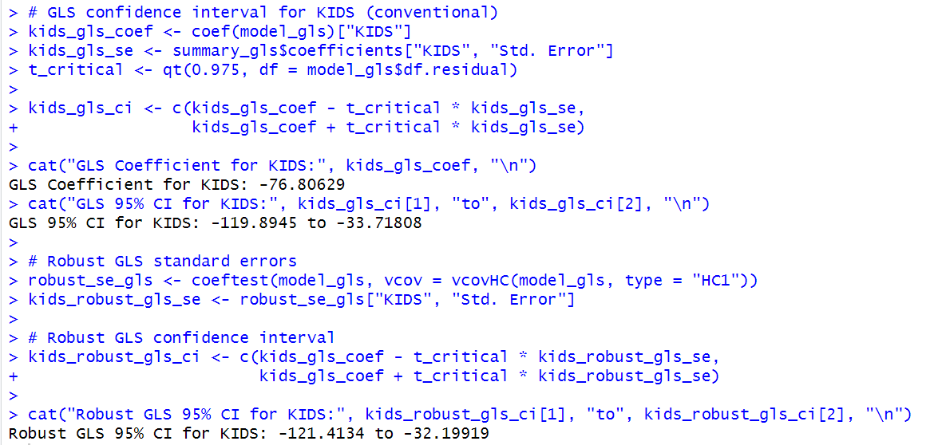

8.18

a.

b.

The Breusch-Pagan tests contradict the conclusion in part (a), showing that even if male/female variances are similar, heteroskedasticity is still present due to other variables.

c.

d.

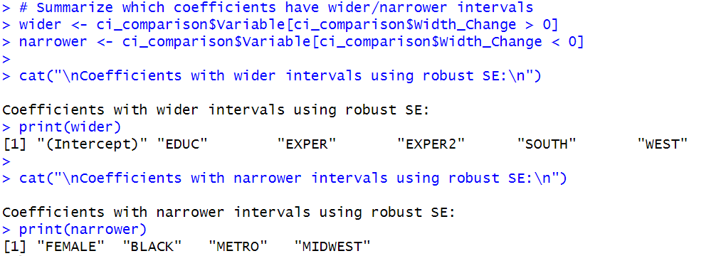

e.

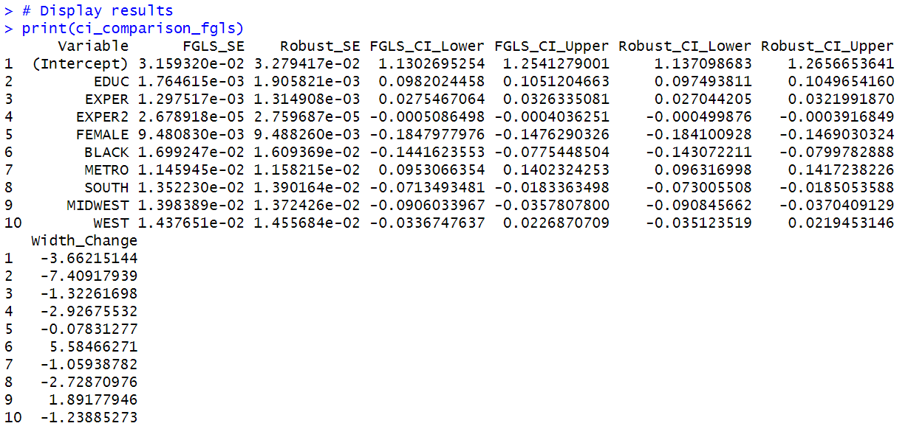

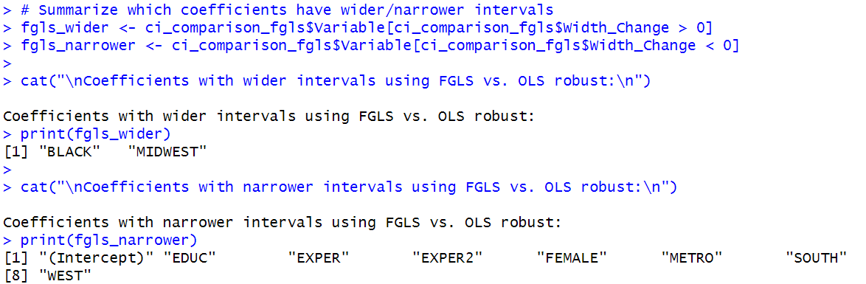

f.

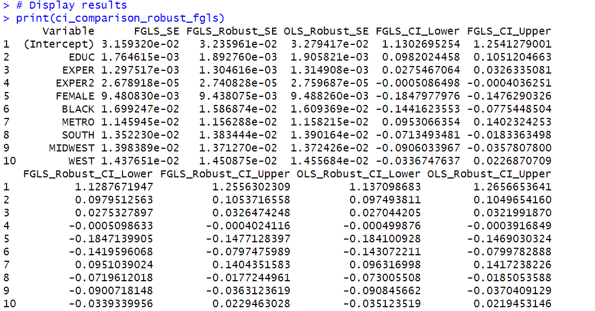

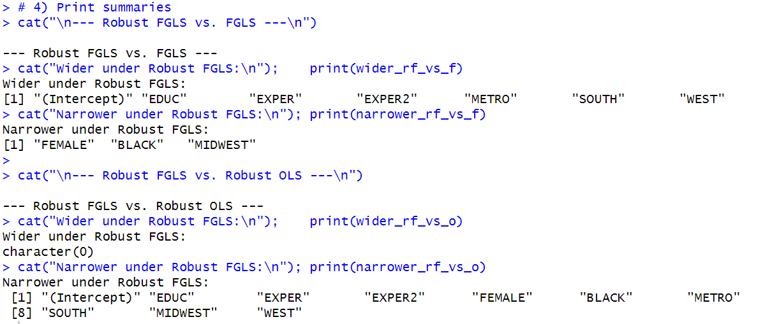

g.

We would go with the **Feasible GLS estimates combined with heteroskedasticity‑consistent (“robust”) standard errors**:

1. **We’ve established there is heteroskedasticity** (White test, NR² tests), so the **conventional** SEs from either OLS or FGLS are invalid. We must use **robust** SEs to get correct inference.
2. **FGLS re‑weights the observations** in a way that – if the estimated variance function is close to the truth – yields **more efficient** (i.e. lower‑variance) coefficient estimates than plain OLS. In the table below, we can see that the FGLS point estimates change slightly (e.g. intercept 1.201→1.192, EDUC 0.1012→0.1017, etc.), and the **FGLS‑robust SEs** are generally a hair **smaller** than the OLS‑robust SEs.
3. By pairing FGLS with robust SEs, we get the “best of both worlds”:
   * **Efficiency** from FGLS weighting
   * **Validity** of inference no matter how perfectly we have modeled the variance
4. In practice, most applied papers therefore report **“FGLS with White (or Huber‑White) SEs”** as their primary specification whenever they’ve confirmed heteroskedasticity.

