**Full name:** Nguyen Nhut Vu Truong

**Student ID:** 413707008

**Course:** Financial Econometrics

**HW0428**

# **Question 18**

a.

b.

MOTHERCOLL and FATHERCOLL are binary variables, reducing potential measurement error compared to continuous variables (MOTHEREDUC, FATHEREDUC). It is easier to explain these two variables: Whether having a high degree of education.

c.

d.

**Reject the null hypothesis** that the coefficient on MOTHERCOLL is zero. MOTHERCOLL is a **strong instrument** for educ based on both tests.

e. The new CI is narrower, then adding FATHERCOLL has improved precision (likely due to stronger instrumentation).

f. **Both results are statistically significant** at the 1% level (***), meaning we reject the null hypothesis that MOTHERCOLL and FATHERCOLL jointly have no effect on educ. The **F-statistics are well above 10** (a common rule-of-thumb threshold), indicating **strong instruments**.

g. The Sargan test yields a p-value of 0.626, indicating that we fail to reject the null hypothesis of instrument validity, and thus both MOTHERCOLL and FATHERCOLL appear to be valid instruments for EDUC in the wage equation.

# **Question 20**

a.

beta = 1.201840 => risky relative to the market portfolio

b. To assess IV conditions:

* **IV1-IV3** refer to: relevance, exogeneity, and exclusion.
* RANK is deterministic from rp_mkt, so it may be **relevant** (IV1), but its validity as **exogenous** (IV2) is debatable.

R2 = 0.9126, Adjusted R2 = 0.9121

**Reject the null hypothesis** that the coefficient on RANK is zero (F-value = 1857.6). RANK is a **strong instrument** for educ based on both tests.

A rule of thumb is that an F-statistic > 10 suggests a strong instrument (Staiger & Stock, 1997).

c. Because **p = 0.0428 > 0.01**, we conclude that **market return is exogenous** in the CAPM for Microsoft.

d. The IV estimate of β (1.2783) is slightly higher than the OLS estimate (1.2018), both highly significant, suggesting little endogeneity in the market return and indicating that OLS provides reliable results consistent with CAPM expectations.

| **Method** | **Estimate of β (rp_mkt)** | **Std. Error** | **t-value** | **Significance** |
| --- | --- | --- | --- | --- |
| OLS | 1.2018 | 0.1222 | 9.84 | *** |
| IV | 1.2783 | 0.1280 | 9.99 | *** |

e. R2 = 0.9149, Adjusted R2 = 0.9139

Since the **F-statistic > 10**, the instruments are considered **jointly strong**.

f. The null hypothesis H0: δ = 0 (market return is exogenous) is tested at the 1% significance level. Since **p-value = 0.0287 > 0.01**, **fail to reject H₀** → Market return is **exogenous.**

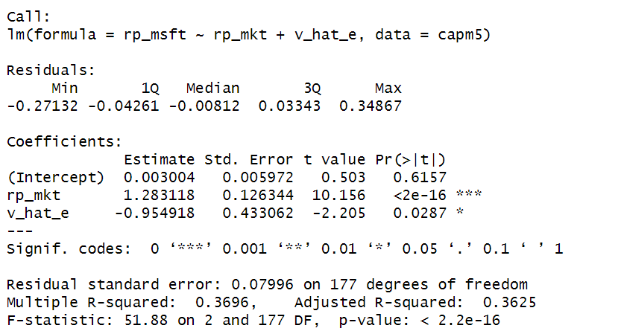

g. The IV estimate of β (1.2831) using both RANK and POS is slightly higher than the OLS estimate (1.2018), consistent with expectations under potential measurement error in the market return, and further supports the reliability of OLS given earlier evidence of exogeneity.

| **Method** | **β Estimate (rp_mkt)** | **Std. Error** | **t-value** | **Conclusion** |
| --- | --- | --- | --- | --- |
| OLS | 1.2018 | 0.1222 | 9.84 | Significant |
| IV (RANK + POS) | **1.2831** | 0.1279 | 10.04 | Significant |

h. We first compute the residuals from the IV/2SLS model in part (g), then regress them on all instruments (RANK and POS), and finally use the NR2 statistic from this regression to perform the Sargan test for instrument validity.

The Sargan test yields a statistic of 0.5585 with a p-value of 0.4549, so we fail to reject the null hypothesis at the 5% level and conclude that the surplus instrument POS is valid and the instruments as a whole are exogenous.

# **Question 24**

a. The residual plot shows no clear pattern of increasing or decreasing spread with experience, indicating that the residuals are **generally consistent with homoskedasticity**.

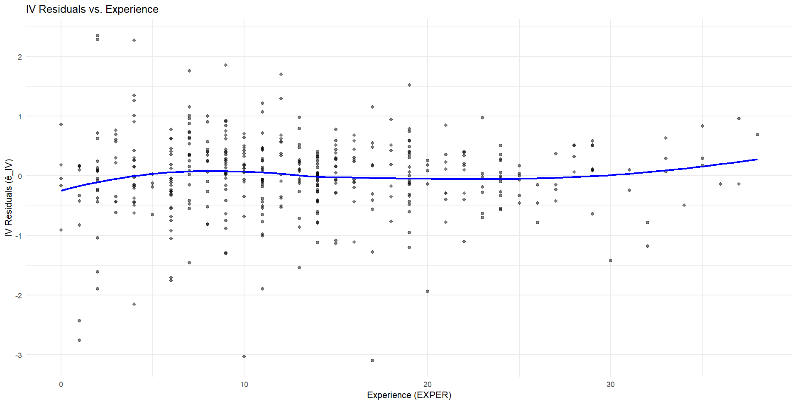

b.

**Null hypothesis H0:** Homoskedasticity (constant variance)

Since the Breusch-Pagan test yields a statistic of 7.44 with a p-value of 0.0064 (< 0.01), we **reject the null hypothesis** of homoskedasticity and conclude that there is **evidence of heteroskedasticity** in the IV residuals.

c. The **robust standard error is slightly larger**, which is expected under heteroskedasticity (0.0333 > 0.0314). The confidence interval for educ is slightly **wider** using heteroskedasticity-robust standard errors (−0.0041 to 0.1269) than with baseline standard errors (−0.0004 to 0.1232), reflecting the adjustment for potential heteroskedasticity in the IV model.



d.

The bootstrap standard error for educ is **0.0323**, which is slightly **larger** than the baseline SE (0.0314) but slightly **smaller** than the robust SE (0.0333); using the bootstrap SE and the original model’s coefficient (0.0614), the **95% confidence interval** is approximately **[−0.0020, 0.1248]**.

The bootstrap standard errors are slightly larger than the baseline SEs and comparable to the robust SEs for all coefficients, with educ having a bootstrap SE of 0.0323 versus 0.0314 (baseline) and 0.0333 (robust), indicating consistent but slightly more conservative inference under heteroskedasticity.

