**Full name:** Nguyen Nhut Vu Truong

**Student ID:** 413707008

**Course:** Financial Econometrics

**HW0512**

**C11Q28, C11Q30, C15Q06, C15Q20, C15Q17**

# 28.

**Part (a): Rewriting the Equations with P on the Left-Hand Side**

Original equations:

* Demand: Qᵢ = α₁ + α₂Pᵢ + α₃PSᵢ + α₄DIᵢ + edᵢ
* Supply: Qᵢ = β₁ + β₂Pᵢ + β₃PFᵢ + eₛᵢ

Rewritten with P on the left-hand side:

**Demand Equation:** α₂Pᵢ = -α₁ + Qᵢ - α₃PSᵢ - α₄DIᵢ - eₐᵢ Pᵢ = (-α₁/α₂) + (1/α₂)Qᵢ - (α₃/α₂)PSᵢ - (α₄/α₂)DIᵢ - (edᵢ/α₂) Pᵢ = γ₁ + γ₂Qᵢ + γ₃PSᵢ + γ₄DIᵢ + udᵢ

Where:

* γ₁ = -α₁/α₂
* γ₂ = 1/α₂
* γ₃ = -α₃/α₂
* γ₄ = -α₄/α₂
* uₐᵢ = -edᵢ/α₂

**Supply Equation:** β₂Pᵢ = -β₁ + Qᵢ - β₃PFᵢ - eₛᵢ = (-β₁/β₂) + (1/β₂)Qᵢ - (β₃/β₂)PFᵢ - (eₛᵢ/β₂) = δ₁ + δ₂Qᵢ + δ₃PFᵢ + uₛᵢ

Where:

* δ₁ = -β₁/β₂
* δ₂ = 1/β₂
* δ₃ = -β₃/β₂
* uₛᵢ = -eₛᵢ/β₂

**Anticipated Signs:**

For the demand equation:

* γ₁ (intercept): Positive (since α₁ is expected to be positive and α₂ negative in the original demand equation)
* γ₂ (coefficient of Q): Negative (since α₂ is expected to be negative in the original demand equation)
* γ₃ (coefficient of PS): Positive (since α₃ is expected to be positive and α₂ negative)
* γ₄ (coefficient of DI): Positive (since α₄ is expected to be positive and α₂ negative)

For the supply equation:

* δ₁ (intercept): Negative (since β₁ is expected to be positive and β₂ positive in the original supply equation)
* δ₂ (coefficient of Q): Positive (since β₂ is expected to be positive in the original supply equation)
* δ₃ (coefficient of PF): Positive (since β₃ is negative and β₂ is positive)

**Part (b):**

**Part (c):**

**Part (d):**

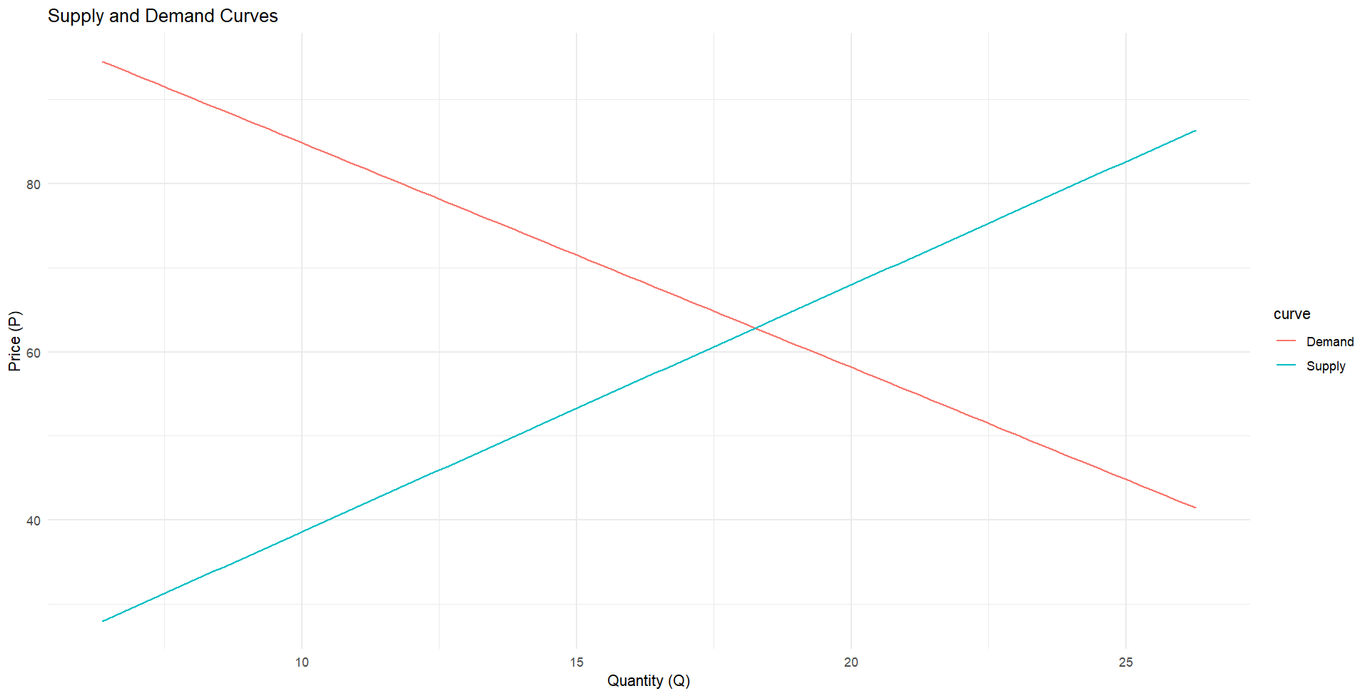

**Part (e):**

The equilibrium values calculated from the structural equations and those predicted from the reduced form equations agree very well:

* **Price**: The difference is only 0.02719676 (about 0.04% difference)
* **Quantity**: The difference is only -0.01018407 (about 0.06% difference)

These extremely small differences indicate excellent agreement between the two methods. This confirms that both the structural approach (solving the simultaneous equations) and the reduced form approach (direct estimation of the equilibrium values) produce consistent results, which validates the model specification and estimation technique. The slight differences are likely due to rounding errors in the calculations or minor numerical imprecisions in the estimation algorithms, rather than any substantive disagreement between the methods.

**Part (f):**

**OLS:**

**Analysis of OLS vs 2SLS Results**

**Demand Equation**

**Sign Analysis**

* **q coefficient**:
  + OLS: Positive (0.1512) - **incorrect sign** for demand curve
  + 2SLS: Negative (-2.6705) - **correct sign** for demand curve
* **ps coefficient**:
  + OLS: Positive (1.3607) - **correct sign** (substitute good price)
  + 2SLS: Positive (3.4611) - **correct sign**
* **di coefficient**:
  + OLS: Positive (12.3582) - **correct sign** (income effect)
  + 2SLS: Positive (13.3899) - **correct sign**

**Statistical Significance**

* **q coefficient**:
  + OLS: Not significant (p=0.7642)
  + 2SLS: Significant (p=0.0315) **
* **ps coefficient**:
  + OLS: Significant (p=0.0303) **
  + 2SLS: Highly significant (p=0.0046) ***
* **di coefficient**:
  + OLS: Highly significant (p<0.0001) ***
  + 2SLS: Highly significant (p<0.0001) ***

**Supply Equation**

**Sign Analysis**

* **q coefficient**:
  + OLS: Positive (2.6613) - **correct sign** for supply curve
  + 2SLS: Positive (2.9367) - **correct sign**
* **pf coefficient**:
  + OLS: Positive (2.9217) - **correct sign** (input price effect)
  + 2SLS: Positive (2.9585) - **correct sign**

**Statistical Significance**

* All coefficients in both OLS and 2SLS supply equations are highly significant (p<0.0001) ***

**Comparison with Part (b)**

1. **Key Finding**: OLS estimation of the demand equation yields an **incorrect positive sign** for the quantity coefficient, while 2SLS correctly produces a negative coefficient.
2. **Simultaneity Bias**: This demonstrates the simultaneity bias in OLS estimation when applied to simultaneous equation models. The OLS estimate fails to account for the endogeneity of quantity.
3. **Supply Equation**: Both methods produce similar estimates for the supply equation, but 2SLS estimates are slightly larger in magnitude.
4. **Statistical Significance**: The quantity coefficient in the demand equation is only statistically significant with 2SLS, not with OLS.
5. **Coefficient Magnitudes**: The 2SLS estimates for the exogenous variables (ps, di, pf) are larger in magnitude than their OLS counterparts, suggesting that OLS underestimates these effects.

In conclusion, the 2SLS results from part (b) correctly identify the structural parameters of the model, while OLS suffers from simultaneity bias, particularly in the demand equation where it fails to capture the negative relationship between price and quantity.

# 30.

**Intercept (β₁ = 10.12579)**

* **Sign**: Positive
* **Significance**: Marginally significant (p = 0.081374) *
* **Interpretation**: When all other variables are zero, the baseline investment level is estimated at about 10.13 units, though this is only significant at the 10% level.

**Current Profits (p) (β₂ = 0.47964)**

* **Sign**: Positive ✓
* **Significance**: Highly significant (p = 0.000125) ***
* **Interpretation**: This positive relationship aligns with economic theory - higher current profits lead to increased investment. For each additional unit of profit, investment increases by approximately 0.48 units, holding other factors constant.

**Lagged Profits (plag) (β₃ = 0.33304)**

* **Sign**: Positive ✓
* **Significance**: Highly significant (p = 0.004212) ***
* **Interpretation**: Past profits also positively affect current investment, suggesting firms use profit history in investment decisions. Each additional unit of last period's profit increases current investment by about 0.33 units.

**Lagged Capital Stock (klag) (β₄ = -0.11179)**

* **Sign**: Negative ✓
* **Significance**: Highly significant (p = 0.000624) ***
* **Interpretation**: This negative relationship suggests a capital adjustment process - firms with higher existing capital stock tend to invest less in the current period, consistent with diminishing returns to capital. For each additional unit of last period's capital stock, current investment decreases by about 0.11 units.

**Part (b)**:

The joint hypothesis test fails to reject the null hypothesis that g, tx, w2, time, and elag are all simultaneously equal to zero (p-value = 0.1566), suggesting these variables do not collectively have a statistically significant effect on the dependent variable at conventional significance levels.

**Results Interpretation: Hausman Test for Endogeneity**

**Key Statistics**

* Residual coefficient: 0.57451
* Standard error: 0.14261
* t-value: 4.029
* p-value: 0.000972 (highly significant)

**Conclusion**

We reject the null hypothesis that δ = 0 at the 5% significance level (and even at the 0.1% level). This provides strong evidence that p (profits) is indeed endogenous in the investment equation.

**Context in Simultaneous Equations Model**

This result aligns with what we would expect in Klein's Model I where:

* Consumption (CN) affects profits (P) through equation 11.17
* Investment (I) affects profits (P) through national income identity
* Profits (P) affects investment (I) through equation 11.18

In this simultaneous equations system, profits cannot be treated as exogenous because they are jointly determined with investment and consumption. The significant residual coefficient confirms this theoretical expectation, indicating that:

1. OLS estimates would be biased and inconsistent
2. Alternative estimation methods like 2SLS or IV are more appropriate
3. The simultaneous nature of the relationship between investment and profits is empirically validated

The high R-squared (0.9659) indicates the model explains most of the variation in investment, and the significant F-statistic confirms the overall model fit.

**Part (d):**

The substantial differences between OLS and 2SLS estimates confirm the presence of endogeneity in the investment equation. The most striking finding is that current profits (p) appear to have a much smaller and statistically insignificant effect on investment when estimated with 2SLS, while lagged profits have a much stronger effect than OLS suggested.

These differences highlight the importance of addressing endogeneity in this model. The OLS estimates were biased due to the simultaneous relationship between investment and profits, and the 2SLS method has helped correct this bias by using instrumental variables. The results suggest that investment decisions are influenced more by past profits than by current profits, which makes economic sense as investment planning typically relies on historical performance.

**Part (e):**

**Coefficients:** The point estimates are identical between the two models.

**Standard Errors:** The manual 2SLS approach consistently produces larger standard errors (about 19% higher) compared to the automated approach. This suggests the manual approach might be less efficient in its estimation.

The differences observed are likely due to how the **standard errors** are calculated in each approach. The automated 2SLS implementation in the ivreg function might use more efficient methods for computing standard errors, possibly accounting for heteroskedasticity or using different degrees of freedom adjustments.

These findings highlight the importance of using specialized software for 2SLS estimation rather than manually implementing the procedure, as the specialized software may incorporate refinements that lead to more efficient estimates and more accurate inference. While the **point estimates** are identical, the inference drawn from them could differ, especially in borderline cases of statistical significance.

**Part (f):**

**Sargan Test Results Summary**

The Sargan test for instrument validity yields:

* Test statistic (TR²): 1.2815
* Critical value (χ²₄,₀.₉₅): 9.4877
* p-value: 0.8645

We fail to reject the null hypothesis of valid instruments. The R² is very low (0.061) and none of the instruments are statistically significant in the residual regression (all p-values > 0.05). This confirms that the surplus instruments used in the 2SLS estimation appear to be valid for the investment equation.

