Econometric_HW0303_蔡霈沅314707033
#2.1 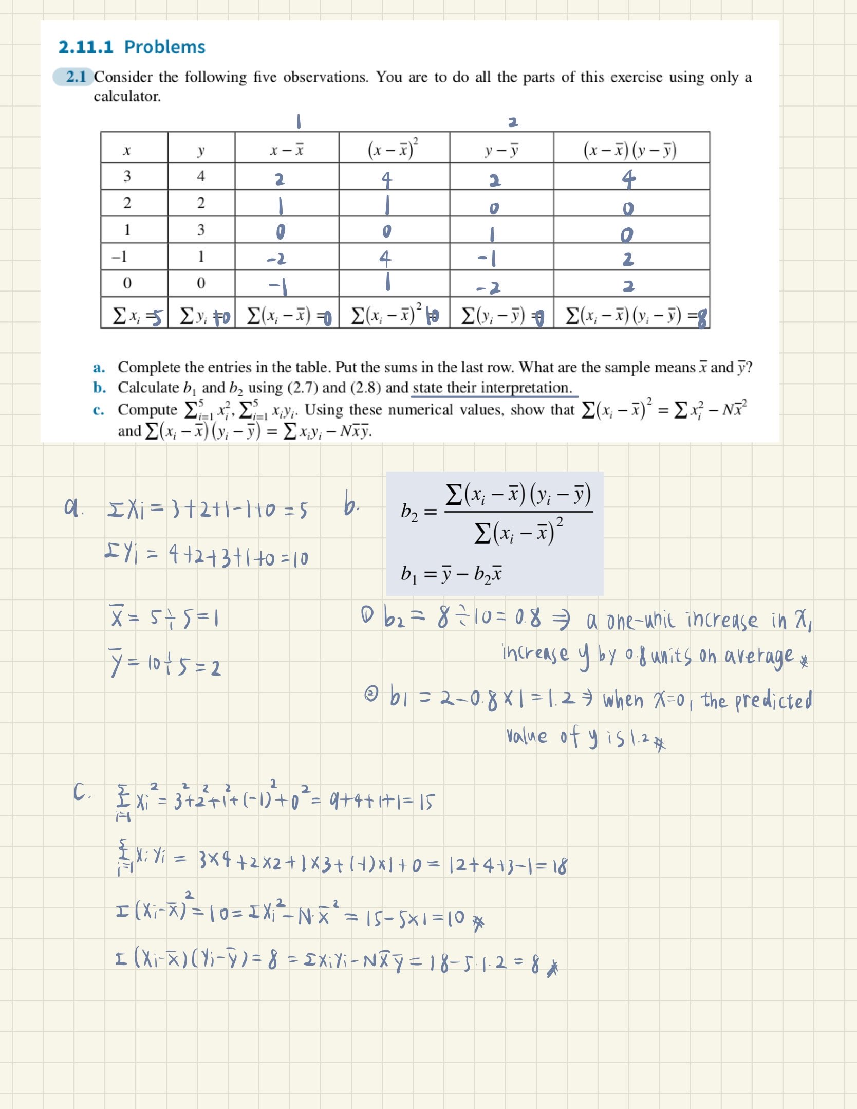
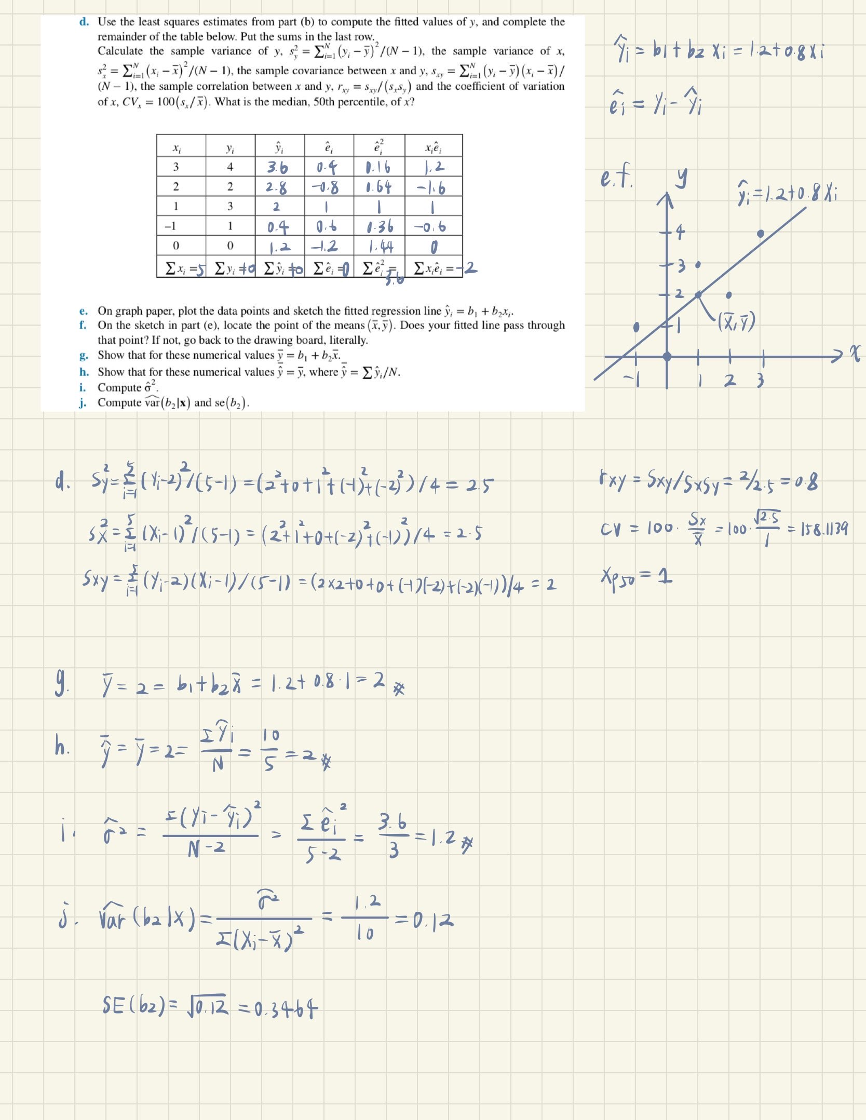

#2.22 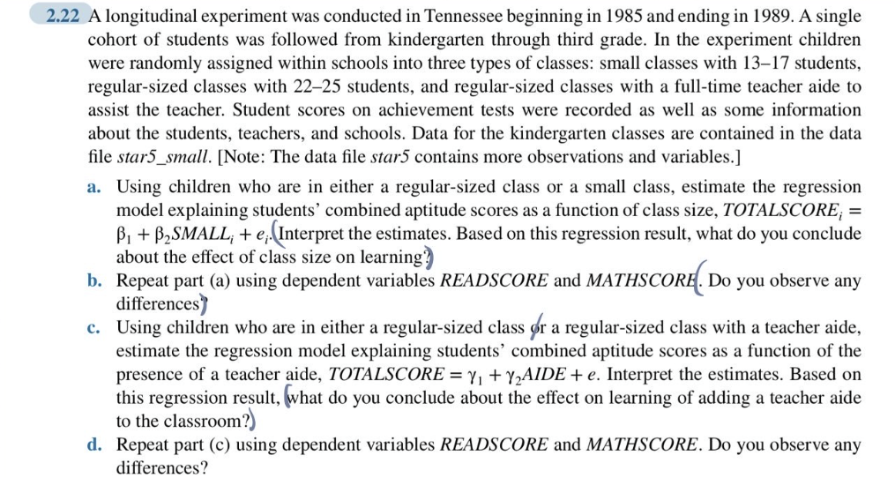
- 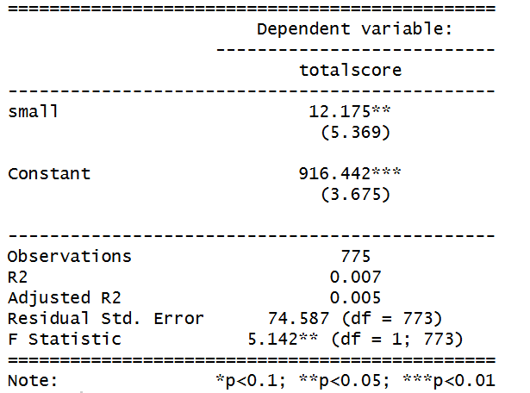
The estimated regression is ${\hat{TOTALSCORE}}_{i}=916.442+12.175\hat{{SMALL}_{i}}$.
$\hat{β_{1}}$=916.442→When $\hat{{SMALL}_{i}}$=0,the predicted value of ${\hat{TOTALSCORE}}_{i}$ is 918.628. This represents the average score for students in regular-sized class.
$\hat{β_{2}}$=12.175→The coefficient on SMALL is statistically significant, and this means that students in small classes score about 12.175 ponits higher on average than students in regular classes.
The result suggests that smaller class sizes improve student achievement.

- 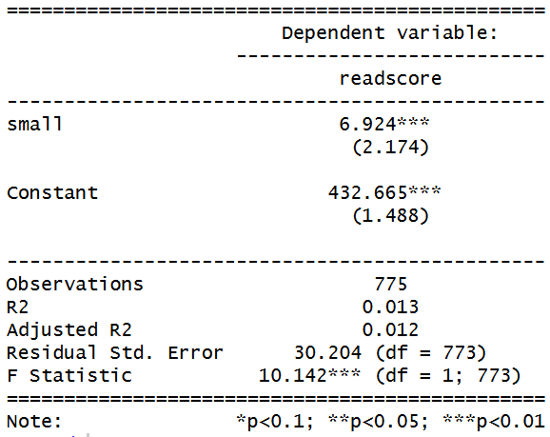
${\hat{READSCORE}}_{i}=432.665+6.924\hat{{SMALL}_{i}}$
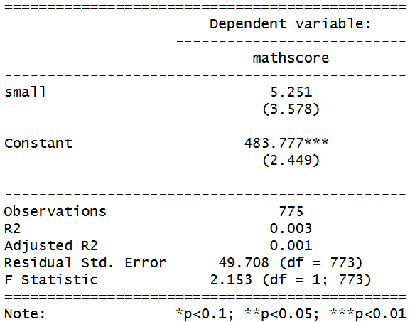
${\hat{MATHSCORE}}_{i}=483.777+5.251\hat{{SMALL}_{i}}$
Yes, there is a small difference. The estimated coefficient on SMALL is 6.924 for reading scores and 5.251 for math scores. This means students in small classes score higher on both subjects than those in regular classes. The effect is slightly larger for reading than for math, although the difference is not large. By the way, the coefficient on SMALL for math scores is not statistically significant, implying that the size of the class dose not have a meaningful effect on learning.

- 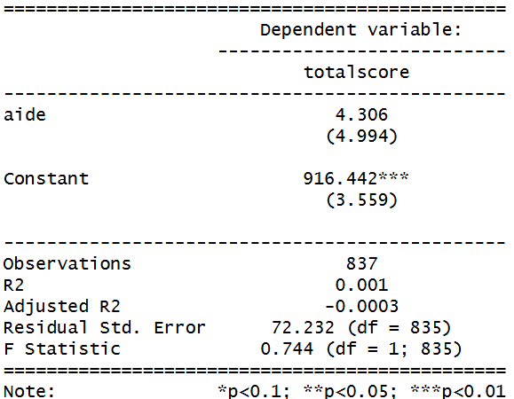
${\hat{TOTALSCORE}}_{i}=916.442+4.306\hat{{AIDE}_{i}}$
The constant (916.442) represents the average score for students in regular class without a teacher aide.
The coefficient on AIDE (4.306) means that students in classes with a teacher aide score about 4.306 points larger on average than those in regular classes.
The effect of adding a teacher aide appears to be very small and does improve student achievement. But it is not statistically significant, implying that adding a teacher aide does not have a meaningful effect on learning.
- 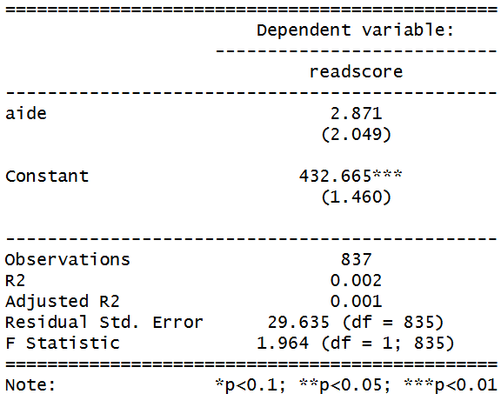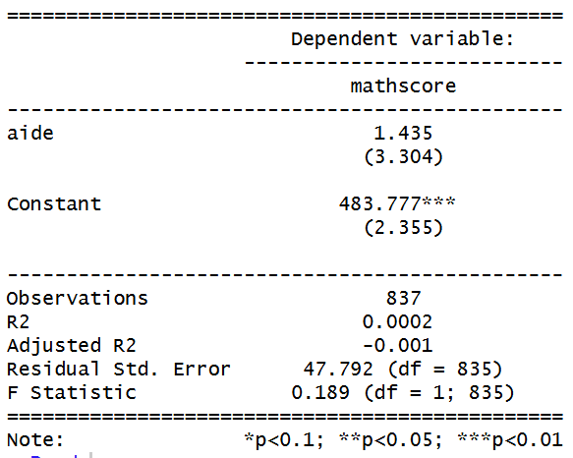
${\hat{READSCORE}}_{i}=432.665+2.871\hat{{AIDE}_{i}}$
${\hat{MATHSCORE}}_{i}=483.777+1.435\hat{{AIDE}_{i}}$
Yes, there is a small difference. The estimated coefficient on AIDE is2.871 for reading scores and 1.435 for math scores. This means students in regular classes with a teacher aide score larger on both subjects than those in regular classes. Both are not statistically significant.

#2.25 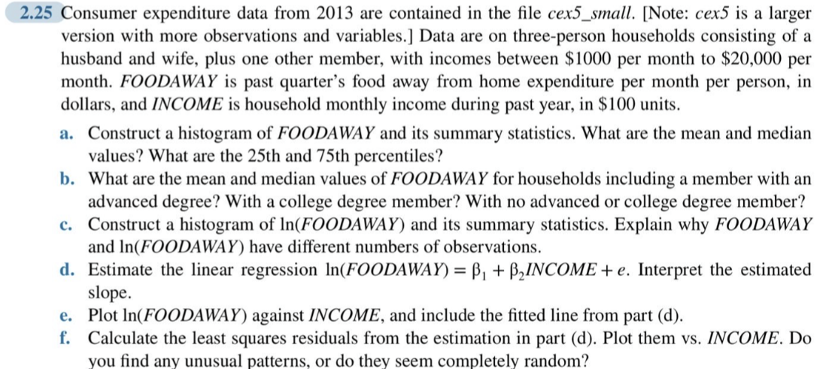
- 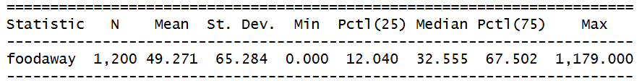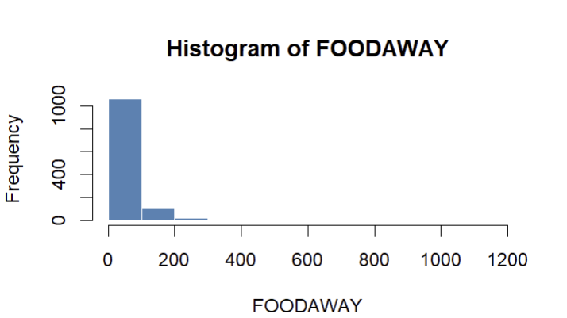

- 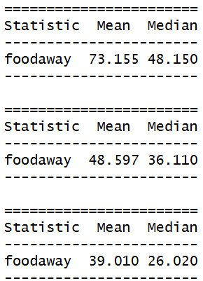

- 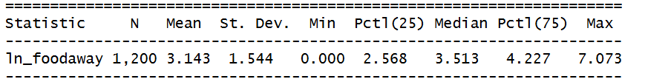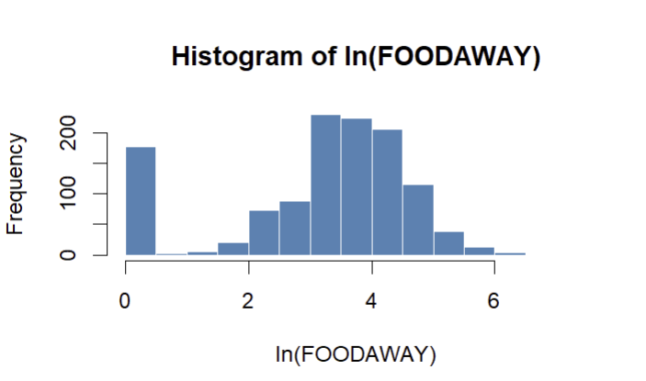
To avoid the problem of taking the log of zero, I transformed the variable using ln(foodaway+1) instead of ln(foodaway). Some observations of FOODAWAY=0, and the log of zero is undefined. Adding 1 can ensure that the log can be computed for all observations while having only a small effect on larger values. So FOODAWAY and ln(FOODAWAY) have different numbers of observations, but adding 1 can avoid the problem of missing values.

- 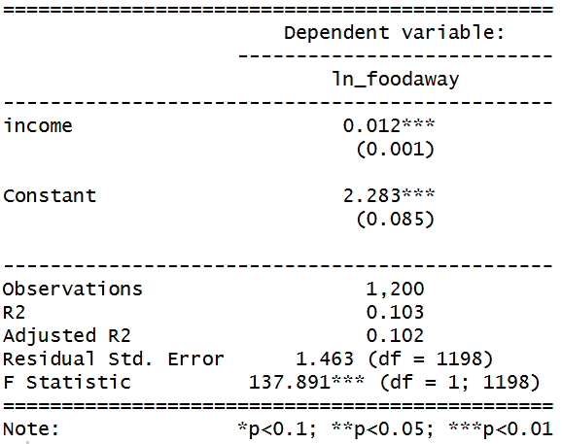
This regression uses a semi-log function form: ${\hat{ln⁡(FOODAWAY)}}_{i}=2.283+0.012\hat{INCOME}$.
The constant (2.283) represents the predicted log value of FOODAWAY when income is zero.
The coefficient on income (0.012) means that a $100 increase in income is associated with approximately a 1.2% increase in food away from home expenditure.
- 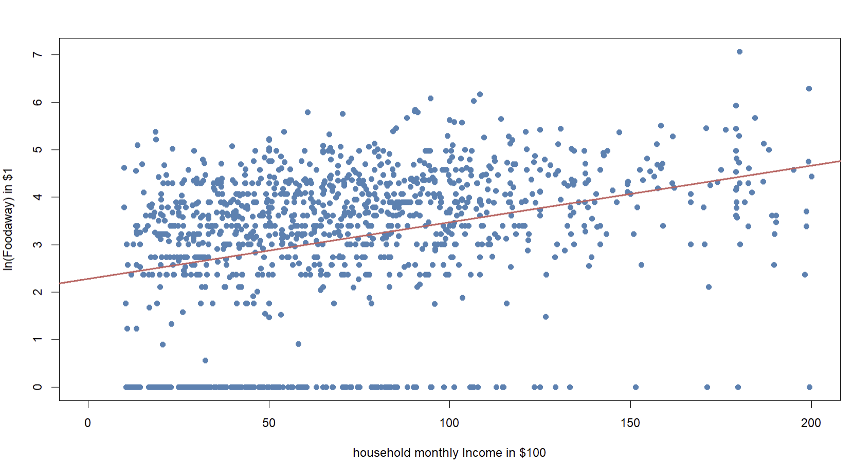
- 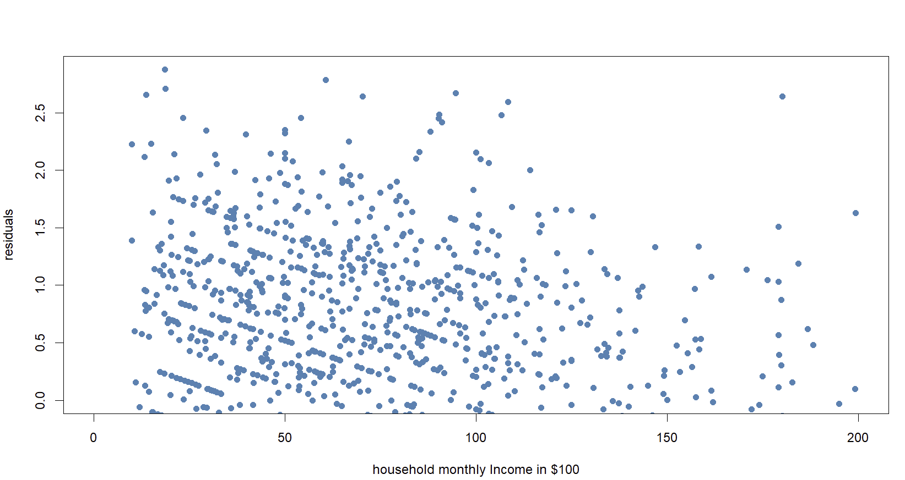
The residuals do not appear to be complete random. They exhibit heteroskedasticity. We can find that the variance of the residuals changes as the income increases, rather than staying constant(homoskedasticity).

