GPUTrain

Multi-server SSH training design and review

STATUS  Review draft |  | OWNER  GPUTrain project |  | LAST UPDATED  10 October 2026

Authors | GPUTrain project / Codex documentation
Reviewers | Project maintainer, backend and operations
Related docs | current-system-design.md; design-review-2026-10-10.md
Scope | Current SSH path, job lifecycle, gaps and acceptance

1. Abstract
The current branch combines a Vue UI, Spring Boot control plane, MySQL state, and SSH access to Linux GPU accounts. New jobs run in per-user systemd transient units. The control plane records jobs, GPU leases, logs, metrics, and alerts and reconciles remote state. Legacy Runner paths remain for history.
This document records the repository snapshot of 10 October 2026 and its unresolved design issues. A one-step job produced completion logs and a checkpoint while the UI remained in a reconciliation state. A missing alert table also caused a monitor error. Multi-server and terminal-state acceptance remains unproven.

2. Goals and Non-goals
Goals | Non-goals
Multi-server SSH management with distinct capability states | Arbitrary shell, general terminal, or file browser
Provable job terminal state and GPU lease convergence | Distributed training across servers
Schema checks before deploy and clear monitor errors | Automatic CUDA, model, or environment installation
Real two-server and recovery acceptance | Code edits or a claim of production acceptance here

3. Background and problem
The README still describes a single-server Runner path as primary, while the current branch introduces multi-server SSH execution. Database state and remote systemd effects cannot share one transaction. The design needs durable evidence for remote exit, safe lease release, and migration readiness.
Invariants: the browser talks only to the control plane; MySQL owns job and lease state; a job UUID determines the remote unit name; uncertain outcomes retain leases. The backend rechecks server, account, and GPU authorization. A success line in a log cannot by itself authorize lease release.

4. Proposed architecture

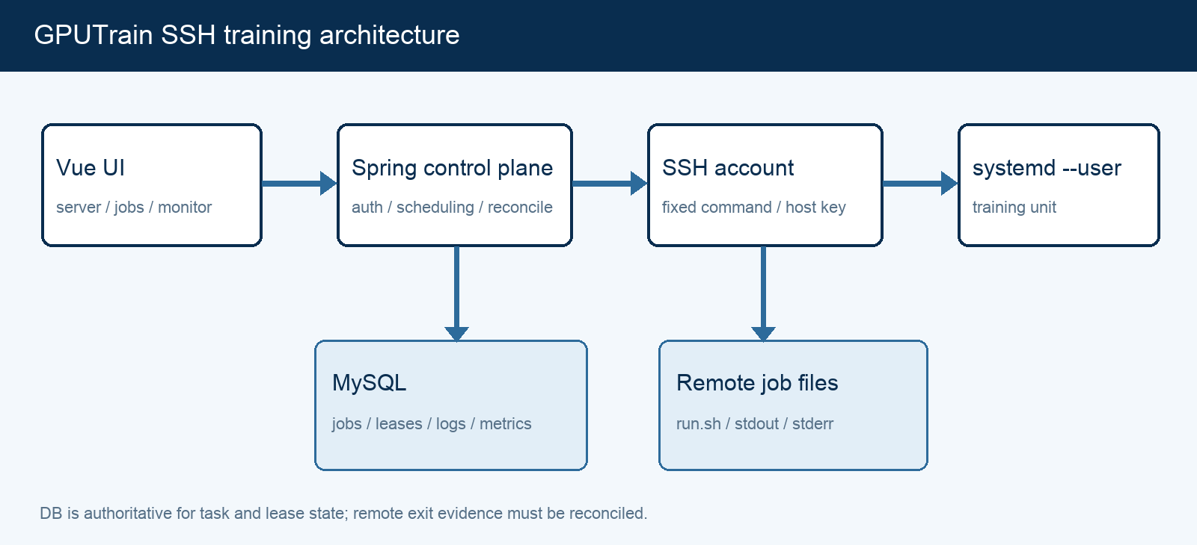
Figure 1. Control plane, durable state, and remote execution boundary.

Core components

Component | Responsibility | Primary storage | Failure behavior
Vue UI | Server, job, and monitor workflows | Browser session | Show errors and stale data explicitly
Spring control plane | Auth, allocation, dispatch, reconciliation | MySQL | Unknown SSH state retains lease
SSH and systemd | Fixed commands and training process | Remote unit and files | Recover from remote evidence
MySQL | Jobs, devices, leases, logs, metrics | Persistent database | Detect missing schema before launch
Monitor API | Logs, SSE, metrics, alerts, resources | MySQL and snapshots | Do not present errors as empty data

5. Request lifecycle
- The user selects a server, their authorized Linux account, three GPUs on that server, and 1–5 steps of the fixed docowl2-srfund profile, then supplies an idempotency key.
- The backend verifies RuoYi permission, owner, server/account binding, host capability, GPU UUIDs, snapshot freshness, free memory, and training-path constraints.
- The control plane loads the pinned host key, encrypted account credential, profile configuration, GPU snapshots, and active leases. Only capable servers can accept jobs.
- The job is persisted first. A dispatcher allocates three GPU leases in a short database transaction and derives a deterministic unit name and paths under the account allowed root.
- The job, owner, request key, server, account, GPUs, and leases must be durable before SSH launch. Remote startup occurs outside the transaction; ambiguous outcomes become UNKNOWN.
- The control plane uses systemd-run --user. A 10-second reconciler checks systemctl --user show. Stop, disconnect, and recovery use remote evidence; startup is not blindly retried.
- After confirmed success, failure, or stop, leases are released. Stream offsets identify captured logs; history and SSE expose logs, metrics, alerts, and resources. Missing terminal evidence keeps the job under review.

6. API and data contracts

Primary job contract

Field | Type | Required | Description
job_id / job_uuid | ID / UUID | Yes | Platform job and remote unit identity
owner_user_id | ID | Yes | RuoYi user ownership
server_id / account_id | ID | Yes | Target host and Linux account
gpu_uuids | 3 x UUID | Yes | Same-server GPUs; backend checked
request_key | String | Yes | Submission idempotency key
status / unit_name | Enum / String | Yes | Database and remote state mapping
log stream / offset | Enum / Integer | For logs | Deduplicate and resume ingestion

Contract guarantees

- Before launch, verify ownership, same-server GPUs, and snapshot freshness; write database state before the remote effect.
- The request key deduplicates submissions. Job UUID fixes the systemd unit name. Logs deduplicate by job, stream, and byte offset. State transitions require the expected prior state.
- Record job ID/UUID, owner, server, account, GPU UUIDs, profile inputs, unit name, and timestamps for audit and recovery.
- MySQL is the job and lease source of truth; SSH is the remote process observation. Logs and UI text alone are insufficient terminal evidence.
Schema: backend/sql/gputrain_phase8_ssh_servers.sql and
backend/sql/gputrain_phase9_ssh_jobs.sql. See docs/architecture/current-system-design.md.

7. Consistency, idempotency, and replay

MySQL and SSH cannot commit atomically. Allocation precedes remote launch; ambiguous launch results are reconciled by the deterministic unit name. Recovery must distinguish running, exited, garbage-collected unit, and unreachable account. Current code returns UNKNOWN for an unloaded unit and lacks a second durable exit signal. This is the highest-priority design gap.
Scenario | Expected behavior | Reasoning
Duplicate request or ambiguous launch | Return same job; inspect fixed unit, do not relaunch | Request key, UUID, conditional state
Missing schema or database outage | Block launch or clearly degrade, never show empty success | Migration preflight and API smoke test
SSH loss or unloaded unit | Hold lease and seek independent exit evidence | No atomic DB/SSH transaction
Stop request timeout | Check process/unit; release only after exit | Sending STOP is not completion

8. Security and privacy

- Check RuoYi permissions and job/account ownership. Allow only fixed SSH commands and a constrained training profile; reject arbitrary shell input.
- Do not return passwords, private keys, or ciphertext through APIs. Redact credentials and training data from diagnostics.
- Encrypt account credentials with a key outside the database and Git. Pin the SSH host key; reject changed fingerprints before sending credentials.
- Manual recovery and administrative migration must check jobs, remote processes, and leases. Age alone cannot justify GPU lease release.
- Define retention, deletion, and archive periods for logs, metrics, alerts, and snapshots; these remain open.

9. Operational readiness
Signal | SLO or alert | Owner | Launch gate
Terminal state | Success/failure/stop have exit evidence; UNKNOWN has recovery path | Backend/Ops | Required
Active GPU leases | Release after confirmed terminal state; no false release | Backend | Required
Schema completeness | Required Phase 4/8/9 objects exist | Release owner | Required
Monitor API | Logs, metrics, alerts, resources query separately | Frontend/Backend | Required
SSH capability | Per-step status, last success, timeout | Backend/Ops | Recommended
Two-server field validation — both auth modes, account isolation, stop and recovery — Required

10. Alternatives considered

Alternative | Why considered | Why not selected
Per-user Runner | Prior path reports state and logs | Requires resident target-side program; history retained
nohup / setsid + PID | Less systemd dependency | PID reuse and process-tree recovery harder
Control plane per server | Direct local execution | Complicates deployment and unified ownership
SSH + user systemd | No GPUTrain resident agent | Selected; needs durable exit evidence

11. Open questions
- Should terminal evidence use a retained systemd unit, an exit-status file, or both? How is exit proved after unit collection?
- What happens to active jobs when an account is revoked, a credential rotates, or a host fingerprint changes?
- What are polling concurrency, timeout, and observability retention limits for two or more servers?
- When can Runner stop accepting new jobs, when can its runtime be removed, and how long must history remain?

12. Decision and next steps
Prioritize two P0 items: durable terminal evidence with lease convergence and schema migration gates. Then improve monitor error states and operator guidance. Validate two real servers, both SSH authentication modes, two accounts observing one GPU, stop, and disconnect/recovery. Decide Runner retirement and main-branch integration only after acceptance. This documentation pass changes no code.
Milestone | Deliverable | Exit criteria
M1 | Terminal evidence and reconciliation design | Unit collection, outage, restart resolved
M2 | Migration gate and monitor error states | Missing tables caught before deployment
M3 | Two-server field acceptance | Both auth modes, accounts, stop, recovery
M4 | Runner retirement and branch integration | History readable, no new Runner jobs, review done

Current design snapshot; the repository review contains source evidence and unresolved risks.

