**Problem 1**

| **scenario 1** | **scenario 2** |
| --- | --- |
| 2.3 | 2.3 |
| 2.15 | 2.15 |
| 3.5 | 3.5 |
| 2.6 | 2.6 |
| 2.75 | 2.75 |
| 2.82 | 2.82 |
| 4.05 | 4.05 |
| 2.25 | 2.25 |
| 2.68 | 2.68 |
| 3 | 3 |
| 4.02 | 40.2 |
| 2.85 | 2.85 |
| 3.38 | 3.38 |

**結果**

| **average** | **2.95** | **5.733077** |
| --- | --- | --- |
| geomean | 2.892048 | 3.452459 |
| median | 2.82 | 2.82 |

**公式**

| **average** | **=AVERAGE(A2:A14)** | **=AVERAGE(B2:B14)** |
| --- | --- | --- |
| geomean | =GEOMEAN(A2:A14) | =GEOMEAN(B2:B14) |
| median | =MEDIAN(A2:A14) | =MEDIAN(B2:B14) |

**Problem 2**

| **Score 1** | **Score 2** |
| --- | --- |
| 19 | 19 |
| 25 | 25 |
| 26 | 26 |
| 28 | 28 |
| 28 | 28 |
| 33 | 33 |
| 34 | 34 |
| 34 | 34 |
| 34 | 34 |
| 35 | 35 |
| 35 | 35 |
| 36 | 36 |
| 36 | 36 |
| 36 | 36 |
| 36 | 36 |
| 37 | 37 |
| 37 | 37 |
| 37 | 37 |
| 37 | 37 |
| 37 | 37 |
| 38 | 38 |
| 39 | 39 |
| 41 | 41 |
| 41 | 41 |
| 41 | 41 |
| 43 | 43 |
| 43 | 43 |
| 43 | 43 |
| 43 | 43 |
| 44 | 43 |
| 45 | 45 |
| 45 | 45 |
| 46 | 46 |
| 48 | 48 |
| 49 | 49 |
| 50 | 50 |
| 51 | 51 |
| 51 | 51 |
| 53 | 53 |
| 58 | 58 |
| 59 | 59 |
| 59 | 59 |
| 59 | 59 |
| 62 | 62 |
| 63 | 63 |
| 63 | 63 |
| 63 | 63 |
| 65 | 65 |
| 65 | 65 |
| 70 | 70 |
| 74 | 74 |
| 74 | 74 |
| 85 | 85 |
| 87 | 87 |
| 89 | 89 |
| 91 | 91 |
| 92 | 92 |

**結果**

|  | **C** | **D** | **E** |
| --- | --- | --- | --- |
| 17 | average | 48.98246 | 48.96491 |
| 18 | geomean | 46.10896 | 46.09037 |
| 19 | mode | 37 | 37 |
| 20 | mode.sngl | 37 | 37 |
| 21 | mode.mult | 37 | 37 |
| 22 |  |  | 43 |

**公式**

| **average** | **=AVERAGE(A17:A73)** | **=AVERAGE(B17:B73)** |
| --- | --- | --- |
| geomean | =GEOMEAN(A17:A73) | =GEOMEAN(B17:B73) |
| mode | =MODE(A17:A73) | =MODE(B17:B73) |
| mode.sngl | =MODE.SNGL(A17:A73) | =MODE.SNGL(B17:B73) |
| mode.mult | =MODE.MULT(A17:A73) | =MODE.MULT(B17:B73) |

**Problem 3**

|  | **F** | **G** | **H** |
| --- | --- | --- | --- |
| 2 | range | 1.9 | 38.05 |
| 3 | IQR | 0.78 | 0.78 |

**公式**

| **range** | **=MAX(A2:A14)-MIN(A2:A14)** | **=MAX(B2:B14)-MIN(B2:B14)** |
| --- | --- | --- |
| IQR | =QUARTILE.INC(A2:A14,3)-QUARTILE.INC(A2:A14,1) | =QUARTILE.INC(B2:B14,3)-QUARTILE.INC(B2:B14,1) |

**Problem 4**

|  | **F** | **G** | **公式** |
| --- | --- | --- | --- |
| 17 | Q1 | 36 | =QUARTILE(A17:A73,1) |
| 18 | Q3 | 59 | =QUARTILE(A17:A73,3) |
| 19 | IQR | 23 | =G18-G17 |
| 20 | Variance | 313.3747 | =VAR.S(A17:A73) |
| 21 | STD | 17.70239 | =STDEV.S(A17:A73) |

|  | **F** | **G** | **公式** |
| --- | --- | --- | --- |
| 23 | median | 43 | =MEDIAN(A17:A73) |
| 24 | STD Q1 apart from median | -0.395427 | =(G17-$G$23)/$G$21 |
| 25 | STD Q3 apart from median | 0.9038327 | =(G18-$G$23)/$G$21 |
| 26 | Q1 apart from median | -7 | =G17-$G$23 |
| 27 | Q3 apart from median | 16 | =G18-$G$23 |

**Problem 5**

**Problem 1**

S1 = [2.3, 2.15,3.5, 2.6,2.75,2.82,4.05,2.25,2.68,3,4.02,2.85,3.38]

|  |  |
| --- | --- |
| **公式** | **答案** |
| mean(S1) | ans =2.9500 |
| geomean(S1) | ans =2.8920 |
| median(S1) | ans =2.8200 |

S2 = [2.3, 2.15,3.5, 2.6,2.75,2.82,4.05,2.25,2.68,3,40.2,2.85,3.38]

|  |  |
| --- | --- |
| **公式** | **答案** |
| mean(S2) | ans =5.7331 |
| geomean(S2) | ans =3.4525 |
| median(S2) | ans =2.8200 |

**problem 2**

|  |  |
| --- | --- |
| **公式** | **答案** |
| mean(Score1) | ans =48.9825 |
| geomean(Score1) | ans =46.1090 |
| mode(Score1) | ans =37 |
| mean(Score2) | ans =48.9649 |
| geomean(Score2) | ans =46.0904 |
| mode(Score2) | ans =37 |

**problem 3**

|  |  |
| --- | --- |
| **公式** | **答案** |
| range(S1) | ans =1.9000 |
| range(S2) | ans =38.0500 |
| iqr(S1) | ans =0.8850 |
| iqr(S2) | ans =0.8850 |

**problem 4**

|  |  |
| --- | --- |
| **公式** | **答案** |
| quantile(Score1,0.25) | ans =36 |
| quantile(Score1,0.75) | ans =59.7500 |
| iqr(Score1) | ans =23.7500 |
| var(Score1) | ans =313.3747 |
| std(Score1) | ans =17.7024 |
| (Q1-med)/STD | ans =0.3954 |
| (Q3-med)/STD | ans =0.9462 |
| Q3-med | ans =16.7500 |
| Q1-med | ans =-7 |

**Problem 6**

**Problem ７**

histogram(Score1)

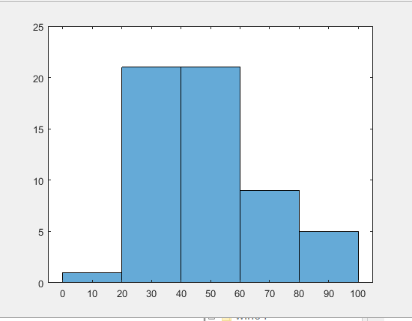

histogram(Score1,10)

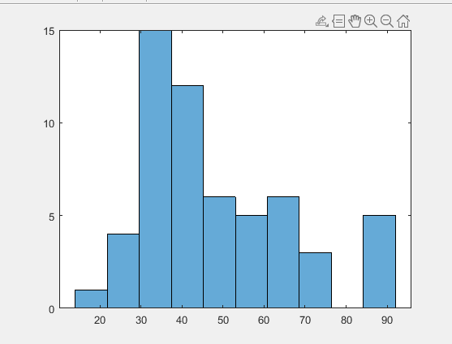

histogram(Score2,10)

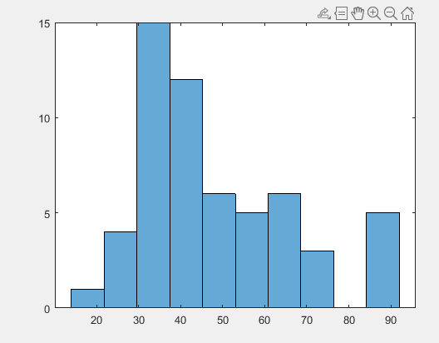

histogram(Score2)

