**WEB动态网页设计-用户注册**

1. **运行截图：**

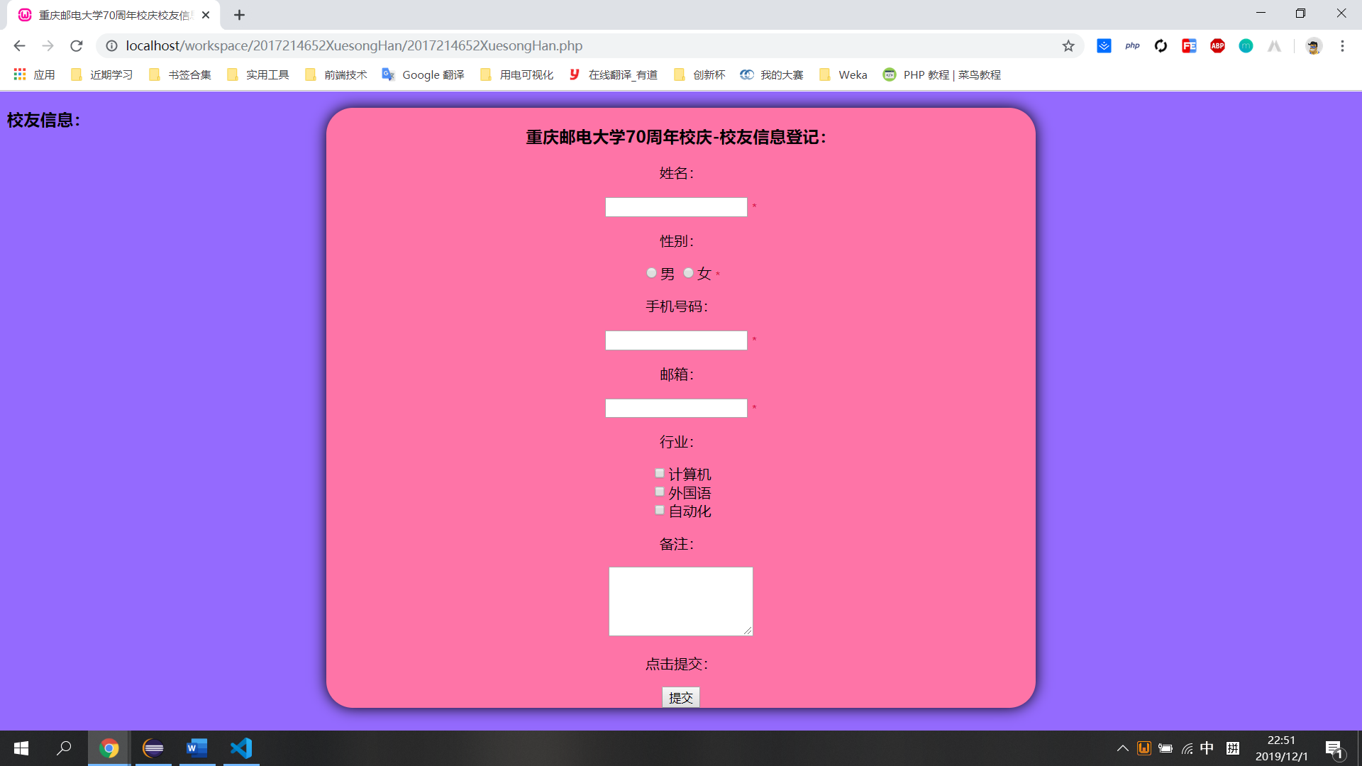

图1 用户注册界面

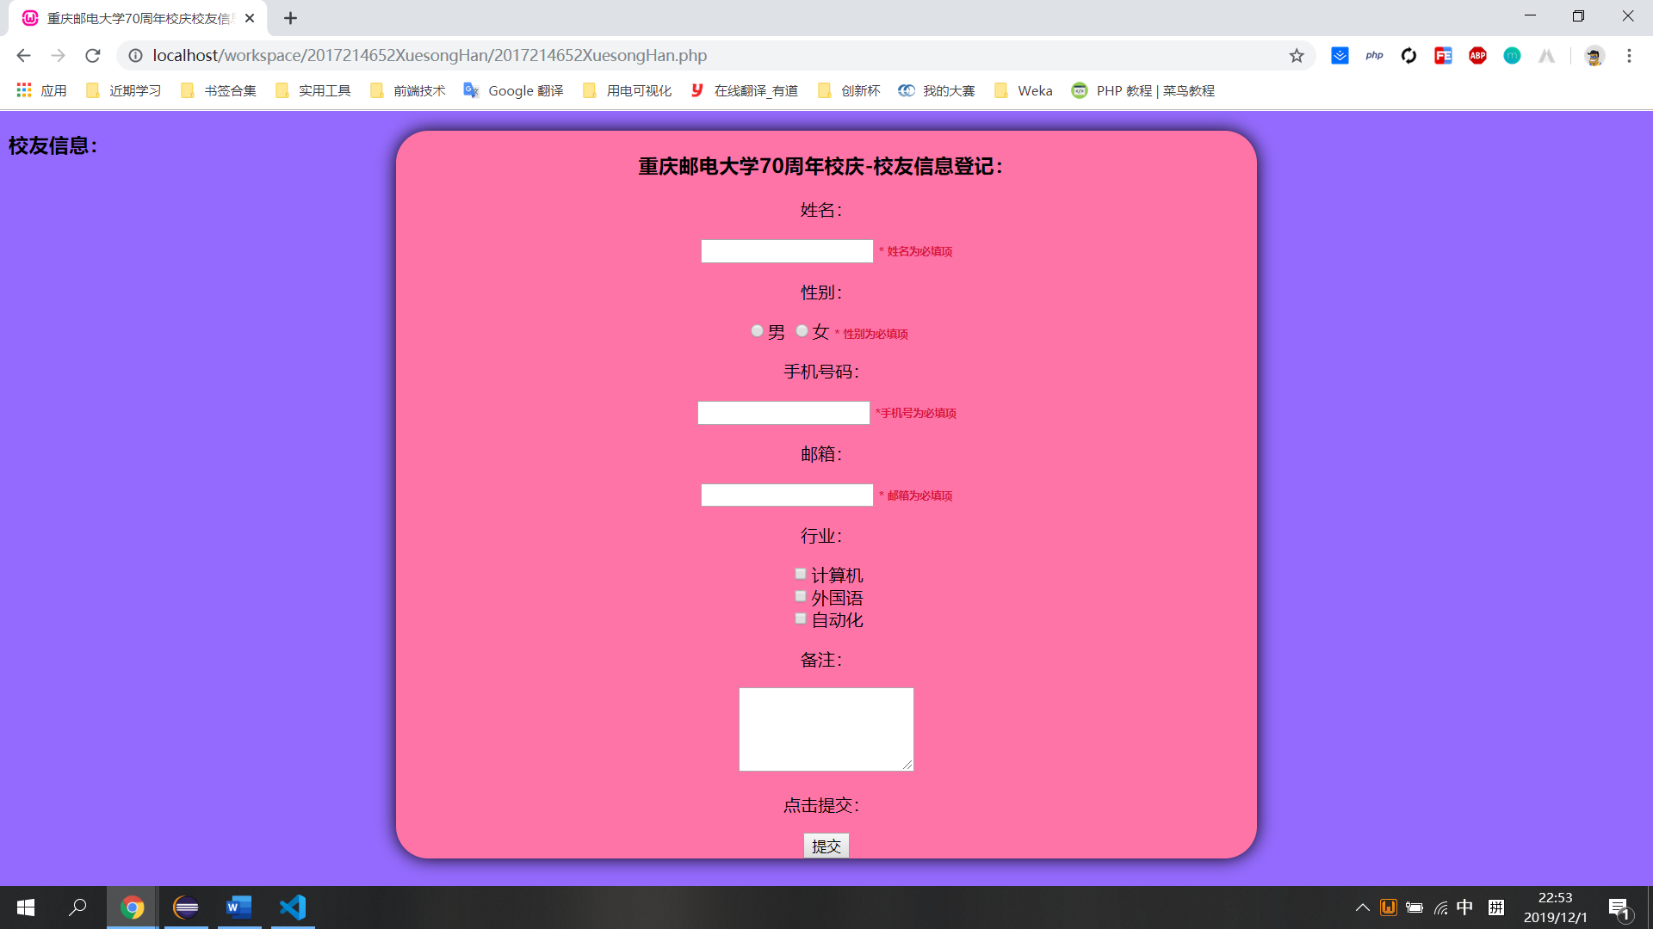

图2 内容空缺提示

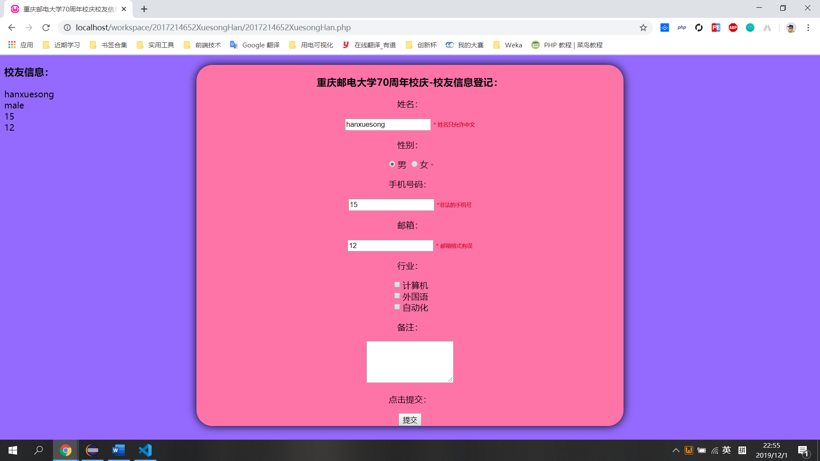

图3 内容格式错误提示

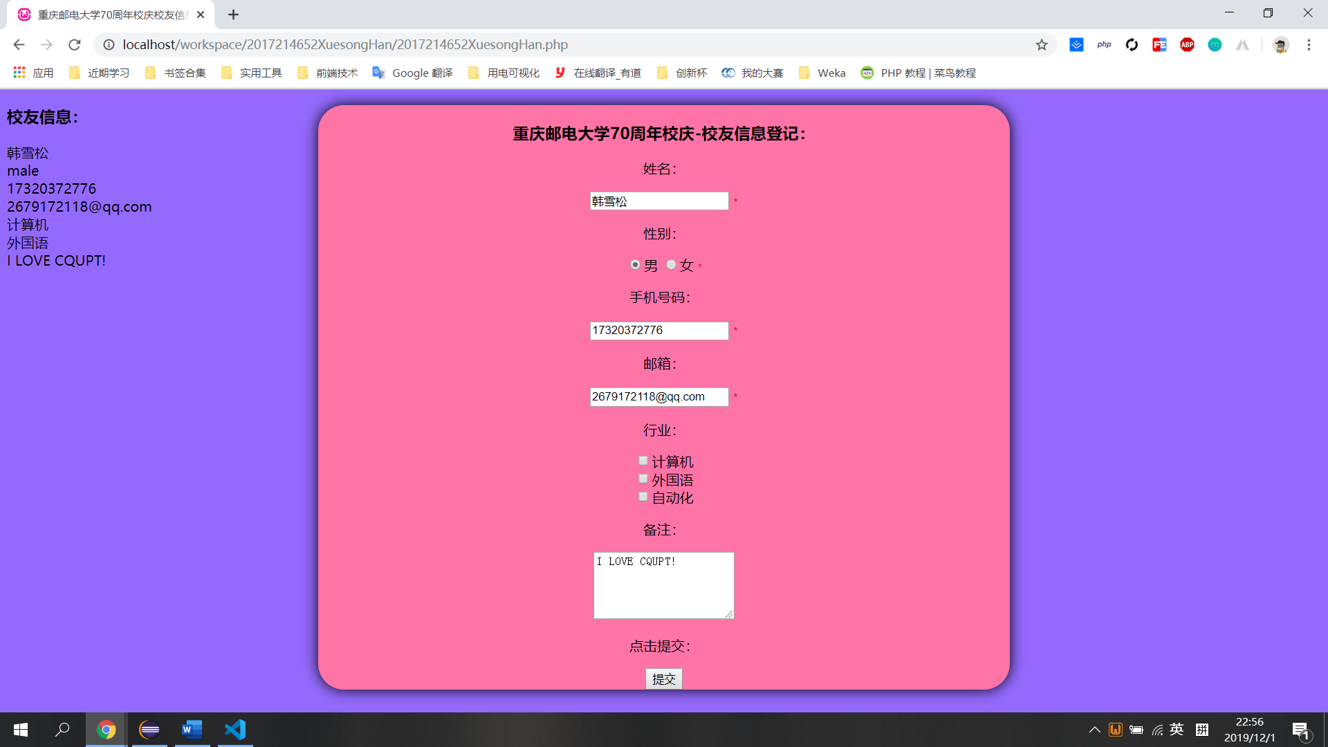

图4 成功输出

**二、源代码：**

<!DOCTYPE html>

<html lang="en">

<head>

    <meta charset="UTF-8">

    <meta name="viewport" content="width=device-width, initial-scale=1.0">

    <meta http-equiv="X-UA-Compatible" content="ie=edge">

    <title>重庆邮电大学70周年校庆校友信息登记</title>

    <style type="text/css">

        body {

            background: #946AFE;

        }

        #container {

            width: 800px;

            height: auto;

            position: absolute;

            left: 50%;

            margin-left: -400px;

            text-align: center;

            background: #FE74A7;

            border-radius: 30px;

            box-shadow:0 0 16px #000;

        }

        .error {

            color: #DC143C;

            font-size: 10px;

            font-weight: bold;

        }

    </style>

</head>

<body>

    <?php

*//定义变量，初始为空*

        $nameErr = $genderErr = $phoneNumErr = $emailErr  = "";

        $name = $gender = $phoneNum = $email = $comment = "";

        if ($_SERVER["REQUEST_METHOD"] == "POST") {

            if (empty($_POST["name"])) {

                $nameErr = "姓名为必填项";

            }else {

                $name = test_input($_POST["name"]);

*//检测姓名是否合法，验证规则：只包含中文*

                if (!preg_match("/^[\x{4e00}-\x{9fa5}]+$/u",$name)) {

                    $nameErr = "姓名只允许中文";

                }

            }

            if (empty($_POST["gender"])) {

                $genderErr = "性别为必填项";

            }else {

                $gender = test_input($_POST["gender"]);

            }

            if (empty($_POST["phoneNum"])) {

                $phoneNumErr = "手机号为必填项";

            }else {

                $phoneNum = test_input($_POST["phoneNum"]);

*//检测手机号码是否合法,验证规则：11位数字，以1开头*

                if(!preg_match("/^1\d{10}$/",$phoneNum)) {

                    $phoneNumErr = "非法的手机号";

                }

            }

            if (empty($_POST["email"])) {

                $emailErr = "邮箱为必填项";

            }else {

                $email = test_input($_POST["email"]);

*//检测邮箱是否合法，验证规则：@前面的字符可以是英文字母和._- ，._-不能放在开头和结尾，且不能连续出现*

                if (!preg_match("/^([0-9A-Za-z\\-_\\.]+)@([0-9a-z]+\\.[a-z]{2,3}(\\.[a-z]{2})?)$/i",$email)) {

                    $emailErr = "邮箱格式有误";

                }

            }

            if (empty($_POST["comment"])) {

                $comment = "";

            }else {

                $comment = test_input($_POST["comment"]);

            }

        }

*//当用户提交表单时：*

*//使用trim()函数，去除用户输入数据中不必要的字符 (如：空格，tab，换行)*

*//使用stripslashes()函数，去除用户输入数据中的反斜杠 (\)*

*//将过滤函数写在test_input()中，提高代码的复用性*

        function test_input($data) {

            $data = trim($data);

            $data = stripslashes($data);

            $data = htmlspecialchars($data);

            return $data;

        }

    ?>

    <div id = "container">

        <h3>重庆邮电大学70周年校庆-校友信息登记：</h3>

*<!--对用户所有提交的数据都通过htmlspecialchars()函数处理，以避免$_SERVER["PHP_SELF"]被利用-->*

        <form method="post" action="<?php echo htmlspecialchars($_SERVER["PHP_SELF"]);?>">

            <p>姓名：</p>

            <input type="text" name="name" value="<?php echo $name;?>">

            <span class="error">* <?php echo $nameErr;?></span>

            <p>性别：</p>

            <input type="radio" name="gender" <?php if (isset($gender) && $gender=="male") echo "checked";?>  value="male">男

            <input type="radio" name="gender" <?php if (isset($gender) && $gender=="female") echo "checked";?>  value="female">女

            <span class="error">* <?php echo $genderErr;?></span>

            <p>手机号码：</p>

            <input type="text" name="phoneNum" value="<?php echo $phoneNum;?>">

            <span class="error">*<?php echo $phoneNumErr;?></span>

            <p>邮箱：</p>

            <input type="text" name="email" value="<?php echo $email;?>">

            <span class="error">* <?php echo $emailErr;?></span>

            <p>行业：</p>

            <input type="checkbox" name="job[]" value="computer">计算机<br>

            <input type="checkbox" name="job[]" value="English">外国语<br>

            <input type="checkbox" name="job[]" value="automation">自动化<br>

            <p>备注：</p>

            <textarea name="comment" rows="5" cols="20"><?php echo $comment;?></textarea>

            <p>点击提交：</p>

            <input type="submit" name="submit" value="提交">

        </form>

    </div>

    <?php

        echo "<h3>校友信息：</h3>";

        echo $name;

        echo "<br>";

        echo $gender;

        echo "<br>";

        echo $phoneNum;

        echo "<br>";

        echo $email;

        echo "<br>";

        $job = isset($_POST['job'])? $_POST['job'] : '';

        if(is_array($job)) {

            $sites = array(

                'computer' => '计算机',

                'English' => '外国语',

                'automation' => '自动化',

            );

            foreach($job as $val) {

*// PHP_EOL 为常量，用于换行*

                echo $sites[$val] . "<br>";

            }

        }

        echo $comment;

    ?>

</body>

</html>