Meeting Minute

14th April 2015

# Attendees

Heeju Lee, Taeyoung Kim, Sangwon Jo, Byeongjin Park, IckChae Na

# Scribe

IckChae Na

# Agenda

Use Case Diagram

## Old Business

* SRS

## 

## New Business

* Use Case Diagram

# New Business

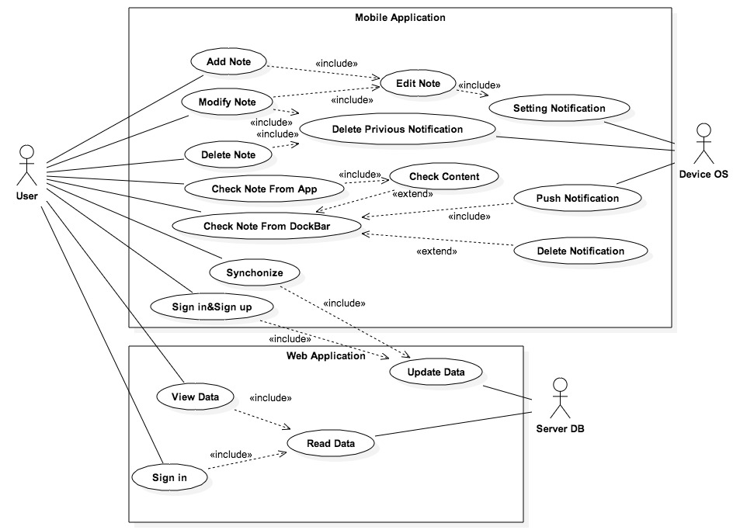

# Next Meeting

2015. 04. 17

# Next Meeting Agenda Items

* SPMP