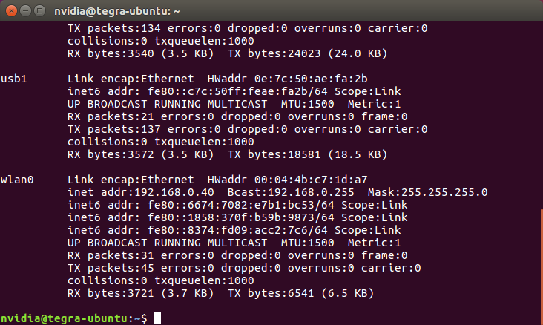
Ip adress check
192.168.0.40

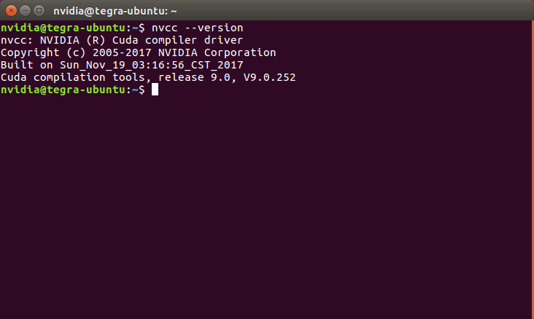
nvcc –version
cuda check

https://developer.nvidia.com/embedded/downloads

https://docs.nvidia.com/deeplearning/frameworks/install-tf-jetson-platform/index.html

sudo apt-get install libhdf5-serial-dev hdf5-tools libhdf5-dev zlib1g-dev zip libjpeg8-dev

sudo apt-get install python3-pip
→python

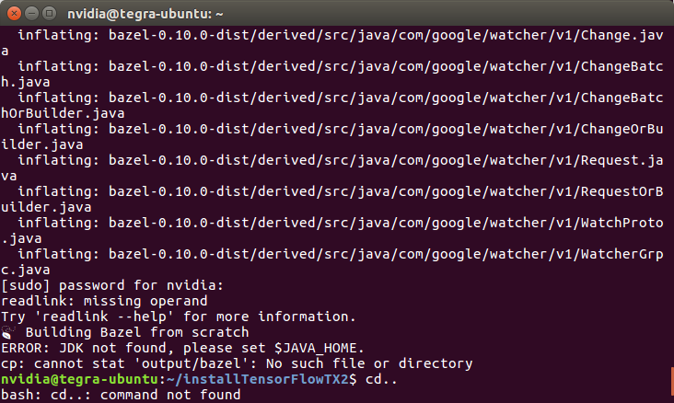
JDK not found, please set $JAVA_HOME.

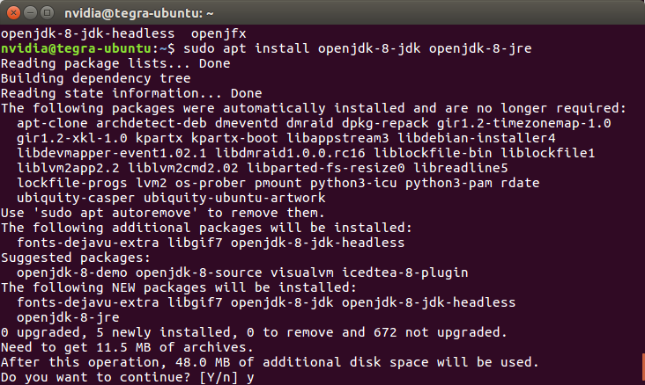
sudo apt install openjdk-8-jdk openjdk-8-jre

