上海电力学院

数据库设计课程设计

题 目: 选题八车票实名销售系统
学生姓名： 洪勇
学 号： 20181389 班 级： 2018053
院 系： 计算机科学与技术学院
专业班级： 计算机科学与技术2016053

2020年 6 月 14 日

二、概念结构设计
画出系统整体的E-R模型；并对模型中所出现的实体及属性等信息加以说明。
实体集：
车次信息：车次、类型（高铁、动车）、起点、终点、发车时间、到达时间、运行时间
站点信息：车次、站点序号、站点信息、到达时间、发车时间、里程（起点一本站点）
座位信息：车次、车厢号、等级（一等座、二等座）、座位号
车票信息：车次、发车日期、车厢号、等级、空余座位号
车票购买信息：车次、发车日期、起点站、终到站、车厢号、座位号、票价、身份证号、购买点、购买日期时间
顾客信息：包括身份证号、姓名等实名认证信息

联系：
一个顾客可以买多张车票
一个车次可以乘坐多位乘客
一个车次会经过多个站点，一个站点会被多个车次经过
一张票对应一个座位
一张票只能有一个乘客的信息

画出E-R图如下
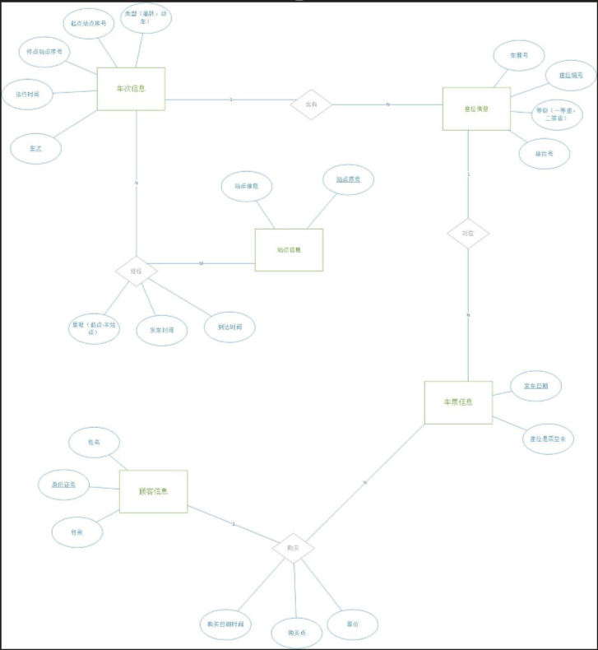

三、逻辑结构设计
（1）模式设计：按系统整体E-R模型，写出关系模式；并利用数据字典加以描述。（如每个关系模式有何属性、属性的类型、属性值的长度、是否可取空值、是否为主码、有何约束条件等信息）
车次信息（车次，类型，起点站点序号，终点站点序号，运行时间）
座位信息（座位编号，车次，车厢号，等级，座位号）
车票信息（座位编号，发车日期，是否空余）
顾客信息（身份证号，姓名，性别）
购票信息（座位编号，身份证号，购买点，票价，购买时间）
站点信息（站点序号，站点信息）
途径站点信息（站点序号，车次，里程，发车时间，到达时间）

五、数据库设计实现及运行
（1）数据库的创建
T-SQL语句：
IF EXISTS(
SELECT Name
FROM Master..SysDatabases
WHERE Name = 'hw_ticket_sys'
)
BEGIN
DROP DATABASE hw_ticket_sys;
PRINT 'delete succsessful'
END
BEGIN
CREATE DATABASE hw_ticket_sys;
PRINT 'create successful'
END
GO

ALTER DATABASE [hw_ticket_sys] COLLATE Chinese_PRC_CI_AS

（2）数据表的创建（可同时在创建时定义相关的约束）
T-SQL语句：
------------------------------------------------------------------------------------------

-- 建Station表
IF EXISTS(
SELECT NAME
FROM SysObjects
WHERE XType = 'U' AND NAME = 'station'
)
BEGIN
DROP TABLE station;
PRINT 'delete station successful'
END
BEGIN
CREATE TABLE station(
ID INT PRIMARY KEY,
Name VARCHAR(10) NOT NULL,
latitude DECIMAL(10, 6) NOT NULL,
longitude DECIMAL(10, 6) NOT NULL
)
END
GO

SELECT * FROM station;

------------------------------------------------------------------------------------------

-- 建train表
IF EXISTS(
SELECT NAME
FROM SysObjects
WHERE XType = 'U' AND NAME = 'train'
)
BEGIN
DROP TABLE train;
PRINT 'delete train successful'
END
BEGIN
CREATE TABLE train(
ID VARCHAR(10) PRIMARY KEY,
Type INT NOT NULL,
origin int NOT NULL ,
dest int NOT NULL,
runtime VARCHAR(20) NOT NULL
);
END
GO

SELECT * FROM train;

------------------------------------------------------------------------------------------

-- 建pass表
IF EXISTS(
SELECT NAME
FROM SysObjects
WHERE XType = 'U' AND NAME = 'pass'
)
BEGIN
DROP TABLE pass;
PRINT 'delete pass successful'
END
BEGIN
CREATE TABLE pass(
Sta_id INT NOT NULL,
train_id VARCHAR(20) NOT NULL,
setoff_time DATETIME NOT NULL,
arrival_time DATETIME NOT NULL
)
END

SELECT * FROM pass;

------------------------------------------------------------------------------------------

-- 建customer表
IF EXISTS(
SELECT NAME
FROM SysObjects
WHERE XType = 'U' AND NAME = 'customer'
)
BEGIN
DROP TABLE customer;
PRINT 'delete customer successful'
END
BEGIN
CREATE TABLE customer(
ID VARCHAR(20) PRIMARY KEY,
name VARCHAR(10) NOT NULL,
sex VARCHAR NOT NULL
)
END

SELECT * FROM customer;

------------------------------------------------------------------------------------------

-- 建seats表
IF EXISTS(
SELECT NAME
FROM SysObjects
WHERE xtype = 'U' AND name = 'seats'
)
BEGIN
DROP TABLE seats;
PRINT 'delete seats successful'
END
BEGIN
CREATE TABLE seats(
ID VARCHAR(20) PRIMARY KEY,
train_id VARCHAR(10) NOT NULL,
car VARCHAR(10) NOT NULL,
TYPE INT NOT NULL,
name VARCHAR(10) NOT NULL
)
END

SELECT * FROM seats;

------------------------------------------------------------------------------------------

-- 建tickets表
IF EXISTS(
SELECT NAME
FROM SysObjects
WHERE xtype = 'U' AND name = 'tickets'
)
BEGIN
DROP TABLE tickets;
PRINT 'delete tickets successful'
END
BEGIN
CREATE TABLE tickets(
seat_id VARCHAR(20) NOT NULL,
set_off_time DATETIME NOT NULL,
isempty INT NOT NULL
)
END

SELECT * FROM tickets;

------------------------------------------------------------------------------------------

-- 建cus_tickets表
IF EXISTS(
SELECT *
FROM SysObjects
WHERE XType = 'U' AND name = 'cus_tickets'
)
BEGIN
DROP TABLE cus_tickets;
PRINT 'delete cus_tickets successful'
END
BEGIN
CREATE TABLE cus_tickets(
seat_id VARCHAR(20) NOT NULL,
cus_id VARCHAR(20) NOT NULL,
get_position VARCHAR(20) NOT NULL,
prices VARCHAR(20) NOT NULL,
get_time DATETIME NOT NULL
)
END

ALTER TABLE [dbo].[cus_tickets] ADD [set_off] int NOT NULL

SELECT * FROM cus_tickets;

------------------------------------------------------------------------------------------

-- 检查看看有没有添加成功
SELECT * FROM SysObjects WHERE xtype = 'U';

------------------------------------------------------------------------------------------

-- 开始添加约束

------------------------------------------------------------------------------------------

-- 主键约束

------------------------------------------------------------------------------------------

-- tickets 主键
IF EXISTS(
SELECT *
FROM SysObjects
WHERE name = 'PK_seatId_setOffDate'
)
BEGIN
ALTER TABLE tickets
DROP CONSTRAINT PK_seatId_setOffDate;
PRINT 'delete successful'
END
BEGIN
ALTER TABLE tickets
ADD CONSTRAINT PK_seatId_setOffDate
PRIMARY KEY CLUSTERED(seat_id, set_off_time);
END

------------------------------------------------------------------------------------------

-- cus_tickets 主键
IF EXISTS(
SELECT *
FROM SysObjects
WHERE name = 'PK_seatId_cusId'
)
BEGIN
ALTER TABLE cus_tickets
DROP CONSTRAINT PK_seatId_cusId;
PRINT 'delete successful'
END
BEGIN
ALTER TABLE cus_tickets
ADD CONSTRAINT PK_seatId_cusId
PRIMARY KEY CLUSTERED(seat_id, cus_id);
END

------------------------------------------------------------------------------------------

-- pass 主键
IF EXISTS(
SELECT *
FROM SysObjects
WHERE name = 'PK_staId_trainId'
)
BEGIN
ALTER TABLE pass
DROP CONSTRAINT PK_staId_trainId;
PRINT 'delete successful'
END
BEGIN
ALTER TABLE pass
ADD CONSTRAINT PK_staId_trainId
PRIMARY KEY CLUSTERED(Sta_id, train_id);
END

------------------------------------------------------------------------------------------

-- 外键约束

------------------------------------------------------------------------------------------

-- seats 外键
IF EXISTS(
SELECT *
FROM SysObjects
WHERE name = 'FK_seats_trainId'
)
BEGIN
ALTER TABLE seats
DROP CONSTRAINT FK_seats_trainId
PRINT 'delete successful'
END
BEGIN
ALTER TABLE seats
ADD CONSTRAINT FK_seats_trainId
FOREIGN KEY (train_id)
REFERENCES train(id)
ON DELETE CASCADE
ON UPDATE CASCADE;
END

------------------------------------------------------------------------------------------

-- tickets 外键
IF EXISTS(
SELECT *
FROM SysObjects
WHERE name = 'FK_tickets_seatId'
)
BEGIN
ALTER TABLE seats
DROP CONSTRAINT FK_tickets_seatId
PRINT 'delete successful'
END
BEGIN
ALTER TABLE tickets
ADD CONSTRAINT FK_tickets_seatId
FOREIGN KEY (seat_id)
REFERENCES seats(ID)
ON DELETE CASCADE
ON UPDATE CASCADE;
END

------------------------------------------------------------------------------------------

-- cus_tickets 外键
IF EXISTS(
SELECT *
FROM SysObjects
WHERE name = 'FK_cus_tickets_cusId'
)
BEGIN
ALTER TABLE seats
DROP CONSTRAINT FK_cus_tickets_cusId
PRINT 'delete successful'
END
BEGIN
ALTER TABLE cus_tickets
ADD CONSTRAINT FK_cus_tickets_cusId
FOREIGN KEY (cus_id)
REFERENCES customer(ID)
ON DELETE CASCADE
ON UPDATE CASCADE;
END

------------------------------------------------------------------------------------------

IF EXISTS(
SELECT *
FROM SysObjects
WHERE name = 'FK_cus_tickets_seatId'
)
BEGIN
ALTER TABLE seats
DROP CONSTRAINT FK_cus_tickets_seatId
PRINT 'delete successful'
END
BEGIN
ALTER TABLE cus_tickets
ADD CONSTRAINT FK_cus_tickets_seatId
FOREIGN KEY (seat_id)
REFERENCES seats(ID)
ON DELETE CASCADE
ON UPDATE CASCADE;
END

------------------------------------------------------------------------------------------

-- pass 外键
IF EXISTS(
SELECT *
FROM SysObjects
WHERE name = 'FK_pass_staId'
)
BEGIN
ALTER TABLE pass
DROP CONSTRAINT FK_pass_staId
PRINT 'delete successful'
END
BEGIN
ALTER TABLE pass
ADD CONSTRAINT FK_pass_staId
FOREIGN KEY (Sta_id)
REFERENCES Station(ID)
ON DELETE CASCADE
ON UPDATE CASCADE;
END

------------------------------------------------------------------------------------------

IF EXISTS(
SELECT *
FROM [SysObjects]
WHERE name = 'FK_pass_trainId'
)
BEGIN
ALTER TABLE [pass]
DROP CONSTRAINT [FK_pass_trainId]
PRINT 'delete successful'
END
BEGIN
ALTER TABLE [pass]
ADD CONSTRAINT [FK_pass_trainId]
FOREIGN KEY (train_id)
REFERENCES train(ID)
ON DELETE CASCADE
ON UPDATE CASCADE;
END

------------------------------------------------------------------------------------------

-- 添加缺省约束

------------------------------------------------------------------------------------------

-- 购买时间默认为系统当前的时间
IF EXISTS(
SELECT *
FROM [SysObjects]
WHERE name = 'D_getTime'
)
BEGIN
ALTER TABLE [cus_tickets]
DROP CONSTRAINT D_getTime
PRINT 'delete successful'
END
BEGIN
ALTER TABLE [cus_tickets]
ADD CONSTRAINT [D_getTime]
DEFAULT GETDATE() FOR [get_time];
END

------------------------------------------------------------------------------------------

-- 所有车票默认未售
IF EXISTS(
SELECT *
FROM [SysObjects]
WHERE name = 'D_notSale'
)
BEGIN
ALTER TABLE [tickets]
DROP CONSTRAINT D_notSale
PRINT 'delete successful'
END
BEGIN
ALTER TABLE [tickets]
ADD CONSTRAINT [D_notSale]
DEFAULT 1 FOR [isempty];
END

------------------------------------------------------------------------------------------

-- check 约束

------------------------------------------------------------------------------------------

-- 到站时间早于发车时间
IF EXISTS(
SELECT *
FROM [SysObjects]
WHERE name = 'CK_time'
)
BEGIN
ALTER TABLE [pass]
DROP CONSTRAINT CK_time
PRINT 'delete successful'
END
BEGIN
ALTER TABLE [pass]
ADD CONSTRAINT [CK_time]
CHECK (setoff_time >= arrival_time);
END

------------------------------------------------------------------------------------------

-- 类型限制为高铁或者动车
IF exists(
SELECT *
FROM [SysObjects]
WHERE name = 'CK_type'
)
BEGIN
ALTER TABLE [train]
DROP CONSTRAINT [CK_type]
PRINT 'delete successful'
END
BEGIN
ALTER TABLE [train]
ADD CONSTRAINT [CK_type]
CHECK ([Type] = 1 or [Type] = 2)
END

------------------------------------------------------------------------------------------

INSERT into customer VALUES('450481200004161013', '洪勇', '男');

INSERT into customer VALUES('450481200004161023', '洪而', '男');

INSERT into customer VALUES('450481200004171013', '勇给', '男');

INSERT into customer VALUES('450483200004161013', '张三', '女');

INSERT into customer VALUES('454481200004161013', '洪五', '女');

------------------------------------------------------------------------------------------
GO

CREATE TRIGGER refresh
ON cus_tickets
FOR INSERT
AS
DECLARE @seats_id INT, @set_off_time INT;
SELECT @seats_id = seat_id, @set_off_time = set_off FROM inserted;
UPDATE tickets
SET isempty = 0
WHERE seat_id = @seats_id AND set_off_time = @set_off_time;
GO

------------------------------------------------------------------------------------------

（4）存储过程的定义实现（仅需给出自己设计模块中所用的）
T-SQL语句：
------------------------------------------------------------------------------------------

-- 存储过程
CREATE PROCEDURE isEmptyTickets
@ID VARCHAR(20),
@time INT,
@@total INT OUTPUT
AS
SELECT @@total = COUNT(*)
FROM tickets JOIN seats ON seat_id = ID
WHERE train_id = @ID AND set_off_time = @time AND isempty = 1;
go
DECLARE @total INT;
EXEC isEmptyTickets @ID = 'C1001', @time = 2, @@total = @total OUTPUT;
PRINT CAST(@total as VARCHAR(20));
GO

------------------------------------------------------------------------------------------

CREATE PROCEDURE trainId
@ID VARCHAR(20),
@total INT OUTPUT
AS
SELECT @total = COUNT(*)
FROM seats
WHERE train_id = @ID;
GO

DECLARE @total INT;
EXEC trainId @ID = 'C1001', @total = @total output;
PRINT CAST(@total AS VARCHAR(20));
GO

------------------------------------------------------------------------------------------

CREATE PROCEDURE typetotal
@type INT,
@total INT OUTPUT
AS
SELECT @total = COUNT(*)
FROM seats
WHERE type = @type;
GO

DECLARE @total INT;
EXEC typetotal @type = 2, @total = @total output;
PRINT CAST(@total AS VARCHAR(20));
GO

------------------------------------------------------------------------------------------

CREATE PROCEDURE levelType
@type INT,
@total INT OUTPUT
AS
SELECT @total = COUNT(*)
FROM seats JOIN train ON train_id = train.ID
WHERE train.[Type] = @type;
GO

DECLARE @total INT;
EXEC levelType @type = 2, @total = @total output;
PRINT CAST(@total AS VARCHAR(20));
GO

在宿主语言中调用存储过程代码段（粘贴）：
DECLARE @total INT;
EXEC isEmptyTickets @ID = 'C1001', @time = 2, @@total = @total OUTPUT;
PRINT CAST(@total as VARCHAR(20));
GO
DECLARE @total INT;
EXEC trainId @ID = 'C1001', @total = @total output;
PRINT CAST(@total AS VARCHAR(20));
GO
DECLARE @total INT;
EXEC typetotal @type = 2, @total = @total output;
PRINT CAST(@total AS VARCHAR(20));
GO
DECLARE @total INT;
EXEC levelType @type = 2, @total = @total output;
PRINT CAST(@total AS VARCHAR(20));
GO

测试结果粘贴：
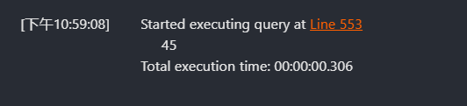
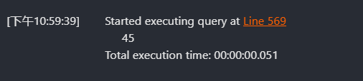
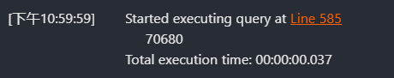
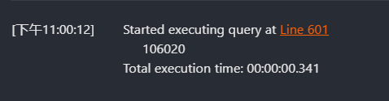
（5）触发器的定义实现（仅需给出自己设计模块中所用的）
T-SQL语句：
CREATE TRIGGER refresh
ON cus_tickets
FOR INSERT
AS
DECLARE @seats_id INT, @set_off_time INT;
SELECT @seats_id = seat_id, @set_off_time = set_off FROM inserted;
UPDATE tickets
SET isempty = 0
WHERE seat_id = @seats_id AND set_off_time = @set_off_time;
GO

测试结果粘贴：
-- 触发器测试
INSERT into cus_tickets VALUEs(1, '450481200004161013', '那没事了', '5000', GETDATE(), 1);

DECLARE @total INT;
EXEC isEmptyTickets @ID = 'C1001', @time = 1, @@total = @total OUTPUT;
PRINT CAST(@total as VARCHAR(20));

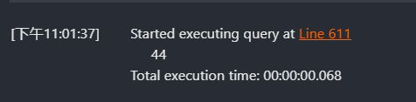

七、总结

八、附录：源程序代码

