实验四 复杂查询
班级 学号 姓名
_______________________________________________________________________________

一、实验目的
掌握两个表以上的连接查询的应用，包括嵌套查询。

二、实验内容
（1）查询比“林红”年纪大的男学生信息。
输入下列命令并运行，可得：
select *
from Student
where Sex = '男'
and Birth < (select Birth from Student where Sname = '林红');
（2）检索所有学生的选课信息，包括学号、姓名、课号、课程名、成绩。
输入下列命令并运行，可得：
select Student.Sno as '学号',
Student.Sname as '姓名',
Course.Cno as '课号',
Course.Cname as '课程名',
SC.Grade as '成绩'
from SC
full outer join Student on SC.Sno = Student.Sno
left outer join Course on SC.Cno = Course.Cno;

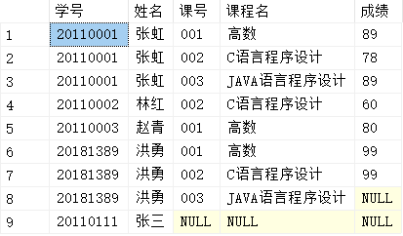

（3）查询已选课学生的学号、姓名、课程名、成绩。
输入下列命令并运行，可得：
select Student.Sno as '学号',
Student.Sname as '姓名',
Course.Cno as '课号',
Course.Cname as '课程名',
SC.Grade as '成绩'
from SC
left outer join Student on SC.Sno = Student.Sno
left outer join Course on SC.Cno = Course.Cno
where Course.Cno is not null;

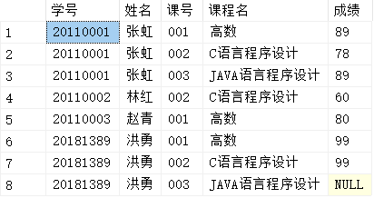

（4）查询选修了“C语言程序设计”的学生的学号和姓名。
输入下列命令并运行，可得：
select Student.Sno as '学号',
Student.Sname as '姓名'
from SC
left outer join Course
on Course.Cno = SC.Cno
left outer join Student
on SC.Sno = Student.Sno
where Course.Cname = 'C语言程序设计';

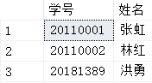
（5）查询与“张虹”在同一个班级的学生学号、姓名、家庭住址。
a.用子查询
输入下列命令并运行，可得：
select Student.Sno as '学生学号',
Student.Sname as '姓名',
Student.Home_addr as '家庭住址'
from Student
where Classno = (select Classno from Student where Sname = '张虹');

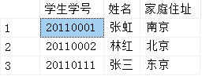

b.用连接查询
输入下列命令并运行，可得：
select S.Sno as '学生学号',
S.Sname as '姓名',
S.Home_addr as '家庭住址'
from (Student left outer join Student as S on S.Classno = Student.Classno)
where Student.Sname = '张虹';

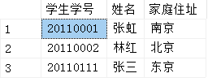

（6）查询其他班级中比“051”班所有学生年龄大的学生的学号、姓名。
输入下列命令并运行，可得：
select Student.Sno as '学号',
Student.Sname as '姓名'
from Student
where Student.Classno <> '051'
and Student.Birth < (select max(Birth) from Student where Classno = '051');

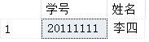
（7）(选作)查询选修了全部课程的学生姓名。
输入下列命令并运行，可得：
select distinct S1.Sno
from SC S1
where not exists(
select *
from Course
where not exists(
select *
from SC S2
where S1.Sno = S2.Sno
and Course.Cno = S2.Cno
)
)

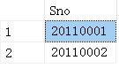
（8）(选作)查询至少选修了学生“20110002”选修的全部课程的学生的学号，姓名。
输入下列命令并运行，可得：
select distinct S1.Sno
from SC S1
where not exists(
select Cno
from SC S2
where Sno = '20110002'
and not exists(
select *
from SC S3
where S1.Sno = S3.Sno
and S3.Cno = S2.Cno
)
)

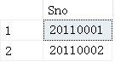
（9）检索学生的学号、姓名、学习课程名及课程成绩。
输入下列命令并运行，可得：
select Student.Sno as '学号',
Student.Sname as '姓名',
Course.Cname as '课程名',
SC.Grade as '课程成绩'
from SC
left outer join Student on SC.Sno = Student.Sno
left outer join Course on Course.Cno = SC.Cno;

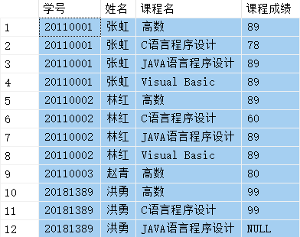
（10）检索选修了“高数”课且成绩至少高于选修课程号为“002”课程的学生的学号、课程号、成绩，并按成绩从高到低次序排列。
输入下列命令并运行，可得：
select Student.Sno as '学号',
Student.Sname as '姓名',
S1.Grade as '课程成绩'
from SC S1
left outer join Student on S1.Sno = Student.Sno
left outer join Course on Course.Cno = S1.Cno
where Course.Cno = (select Cno from Course where Course.Cname = '高数')
and S1.Grade > (select SC.Grade from SC where SC.Sno = S1.Sno and SC.Cno = '002')
order by S1.Grade desc;

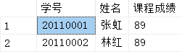
（11）检索选修3门以上课程的学生的学号、总成绩（不统计不及格的课程），并要求按总成绩的降序排列出来。
输入下列命令并运行，可得：
select SC.Sno as '学号',
sum(SC.Grade) as '总成绩'
from SC
where SC.Grade > 60
group by SC.Sno
having COUNT(SC.Cno) >= 3
order by sum(SC.Grade) desc;

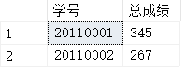
（12）检索多于3名学生选修的并以3结尾的课程号的平均成绩。
输入下列命令并运行，可得：
select avg(SC.Grade) as '平均成绩'
from SC
where SC.Cno in (select Cno from SC group by Cno having COUNT(Sno) > 3)
and SC.Cno like ('%3')
group by SC.Cno;

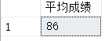
（13）检索最高分与最低分之差大于5分的学生的学号、姓名、最高分、最底分。
输入下列命令并运行，可得：
select t.学号,
t.最高分,
t.最低分,
Student.Sname
from
(
select SC.Sno as '学号',
MAX(SC.Grade) as '最高分',
MIN(SC.Grade) as '最低分'
from SC
left outer join Course on Course.Cno = SC.Cno
group by SC.Sno
) t
left outer join Student on Student.Sno = T."学号"
where t.最高分 - t.最低分 > 5

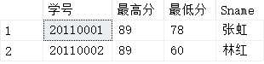
（14）外连接
对实验二中的表6和表7做一个外连接查询，显示每门课程的课号、课名、选修该门课的学号、成绩，没有同学选修的课程（如Visual_Basic）也要在查询结果中。
输入下列命令并运行，可得：
SELECT Course.Cno, Course.Cname, Student.Sno, SC.Grade
FROM Course LEFT OUTER JOIN SC ON Course.Cno = SC.Cno
LEFT OUTER JOIN Student ON SC.Sno = Student.Sno

# 结果
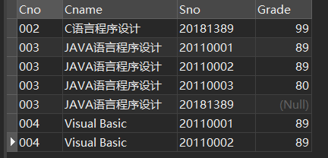

（15）创建一个表Student_other，结构同Student,输入若干记录，部分记录和Student表中的相同。
输入下列命令并运行，可得：
CREATE TABLE student_20181389_other
( Sno CHAR(8) NOT NULL PRIMARY KEY,
Sname VARCHAR(8) NOT NULL,
Sex CHAR(2) NOT NULL DEFAULT '男',
Birth smalldatetime NOT NULL,
Classno CHAR(3) NOT NULL,
Entrance_date smalldatetime NOT NULL,
Home_addr VARCHAR(40));

ALTER TABLE student_20181389_other
ADD Sdept CHAR(20) NOT NULL;

ALTER TABLE student_20181389_other
ADD Postcode CHAR(6) CHECK(postcodeLIKE '[0-9][0-9][0-9][0-9][0-9][0-9]');

ALTER TABLE student_20181389_other
ADD CONSTRAINT CK_BirthAndEntrance CHECK(Birth<Entrance_date);

INSERT INTO student_20181389_other
(Sno, Sname, Sex, Birth, Classno, Entrance_date, Home_addr, Sdept, Postcode)
VALUES ('20110001', '张虹','男', '1992-09-11', '051', '2011-09-01', '南京', '计算机系', '200413'),
('20110002', '林红','女', '1991-11-12', '051', '2011-09-01', '北京', '计算机系', '100010'),
('20110003', '赵青','男', '1993-05-11', '061', '2011-09-01', '上海', '软件工程', '200013');
结果
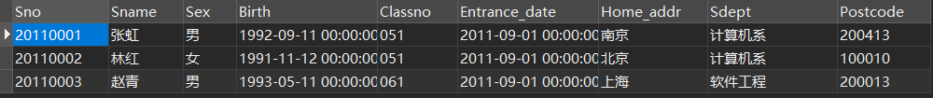
a.查询同时出现在Student表和Student_other表中的记录
输入下列命令并运行，可得：
SELECT *
FROM Student
INTERSECT
SELECT *
FROM student_20181389_other;
# 结果

b. 查询Student表和Student_other表中的全部记录
输入下列命令并运行，可得：
SELECT *
FROM Student
UNION
SELECT *
FROM student_20181389_other;
# 结果
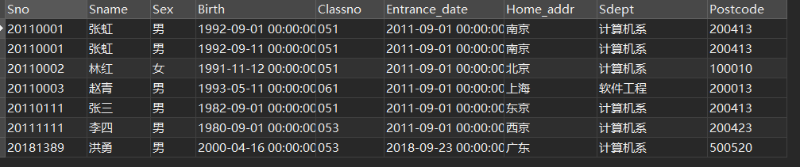

（16）创建一个数据库Student_info_other,参数自定。

a.当前数据库为Student_info，将Student_info数据库中的表student_other复制到数据库Student_info_otherStudent_other中
输入下列命令并运行，可得：
CREATE DATABASE [student_inf_2018189_other]
ON
PRIMARY
(
NAME = N'student_inf_2018189_other',
FILENAME = N'/var/opt/mssql/data\student_inf_2018189_other.mdf',
SIZE = 20MB,
MAXSIZE = 300,
FILEGROWTH = 5MB
)
LOG ON
(
NAME = N'student_inf_2018189_other_log',
FILENAME = N'/var/opt/mssql/data\student_inf_2018189_other_log.ldf',
SIZE = 5MB,
MAXSIZE = 50MB,
FILEGROWTH = 1MB
)
GO

ALTER DATABASE [student_inf_2018189_other] COLLATE Chinese_PRC_90_CI_AS

# 结果
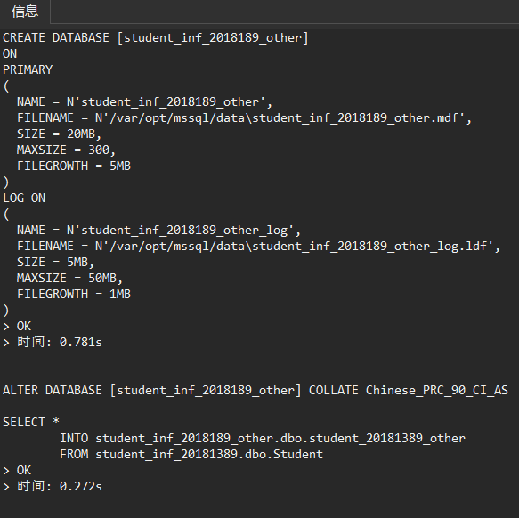

b.查询同时出现在Student表和Student_info_other数据库Student_other表中的记录。
输入下列命令并运行，可得：
SELECT *
FROM student_inf_20181389.dbo.Student
INTERSECT
SELECT *
FROM student_inf_2018189_other.dbo.student_20181389_other

# 结果
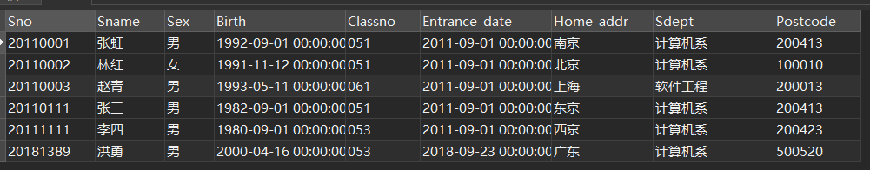

（17）（补充）查询没有不及格记录且加权平均成绩在班级排名前10%的学生基本信息
输入下列命令并运行，可得：
WITH t1 as (
SELECT SC.Sno, SUM(1.0 * Credit / t.s * Grade) g
FROM SC INNER JOIN Course ON (Course.Cno = SC.Cno)
INNER JOIN ( SELECT SC.Sno, SUM(Course.Credit) s
FROM SC INNER JOIN Course ON (Course.Cno = SC.Cno)
GROUP BY SC.Sno)t ON (SC.Sno = t.Sno)
GROUP BY SC.Sno
HAVING SC.Sno not IN(SELECT DISTINCT Sno FROM SC WHERE SC.Grade < 60)
)
SELECT s1.Sname, s1.Sno, S1.Classno
FROM Student s1 INNER JOIN t1 ON (s1.Sno = t1.Sno)
WHERE s1.Sno IN(SELECT TOP 10 PERCENT Student.Sno
FROM Student INNER JOIN t1 ON (Student.Sno = t1.Sno)
WHERE s1.Classno = Student.Classno
ORDER BY t1.g);

# 结果
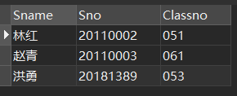
（18）（补充）按如下格式查询获得奖学金的同学，获取奖学金标准按你们的实际标准处理
学号 | 姓名 | 一等奖学金 | 二等奖学金
输入下列命令并运行，可得：

