MODULE 2: QUERIES

4a.Write a query to display customer number, customer’s firstname , account number where the accountstatus is terminated. Display the records sorted inascending order based on customer number and then by account number.

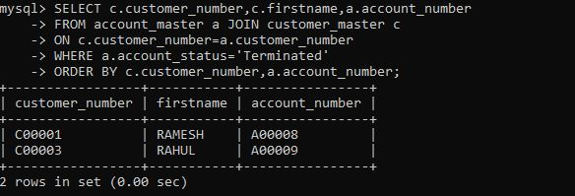

b. Write a query to display the number of accounts opened in each city. The query should display the Branch city and the number of No_of_Accounts for the branch city where we don’t have any accounts opened display 0. Display the records in the sorted order based on branch city.

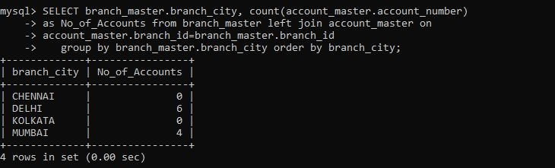

c. Write a query to display the customer number, customer firstname, customer lastname who has taken loan from more than 1 branch. Display the records sorted in order based on customer number.

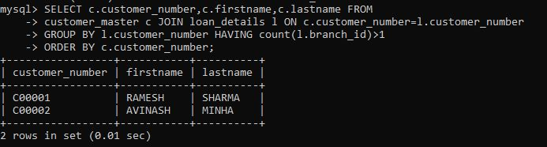

d. Write a query to display the number of clients who have asked for loan but they don’t have any account in the bank though they are registered customers. Give the count an alias name of Count.

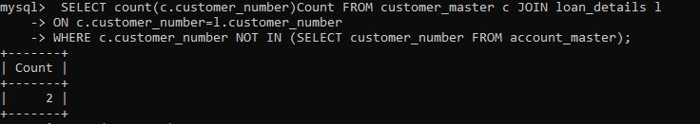

e. Write a equerry to display customers firstname, city and account number whose occupation are not business , Services or Student. Display the records sorted in ascending order based on customer firstname and by account number.

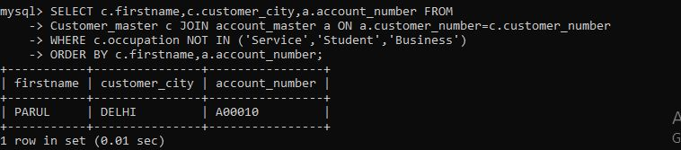

MODULE:1 HTML&CSS

1. (a) Create a html web page that contains a button with which it is possible to change the text that is shown on the screen. The file ButtonDemo.html has a JavaScript function named change_text() which is called after the button is pressed. When the button is pressed repeatedly the text changes Hello! ... Well done! ... Hello! ... Well done! ... Hello! ..

Code:

<html>

<script>

function change_text()

{

var text=document.createTextNode("Hello!...well done!...");

var p=document.createElement(p);

var temp=p.appendChild(text);

document.body.appendChild(temp);

}

</script>

<body>

<input type="submit" value="button" onclick="change_text()">

</body>

</html>

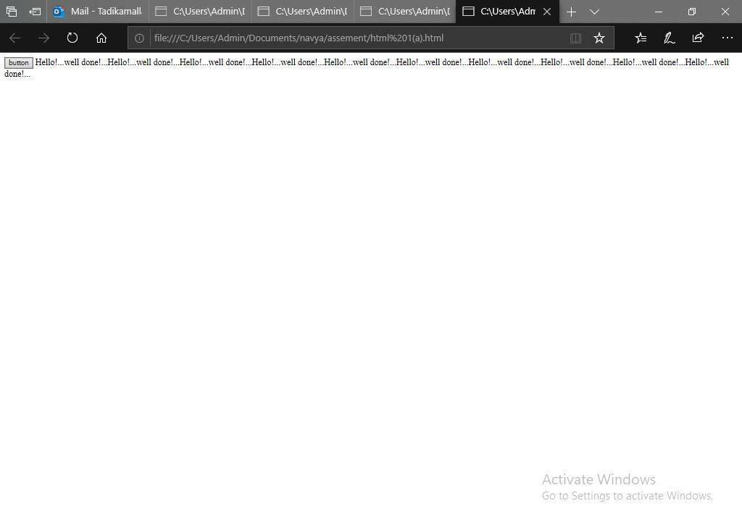

(b) Modify the program so that the initial text shown on the screen is "Monday", and it will change in the following way when the button is pressed repeatedly: Monday ... Tuesday ... Wednesday ... Thursday ... Friday ... Saturday ... Sunday ... Monday ... Tuesday ... etc. You should also change the button text so that there is written "Change day" on the button.

<!DOCTYPE html>

<html>

<script>

var index=0;

function change_day()

{

if (index>6)

{

index=0;

}

var days=['Monday','Tuesday','Wednesday','Thursday','Friday','Saturday','Sunday'];

var text=document.createTextNode(days[index]);

var p=document.createElement(p);

var temp=p.appendChild(text);

document.body.appendChild(temp);

index=index +1;

}

</script>

<body>

<input type="submit" value="button" onclick="change_day()">

</body>

</html>

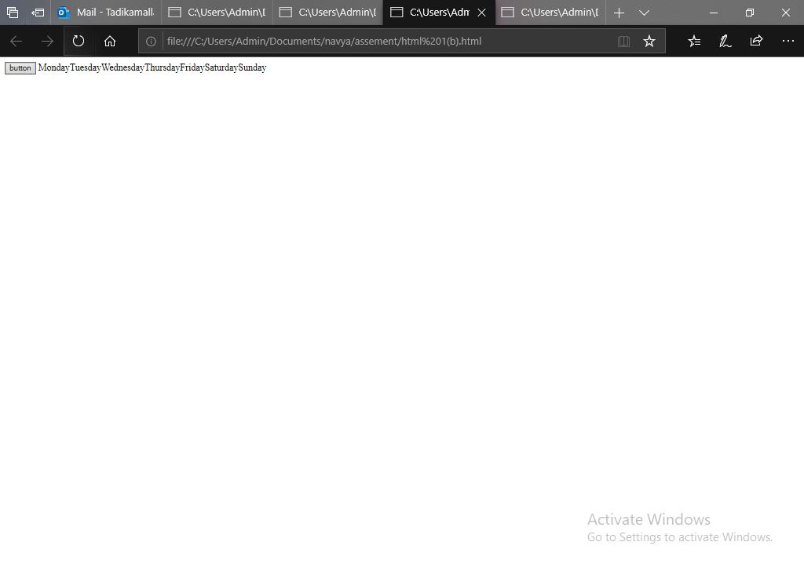

3.Using CSS properties create a calendar with following Calender Template

<html>

<head>

<style>

{box-sizing: border-box;}

ul {list-style-type: none;}

body {font-family: Verdana, sans-serif;}

.month {

padding: 5px 25px;

width: 100%;

background: #FFC0CB;

text-align: center;

}

.month ul {

margin: 0;

padding: 0;

}

.month ul li {

color: white;

font-size: 20px;

text-transform: uppercase;

letter-spacing: 3px;

}

.month .prev {

float: left;

padding-top: 10px;

}

.month .next {

float: right;

padding-top: 10px;

}

.weekdays {

margin: 0;

padding: 10px 0;

background-color: #ddd;

}

.weekdays li {

display: inline-block;

width: 13.6%;

color: #FFC0CB;

text-align: center;

}

.days {

padding: 10px 0;

background: #eee;

margin: 0;

}

.days li {

list-style-type: none;

display: inline-block;

width: 13.6%;

text-align: center;

margin-bottom: 5px;

font-size:12px;

color: #777;

}

.days li .active {

padding: 5px;

background: #FFC0CB;

color: white !important

}

@media screen and (max-width:720px) {

.weekdays li, .days li {width: 13.1%;}

}

@media screen and (max-width: 420px) {

.weekdays li, .days li {width: 12.5%;}

.days li .active {padding: 2px;}

}

@media screen and (max-width: 290px) {

.weekdays li, .days li {width: 12.2%;}

}

</style>

</head>

<body>

<div class="month">

<ul>

<li class="prev">&#10094;</li>

<li class="next">&#10095;</li>

<li>

MAY<br>

<span style="font-size:18px">2017</span>

</li>

</ul>

</div>

<ul class="weekdays">

<li>Mon</li>

<li>Tue</li>

<li>Wed</li>

<li>Thu</li>

<li>Fri</li>

<li>Sat</li>

<li>Sun</li>

</ul>

<ul class="days">

<li>1</li>

<li>2</li>

<li>3</li>

<li>4</li>

<li>5</li>

<li>6</li>

<li>7</li>

<li>8</li>

<li>9</li>

<li><span class="active">15</span></li>

<li>11</li>

<li>12</li>

<li>13</li>

<li>14</li>

<li>15</li>

<li>16</li>

<li>17</li>

<li>18</li>

<li>19</li>

<li>20</li>

<li>21</li>

<li>22</li>

<li>23</li>

<li>24</li>

<li>25</li>

<li>26</li>

<li>27</li>

<li>28</li>

<li>29</li>

<li>30</li>

<li>31</li>

</ul>

</body>

</html>

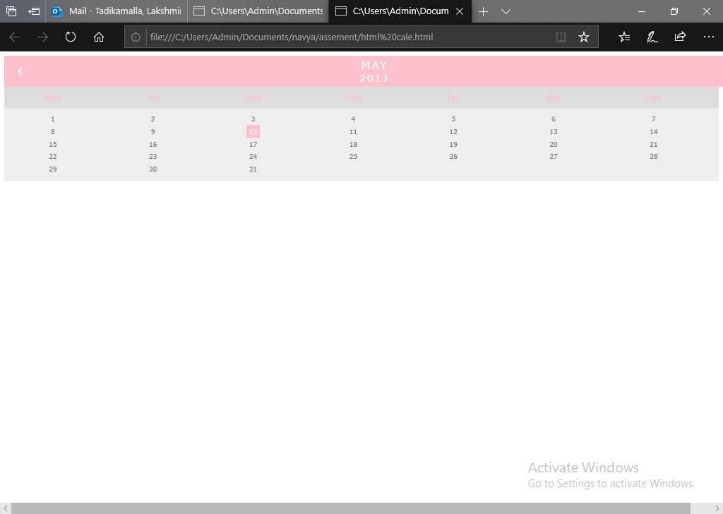

MODULE:1 JAVASCRIPT

1. Write a Java Script to find the n prime number.

code

<!DOCTYPE html>

<html>

<head>

<script>

function nextPrime(value) {

if (value > 2) {

var i, q;

do {

i = 3;

value += 2;

q = Math.floor(Math.sqrt(value));

while (i <= q && value % i) {

i += 2;

}

} while (i <= q);

return value;

}

return value === 2 ? 3 : 2;

}

function generatePrime() {

var userValue = document.getElementById("inputValue").value;

var value = 0, result = [];

for (var i = 0; i < userValue; i++) {

value = nextPrime(value);

result.push(value);

}

document.getElementById("returnValue").innerHTML = result[userValue-1];

}

</script>

</head>

<body>

Input value: <input type="text" name="inputValue" id="inputValue"/>

<button onclick="generatePrime()">Prime number</button>

<div id="returnValue">Test: </div>

</body>

</html>

