1(a) Create a html web page that contains a button with which it is possible to change the text that is shown on the screen. The file ButtonDemo.html has a JavaScript function named change_text() which is called after the button is pressed. When the button is pressed repeatedly the text changes Hello! ... Well done! ... Hello! ... Well done! ... Hello! ..

<html>

<script>

function change_text()

{

var text=document.createTextNode("Hello!...well done!...");

var p=document.createElement(p);

var temp=p.appendChild(text);

document.body.appendChild(temp);

}

</script>

<body>

<input type="submit" value="button" onclick="change_text()">

</body>

</html>

Output:

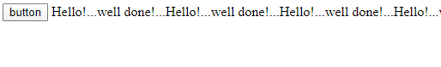

1(b) Modify the program so that the initial text shown on the screen is "Monday", and it will change in the following way when the button is

pressed repeatedly: Monday ... Tuesday ... Wednesday ... Thursday ... Friday ... Saturday ... Sunday ... Monday ... Tuesday ... etc. You should also change the button text so that there is written "Change day" on the button.

<html>

<head>

<script>

var p1=0;

function Change_Days(){

var a=document.getElementById("m");

if(a.innerHTML==="Sunday"){

a.innerHTML="Monday";

}

else if(a.innerHTML==="Monday")

{

a.innerHTML="Tuesday";

}

else if(a.innerHTML==="Tuesday")

{

a.innerHTML="Wednesday";

}

else if(a.innerHTML==="Wednesday")

{

a.innerHTML="Thursday";

}

else if(a.innerHTML==="Thursday")

{

a.innerHTML="Friday";

}

else if(a.innerHTML==="Friday")

{

a.innerHTML="Saturday";

}

else

{

a.innerHTML="Sunday";

}

}

</script>

</head>

<body>

<div id="m">Sunday</div>

<input id="mybutton" type="button" value="Change Day" onclick="Change_Days()">

</body>

</html>

3. 3. Using CSS properties create a calendar with following Calender Template 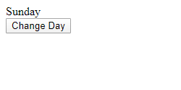

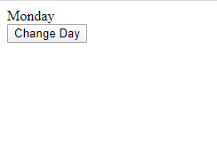

3. Using CSS properties create a calendar with following Calender Template

<html>

<head>

<style>

* {box-sizing: border-box;}

ul {list-style-type: none;}

body {font-family: Verdana, sans-serif;}

.month {

padding: 5px 25px;

width: 100%;

background:red;

text-align: center;

}

.month ul {

margin: 0;

padding: 0;

}

.month ul li {

color: white;

font-size: 20px;

text-transform: uppercase;

letter-spacing: 3px;

}

.month .prev {

float: left;

padding-top: 10px;

}

.month .next {

float: right;

padding-top: 10px;

}

.weekdays {

margin: 0;

padding: 10px 0;

background-color: #ddd;

}

.weekdays li {

display: inline-block;

width: 13.6%;

color: #666;

text-align: center;

}

.days {

padding: 10px 0;

background: #eee;

margin: 0;

}

.days li {

list-style-type: none;

display: inline-block;

width: 13.6%;

text-align: center;

margin-bottom: 5px;

font-size:12px;

color: #777;

}

.days li .active {

padding: 5px;

background: #FFC0CB;

color: white !important

}

/* Add media queries for smaller screens */

@media screen and (max-width:720px) {

.weekdays li, .days li {width: 13.1%;}

}

@media screen and (max-width: 420px) {

.weekdays li, .days li {width: 12.5%;}

.days li .active {padding: 2px;}

}

@media screen and (max-width: 290px) {

.weekdays li, .days li {width: 12.2%;}

}

</style>

</head>

<body>

<div class="month">

<ul>

<li class="prev">&#10094;</li>

<li class="next">&#10095;</li>

<li>

MAY<br>

<span style="font-size:18px">2017</span>

</li>

</ul>

</div>

<ul class="weekdays">

<li>Mon</li>

<li>Tue</li>

<li>Wed</li>

<li>Thu</li>

<li>Fri</li>

<li>Sat</li>

<li>Sun</li>

</ul>

<ul class="days">

<li>1</li>

<li>2</li>

<li>3</li>

<li>4</li>

<li>5</li>

<li>6</li>

<li>7</li>

<li>8</li>

<li>9</li>

<li><span class="active">15</span></li>

<li>11</li>

<li>12</li>

<li>13</li>

<li>14</li>

<li>15</li>

<li>16</li>

<li>17</li>

<li>18</li>

<li>19</li>

<li>20</li>

<li>21</li>

<li>22</li>

<li>23</li>

<li>24</li>

<li>25</li>

<li>26</li>

<li>27</li>

<li>28</li>

<li>29</li>

<li>30</li>

<li>31</li>

</ul>

</body>

</html>

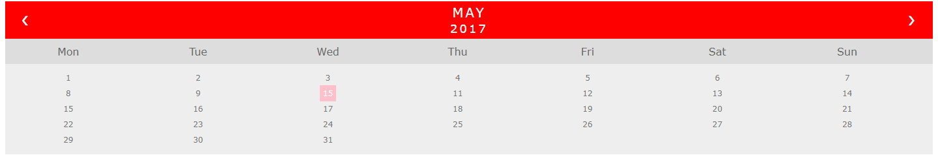

4. Write the queries Based on following Loan Schema:

Create database loanschema;

Use loanschema;

CREATE TABLE customer_master(

customer_number VARCHAR(6),

firstname VARCHAR(30),

middlename VARCHAR(30),

lastname VARCHAR(30),

customer_city VARCHAR(15),

customer_contact_no VARCHAR(10),

occupation VARCHAR(10),

customer_date_of_birth DATE,

CONSTRAINT customer_custid_pk PRIMARY KEY (customer_number));

CREATE TABLE branch_master(

branch_id VARCHAR(6),

branch_name VARCHAR(30),

branch_city VARCHAR(30),

CONSTRAINT branch_bid_pk PRIMARY KEY (branch_id));

CREATE TABLE account_master

(account_number VARCHAR(255),

customer_number VARCHAR(255),

branch_id VARCHAR(255),

opening_balance INT(20),

account_opening_date DATE,

account_type VARCHAR(10),

account_status VARCHAR(10),

PRIMARY KEY (account_number),

FOREIGN KEY (customer_number) references customer_master(customer_number),

FOREIGN KEY (branch_id) references branch_master(branch_id));

CREATE TABLE transaction_details(

transaction_number VARCHAR(6),

account_number VARCHAR(6),

date_of_transaction DATE,

medium_of_transaction VARCHAR(20),

transaction_type VARCHAR(20),

transaction_amount INT(7),

CONSTRAINT transaction_details_tnumber_pk PRIMARY KEY (transaction_number),

CONSTRAINT transaction_details_acnumber_fk FOREIGN KEY (account_number)

REFERENCES account_master (account_number));

CREATE TABLE loan_details

(customer_number varchar(255),

branch_id varchar(255),

loan_amount bigint(20),

foreign key(customer_number) references customer_master(customer_number));

a. Write a query to display customer number, customer’s firstname , account number where the account status is terminated. Display the records sorted in ascending order based on customer number and then by account number.

SELECT c.customer_number,c.firstname,a.account_number

FROM account_master a JOIN customer_master c

ON c.customer_number=a.customer_number

WHERE a.account_status='Terminated'

ORDER BY c.customer_number,a.account_number;

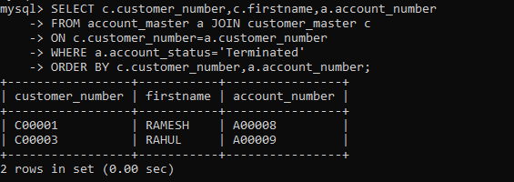

b. Write a query to display the number of accounts opened in each city. The query should display the Branch city and the number of No_of_Accounts for the branch city where we don’t have any accounts opened display 0. Display the records in the sorted order based on branch city.

select branch_city,count(account_number) No_of_Accounts from branch_master b

left join account_master a

on b.branch_id=a.branch_id

group by b.branch_city

order by b.branch_city;

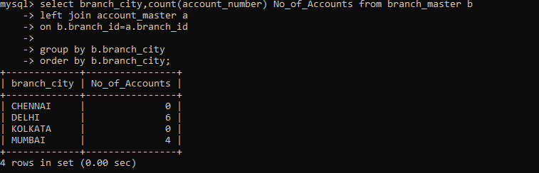

c. Write a query to display the customer number, customer firstname, customer lastname who has taken loan from more than 1 branch. Display the records sorted in order based on customer number.

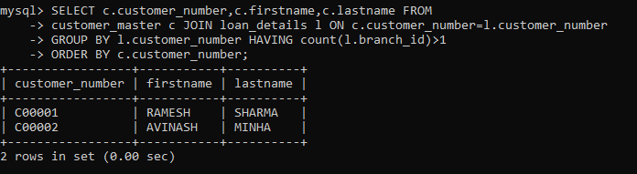

d. Write a query to display the number of clients who have asked for loan but they don’t have any account in the bank though they are registered customers. Give the count an alias name of Count.

SELECT count(c.customer_number)Count FROM customer_master c JOIN loan_details l ON c.customer_number=l.customer_number WHERE c.customer_number NOT IN (SELECT customer_number FROM account_master);

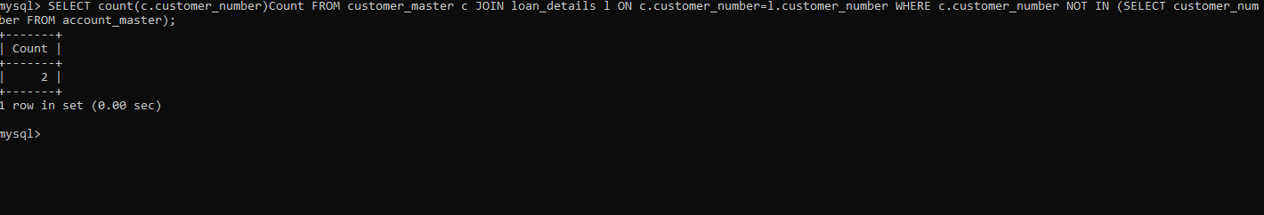

e. Write a equerry to display customers firstname, city and account number whose occupation are not business , Services or Student. Display the records sorted in ascending order based on customer firstname and by account number.

SELECT c.firstname,c.customer_city,a.account_number FROM Customer_master c JOIN account_master a ON a.customer_number=c.customer_number WHERE c.occupation NOT IN ('Service','Student','Business') ORDER BY c.firstname,a.account_number;

