**Module 2: Java Script and SQL**

(4)

(a)Write a query to display customer number, customer’s firstname , account number where the account status is terminated. Display the records sorted in ascending order based on customer number and then by account number.

SELECT c.customer_number,c.firstname,a.account_number

FROM account_master a JOIN customer_master c

ON c.customer_number=a.customer_number

WHERE a.account_status='Terminated'

ORDER BY c.customer_number,a.account_number;

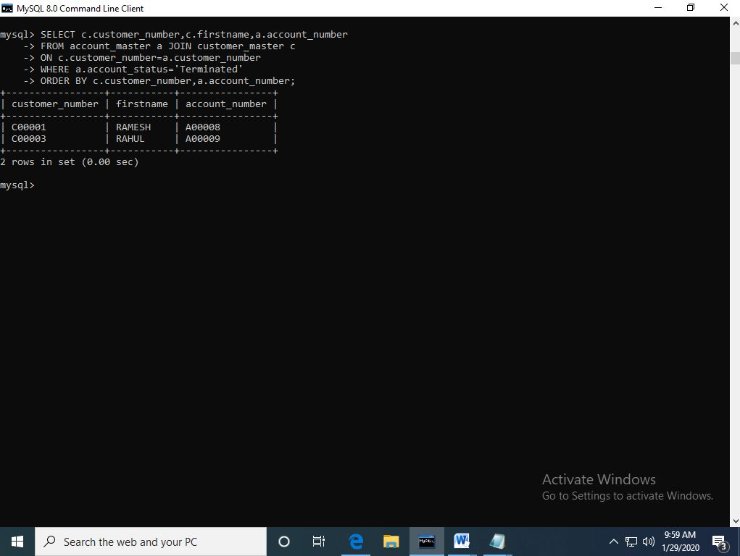

(b)Write a query to display the number of accounts opened in each city. The query should display the Branch city and the number of No_of_Accounts for the branch city where we don’t have any accounts opened display 0. Display the records in the sorted order based on branch city.

SELECT b.branch_city, count(a.account_number) No_of_Accounts

FROM branch_master b LEFT JOIN account_master a

ON a.branch_id=b.branch_id

GROUP BY b.branch_city ORDER BY branch_city;

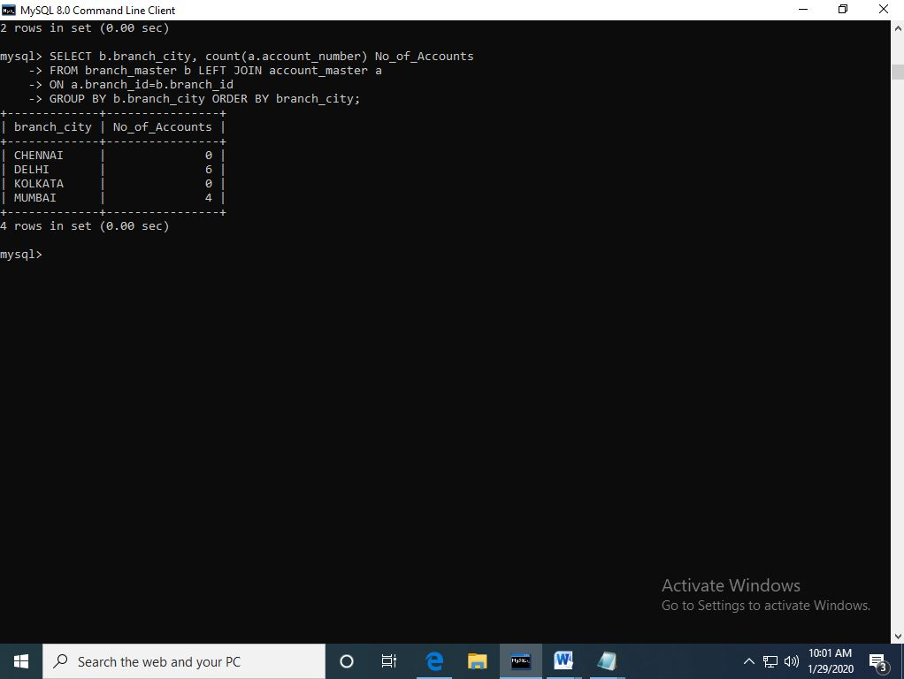

(c) Write a query to display the customer number, customer firstname, customer lastname who has taken loan from more than 1 branch. Display the records sorted in order based on customer number.

SELECT c.customer_number,c.firstname,c.lastname FROM

customer_master c JOIN loan_details l ON c.customer_number=l.customer_number

GROUP BY l.customer_number HAVING count(l.branch_id)>1

ORDER BY c.customer_number;

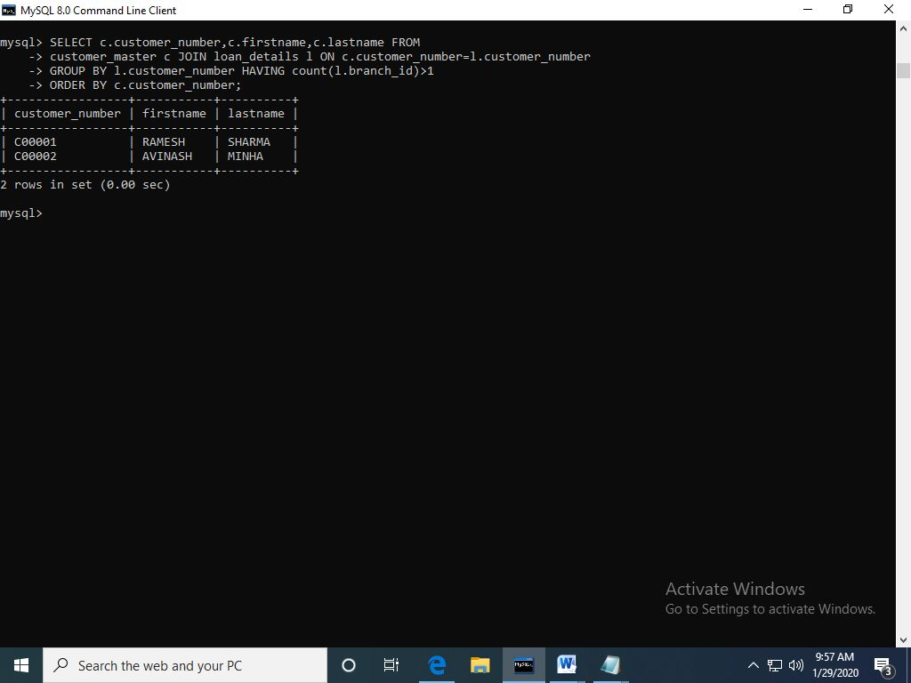

(d) Write a query to display the number of clients who have asked for loan but they don’t have any account in the bank though they are registered customers. Give the count an alias name of Count.

SELECT count(c.customer_number) Count FROM customer_master c JOIN loan_details l ON c.customer_number=l.customer_number

WHERE c.customer_number NOT IN (SELECT customer_number FROM

account_master);

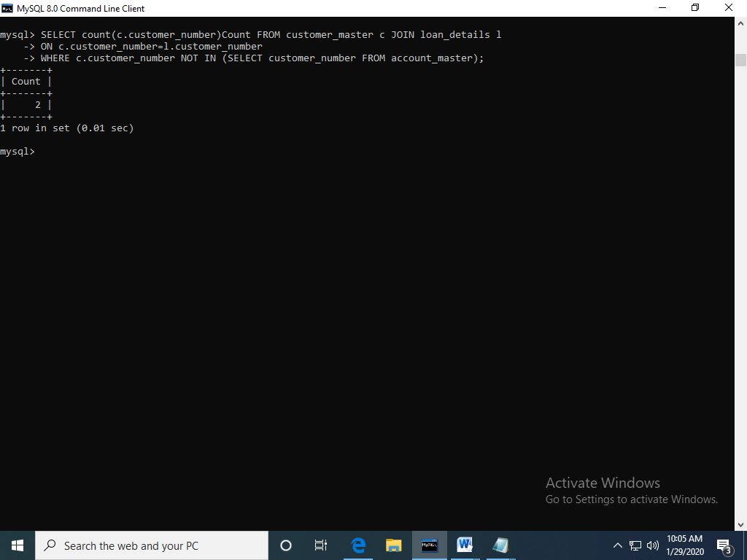

(e) Write a query to display customers firstname, city and account number whose occupation are not business , Services or Student. Display the records sorted in ascending order based on customer firstname and by account number.

SELECT c.firstname,c.customer_city,a.account_number FROM

Customer_master c JOIN account_master a ON

a.customer_number=c.customer_number

WHERE c.occupation NOT IN ('Service','Student','Business')

ORDER BY c.firstname,a.account_number;

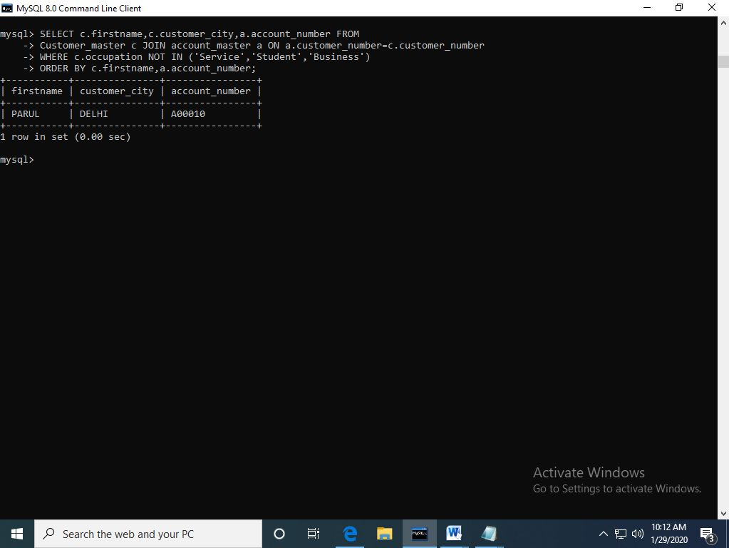

**Module 1: Software Engineering, HTML and CSS**

1. (a) Create a html web page that contains a button with which it is possible to change the text that is shown on the screen. The file ButtonDemo.html has a JavaScript function named change_text() which is called after the button is pressed. When the button is pressed repeatedly the text changes Hello! ... Well done! ... Hello! ... Well done! ... Hello! ..

<html>  
<head>  
<script>  
function change_text()  
{  
var string=document.getElementById("p1").value;  
var text=document.createTextNode(string);  
var para=document.createElement("p");  
var temp=para.appendChild(text);  
document.body.appendChild(temp);  
}  
</script>  
</head  
<body>  
Enter your text<input type="text" id="p1"/>  
<input type="submit" value="create" onclick="change_text()"/>  
</body>  
  
</html>

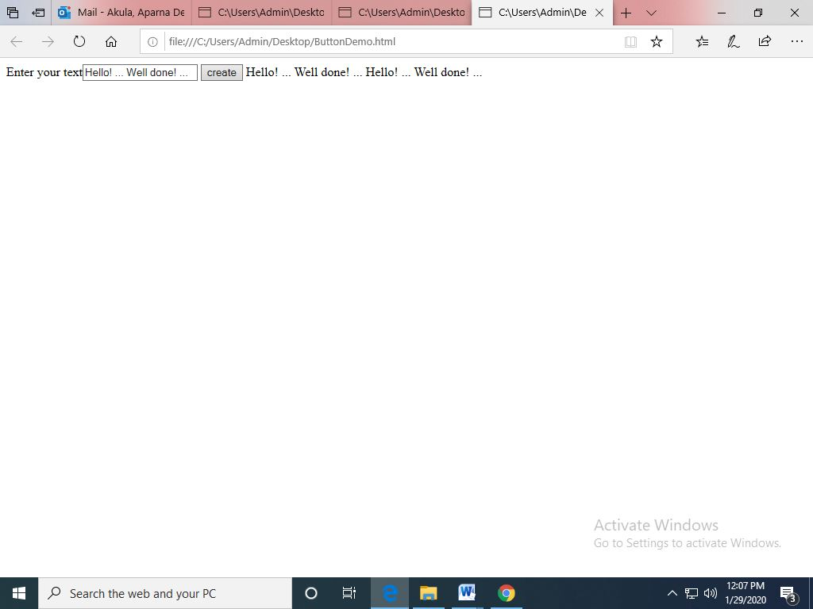

(b) Modify the program so that the initial text shown on the screen is "Monday", and it will change in the following way when the button is pressed repeatedly: Monday ... Tuesday ... Wednesday ... Thursday ... Friday ... Saturday ... Sunday ... Monday ... Tuesday ... etc. You should also change the button text so that there is written "Change day" on the button.

<!DOCTYPE html>  
<html>  
<script>  
var index=0;  
  function change_day()  
   {  
if (index>6)  
{  
index=0;  
}  
  
var days=['Monday','Tuesday','Wednesday','Thursday','Friday','Saturday','Sunday'];  
var text=document.createTextNode(days[index]);  
var p=document.createElement(p);  
var temp=p.appendChild(text);  
document.body.appendChild(temp);  
index=index +1;  
}  
</script>  
<body>  
  <input type="submit" value="button"  onclick="change_day()">  
</body>  
</html>

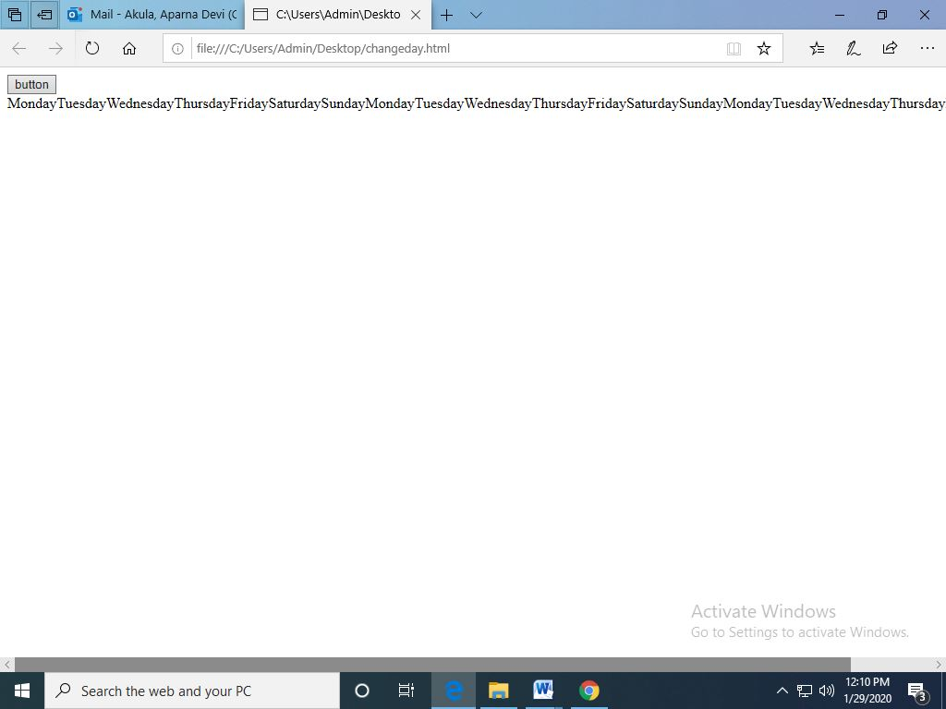

(3) Using CSS properties create a calendar with following Calendar.

<html>

<head>

<style>

ul {list-style-type: none;}

body {font-family: Verdana;}

.month {

padding: 70px 25px;

width: 100%;

background: #11abcc;

text-align: center;

}

.month ul {

margin: 0;

padding: 0;

}

.month ul li {

color: white;

font-size: 20px;

text-transform: uppercase;

letter-spacing: 3px;

}

.month .prev {

float: left;

padding-top: 10px;

}

.month .next {

float: right;

padding-top: 10px;

}

.weekdays {

margin: 0;

padding: 10px 0;

background-color:#ddd;

}

.weekdays li {

display: inline-block;

width: 13.6%;

color: #666;

text-align: center;

}

.days {

padding: 10px 0;

background: #eee;

margin: 0;

}

.days li {

list-style-type: none;

display: inline-block;

width: 13.6%;

text-align: center;

margin-bottom: 5px;

font-size:12px;

color: #777;

}

.days li .active {

padding: 5px;

background: #11abcc;

color: white !important

}

</style>

</head>

<body >

<div class="month">

<ul>

<li class="prev">&#10094;</li>

<li class="next">&#10095;</li>

<li>January<br><span style="font-size:18px">2020</span></li>

</ul>

</div>

<ul class="weekdays">

<li>Mon</li>

<li>Tue</li>

<li>Wed</li>

<li>Thurs</li>

<li>Fri</li>

<li>Sat</li>

<li>Sun</li>

</ul>

<ul class="days">

<li>1</li>

<li>2</li>

<li>3</li>

<li>4</li>

<li>5</li>

<li>6</li>

<li>7</li>

<li>8</li>

<li>9</li>

<li>10</li>

<li>11</li>

<li>12</li>

<li>13</li>

<li>14</li>

<li>15</li>

<li>16</li>

<li>17</li>

<li>18</li>

<li>19</li>

<li>20</li>

<li>21</li>

<li>22</li>

<li>23</li>

<li>24</li>

<li>25</li>

<li>26</li>

<li>27</li>

<li>28</li>

<li><span class="active">29</span></li>

<li>30</li>

</ul>

</body>

</html>

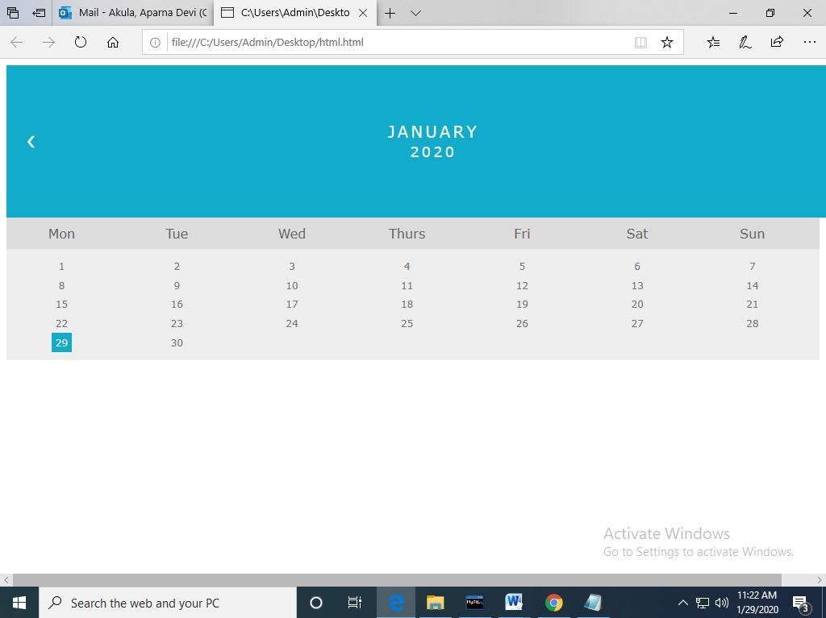

**Module 2: Java Script and SQL**

2.Write a Java Script to find the n prime number.

<!DOCTYPE html>  
<html>  
<head>  
<script>  
function nextPrime(value) {  
   if (value > 2) {  
       var i, q;  
       do {  
           i = 3;  
           value += 2;  
           q = Math.floor(Math.sqrt(value));  
           while (i <= q && value % i) {  
               i += 2;  
           }  
       } while (i <= q);  
       return value;  
   }  
   return value === 2 ? 3 : 2;  
}  
function generatePrime() {  
var userValue = document.getElementById("inputValue").value;  
var value = 0, result = [];  
for (var i = 0; i < userValue; i++) {  
value = nextPrime(value);  
result.push(value);  
}  
 document.getElementById("returnValue").innerHTML = result[userValue-1];  
}  
</script>  
</head>  
<body>  
Input value: <input type="text" name="inputValue" id="inputValue"/>  
<button onclick="generatePrime()">Prime number</button>  
<div id="returnValue">Test: </div>  
</body>  
</html>

