**Module 2: Java Script and SQL**

**SQL Queries:**

1)

select c.customer_number,c.firstname,a.account_number from customer_master c

join account_master a

on c.customer_number=a.customer_number

where a.account_status='TERMINATED'

group by c.customer_number

order by c.customer_number,a.account_number;

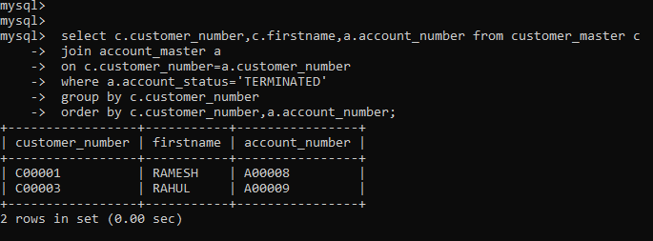

2)

select branch_city,count(account_number) No_of_Accounts from branch_master b

left join account_master a

on b.branch_id=a.branch_id

group by b.branch_city

order by b.branch_city;

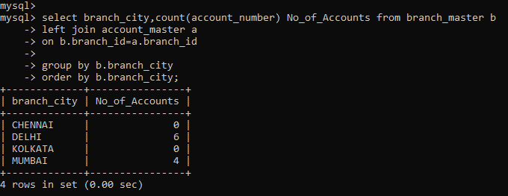

3)

select c.customer_number,c.firstname,c.lastname from customer_master c

join account_master a

on c.customer_number=a.customer_number

join loan_details l on l.branch_id=a.branch_id

having count(l.branch_id) > 1

order by c.customer_number;

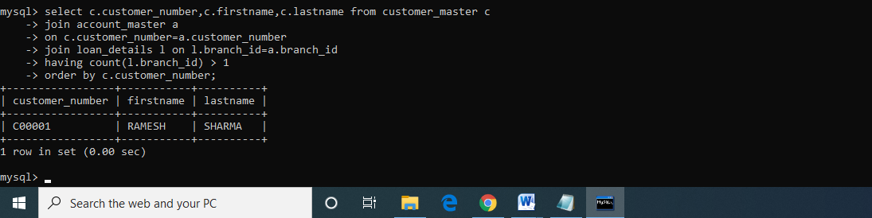

4)

select count(c.customer_number) Count from customer_master c

inner join loan_details l

on c.customer_number=l.customer_number

where c.customer_number not in(select customer_number from account_master);

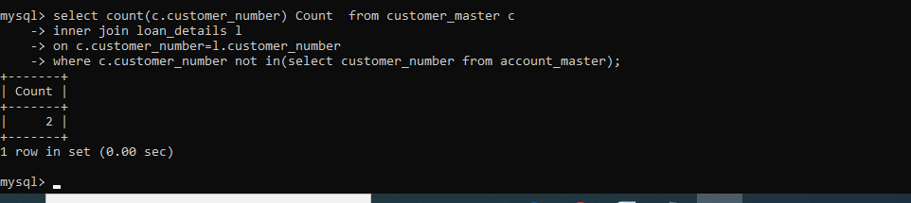

5)

select c.firstname,c.customer_city,a.account_number from customer_master c

join account_master a

on c.customer_number=a.customer_number

where occupation not in('business','service','student')

order by c.firstname,a.account_number;

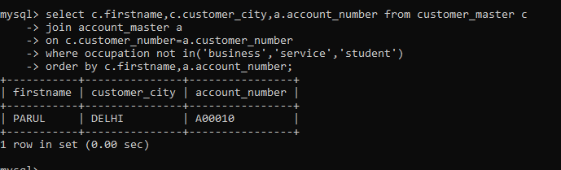

Write a Java Script to find the n prime number:

<html>

<body>

<script>

var n=prompt("Enter a number ");

var i,pc=0,k=1;

while(pc<n)

{

k=k+1;

for(i=2;i<=k;i++)

{

if(k%i==0)

{

break;

}

}

if(k==i)

{

pc++;

}

}

document.write("nth prime is"+k);

</script>

</body>

</html>

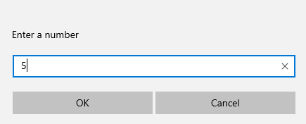

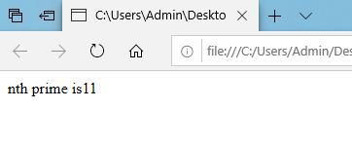

Create a html web page that contains a button with which it is possible to change the text that is shown on the screen. The file ButtonDemo.html has a JavaScript function named change_text() which is called after the button is pressed. When the button is pressed repeatedly the text changes Hello! ... Well done! ... Hello! ... Well done! ... Hello! ..

<html>

<script>

function change_text()

{

var text=document.createTextNode("Hello!...well done!...");

var p=document.createElement(p);

var temp=p.appendChild(text);

document.body.appendChild(temp);

}

</script>

<body>

<input type="submit" value="ClickME" onclick="change_text()">

</body>

</html>

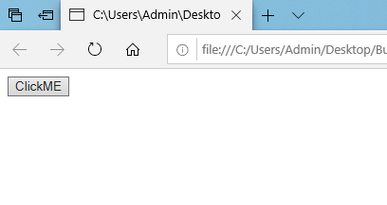

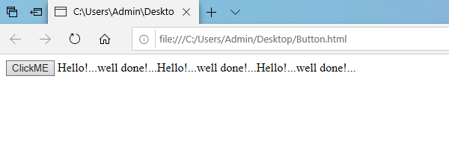

Using CSS properties create a calendar with following Calender Template:

<html>

<head>

<title>Calander</title>

<style> .tableMain

{

width:650px;

height:450px;

padding:5px;

border-radius: 7px;

background:#cbafbd;

border-collapse:collapse;

}

.tdhov1 {

border-top: 2px solid black;

border-left:2px solid black;

border-right: 2px solid black;

text-align: center;

color:#94c3c6;

text-shadow: 1px 1px 5px #C0C0C0;//silver

}

.th1 {

border-bottom: 3px solid black;

}

.th1 {

background:#293038;

font-size:20px;

color:#19b164;

text-shadow: 1px 1px 5px #000000;

}

.thmain {

text-shadow: 1px 1px 5px #000000;

font-size:25px;

color:#94c3c6;

}

.tdhov1:hover {

color:#F08080;//brick red

background:#293038;

text-shadow: 1px 1px 5px #ffffff;

border-radius: 5px;

}

.cbody {

background-image: url('bgi2.jpg');

background-repeat: no-repeat;

background-attachment: fixed;

background-size: cover;

}

</style>

</head>

<body class="cbody">

<table align="center" class="tableMain">

<tr>

<th colspan="7" class="thmain"><font face="Ariel">January 2020</font></th>

</tr>

<tr>

<th class="th1">Su</th>

<th class="th1">Mo</th>

<th class="th1">Tu</th>

<th class="th1">We</th>

<th class="th1">Th</th>

<th class="th1">Fr</th>

<th class="th1">Sa</th>

</tr>

<tr>

<td></td>

<td></td>

<td></td>

<td></td>

<td class="tdhov1">1</td>

<td class="tdhov1">2</td>

<td class="tdhov1">3</td>

</tr>

<tr>

<td class="tdhov1">4</td>

<td class="tdhov1">5</td>

<td class="tdhov1">6</td>

<td class="tdhov1">7</td>

<td class="tdhov1">8</td>

<td class="tdhov1">9</td>

<td class="tdhov1">10</td>

</tr>

<tr>

<td class="tdhov1">11</td>

<td class="tdhov1">12</td>

<td class="tdhov1">13</td>

<td class="tdhov1">14</td>

<td class="tdhov1">15</td>

<td class="tdhov1">16</td>

<td class="tdhov1">17</td>

</tr>

<tr>

<td class="tdhov1">18</td>

<td class="tdhov1">19</td>

<td class="tdhov1">20</td>

<td class="tdhov1">21</td>

<td class="tdhov1">22</td>

<td class="tdhov1">23</td>

<td class="tdhov1">24</td>

</tr>

<tr>

<td class="tdhov1">25</td>

<td class="tdhov1">26</td>

<td class="tdhov1">27</td>

<td class="tdhov1">28</td>

<td class="tdhov1">29</td>

<td class="tdhov1">30</td>

<td class="tdhov1">31</td>

</tr>

</table>

</body>

</html>

