1. Write a query to display customer number, customer’s firstname , account number where the account status is terminated. Display the records sorted in ascending order based on customer number and then by account number.

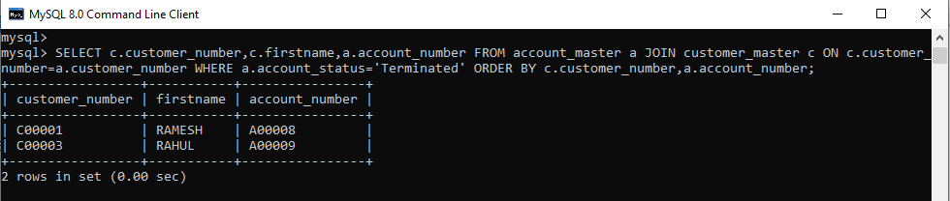

1. Write a query to display the number of accounts opened in each city. The query should display the Branch city and the number of No_of_Accounts for the branch city where we don’t have any accounts opened display 0. Display the records in the sorted order based on branch city.

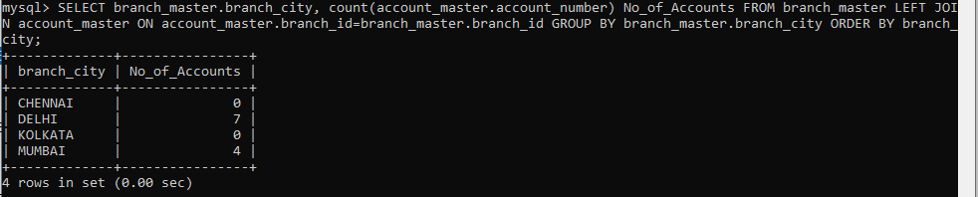

1. Write a query to display the customer number, customer firstname, customer lastname who has taken loan from more than 1 branch. Display the records sorted in order based on customer number.

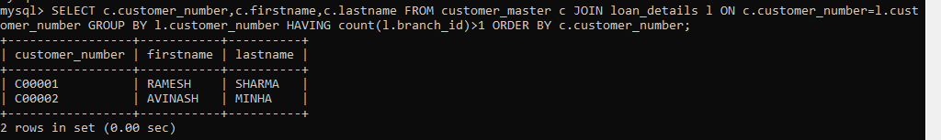

1. Write a query to display the number of clients who have asked for loan but they don’t have any account in the bank though they are registered customers. Give the count an alias name of Count.

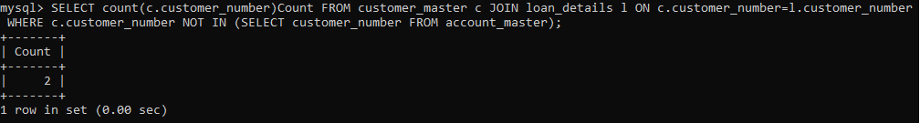

1. Write a equerry to display customers firstname, city and account number whose occupation are not business , Services or Student. Display the records sorted in ascending order based on customer firstname and by account number.

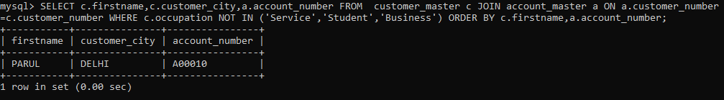

**Module 2: Java Script and SQL**

1. Write a guessing game where the user has to guess a secret number. After every guess the program tells the user whether their number was too large or too small. At the end the number of tries needed should be printed. It counts only as one try if they input the same number multiple times consecutively.

<!DOCTYPE html>

<html>

<head>

<meta charset="utf-8">

<title>Number Guessing Game</title>

<style>

html {

font-family: sans-serif;

}

body {

width: 50%;

max-width: 800px;

min-width: 480px;

margin: 0 auto;

}

</style>

</head>

<body>

<h1>Guess The Number</h1>

<p>We have selected a random number between 1 - 10.

See if you can guess it.</p>

<div class="form">

<label for="guessField">Enter a guess: </label>

<input type = "text" id = "guessField" class = "guessField">

<input type = "submit" value = "Submit guess"

class = "guessSubmit" id = "submitguess">

</div>

<script type = "text/javascript">

var y = Math.floor(Math.random() * 10 + 1);

var guess = 1;

document.getElementById("submitguess").onclick = function(){

var x = document.getElementById("guessField").value;

if(x == y)

{

alert("CONGRATULATIONS!!! YOU GUESSED IT RIGHT IN "

+ guess + " GUESS ");

}

else if(x > y) /* if guessed number is greater

than actual number*/

{

guess++;

alert("OOPS SORRY!! TRY A SMALLER NUMBER");

}

else

{

guess++;

alert("OOPS SORRY!! TRY A GREATER NUMBER")

}

}

</script>

</body>

</html>

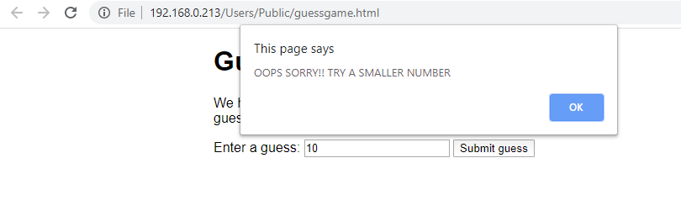

1. **Write a Java Script to find the n prime number**.

<!DOCTYPE html>

<html>

<head>

<script>

function nextPrime(value) {

if (value > 2) {

var i, q;

do {

i = 3;

value += 2;

q = Math.floor(Math.sqrt(value));

while (i <= q && value % i) {

i += 2;

}

} while (i <= q);

return value;

}

return value === 2 ? 3 : 2;

}

function generatePrime() {

var userValue = document.getElementById("inputValue").value;

var value = 0, result = [];

for (var i = 0; i < userValue; i++) {

value = nextPrime(value);

result.push(value);

}

document.getElementById("returnValue").innerHTML = result[userValue-1];

}

</script>

</head>

<body>

Input value: <input type="text" name="inputValue" id="inputValue"/>

<button onclick="generatePrime()">Prime number</button>

<div id="returnValue">Test: </div>

</body>

</html>

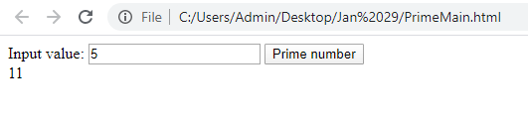

1. Write a function that rotates a list by k elements. For example [1,2,3,4,5,6] rotated by two becomes [3,4,5,6,1,2]. Try solving this without creating a copy of the list. How many swap or move operations do you need?

<html>

<head>

<script>

function change_values()

{

var x=[1,2,3,4,5,6];

var y=[];

var count=document.getElementById(txt).value;

for(var i=0;i<x.length();i++)

{

for(var j=0;j<count;j++)

{

var temp=x[i];

x[i-1]=temp;

x[i]=x[i-1];

y[i]=x[i];

}

}

</script>

<body>

<input type="text" value=" " id="txt"><br>

<input type="button" value="click" onclick="change_values">

</body>

</html>

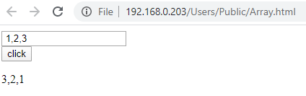

**Module 1: Software Engineering, HTML and CSS**

1. **(a) Create a html web page that contains a button with which it is possible to change the text that is shown on the screen. The file ButtonDemo.html has a JavaScript function named change_text() which is called after the button is pressed. When the button is pressed repeatedly the text changes Hello! ... Well done! ... Hello! ... Well done! ... Hello! ..**

<!DOCTYPE html>

<html>

<head>

<meta name="viewport" content="width=device-width, initial-scale=1">

</head>

<body>

<p><button onclick="change_text()">Change Day</button></p>

<div id="myDIV">Hello!...</div>

<script>

function change_text() {

var x = document.getElementById("myDIV");

if(x.innerHTML === "Hello!..."){

x.innerHTML = "Well done!...";

}else{

x.innerHTML = "Hello!...";

}

}

</script>

</body>

</html>

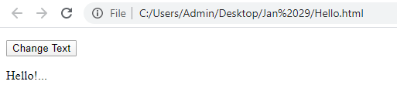

(b) **Modify the program so that the initial text shown on the screen is "Monday", and it will change in the following way when the** **button is pressed repeatedly: Monday ... Tuesday ... Wednesday ... Thursday ... Friday ... Saturday ... Sunday ... Monday ... Tuesday ... etc. You should also change the button text so that there is written "Change day" on the button.**

<!DOCTYPE html>

<html>

<head>

<meta name="viewport" content="width=device-width, initial-scale=1">

</head>

<body>

<p><button onclick="change_text()">Change Day</button></p>

<div id="myDIV">Monday</div>

<script>

function change_text() {

var x = document.getElementById("myDIV");

if (x.innerHTML === "Monday") {

x.innerHTML = "Tuesday";

} else if(x.innerHTML === "Tuesday"){

x.innerHTML = "Wednesday";

}

else if(x.innerHTML === "Wednesday"){

x.innerHTML = "Thursday";

}

else if(x.innerHTML === "Thursday"){

x.innerHTML = "Friday";

}

else if(x.innerHTML === "Friday"){

x.innerHTML = "Saturday";

}

else if(x.innerHTML === "Saturday"){

x.innerHTML = "Sunday";

}

else{

x.innerHTML = "Monday";

}

}

</script>

</body>

</html>

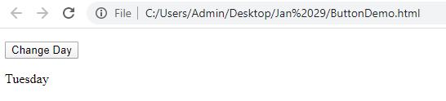

1. **a. Create a newHTML-document with an unordered list element, a text-box,and a button that says “Add.”**

**b. Add JavaScript(and/or jQuery)that appendsa new <li> element to the unordered list when the button is clicked. The text of the new li-element should correspond to the text entered by the user in the text-box. Make sure thatthe content of the text-box is cleared when the button is clicked to be ready for new input from the user.**

**c. Add functionality to allow the user to delete a selected list item. When the“delete” button is clicked, the itemshould be removed from the list.**

<!DOCTYPE html>

<html>

<head>

<meta name="viewport" content="width=device-width, initial-scale=1">

</head>

<body>

<div id="myDIV" class="header">

<input type="text" id="myInput" placeholder="Add">

<button onclick="newElement()" class="addBtn">Add</button>

</div>

<ul id="myUL">

</ul>

<script>

var myNodelist = document.getElementsByTagName("LI");

var i;

for (i = 0; i < myNodelist.length; i++) {

var span = document.createElement("SPAN");

var txt = document.createTextNode("\u00D7");

span.className = "close";

span.appendChild(txt);

myNodelist[i].appendChild(span);

}

// Click on a close button to hide the current list item

var close = document.getElementsByClassName("close");

var i;

for (i = 0; i < close.length; i++) {

close[i].onclick = function() {

var div = this.parentElement;

div.style.display = "none";

}

}

// Add a "checked" symbol when clicking on a list item

var list = document.querySelector('ul');

list.addEventListener('click', function(ev) {

if (ev.target.tagName === 'LI') {

ev.target.classList.toggle('checked');

}

}, false);

function newElement() {

var li = document.createElement("li");

var inputValue = document.getElementById("myInput").value;

var t = document.createTextNode(inputValue);

li.appendChild(t);

if (inputValue === '') {

alert("You must write something!");

} else {

document.getElementById("myUL").appendChild(li);

}

document.getElementById("myInput").value = "";

var span = document.createElement("SPAN");

var txt = document.createTextNode("\u00D7");

span.className = "close";

span.appendChild(txt);

li.appendChild(span);

for (i = 0; i < close.length; i++) {

close[i].onclick = function() {

var div = this.parentElement;

div.style.display = "none";

}

}

}

</script>

</body>

</html>

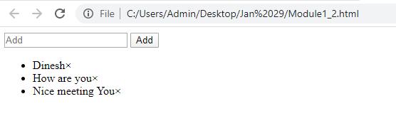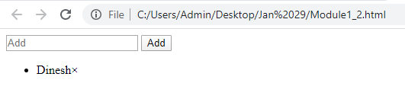

**3. Using CSS properties create a calendar with following Calender Template:**

<!DOCTYPE html>

<html>

<head>

<style>

* {box-sizing: border-box;}

ul {list-style-type: none;}

body {font-family: Verdana, sans-serif;}

.month {

padding: 70px 25px;

width: 100%;

background: #1affff;

text-align: center;

}

.month ul {

margin: 0;

padding: 0;

}

.month ul li {

color: white;

font-size: 20px;

text-transform: uppercase;

letter-spacing: 3px;

}

.month .prev {

float: left;

padding-top: 10px;

}

.month .next {

float: right;

padding-top: 10px;

}

.weekdays {

margin: 0;

padding: 10px 0;

background-color: #ddd;

}

.weekdays li {

display: inline-block;

width: 13.6%;

color: #666;

text-align: center;

}

.days {

padding: 10px 0;

background: #eee;

margin: 0;

}

.days li {

list-style-type: none;

display: inline-block;

width: 13.6%;

text-align: center;

margin-bottom: 5px;

font-size:12px;

color: #777;

}

.days li .active {

padding: 5px;

background: #1affff;

color: white !important

}

/* Add media queries for smaller screens */

@media screen and (max-width:720px) {

.weekdays li, .days li {width: 13.1%;}

}

@media screen and (max-width: 420px) {

.weekdays li, .days li {width: 12.5%;}

.days li .active {padding: 2px;}

}

@media screen and (max-width: 290px) {

.weekdays li, .days li {width: 12.2%;}

}

</style>

</head>

<body>

<div class="month">

<ul>

<li class="prev">&#10094;</li>

<li class="next">&#10095;</li>

<li>

January<br>

<span style="font-size:18px">2020</span>

</li>

</ul>

</div>

<ul class="weekdays">

<li>Mo</li>

<li>Tu</li>

<li>We</li>

<li>Th</li>

<li>Fr</li>

<li>Sa</li>

<li>Su</li>

</ul>

<ul class="days">

<li>1</li>

<li>2</li>

<li>3</li>

<li>4</li>

<li>5</li>

<li>6</li>

<li>7</li>

<li>8</li>

<li>9</li>

<li>10</li>

<li>11</li>

<li>12</li>

<li>13</li>

<li>14</li>

<li>15</li>

<li>16</li>

<li>17</li>

<li>18</li>

<li>19</li>

<li>20</li>

<li>21</li>

<li>22</li>

<li>23</li>

<li>24</li>

<li>25</li>

<li>26</li>

<li>27</li>

<li>28</li>

<li><span class="active">29</span></li>

<li>30</li>

<li>31</li>

</ul>

</body>

</html>

