1. SELECT c.customer_number,c.firstname,a.account_number

FROM account_master a JOIN customer_master c

ON c.customer_number=a.customer_number

WHERE a.account_status='Terminated'

ORDER BY c.customer_number,a.account_number;

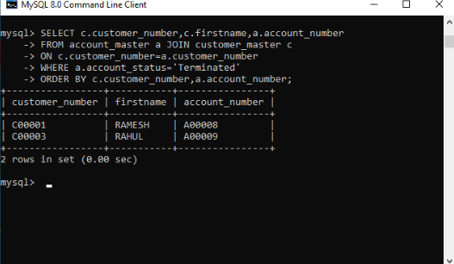

2. SELECT branch.branch_city, count(account.account_number) No_of_Accounts

FROM branch_master branch LEFT JOIN account_master account

ON account.branch_id=branch.branch_id

GROUP BY branch.branch_city ORDER BY branch_city;

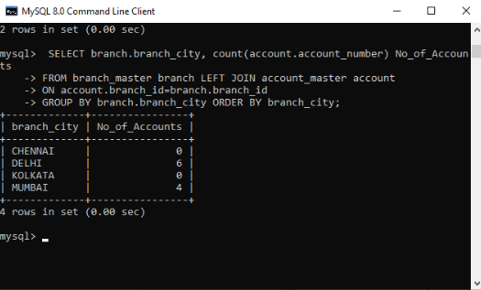

3. SELECT c.customer_number,c.firstname,c.lastname FROM

customer_master c JOIN loan_details l

ON c.customer_number=l.customer_number

GROUP BY l.customer_number HAVING count(l.branch_id)>1

ORDER BY c.customer_number;

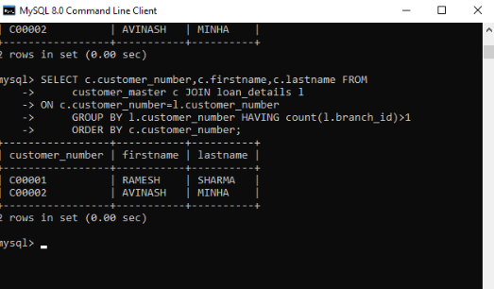

4. SELECT count(c.customer_number)Count FROM

customer_master c JOIN loan_details l

ON c.customer_number=l.customer_number

WHERE c.customer_number NOT IN

(SELECT customer_number FROM account_master);

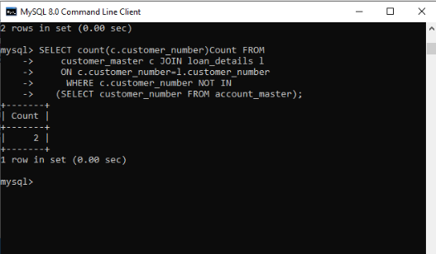

5. SELECT c.firstname,c.customer_city,a.account_number

FROM Customer_master c JOIN account_master a

ON a.customer_number=c.customer_number

WHERE c.occupation NOT IN

('Service','Student','Business')

ORDER BY c.firstname,a.account_number;

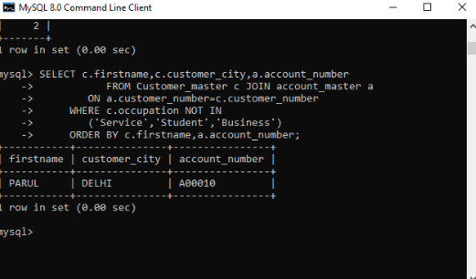

**MODULE 1:HTML,CSS**

1. (a):Create a html web page that contains a button with which it is possible to change the text that is shown on the screen. The file ButtonDemo.html has a JavaScript function named change_text() which is called after the button is pressed. When the button is pressed repeatedly the text changes Hello! ... Well done! ... Hello! ... Well done! ... Hello! ..

<html>

<head>

<script>

var p1=0

function change_text(){

if(p1==0){

document.getElementById("a").innerHTML="WELL DONE!.......";

P1=1;

}

else{

document.getElementById("a").innerHTML="hello!.......";

}

}

</script>

</head>

<body>

<div id="a">Hello</div>

<input id="mybutton" type="button" value="Change Text" onclick="change_text()">

</body>

</html>

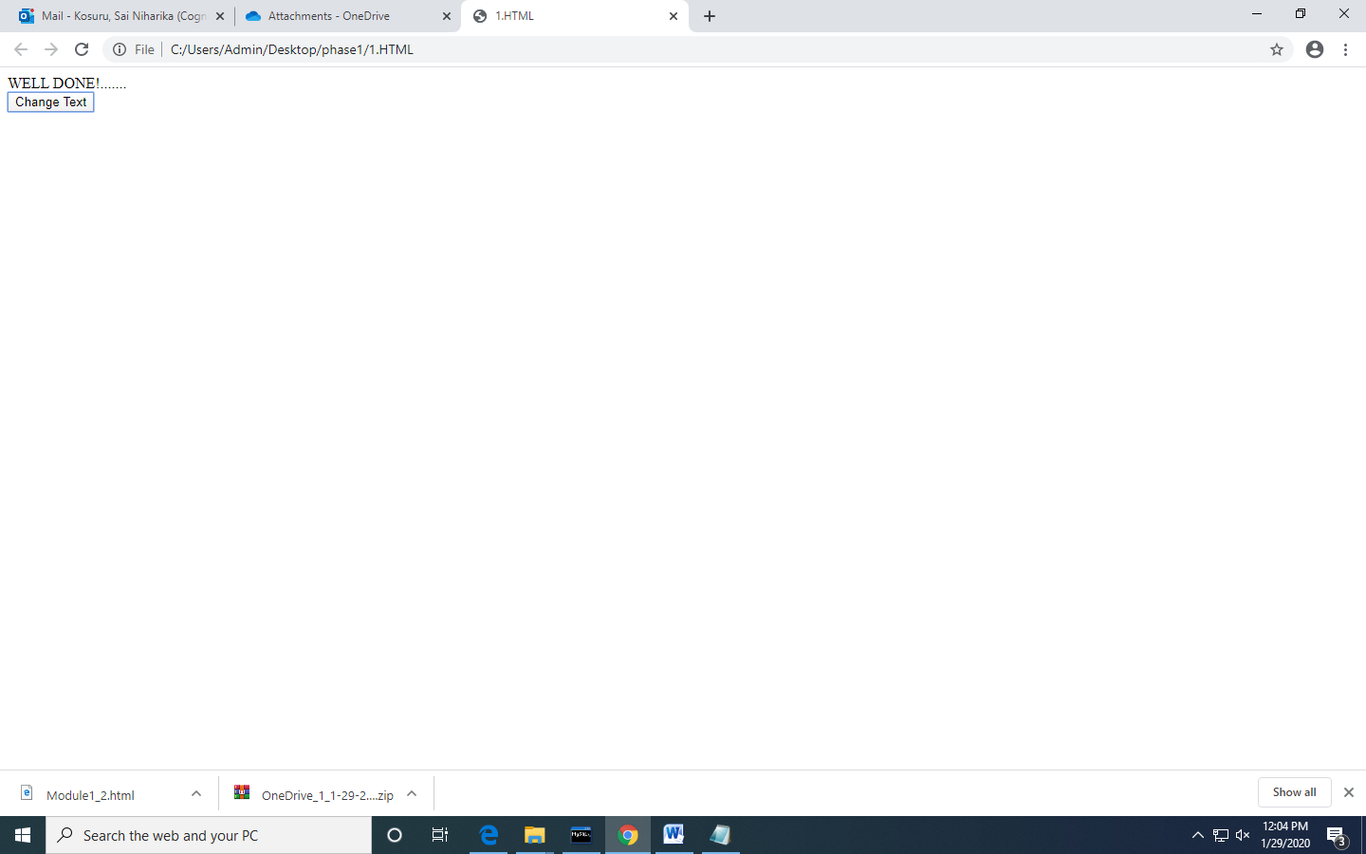

1(b): Modify the program so that the initial text shown on the screen is "Monday", and it will change in the following way when the button is pressed repeatedly: Monday ... Tuesday ... Wednesday ... Thursday ... Friday ... Saturday ... Sunday ... Monday ... Tuesday ... etc. You should also change the button text so that there is written "Change day" on the button.

<html>

<head>

<script>

var p1=0

function change_days(){

var a=document.getElementById("m");

if(a.innerHTML==="Sunday"){

a.innerHTML="Monday";

}else if(a.innerHTML==="Monday"){

a.innerHTML="Tuesday";

}else if(a.innerHTML==="Tuesday"){

a.innerHTML="Wednesday";

}

else if(a.innerHTML==="Wednesday"){

a.innerHTML="Thursday";

}

else if(a.innerHTML==="Thursday"){

a.innerHTML="Friday";

}

else if(a.innerHTML==="Friday"){

a.innerHTML="Saturday";

}

else{

a.innerHTML="Sunday";

}

}

</script>

</head>

<body>

<div id="m">Sunday</div>

<input id="mybutton" type="button" value="Change Text" onclick="change_days()">

</body>

</html>

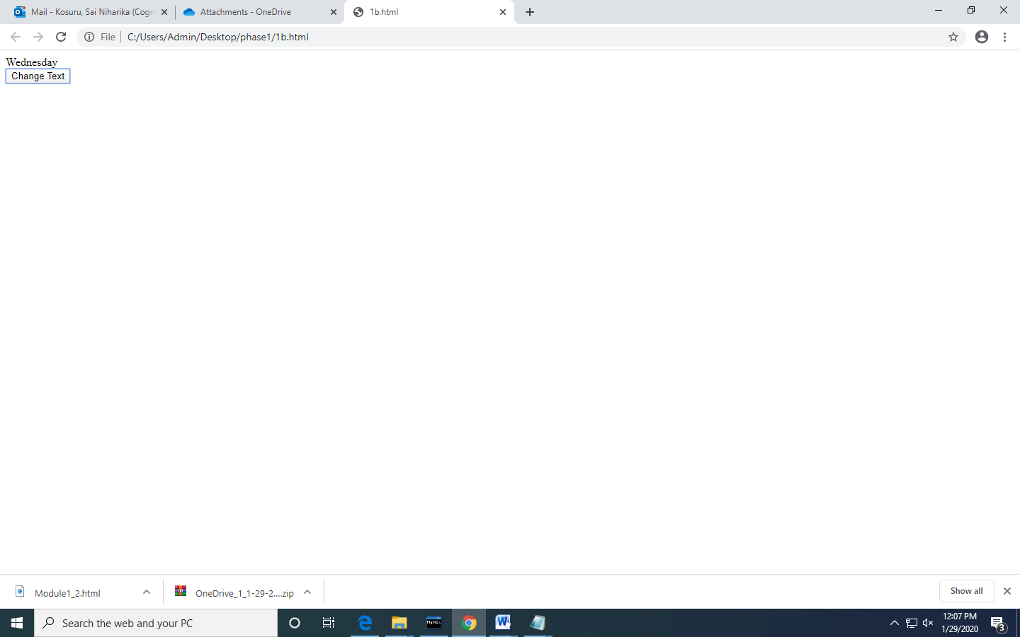

2. a. Create a newHTML-document with an unordered list element, a text-box,and a button that says “Add.”

b. Add JavaScript(and/or jQuery)that appendsa new <li> element to the unordered list when the button is clicked. The text of the new li-element should correspond to the text entered by the user in the text-box. Make sure thatthe content of the text-box is cleared when the button is clicked to be ready for new input from the user.

<!DOCTYPE html>

<html>

<head>

<meta name="viewport" content="width=device-width, initial-scale=1">

</head>

<body>

<div id="myDIV" class="header">

<input type="text" id="myInput" placeholder="Add">

<button onclick="newElement()" class="addBtn">Add</button>

</div>

<ul id="myUL">

</ul>

<script>

var myNodelist = document.getElementsByTagName("LI");

var i;

for (i = 0; i < myNodelist.length; i++) {

var span = document.createElement("SPAN");

var txt = document.createTextNode("\u00D7");

span.className = "close";

span.appendChild(txt);

myNodelist[i].appendChild(span);

}

// Click on a close button to hide the current list item

var close = document.getElementsByClassName("close");

var i;

for (i = 0; i < close.length; i++) {

close[i].onclick = function() {

var div = this.parentElement;

div.style.display = "none";

}

}

// Add a "checked" symbol when clicking on a list item

var list = document.querySelector('ul');

list.addEventListener('click', function(ev) {

if (ev.target.tagName === 'LI') {

ev.target.classList.toggle('checked');

}

}, false);

function newElement() {

var li = document.createElement("li");

var inputValue = document.getElementById("myInput").value;

var t = document.createTextNode(inputValue);

li.appendChild(t);

if (inputValue === '') {

alert("You must write something!");

} else {

document.getElementById("myUL").appendChild(li);

}

document.getElementById("myInput").value = "";

var span = document.createElement("SPAN");

var txt = document.createTextNode("\u00D7");

span.className = "close";

span.appendChild(txt);

li.appendChild(span);

for (i = 0; i < close.length; i++) {

close[i].onclick = function() {

var div = this.parentElement;

div.style.display = "none";

}

}

}

</script>

</body>

</html>

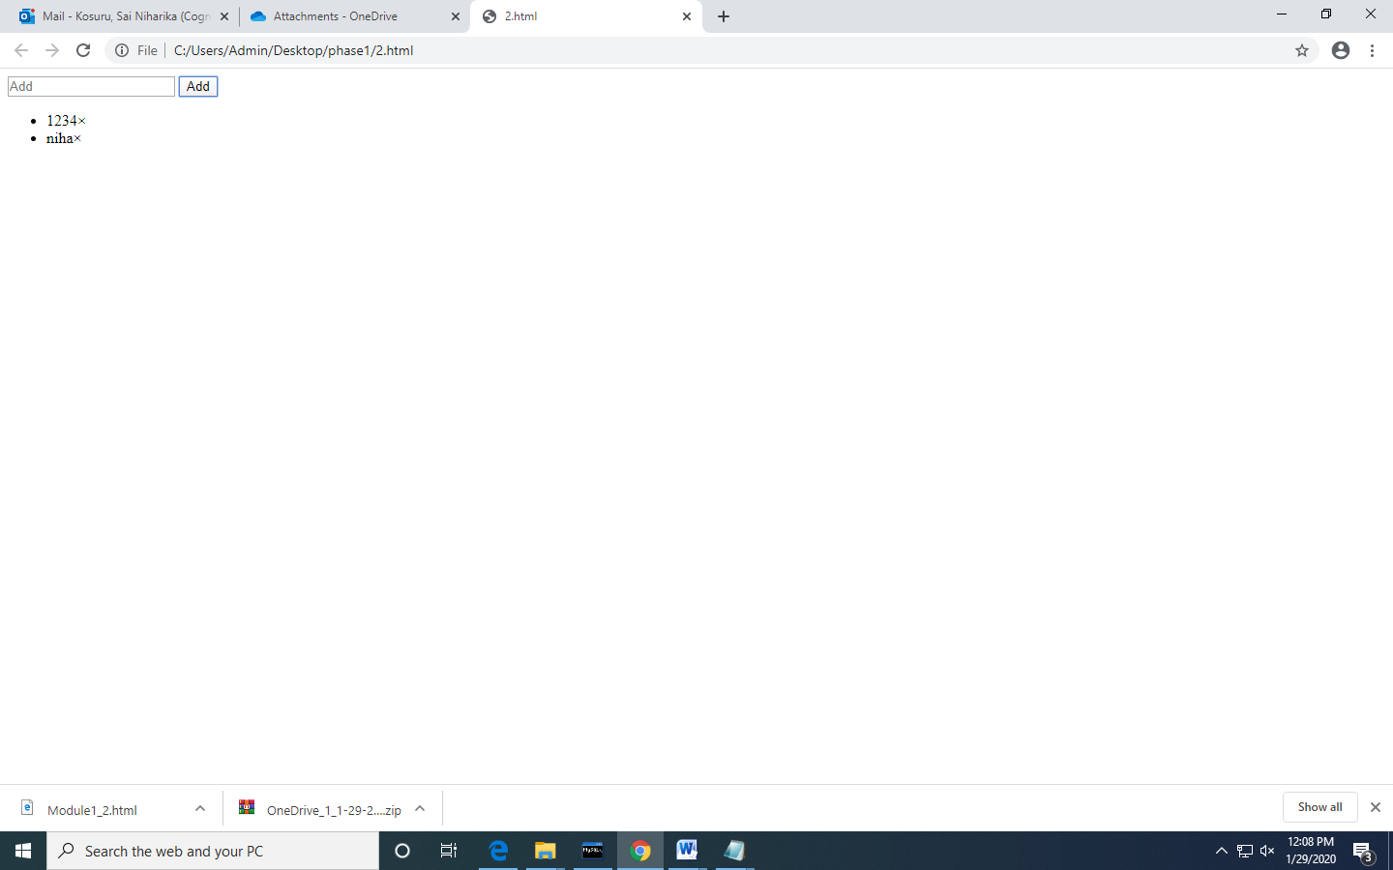

3. Using CSS properties create a calendar with following Calender Template:

<html>

<head>

<style>

* {box-sizing: border-box;}

ul {list-style-type: none;}

body {font-family: Verdana, sans-serif;}

.month {

padding: 5px 25px;

width: 100%;

background: #FFC0CB;

text-align: center;

}

.month ul {

margin: 0;

padding: 0;

}

.month ul li {

color: white;

font-size: 20px;

text-transform: uppercase;

letter-spacing: 3px;

}

.month .prev {

float: left;

padding-top: 10px;

}

.month .next {

float: right;

padding-top: 10px;

}

.weekdays {

margin: 0;

padding: 10px 0;

background-color: #ddd;

}

.weekdays li {

display: inline-block;

width: 13.6%;

color: #666;

text-align: center;

}

.days {

padding: 10px 0;

background: #eee;

margin: 0;

}

.days li {

list-style-type: none;

display: inline-block;

width: 13.6%;

text-align: center;

margin-bottom: 5px;

font-size:12px;

color: #777;

}

.days li .active {

padding: 5px;

background: #FFC0CB;

color: white !important

}

/* Add media queries for smaller screens */

@media screen and (max-width:720px) {

.weekdays li, .days li {width: 13.1%;}

}

@media screen and (max-width: 420px) {

.weekdays li, .days li {width: 12.5%;}

.days li .active {padding: 2px;}

}

@media screen and (max-width: 290px) {

.weekdays li, .days li {width: 12.2%;}

}

</style>

</head>

<body>

<h1>CSS Calendar</h1>

<div class="month">

<ul>

<li class="prev">&#10094;</li>

<li class="next">&#10095;</li>

<li>

MAY<br>

<span style="font-size:18px">2017</span>

</li>

</ul>

</div>

<ul class="weekdays">

<li>Mon</li>

<li>Tue</li>

<li>Wed</li>

<li>Thu</li>

<li>Fri</li>

<li>Sat</li>

<li>Sun</li>

</ul>

<ul class="days">

<li>1</li>

<li>2</li>

<li>3</li>

<li>4</li>

<li>5</li>

<li>6</li>

<li>7</li>

<li>8</li>

<li>9</li>

<li><span class="active">15</span></li>

<li>11</li>

<li>12</li>

<li>13</li>

<li>14</li>

<li>15</li>

<li>16</li>

<li>17</li>

<li>18</li>

<li>19</li>

<li>20</li>

<li>21</li>

<li>22</li>

<li>23</li>

<li>24</li>

<li>25</li>

<li>26</li>

<li>27</li>

<li>28</li>

<li>29</li>

<li>30</li>

<li>31</li>

</ul>

</body>

</html>

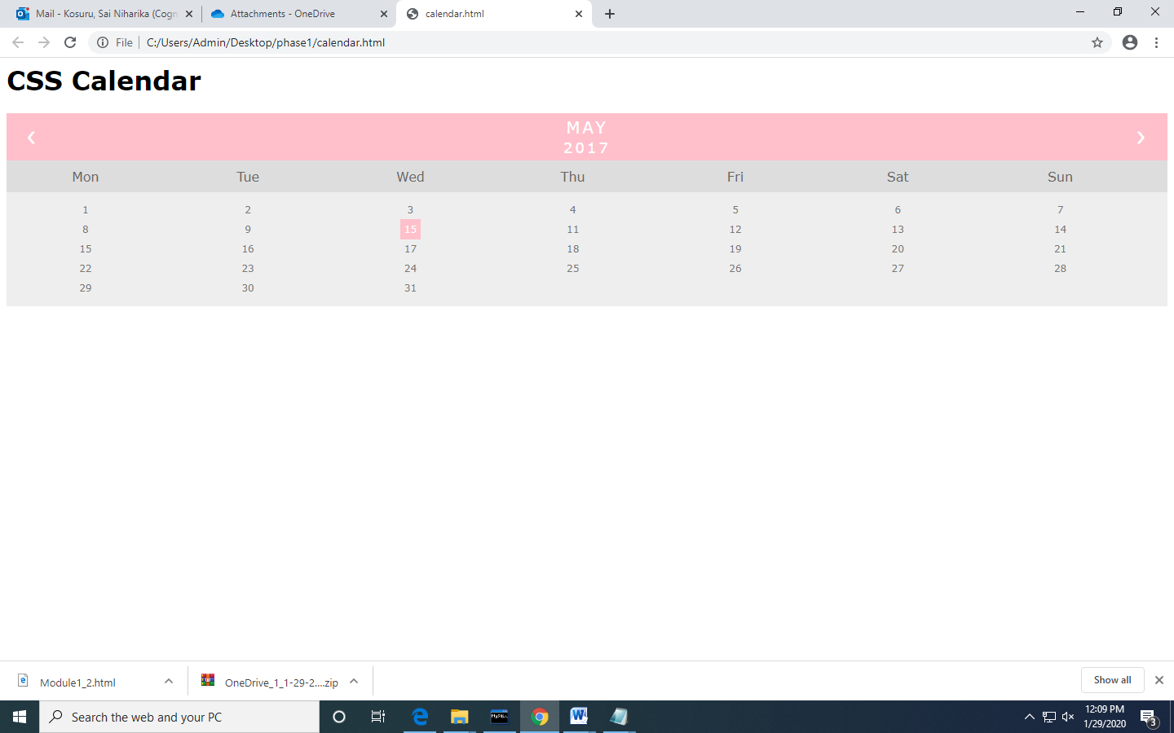

**MODULE 1:java script:**

1. Write a Java Script to find the n prime number.

<!DOCTYPE html>

<html>

<head>

<script>

function nextPrime(value) {

if (value > 2) {

var i, q;

do {

i = 3;

value += 2;

q = Math.floor(Math.sqrt(value));

while (i <= q && value % i) {

i += 2;

}

} while (i <= q);

return value;

}

return value === 2 ? 3 : 2;

}

function generatePrime() {

var userValue = document.getElementById("inputValue").value;

var value = 0, result = [];

for (var i = 0; i < userValue; i++) {

value = nextPrime(value);

result.push(value);

}

document.getElementById("returnValue").innerHTML = result[userValue-1];

}

</script>

</head>

<body>

Input value: <input type="text" name="inputValue" id="inputValue"/>

<button onclick="generatePrime()">Prime number</button>

<div id="returnValue">Test: </div>

</body>

</html>

