Mysql

a. Write a query to display customer number, customer’s firstname , account number where the account status is terminated. Display the records sorted in ascending order based on customer number and then by account number.

mysql> select cm.customer_number,cm.firstname,am.account_number from customer_master cm inner join account_master am on cm.customer_number=am.customer_number where account_status='terminated' group by cm.customer_number order by cm.customer_number,am.account_number;

+-----------------+-----------+----------------+

| customer_number | firstname | account_number |

+-----------------+-----------+----------------+

| C00001 | RAMESH | A00008 |

| C00003 | RAHUL | A00009 |

+-----------------+-----------+----------------+

2 rows in set (0.00 sec)

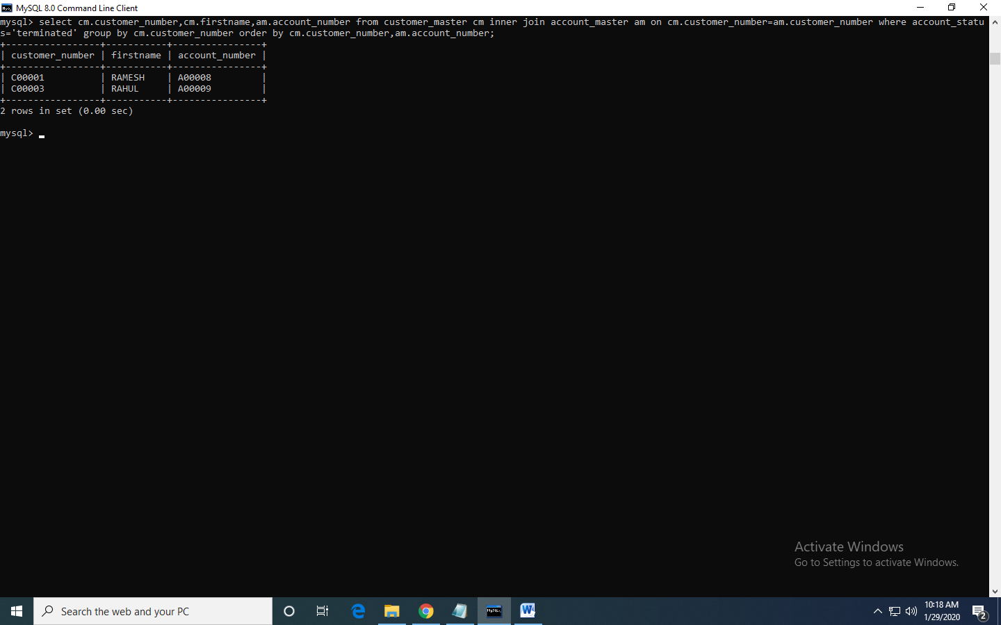

b. Write a query to display the number of accounts opened in each city. The query should display the Branch city and the number of No_of_Accounts for the branch city where we don’t have any accounts opened display 0. Display the records in the sorted order based on branch city.

select bm.branch_city,count(am.account_number)no_of_accounts from branch_master bm inner join account_master am on bm.branch_id=am.branch_id group by bm.branch_city order by bm.branch_city;

+-------------+----------------+

| branch_city | no_of_accounts |

+-------------+----------------+

| DELHI | 6 |

| MUMBAI | 4 |

+-------------+----------------+

2 rows in set (0.00 sec)

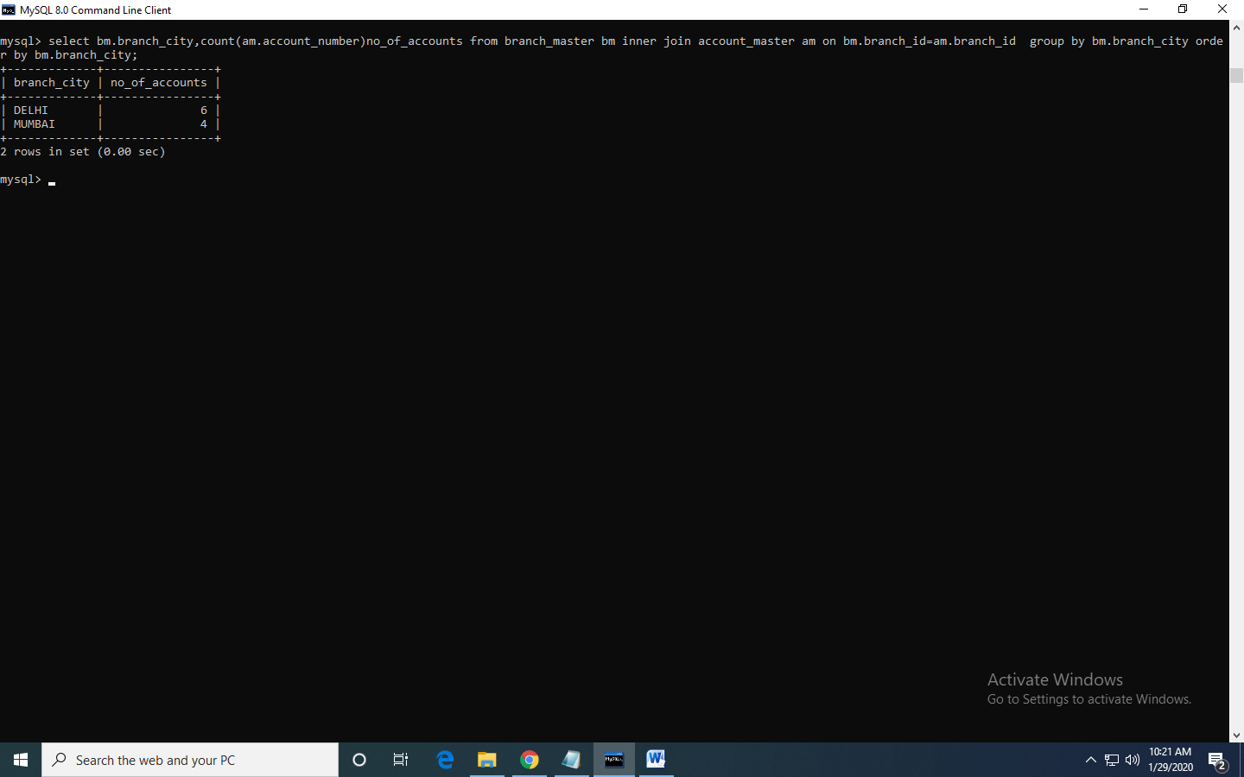

c. Write a query to display the customer number, customer firstname, customer lastname who has taken loan from more than 1 branch. Display the records sorted in order based on customer number.

select cm.customer_number,cm.firstname,cm.lastname from customer_master cm join account_master am on cm.customer_number=am.customer_number join branch_master bm on bm.branch_id=am.branch_id having count(bm.branch_id)>1 order by cm.customer_number;

+-----------------+-----------+----------+

| customer_number | firstname | lastname |

+-----------------+-----------+----------+

| C00001 | RAMESH | SHARMA |

+-----------------+-----------+----------+

1 row in set (0.00 sec)

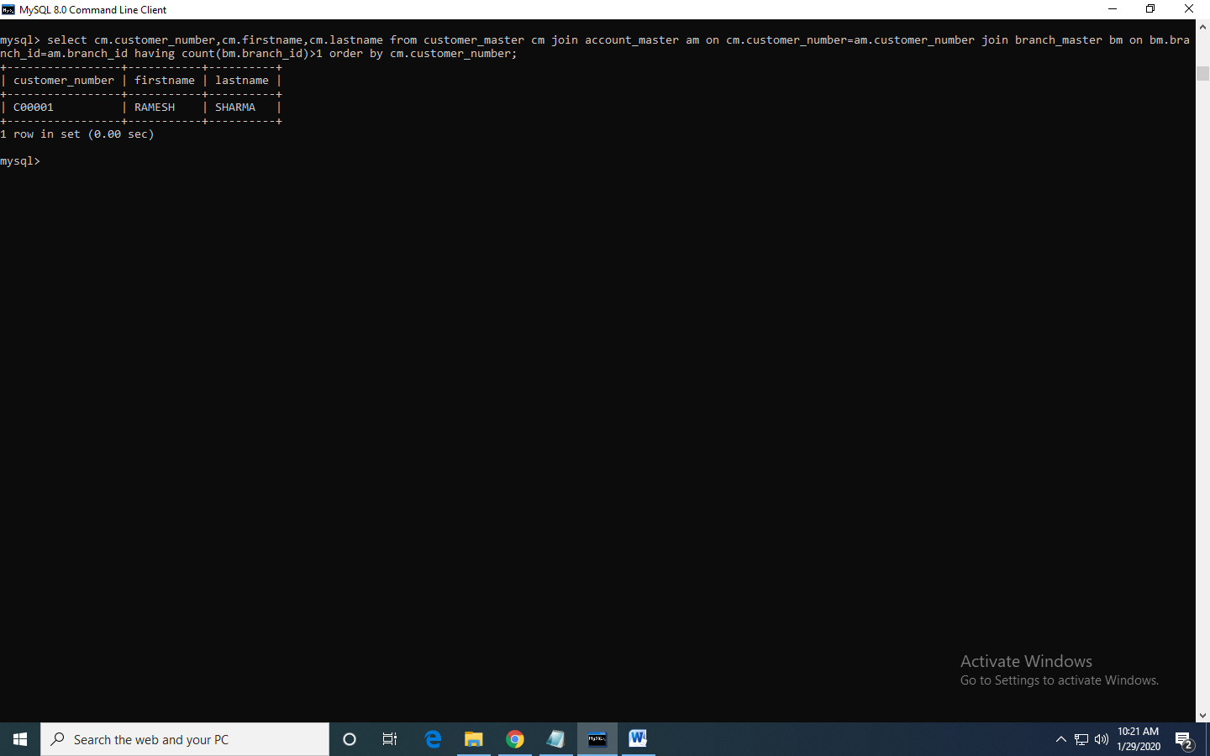

d. Write a query to display the number of clients who have asked for loan but they don’t have any account in the bank though they are registered customers. Give the count an alias name of Count.select count(cm.customer_number)count from customer_master cm inner join loan_details l on cm.customer_number=l.customer_number where cm.customer_number not in(select customer_number from account_master) group by cm.customer_number;

+-------+

| count |

+-------+

| 1 |

| 1 |

+-------+

2 rows in set (0.00 sec)

select count(cm.customer_number)count from customer_master cm inner join loan_details l on cm.customer_number=l.customer_number where cm.customer_number not in(select customer_number from account_master);

+-------+

| count |

+-------+

| 2 |

|  |
| --- |
|  |

e. Write a equerry to display customers firstname, city and account number whose occupation are not business , Services or Student. Display the records sorted in ascending order based on customer firstname and by account number.

select cm.firstname,cm.customer_city,am.account_number from customer_master cm inner join account_master am on cm.customer_number=am.customer_number where occupation not in('service','student') group by cm.firstname order by cm.firstname,am.account_number

+-----------+---------------+----------------+

| firstname | customer_city | account_number |

+-----------+---------------+----------------+

| PARUL | DELHI | A00010 |

+-----------+---------------+----------------+

1 row in set (0.00 sec)

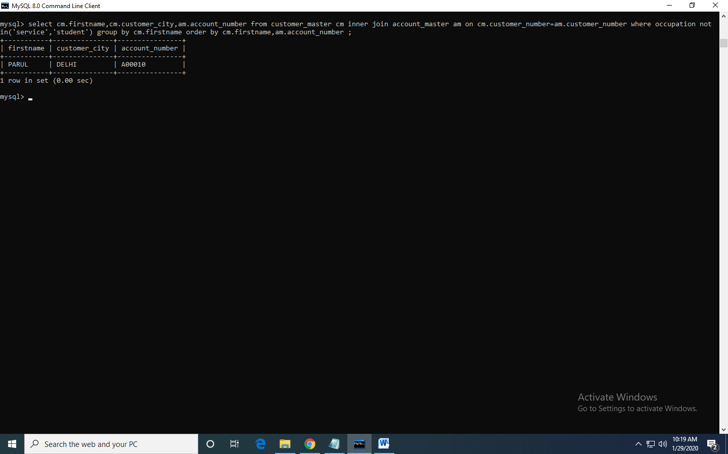

HTML

Calander

<!DOCTYPE html

<html>

<head>

<title>Calander</title>

<style> .tableMain

{

width:650px;

height:450px;

padding:5px;

border-radius: 7px;

background:grey;

border-collapse:collapse;

}

.tdhov1 {

border-top: 2px solid black;

border-left:2px solid black;

border-right: 2px solid black;

text-align: center;

color:#94c3c6;

text-shadow: 1px 1px 5px #C0C0C0;//silver

}

.th1 {

border-bottom: 3px solid black;

}

.th1 {

background:#293038;

font-size:20px;

color:#19b164;

text-shadow: 1px 1px 5px #000000;

}

.thmain {

text-shadow: 1px 1px 5px #000000;

font-size:25px;

color:#94c3c6;

}

.tdhov1:hover {

color:#F08080;//brick red

background:#293038;

text-shadow: 1px 1px 5px #ffffff;

border-radius: 5px;

}

.cbody {

background-image: url('bgi2.jpg');

background-repeat: no-repeat;

background-attachment: fixed;

background-size: cover;

}

</style>

</head>

<body class="cbody">

<table align="center" class="tableMain">

<tr>

<th colspan="7" class="thmain"><font face="Ariel">January 2020</font></th>

</tr>

<tr>

<th class="th1">Su</th>

<th class="th1">Mo</th>

<th class="th1">Tu</th>

<th class="th1">We</th>

<th class="th1">Th</th>

<th class="th1">Fr</th>

<th class="th1">Sa</th>

</tr>

<tr>

<td></td>

<td></td>

<td></td>

<td></td>

<td class="tdhov1">1</td>

<td class="tdhov1">2</td>

<td class="tdhov1">3</td>

</tr>

<tr>

<td class="tdhov1">4</td>

<td class="tdhov1">5</td>

<td class="tdhov1">6</td>

<td class="tdhov1">7</td>

<td class="tdhov1">8</td>

<td class="tdhov1">9</td>

<td class="tdhov1">10</td>

</tr>

<tr>

<td class="tdhov1">11</td>

<td class="tdhov1">12</td>

<td class="tdhov1">13</td>

<td class="tdhov1">14</td>

<td class="tdhov1">15</td>

<td class="tdhov1">16</td>

<td class="tdhov1">17</td>

</tr>

<tr>

<td class="tdhov1">18</td>

<td class="tdhov1">19</td>

<td class="tdhov1">20</td>

<td class="tdhov1">21</td>

<td class="tdhov1">22</td>

<td class="tdhov1">23</td>

<td class="tdhov1">24</td>

</tr>

<tr>

<td class="tdhov1">25</td>

<td class="tdhov1">26</td>

<td class="tdhov1">27</td>

<td class="tdhov1">28</td>

<td class="tdhov1">29</td>

<td class="tdhov1">30</td>

<td class="tdhov1">31</td>

</tr>

</table>

</body>

</html>

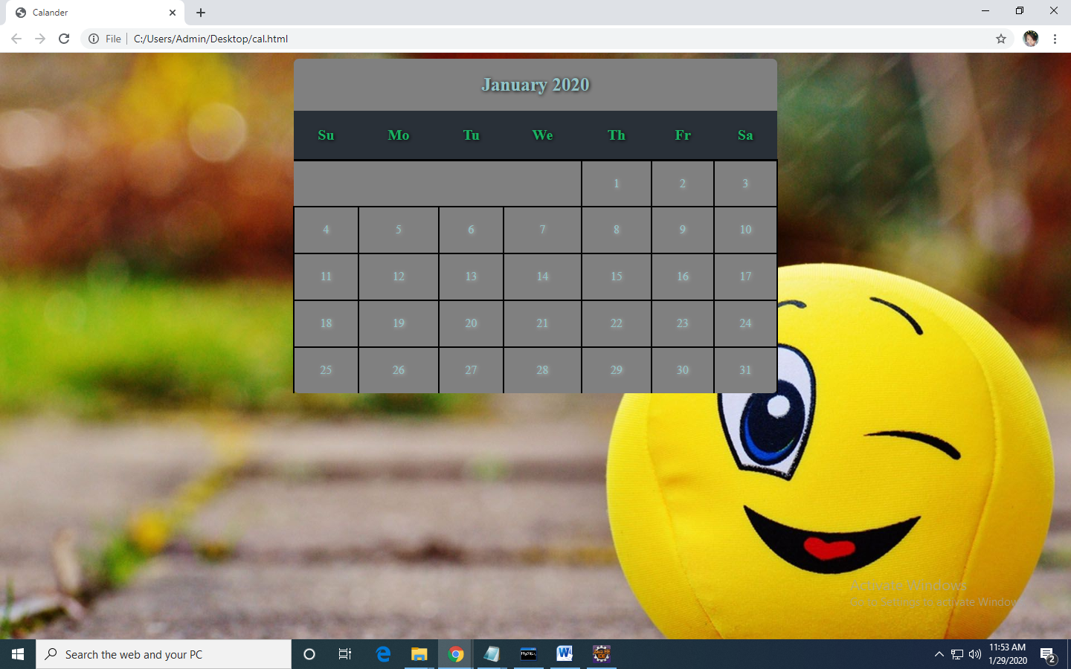

2.BUTTON DEMO

<!DOCTYPE html>

<html>

<head>

<title>HTML BUTTON DEMO</title>

</head>

<body>

<h1>BUTTON DEMO </h1>

<p>MANE JERUSHA NISSI FIRST HTML CSS PROGRAM</p>

<p id="demo"> "Hello! ... Well done! ... Hello! ... Well done! ... Hello! </p>

<button onclick="change_text()">Click me</button>

<script>

function change_text()

{

var text=document.createTextNode("Hello!...well done!...");

var p=document.createElement(p);

var temp=p.appendChild(text);

document.body.appendChild(temp);

}

</script>

</body>

</html>

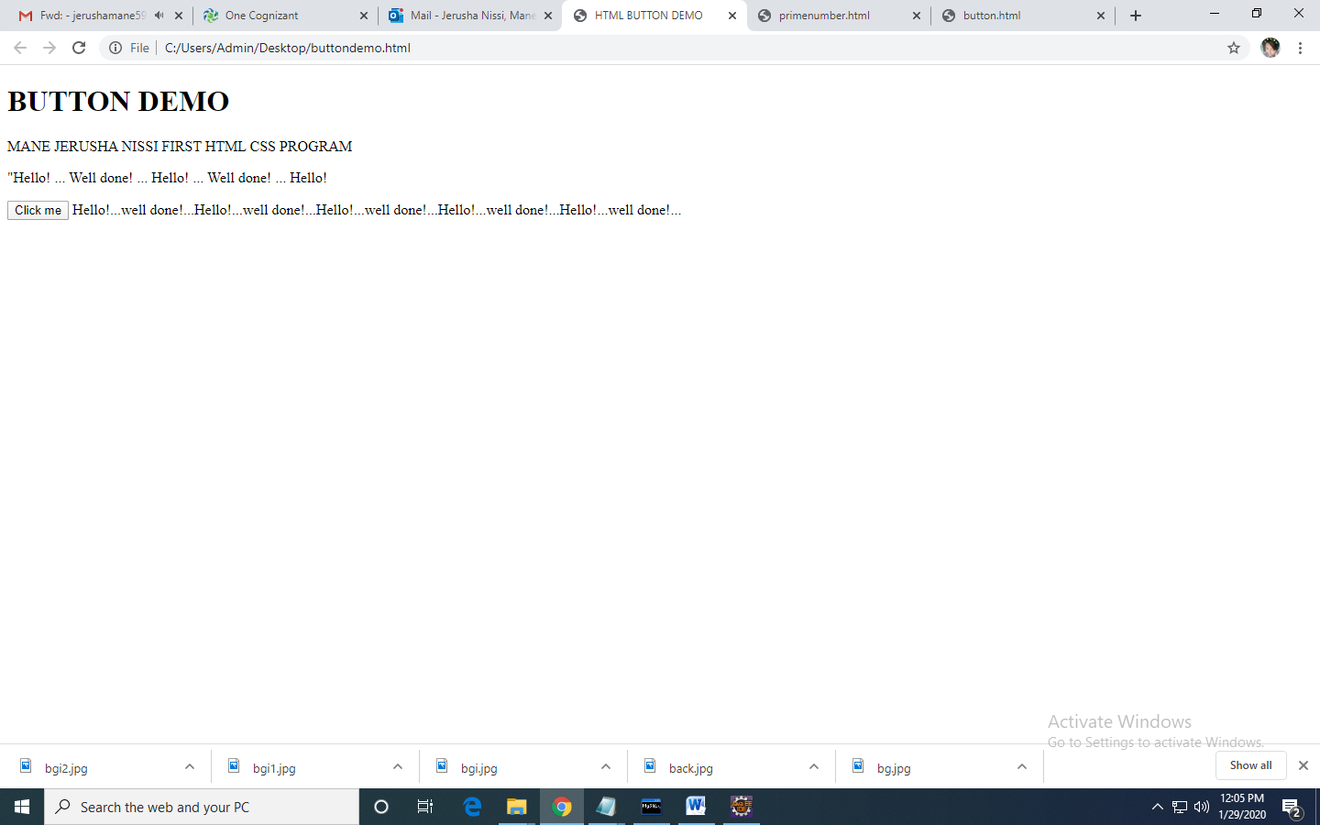

3.prime number

<html>

<head>

<script type="text/javascript">

var num=window.prompt("Enter the number:","");

var n=parseInt(num);

var number=0;

var primenumbers=" ";

for(i=1;i<=n;i++)

{

var count=0;

for(number =i; number>=1; number--)

{

if(i%number==0)

{

count=count+1;

}

}

if(count==2)

{

primenumbers = primenumbers + i + " ";

}

}

document.write(primenumbers);

</script>

</head>

</html>

