1.Write a query to display customer number, cus tomer’s firstname , account number where the account status is terminated. Display the records sorted in ascending order based on customer number and then by account number.

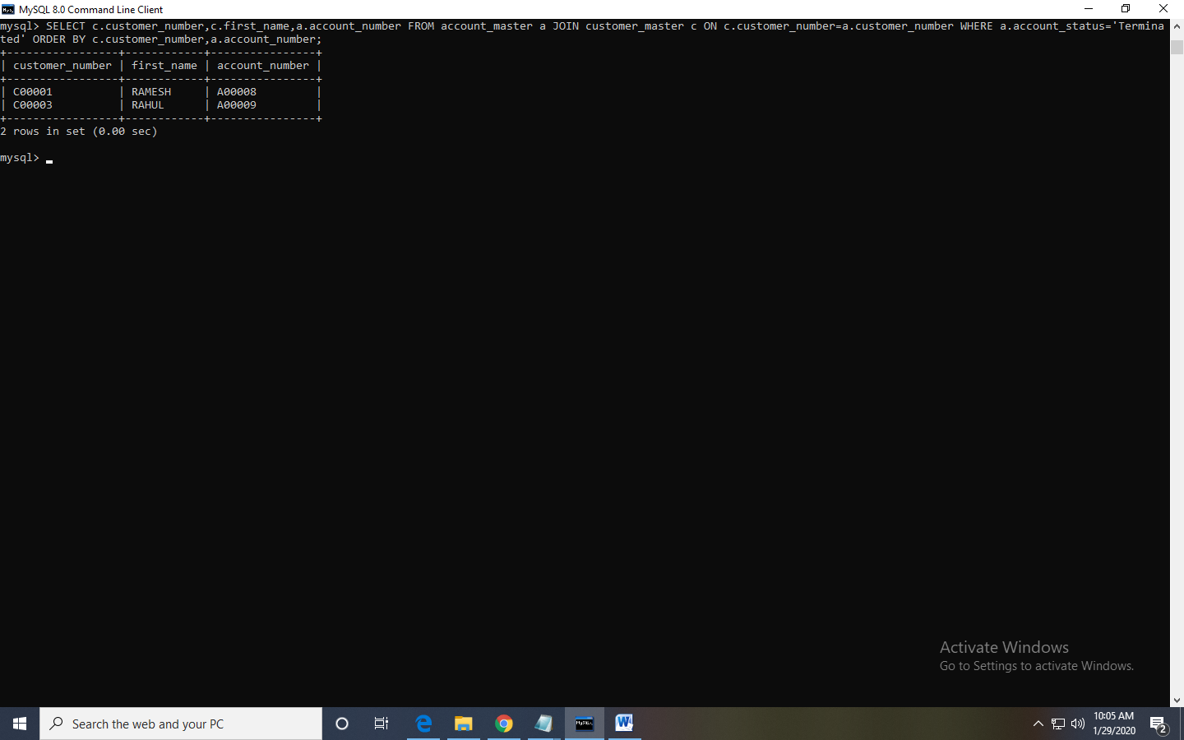

b. Write a query to display the number of accounts opened in each city. The query should display the Branch city and the number of No_of_Accounts for the branch city where we don’t have any accounts opened display 0. Display the records in the sorted order based on branch city.

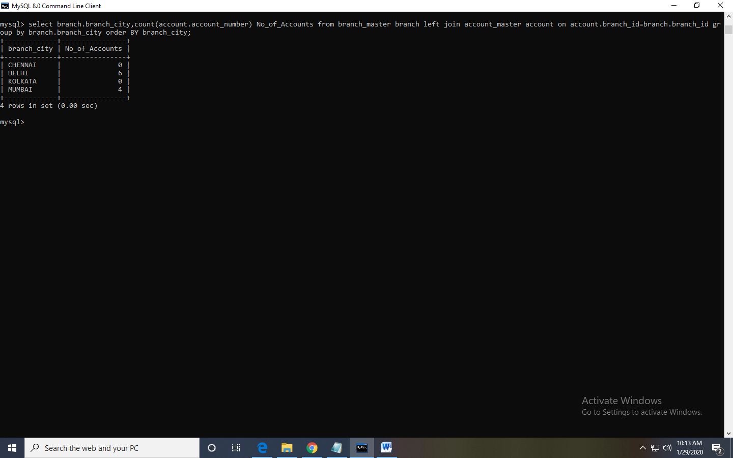

c. Write a query to display the customer number, customer firstname, customer lastname who has taken loan from more than 1 branch. Display the records sorted in order based on customer number.

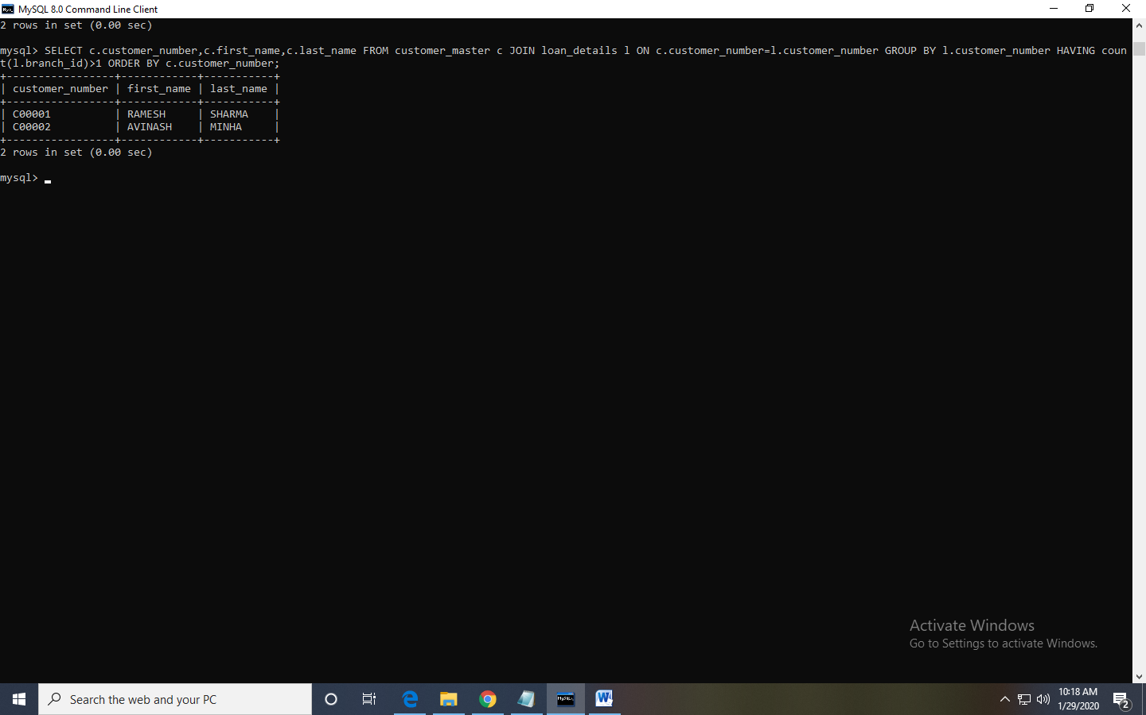

d. Write a query to display the number of clients who have asked for loan but they don’t have any account in the bank though they are registered customers. Give the count an alias name of Count.

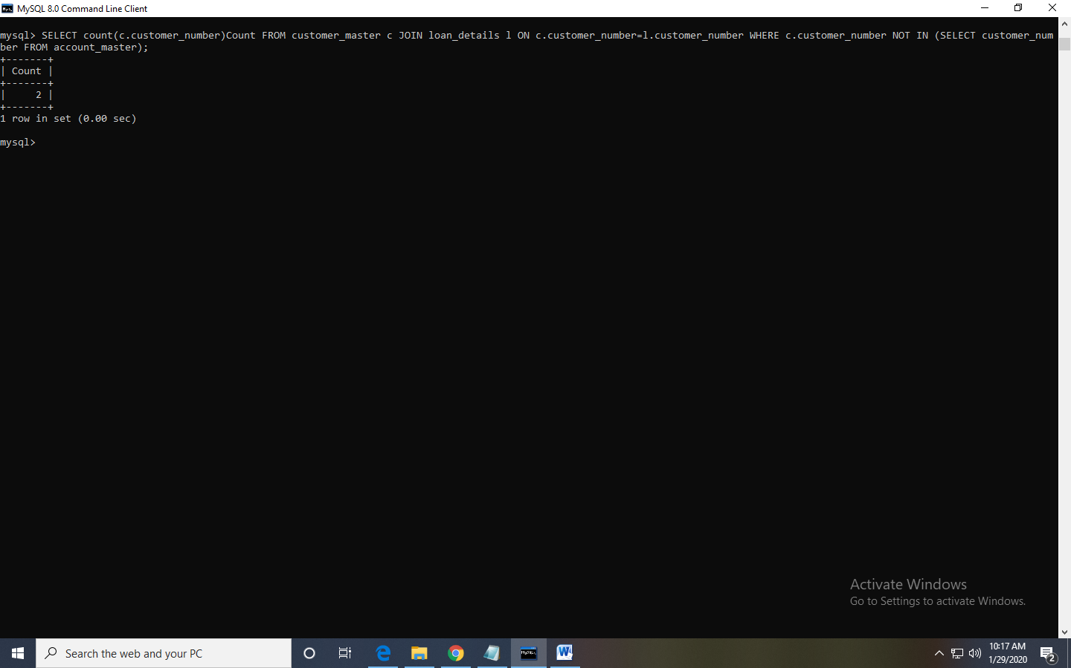

e. Write a equerry to display customers firstname, city and account number whose occupation are not business , Services or Student. Display the records sorted in ascending order based on customer firstname and by account number.

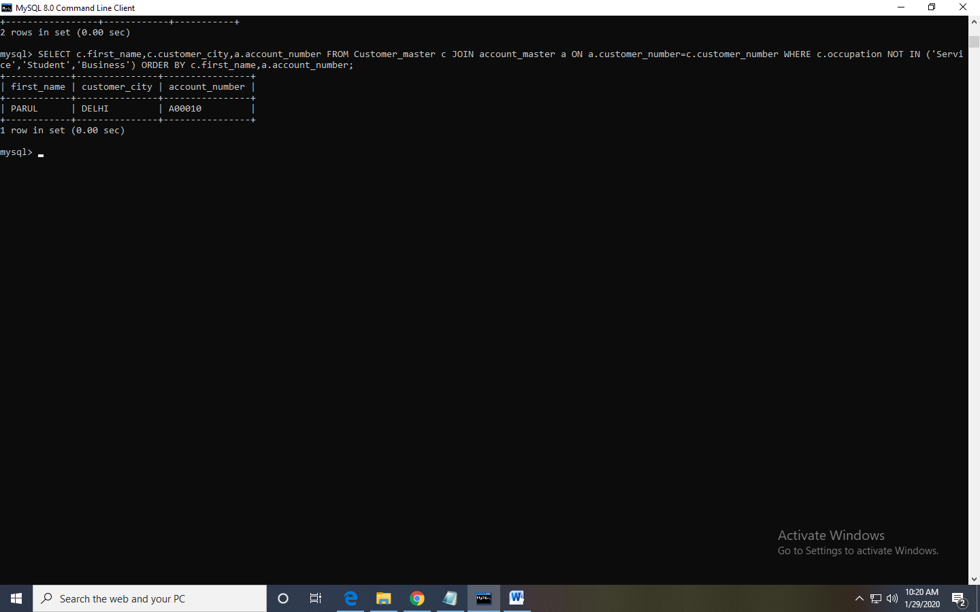

Calendar program

Code-

<!DOCTYPE html>

<html>

<head>

<style>

* {box-sizing: border-box;}

ul {list-style-type: none;}

body {font-family: Verdana, sans-serif;}

.month {

padding: 70px 25px;

width: 100%;

background: grey;

text-align: center;

}

.month ul {

margin: 1

padding: 0;

}

.month ul li {

color: white;

font-size: 30px;

text-transform: uppercase;

letter-spacing: 3px;

}

.month .prev {

float: left;

padding-top: 10px;

}

.month .next {

float: right;

padding-top: 10px;

}

.weekdays {

margin: 0;

padding: 10px 0;

background-color: pink;

}

.weekdays li {

display: inline-block;

width: 13.6%;

color: green;

text-align: center;

}

.days {

padding: 10px 0;

background: lightblue;

margin: 0;

}

.days li {

list-style-type: none;

display: inline-block;

width: 13.6%;

text-align: center;

margin-bottom: 5px;

font-size:12px;

color: blue;

}

.days li .active {

padding: 5px;

background: #1abc9c;

color: white !important

}

</style>

</head>

<body>

<div class="month">

<ul>

<li>

December<br>

<span style="font-size:18px">2020</span>

</li>

</ul>

</div>

<ul class="weekdays">

<li>Mo</li>

<li>Tu</li>

<li>We</li>

<li>Th</li>

<li>Fr</li>

<li>Sa</li>

<li>Su</li>

</ul>

<ul class="days">

<li>1</li>

<li>2</li>

<li>3</li>

<li>4</li>

<li>5</li>

<li>6</li>

<li>7</li>

<li>8</li>

<li>9</li>

<li><span class="active">10</span</li>

<li>11</li>

<li>12</li>

<li>13</li>

<li>14</li>

<li></li>

<li>16</li>

<li>17</li>

<li>18</li>

<li>19</li>

<li>20</li>

<li>21</li>

<li>22</li>

<li>23</li>

<li>24</li>

<li>25</li>

<li>26</li>

<li>27</li>

<li>28</li>

<li>29</li>

<li>30>/li>

<li>31</li>

</ul>

</body>

</html>

Output-

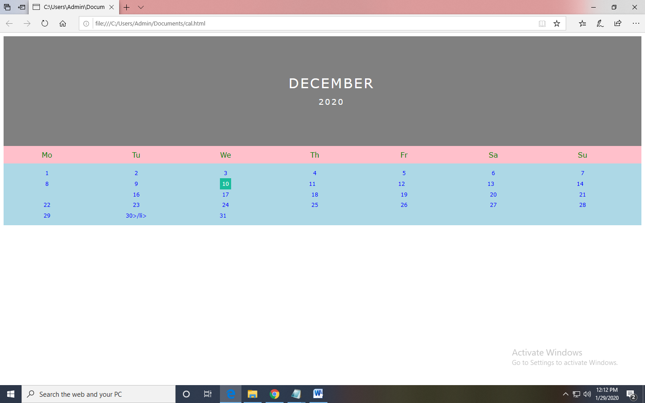

Guess game---

<!DOCTYPE html>

<html>

<head>

<meta charset="utf-8">

<title>Number Guessing Game</title>

<style>

html {

font-family: sans-serif;

}

body {

width: 50%;

max-width: 800px;

min-width: 480px;

margin: 0 auto;

}

</style>

</head>

<body>

<h1>Guess The Number</h1>

<p>We have selected a random number between 1 - 10.

See if you can guess it.</p>

<div class="form">

<label for="guessField">Enter a guess: </label>

<input type = "text" id = "guessField" class = "guessField">

<input type = "submit" value = "Submit guess"

class = "guessSubmit" id = "submitguess">

</div>

<script type = "text/javascript">

// random value generated

var y = Math.floor(Math.random() * 10 + 1);

// counting the number of guesses

// made for correct Guess

var guess = 1;

document.getElementById("submitguess").onclick = function(){

// number guessed by user

var x = document.getElementById("guessField").value;

if(x == y)

{

alert("CONGRATULATIONS!!! YOU GUESSED IT RIGHT IN "

+ guess + " GUESS ");

}

else if(x > y) /* if guessed number is greater

than actual number*/

{

guess++;

alert(" SORRY!! TRY A SMALLER NUMBER");

}

else

{

guess++;

alert(" SORRY!! TRY A GREATER NUMBER")

}

}

</script>

</body>

</html>

Output-

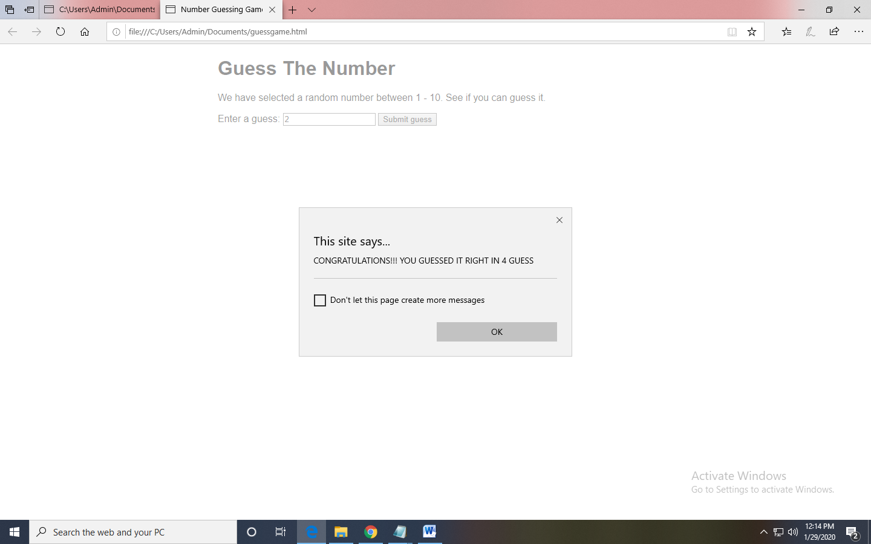

Day change in java script—

<html>

<head>

</head>

<p><button onclick="change_text()">Change Day</button></p>

<div id="myDIV">Monday</div>

<script>

function change_text() {

var x = document.getElementById("myDIV");

if (x.innerHTML === "Monday") {

x.innerHTML = "Tuesday";

} else if(x.innerHTML === "Tuesday"){

x.innerHTML = "Wednesday";

}

else if(x.innerHTML === "Wednesday"){

x.innerHTML = "Thursday";

}

else if(x.innerHTML === "Thursday"){

x.innerHTML = "Friday";

}

else if(x.innerHTML === "Friday"){

x.innerHTML = "Saturday";

}

else if(x.innerHTML === "Saturday"){

x.innerHTML = "Sunday";

}

else{

x.innerHTML = "Monday";

}

}

</script>

</body>

Output:

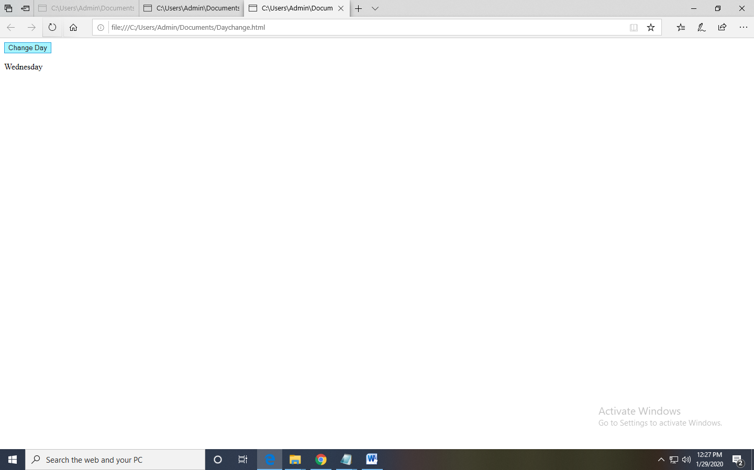

Prime number in javascript-

<!DOCTYPE html>

<html>

<head>

<script>

function nextPrime(value) {

if (value > 2) {

var i, q;

do {

i = 3;

value += 2;

q = Math.floor(Math.sqrt(value));

while (i <= q && value % i) {

i += 2;

}

} while (i <= q);

return value;

}

return value === 2 ? 3 : 2;

}

function generatePrime() {

var userValue = document.getElementById("inputValue").value;

var value = 0, result = [];

for (var i = 0; i < userValue; i++) {

value = nextPrime(value);

result.push(value);

}

document.getElementById("returnValue").innerHTML = result[userValue-1];

}

</script>

</head>

<body>

Input value: <input type="text" name="inputValue" id="inputValue"/>

<button onclick="generatePrime()">Prime number</button>

<div id="returnValue">Test: </div>

</body>

</html>

Outpu:

