Module 2

2. body >

<p id="demo"></p>

<script>

function isPrime(num) {

for ( var i = 2; i < num; i++ ) {

if ( num % i === 0 ) {

return false;

}

}

return true;

}

function display(n) {

var arr = [2];

for ( var i = 3; i < n; i+=2 ) {

if ( isPrime(i) ) {

arr.push(i);

}

}

console.log(arr); // use arr result on your own

}

var x = prompt("enter your number");

document.getElementById("demo").innerHTML =+x;

display(x);

</script>

<body>

</html>

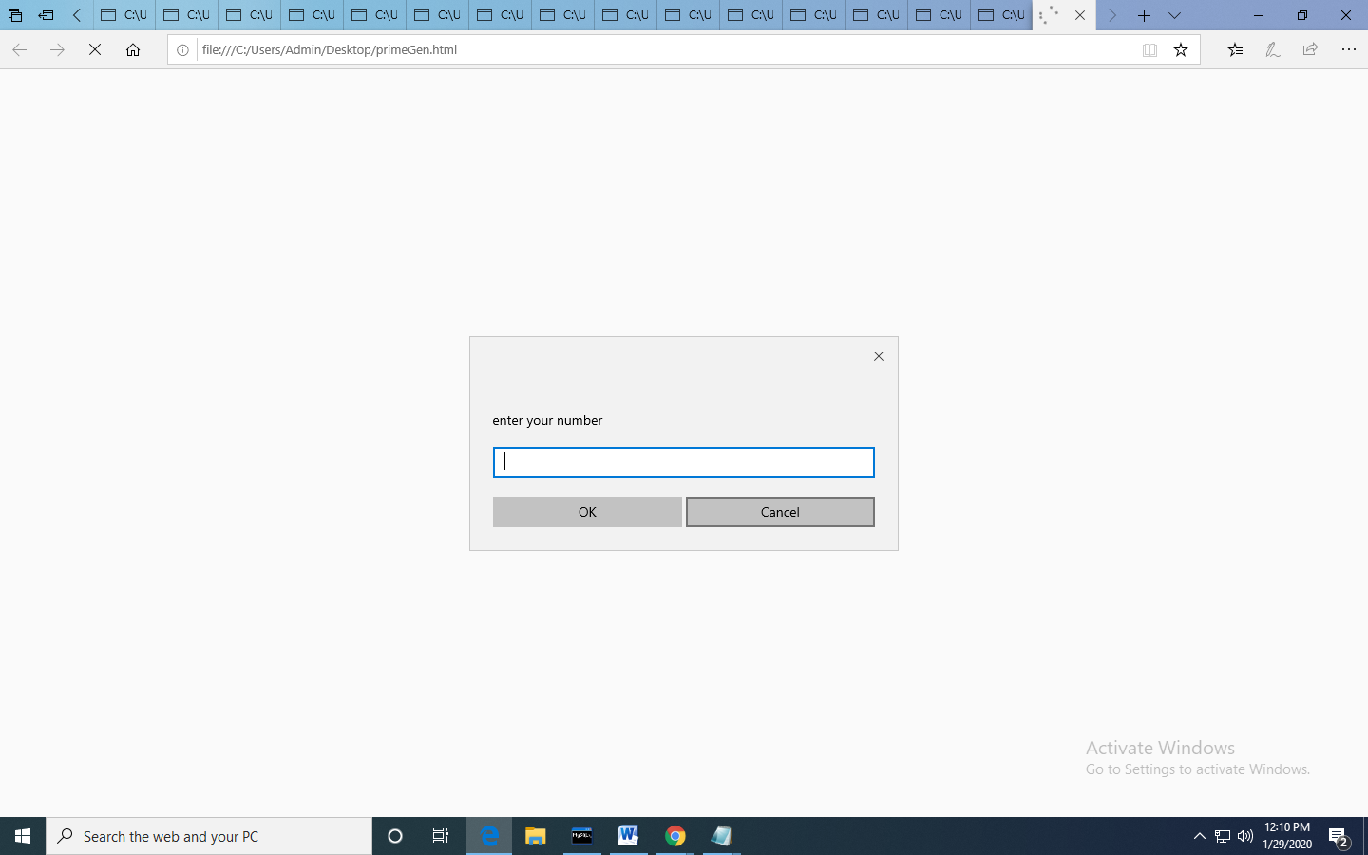

4.

a. SELECT c.customer_number,c.FIRSTNAME,a.account_number from account_master a JOIN customer_master c ON a.customer_number=c.customer_number WHERE a.account_status='TERMINATED' ORDER BY a.customer_number, a.account_number;

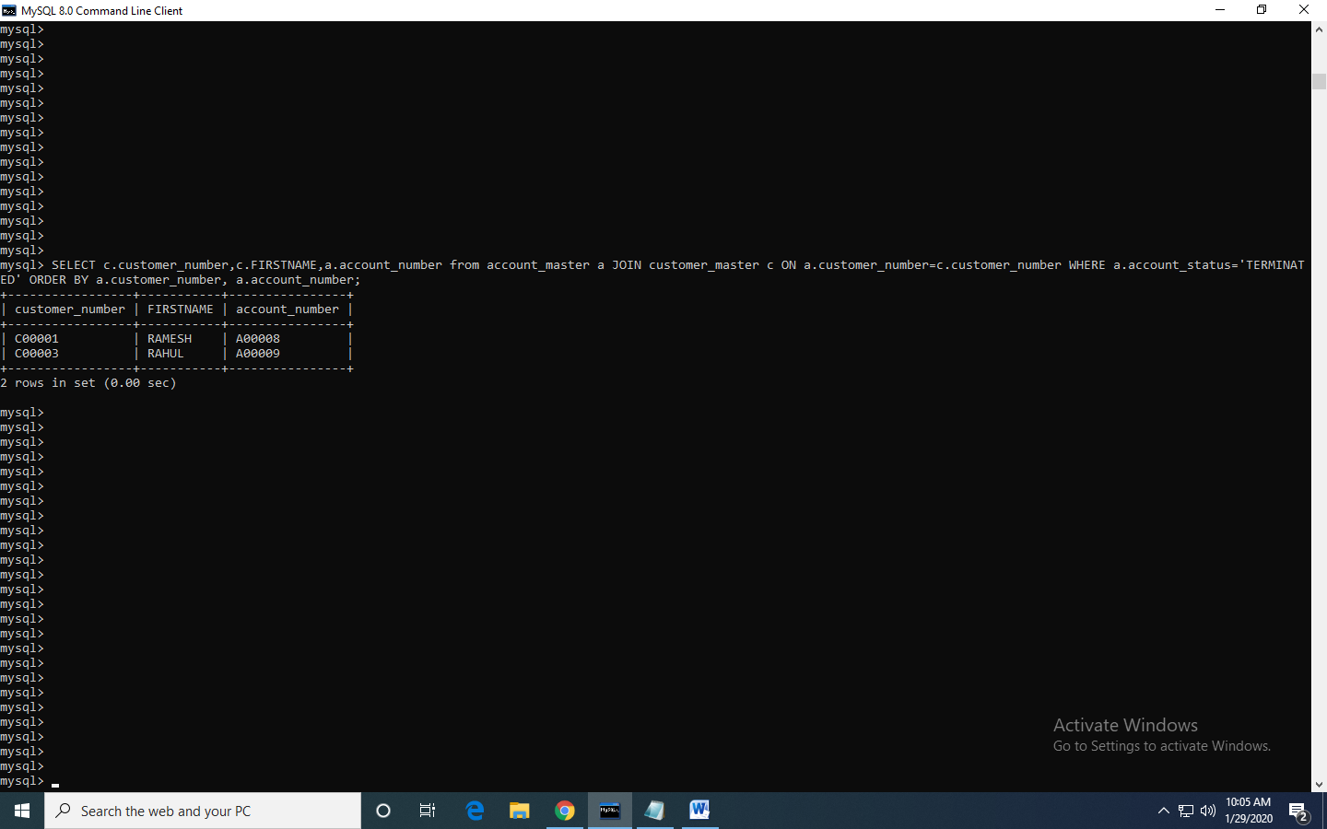

b. SELECT branch.branch_city, count(account.account_number) No_of_Accounts FROM branch_master branch LEFT JOIN account_master account ON account.branch_id=branch.branch_id GROUP BY branch.branch_city ORDER BY branch_city;

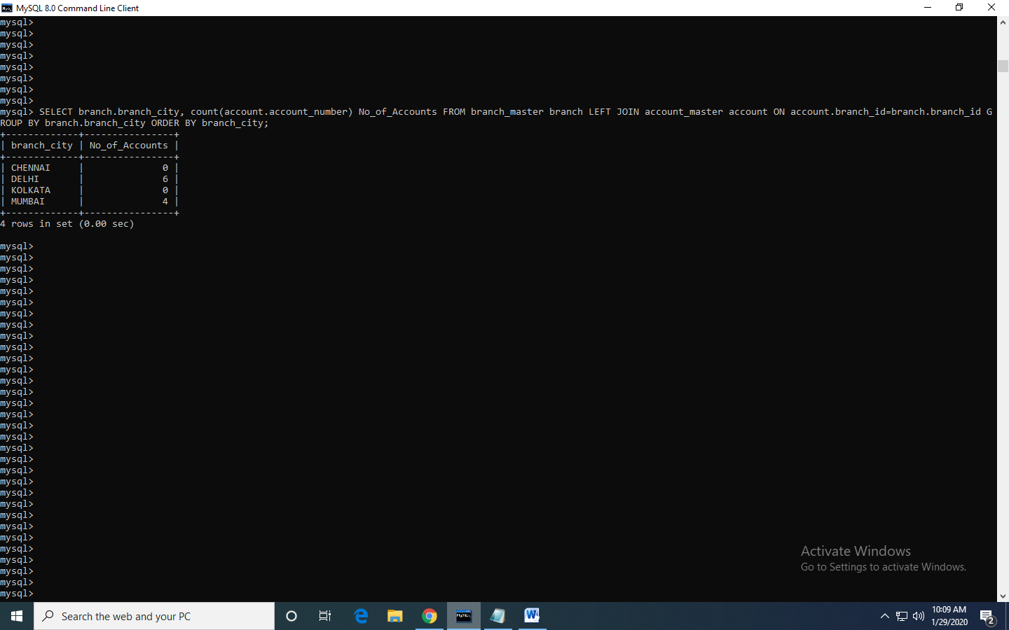

c. SELECT c.customer_number,c.firstname,c.lastname FROM customer_master c JOIN loan_details l ON c.customer_number=l.customer_number GROUP BY l.customer_number HAVING count(l.branch_id)>1 ORDER BY c.customer_number;

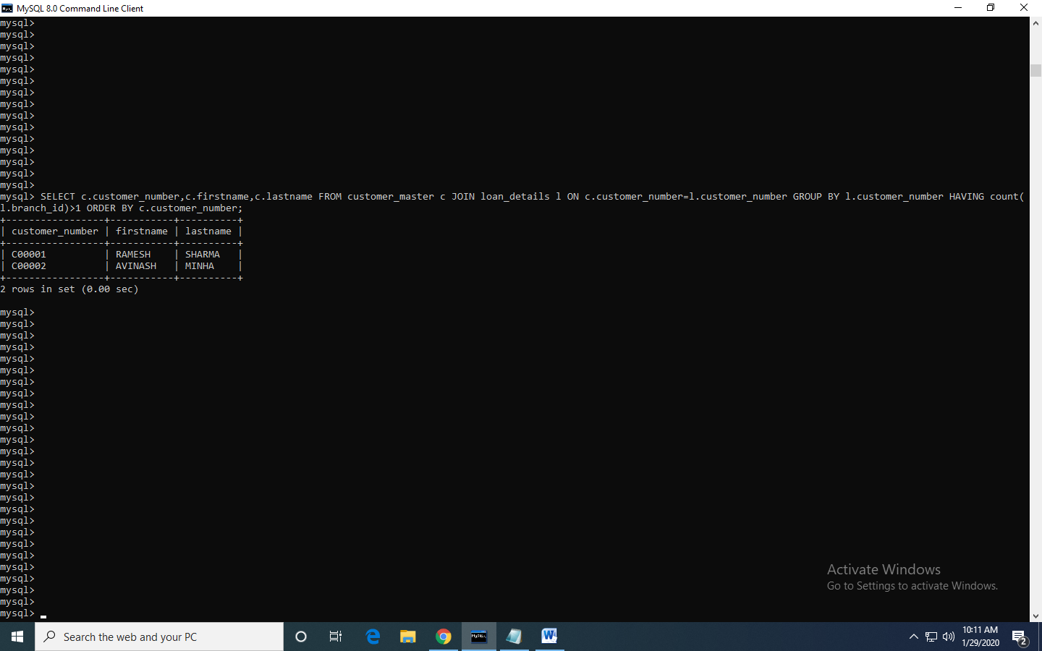

d. SELECT count(c.customer_number) Count FROM customer_master c JOIN loan_details l ON c.customer_number=l.customer_number WHERE c.customer_number NOT IN (SELECT customer_number FROM account_master);

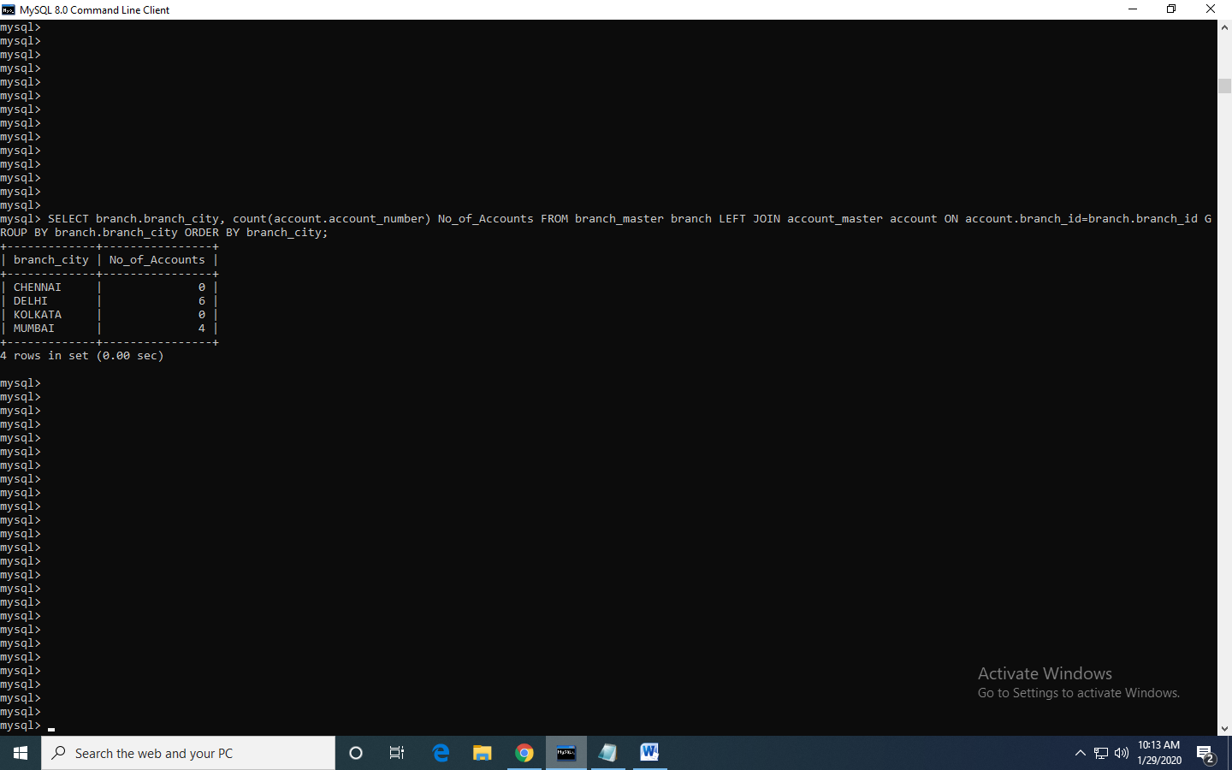

e. SELECT c.firstname,c.customer_city,a.account_number FROM customer_master c JOIN account_master a ON c.customer_number=a.customer_number where c.occupation!='business' and c.occupation!='service' and c.occupation!='student' ORDER BY c.FIRSTNAME,a.account_number;

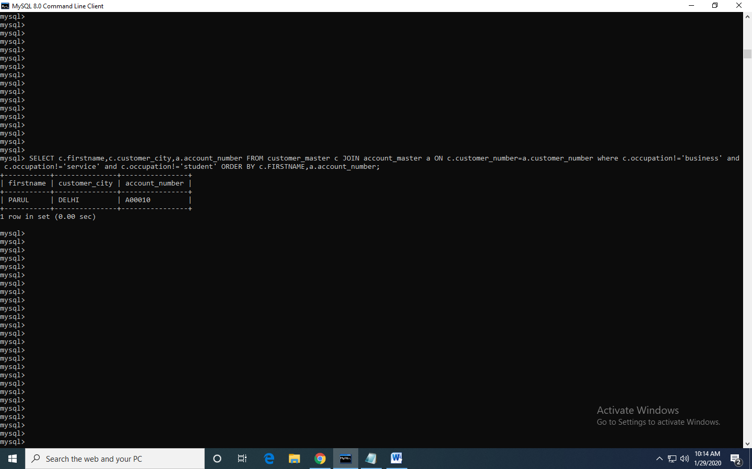

MODULE-1

1.a) <html>

<body>

<p><button onclick="myFunction()">Click Me</button></p>

<div id="myDIV">Hello</div>

<script>

function myFunction() {

var x = document.getElementById("myDIV");

if (x.innerHTML === "Hello") {

x.innerHTML = "Well Done!";

} else {

x.innerHTML = "Hello";

}

}

</script>

</body>

</html>

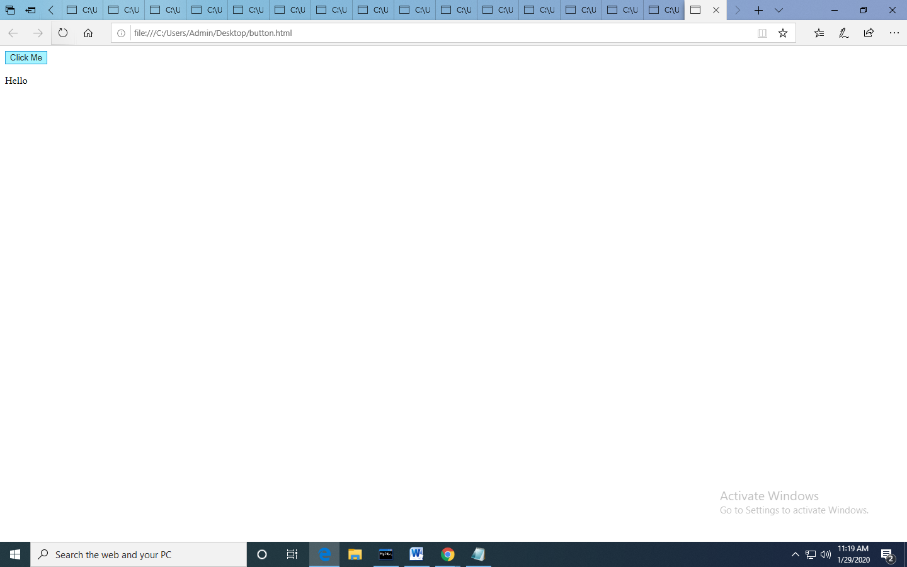

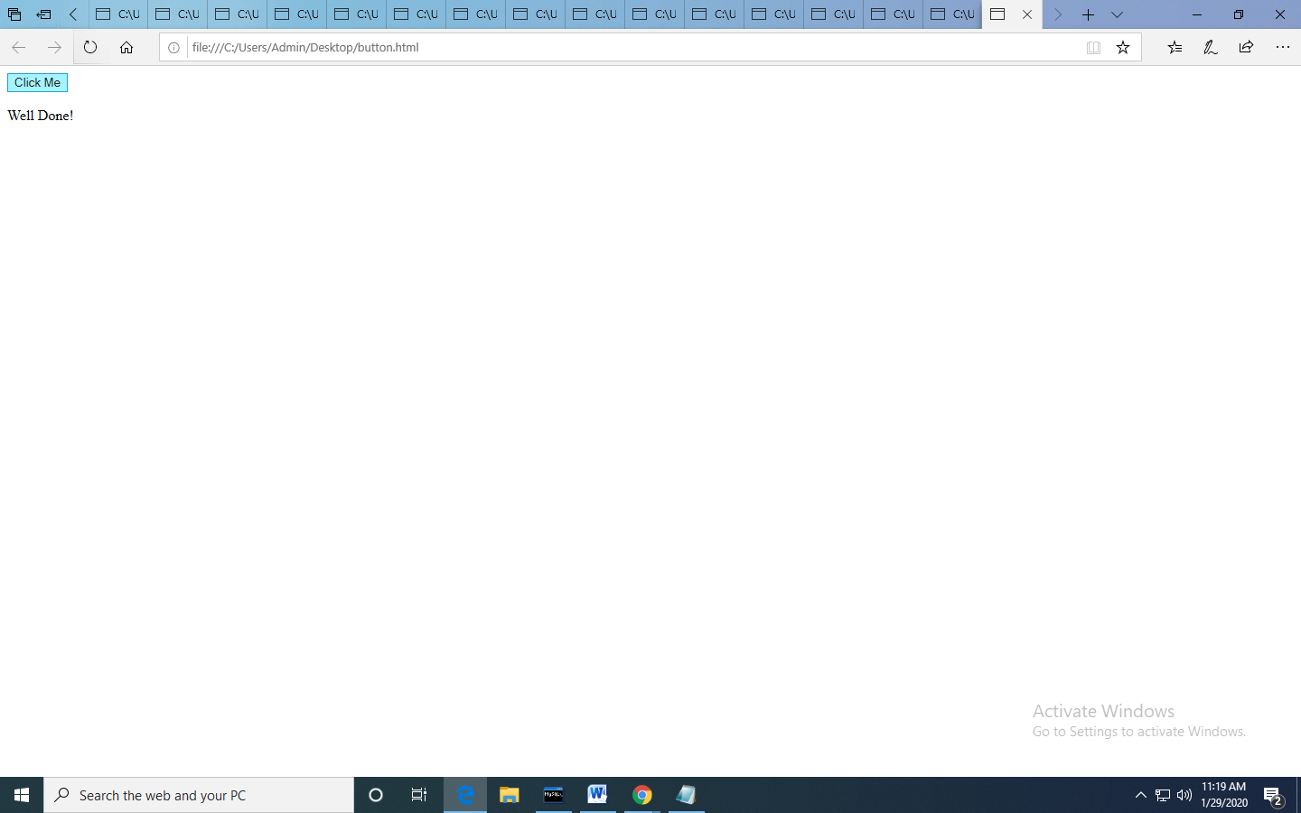

3. <html>

<head>

<style>

* {box-sizing: border-box;}

ul {list-style-type: none;}

body {font-family: Verdana, sans-serif;}

.month {

padding: 30px 25px;

width: 100%;

background: #1abc9c;

text-align: center;

}

.month ul {

margin: 0;

padding: 0;

}

.month ul li {

color: white;

font-size: 20px;

text-transform: uppercase;

letter-spacing: 3px;

}

.month .prev {

float: left;

padding-top: 10px;

}

.month .next {

float: right;

padding-top: 10px;

}

.weekdays {

margin: 0;

padding: 10px 0;

background-color: #ddd;

}

.weekdays li {

display: inline-block;

width: 13.6%;

color: #666;

text-align: center;

}

.days {

padding: 10px 0;

background: #eee;

margin: 0;

}

.days li {

list-style-type: none;

display: inline-block;

width: 13.6%;

text-align: center;

margin-bottom: 5px;

font-size:12px;

color: #777;

}

.days li .active {

padding: 5px;

background: #1abc9c;

color: white !important

}

/* Add media queries for smaller screens */

@media screen and (max-width:720px) {

.weekdays li, .days li {width: 13.1%;}

}

@media screen and (max-width: 420px) {

.weekdays li, .days li {width: 12.5%;}

.days li .active {padding: 2px;}

}

@media screen and (max-width: 290px) {

.weekdays li, .days li {width: 12.2%;}

}

</style>

</head>

<body>

<h1>CSS Calendar</h1>

<div class="month">

<ul>

<li class="prev">&#10094;</li>

<li class="next">&#10095;</li>

<li>

August<br>

<span style="font-size:18px">2017</span>

</li>

</ul>

</div>

<ul class="weekdays">

<li>Mo</li>

<li>Tu</li>

<li>We</li>

<li>Th</li>

<li>Fr</li>

<li>Sa</li>

<li>Su</li>

</ul>

<ul class="days">

<li>1</li>

<li>2</li>

<li>3</li>

<li>4</li>

<li>5</li>

<li>6</li>

<li>7</li>

<li>8</li>

<li>9</li>

<li><span class="active">10</span></li>

<li>11</li>

<li>12</li>

<li>13</li>

<li>14</li>

<li>15</li>

<li>16</li>

<li>17</li>

<li>18</li>

<li>19</li>

<li>20</li>

<li>21</li>

<li>22</li>

<li>23</li>

<li>24</li>

<li>25</li>

<li>26</li>

<li>27</li>

<li>28</li>

<li>29</li>

<li>30</li>

<li>31</li>

</ul>

</body>

</html>

