1. Write a query to display customer number, customer’s firstname , account number where the account status is terminated. Display the records sorted in ascending order based on customer number and then by account number.

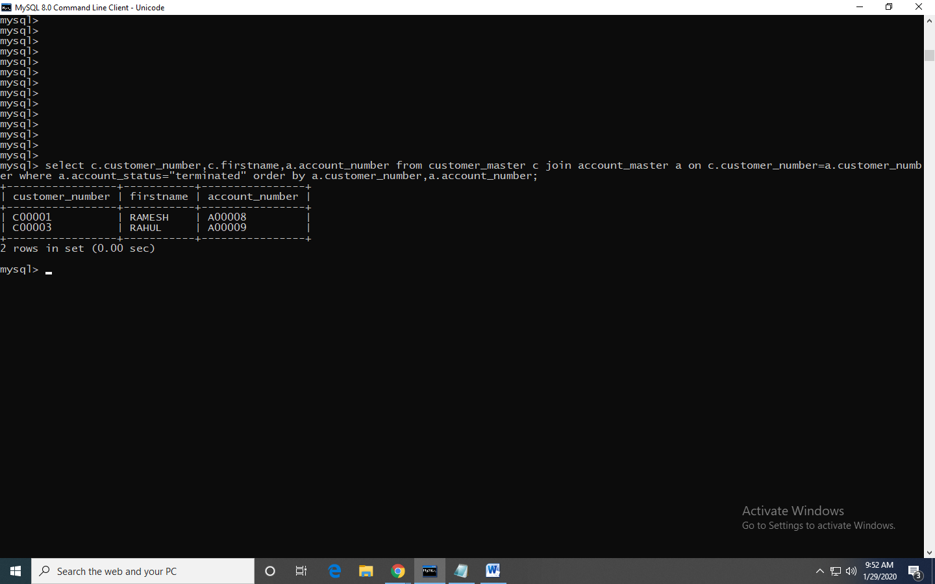

1. Write a query to display the number of accounts opened in each city. The query should display the Branch city and the number of No_of_Accounts for the branch city where we don’t have any accounts opened display 0. Display the records in the sorted order based on branch city.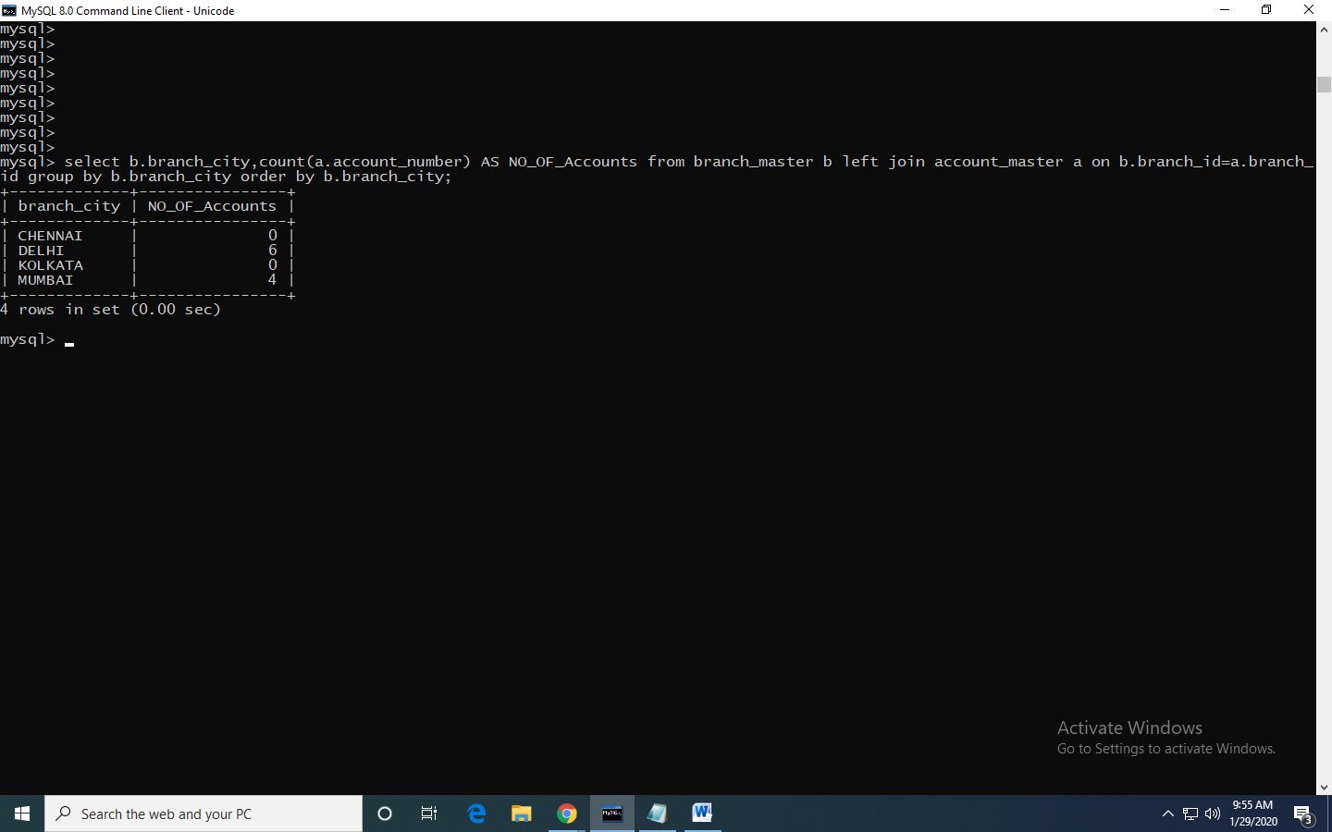
2. Write a query to display the customer number, customer firstname, customer lastname who has taken loan from more than 1 branch. Display the records sorted in order based on customer number.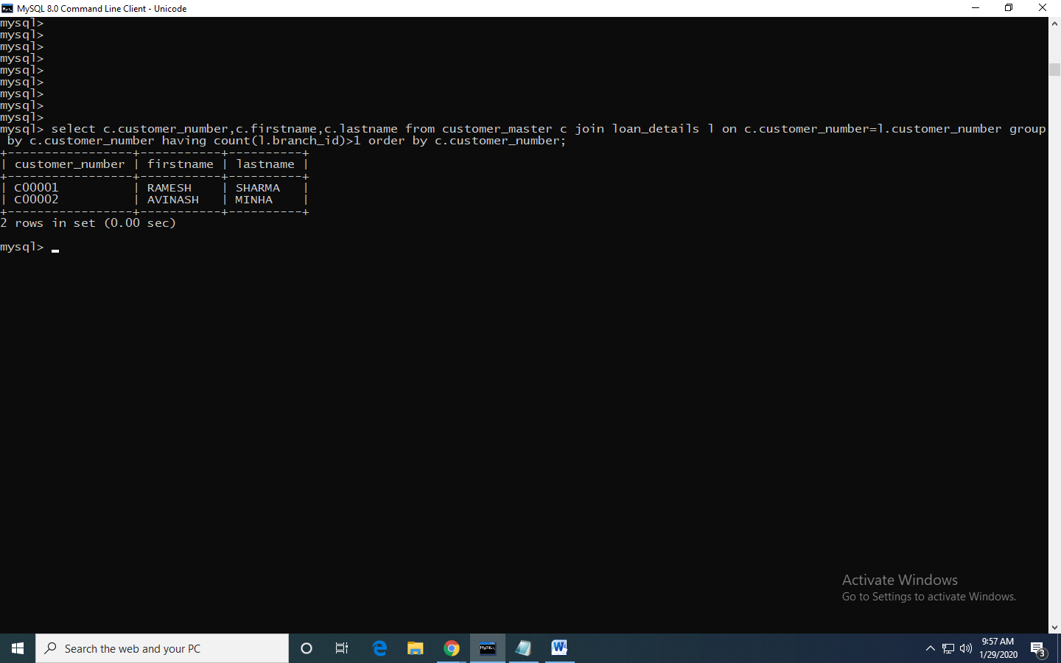
3. Write a query to display the number of clients who have asked for loan but they don’t have any account in the bank though they are registered customers. Give the count an alias name of Count.

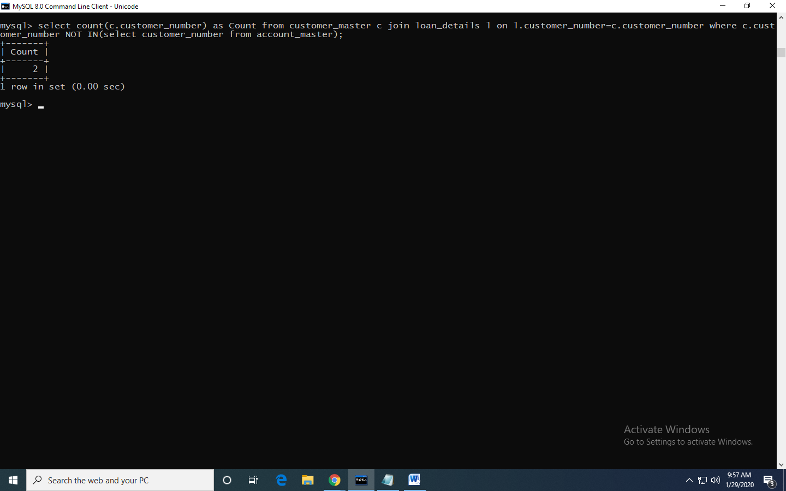

e. Write a equerry to display customers firstname, city and account number whose occupation are not business , Services or Student. Display the records sorted in ascending order based on customer firstname and by account number.

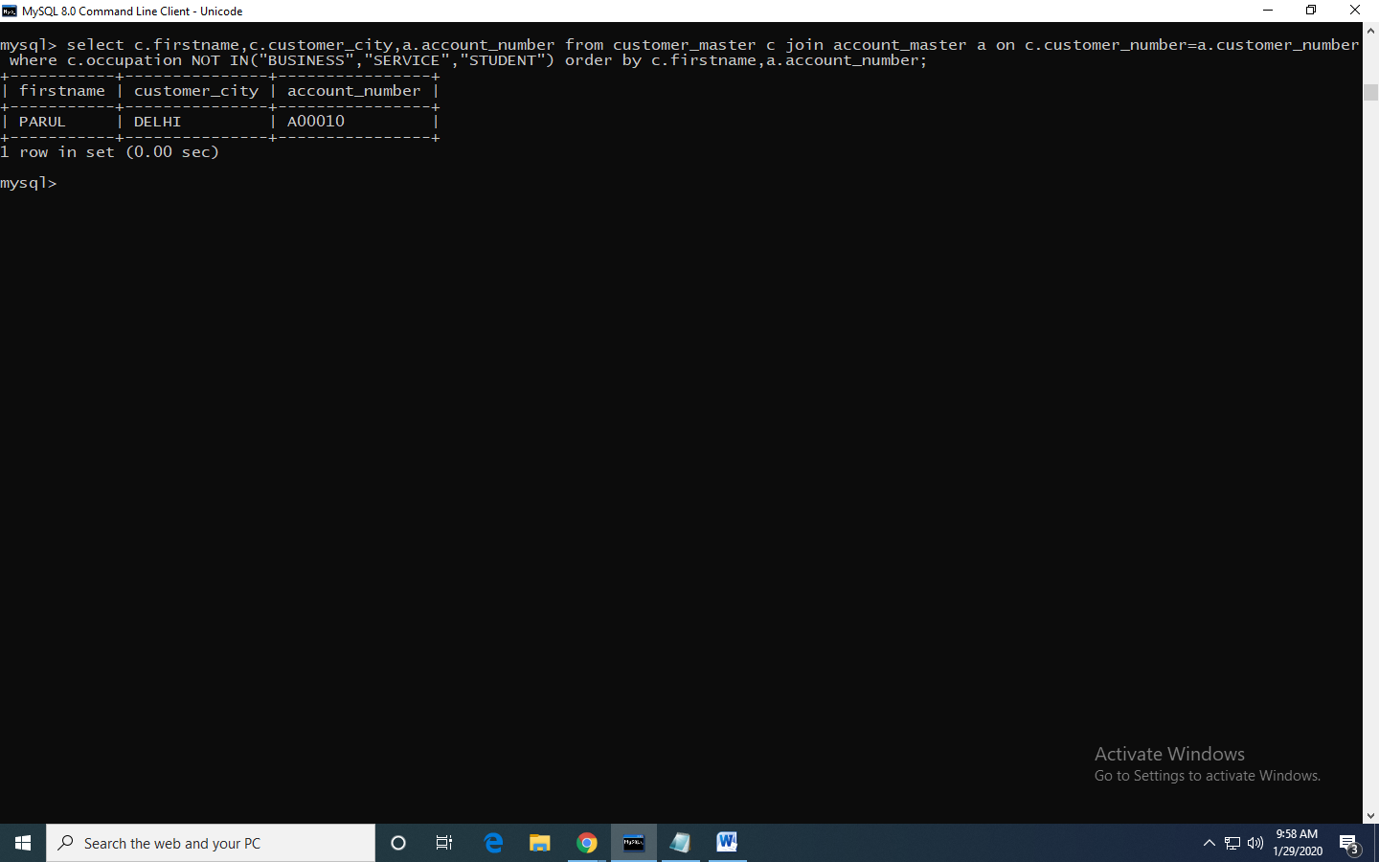

3.Using CSS properties create a calendar with following Calender Template:

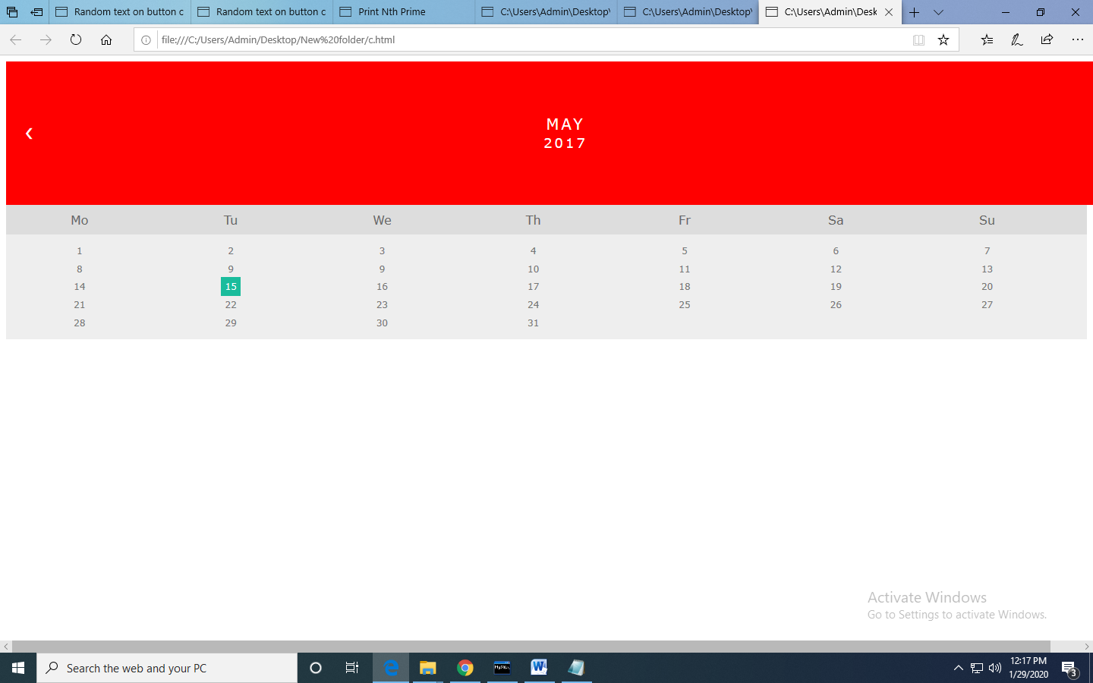

<!doctype html>

<html>

<head>

<link rel="stylesheet" type="text/css" href="style.css">

</head>

<div class="month">

<ul>

<li class="prev">&#10094;</li>

<li class="next">&#10095;</li>

<li>May<br><span style="font-size:18px">2017</span></li>

</ul>

</div>

<ul class="weekdays">

<li>Mo</li>

<li>Tu</li>

<li>We</li>

<li>Th</li>

<li>Fr</li>

<li>Sa</li>

<li>Su</li>

</ul>

<ul class="days">

<li>1</li>

<li>2</li>

<li>3</li>

<li>4</li>

<li>5</li>

<li>6</li>

<li>7</li>

<li>8</li>

<li>9</li>

<li>9</li>

<li>10</li>

<li>11</li>

<li>12</li>

<li>13</li>

<li>14</li>

<li><span class="active">15</span></li>

<li>16</li>

<li>17</li>

<li>18</li>

<li>19</li>

<li>20</li>

<li>21</li>

<li>22</li>

<li>23</li>

<li>24</li>

<li>25</li>

<li>26</li>

<li>27</li>

<li>28</li>

<li>29</li>

<li>30</li>

<li>31</li>

</ul>

<html>

-------------------------------------------------------------

ul {list-style-type: none;}

body {font-family: Verdana, sans-serif;}

/* Month header */

.month {

padding: 70px 25px;

width: 100%;

background: #FF0000;

text-align: center;

}

/* Month list */

.month ul {

margin: 0;

padding: 0;

}

.month ul li {

color: white;

font-size: 20px;

text-transform: uppercase;

letter-spacing: 3px;

}

/* Previous button inside month header */

.month .prev {

float: left;

padding-top: 10px;

}

/* Next button */

.month .next {

float: right;

padding-top: 10px;

}

/* Weekdays (Mon-Sun) */

.weekdays {

margin: 0;

padding: 10px 0;

background-color:#ddd;

}

.weekdays li {

display: inline-block;

width: 13.6%;

color: #666;

text-align: center;

}

/* Days (1-31) */

.days {

padding: 10px 0;

background: #eee;

margin: 0;

}

.days li {

list-style-type: none;

display: inline-block;

width: 13.6%;

text-align: center;

margin-bottom: 5px;

font-size:12px;

color: #777;

}

/* Highlight the "current" day */

.days li .active {

padding: 5px;

background: #1abc9c;

color: white !important

}

(a) Create a html web page that contains a button with which it is possible to change the text that is shown on the screen. The file ButtonDemo.html has a JavaScript function named change_text() which is called after the button is pressed. When the button is pressed repeatedly the text changes Hello! ... Well done! ... Hello! ... Well done! ... Hello! ..

<!DOCTYPE html>

<html lang="en">

<head>

<title>Random text on button click</title>

</head>

<body>

<p id="de">&nbsp;</p>

<button id="button">Press</button>

<script>

function rndEl(){

return arr[~~(rnd()*arr.length)];

}

function rndTx(){

var tx = rndEl();

var txt = document.createTextNode(tx);

var sp = document.createElement('span');

sp.appendChild(txt);

de.innerHTML = '';

de.appendChild(sp).style.color = tx;

}

rnd = Math.random;

arr = ['Hello!', 'WellDone!'];

de = document.getElementById('de');

document.getElementById("button").addEventListener('click',rndTx,false);

</script>

</body>

</html>

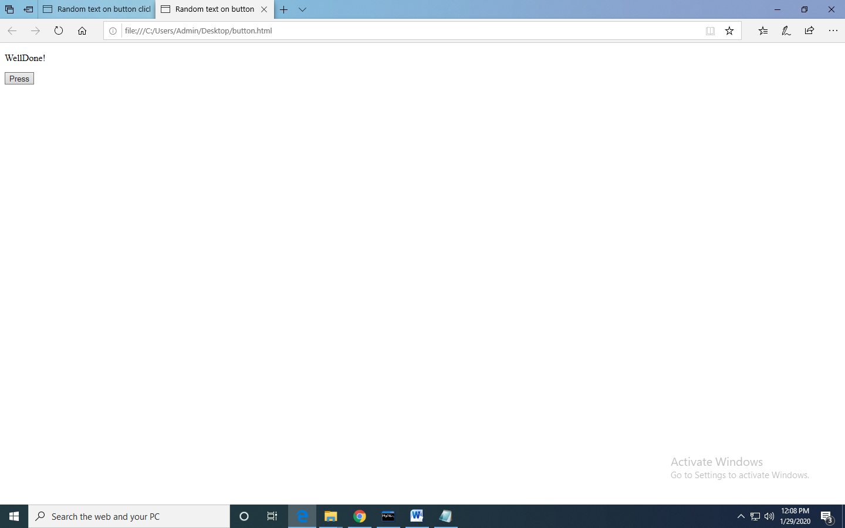

(b) Modify the program so that the initial text shown on the screen is "Monday", and it will change in the following way when the button is

pressed repeatedly: Monday ... Tuesday ... Wednesday ... Thursday ... Friday ... Saturday ... Sunday ... Monday ... Tuesday ... etc. You should also change the button text so that there is written "Change day" on the button.

<!DOCTYPE html>

<html lang="en">

<head>

<title>Random text on button click</title>

</head>

<body>

<p id="de">&nbsp;</p>

<button id="button">Change Day</button>

<script>

function rndEl(){

return arr[~~(rnd()*arr.length)];

}

function rndTx(){

var tx = rndEl();

var txt = document.createTextNode(tx);

var sp = document.createElement('span');

sp.appendChild(txt);

de.innerHTML = '';

de.appendChild(sp).style.color = tx;

}

rnd = Math.random;

arr = ['Monday', 'Tuesday','Wednesday','Thursday','Friday','Saturday','Sunday'];

de = document.getElementById('de');

document.getElementById("button").addEventListener('click',rndTx,false);

</script>

</body>

</html>

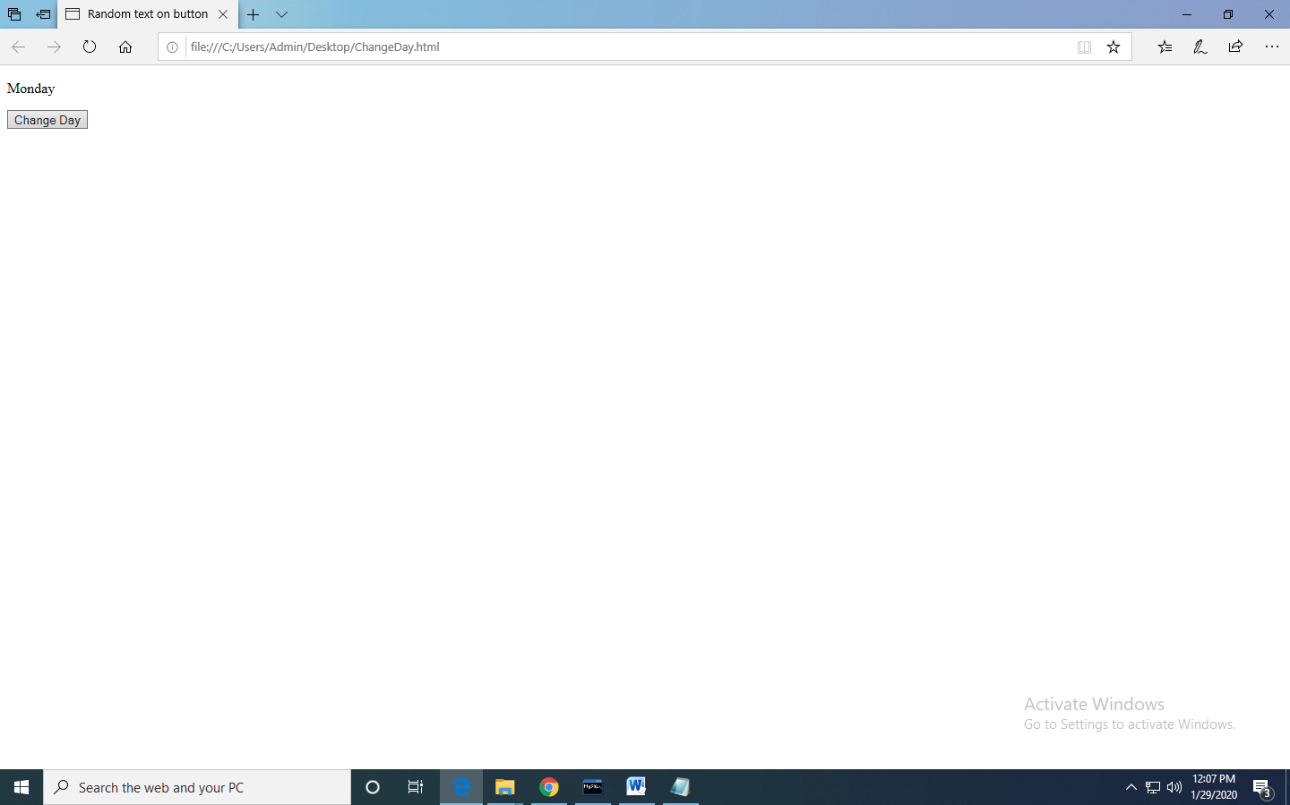

1. Write a Java Script to find the n prime number

<!DOCTYPE html>

<html>

<head>

<title>

Print Nth Prime

</title>

<script type="text/javascript">

function countPrime()

{

n = document.myform.n.value;

n = parseInt(n)

var count=0,a=false,s=0;

for(int z=2;z<=735457;z++)

{

a=p(z);

if(a==true)

{

count=count+1;

if(count==n)

s=z;

alert(s);

}

}

}

function p(z) {

var i, flag = true;

for(i = 2; i <= z- 1; i++)

if (z % i == 0) {

flag = false;

break;

}

if (flag == true)

return true;

else

return false;

}

</script>

</head>

<body>

<center>

<h4>Enter the number</h4>

<hr color="Green">

<form name="myform">

Enter the number:

<input type="text" name=n value="">

<br><br>

<input type="button" value="GetPrime" onClick="countPrime()">

<br>

</form>

</center>

</body>

</html>

