Nicole Larson

Climate Change Paper

Wisconsin generally has cold and snowy winters, and the Great Lakes are usually frozen over at least through February. Historically temperatures are above 32.2 degrees Celsius (90 degrees Fahrenheit) less than 14 times a year. Because of its climate, it has a high level of dairy farming and vegetable farming, especially corn, hay, and soybeans (University of Wisconsin, 2013. Additionally, many cold-water species of fish, like trout, inhabit the lakes and streams. Wisconsin has a lot of winter recreational activities, including cross-country skiing, snowmobiling, ice fishing, snowshoeing, hockey, and more (University of Wisconsin, 2013). In the future, the climate is expected to warm, along with various other effects noted later on. The future climate of Green Bay, which is directly east from Marshfield, is expected to become similar to the current climate of Reeses Mill, West Virginia, far southeast of Wisconsin. Change in mean average temperature is supposed to increase significantly as well (Veloz et al., 2012).

We obtained data from the National Oceanic and Atmospheric Administration’s (NOAA) National Centers for Environmental Information page. The data I obtained was from the Marshfield Experimental Farm location, in Marshfield, Wisconsin, and ranges from December 1912 until December 2016. We analyzed this data through R Studio, by putting it into graphs showing the mean of the maximum daily temperatures per month, and the mean of the minimum daily temperatures per month. After adding a best fit line, through R we were able to see the p-value, allowing us to tell whether the data was significant or not. If the p-value was below 0.05, it was statistically significant.

From 1970 until 2012, average temperatures in Wisconsin have increased by about .342 degrees Celsius per decade. This is the fourth fastest warming state in the United States (Tebaldi, Adams-Smith, & Heller, 2012). However, when looking at average minimum temperatures, Wisconsin is the third fastest warming state, with an increase of about .406 degrees Celsius per decade (Tebaldi, Adams-Smith, & Heller, 2012). This would seem to be consistent with the data I obtained from NOAA, and analyzed using R Studio, since nine out of the 12 months showed statistically significant upward warming trends for the average monthly minimum temperatures from 1912 through 2016. When looking at average maximum monthly temperatures, although most of the average lines sloped up, only February and March were statistically significant. This suggests that possibly the maximum temperatures the state is experiencing are not changing as much as the minimum temperatures, which could have significant effects for agriculture, as warmer minimum temperatures (or maximum temperatures in the early spring), means a longer growing season, and more frost-free days.

Winter wheat, corn, and soybean crops are supposed to harvest record-high amounts in 2016, according to the US Department of Agriculture (USDA). Because of favorable weather conditions “record soybean yields are expected in Illinois, Iowa, Missouri, Nebraska, and Wisconsin” (Minchenkov & Honig, 2016). This could be due to an increase in the length of the growing season, especially in these regions, which have a lot of agriculture. In the Midwest, where many of the crop yields are expected to break records, winters are usually snowy, and frosty days last through mid to late spring. However, with these states warming, the number of frost-free days may increase, leading to more time to grow crops, and a more productive season. In Wisconsin, agriculture could continue to experience boosts due to warming, an argument used by climate skeptics to question whether climate change is really something to worry about. However, there are additional negative effects of climate change, and if the warming is not stopped or slowed reasonably soon, crop production could continue to increase and then plunge. In fact, in the White House fact sheet about how climate change will affect Wisconsin, the Office of the Press Secretary noted in 2014 that, ““In the next few decades, longer growing seasons and rising carbon dioxide levels will increase yields of some crops… in the long term, the combined stresses associated with climate change are expected to decrease agricultural productivity” (Office of the Press Secretary, 2014).

There are many risks associated with climate change, and Wisconsin is expected to experience many of these. Public health will be affected by increased intensity and frequency of extreme heat events, air and water quality is expected to degrade, and humidity will increase (Office of the Press Secretary, 2014). In addition, the Great Lakes are likely to experience effects such as algal blooms, increased invasive species, and harm to native lake ecology (Office of the Press Secretary, 2014). The mean temperatures in the upper Great Lakes region have increased nearly four degrees in the last hundred years, with two thirds of that increase within the last 30 years, suggesting that the rate of warming is speeding up. Lakes previously frozen over all winter are experiencing midwinter thaws, and staying frozen for shorter periods of time. This pattern is expected to continue, and average winter temperatures could rise above freezing all year long by 2100 in the business as usual scenario (University of Wisconsin, 2013). Average rainfall has also increased since 1991 by more than 30 percent, leading to an increase in flooding events throughout the Midwest. This increase in floods and precipitation has led to sewer overflow, since the storm and sewage drainage systems are combined (Office of the Press Secretary, 2014). These overflows are expected to rise in frequency by 50-120 percent by the end of the century, and can contaminate the beaches and drinking water of more than 40 million people, as well as increase the risk of waterborne diseases. Models expect extreme precipitation events to also become 10-40 percent stronger. Furthermore, Wisconsin’s forests could be in danger (Patz et al., 2008). Tree species have been and are expected to continue to move north as warming occurs, changing the composition of the forest. Also, windstorms, wildfires, and insect outbreaks are expected to become more frequent (Office of the Press Secretary, 2014).

Although there are some potential benefits from climate change in Wisconsin in the near future, including decreased heating costs, improved agriculture, and more summer recreational sports, the overall negative effects, especially once climate change accelerates further, are a cause for worry. In terms of data, climate change is a relatively recent notable phenomenon, but it is still significant in a large number of the graphs I analyzed in R. Not only are statistically significant data rare in environmental science, but if you look at data collected from the 1970s to the present, such as the data collected and analyzed by Tebaldi, Adams-Smith, and Heller, the trends towards warming in this region are even more apparent. Although based on the data since 1912 that I analyzed it cannot be definitively concluded that average maximum daily temperatures per month are rising because the data is not always or even mostly statistically significant, it seems pretty apparent from the average minimum temperature graphs and p-values that temperatures are rising in a statistically significant manner. Furthermore, due to the current pace of climate change and expected affects, we do not necessarily have time to collect and analyze enough data to prove beyond a reasonable doubt that the climate is warming. Every year we seem to be breaking record temperatures, and if we are to avoid the worst effects of global warming, it is critical that we implement policy initiatives and expand green energy production now.

References

Minchenkov, A. & Honig, L. (2016, August 12). USDA forecasts record-high corn and soybean production in 2016. *United States Department of Agriculture.* Retrieved from https://www.nass.usda.gov/Newsroom/2016/08_12_2016.php

Office of the Press Secretary. (2014, May 6) *Fact sheet: What climate change means for Wisconsin and the Midwest*. Retrieved from https://www.whitehouse.gov/sites/default/files/microsites/ostp/WISCONSIN_NCA_2014.pdf

Patz, J. A., Vavrus, S. J., Uejio, C. K., & McLellan, S. L. (2008). Climate Change and Waterborne Disease Risk in the Great Lakes Region of the U.S. *American Journal Of Preventive Medicine*, *35*(5), 451-458. doi:10.1016/j.amepre.2008.08.026

Tebaldi, C., Adams-Smith, D., & Heller, N. (2012, June). The heat is on: U.S. temperature trends. *Climate Central*. Retrieved from http://www.climatecentral.org/wgts/heat-is-on/HeatIsOnReport.pdf

University of Wisconsin. (2013). *What climate change means for Wisconsin and the Upper Midwest*. Retrieved from http://www.seagrant.wisc.edu/Home/Topics/ClimateChange/Details.aspx?PostID=832

Veloz, S., Williams, J. W., Lorenz, D., Notaro, M., Vavrus, S., & Vimont, D. J. (2012). Identifying climatic analogs for wisconsin under 21st-century climate-change scenarios. *Climatic Change, 112*(3-4), 1037-1058. doi:http://dx.doi.org/10.1007/s10584-011-0261-z

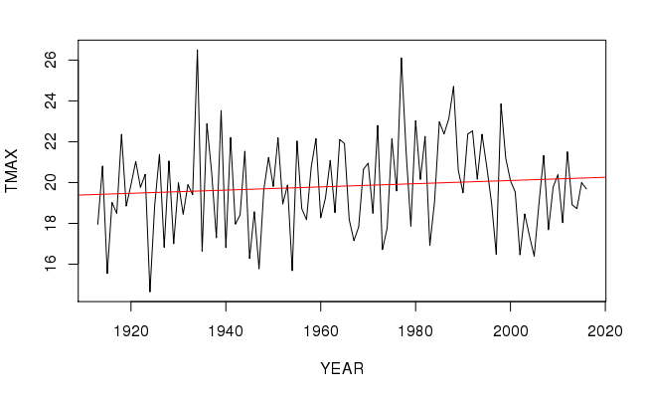

MAY MAX VALUES p-value = 0.299

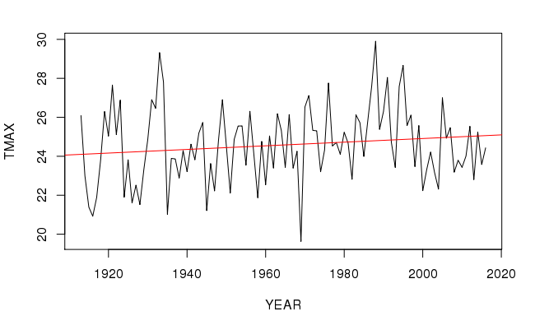

JUNE MAX VALUE p-value = 0.1373

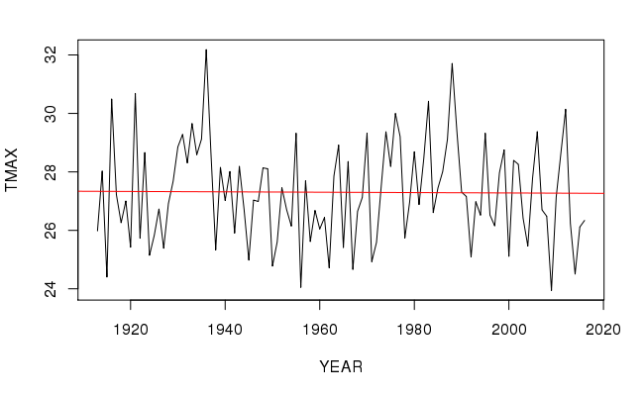

JULY MAX VALUE p-value = 0.9084

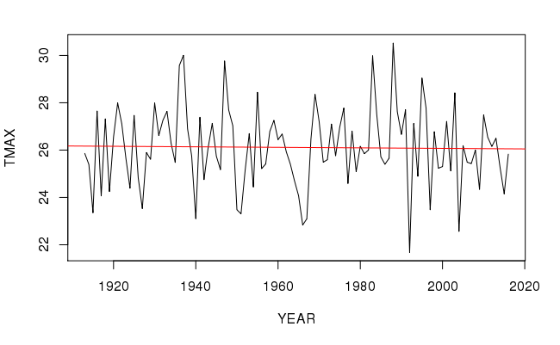

AUGUST MAX VALUES p-value = 0.8407

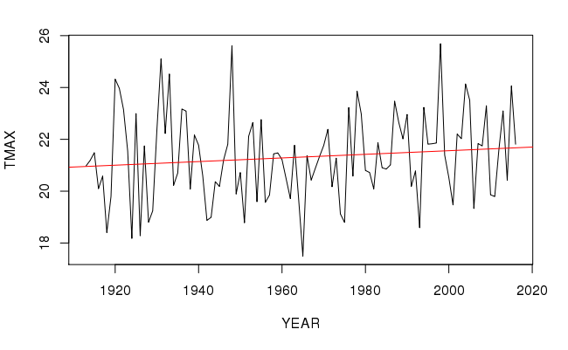

SEPTEMBER MAX VALUES p-value = 0.2061

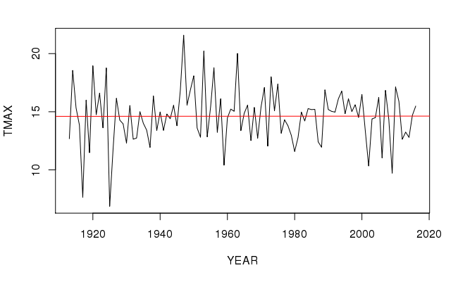

OCTOBER MAX VALUES p-value = 0.9786

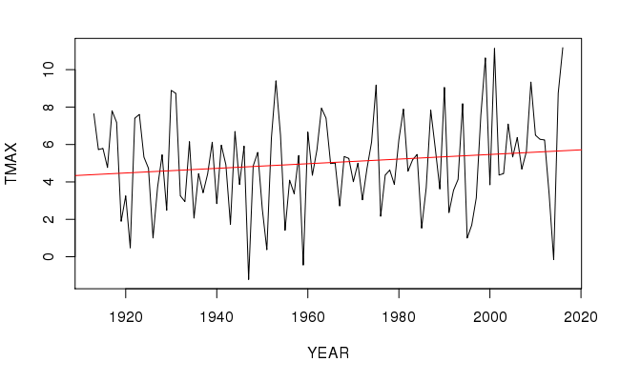

NOVEMBER MAX VALUES p-value = 0.1315

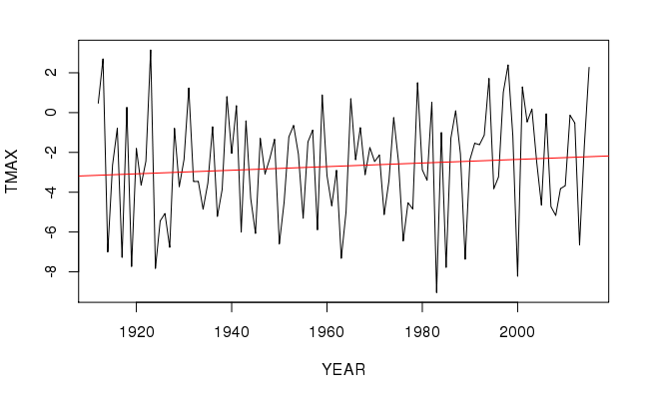

DECEMBER MAX VALUES p-value = .314

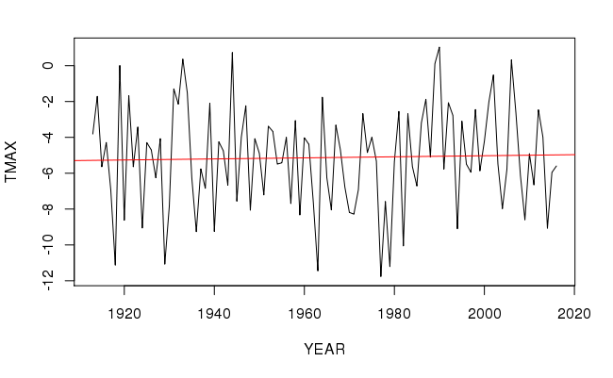

JANUARY MAX VALUES p-value = 0.7538

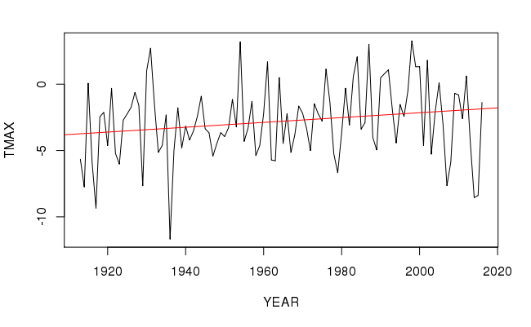

FEBRUARY MAX VALUES p-value = 0.04979

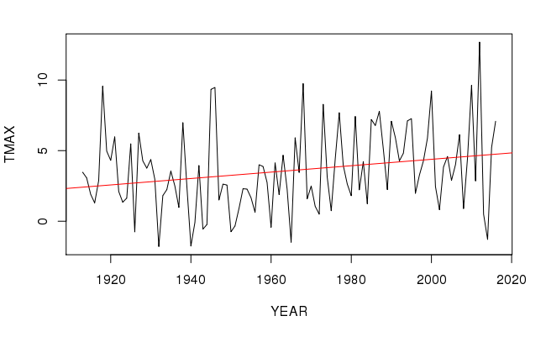

MARCH MAX VALUES p-value = 0.01595

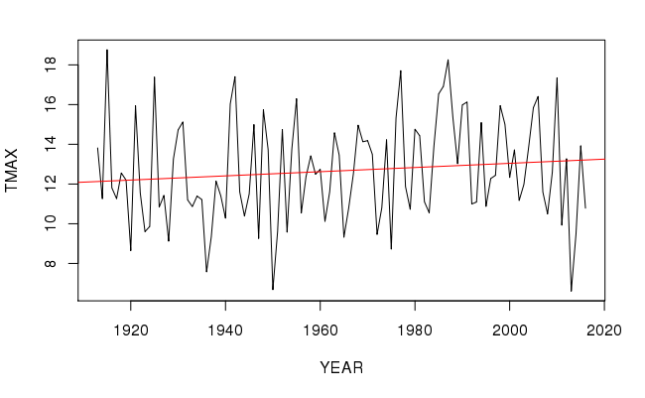

APRIL MAX VALUES p-value = 0.2193

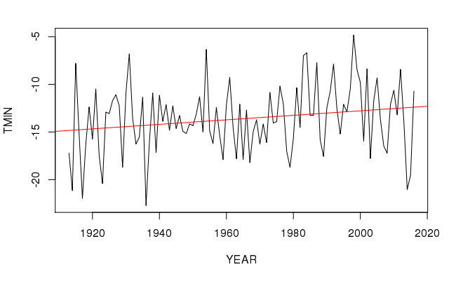

FEBRAURY MIN VALUES p-value = 0.04159

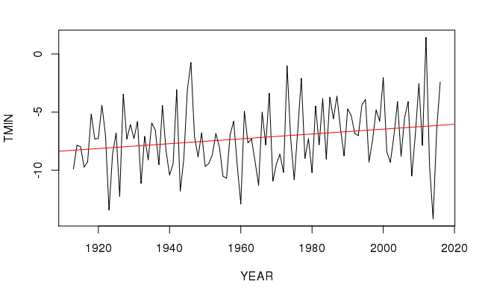

MARCH MIN VALUES p-value = 0.02517

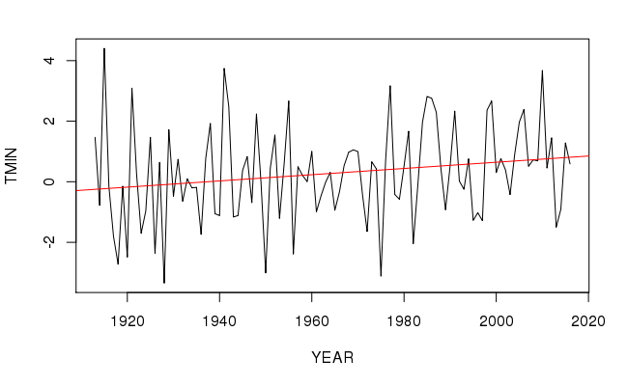

APRIL MIN VALUES p-value = 0.04453

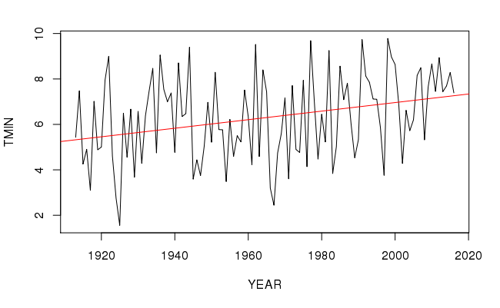

MAY MIN VALUES p-value = 0.001907

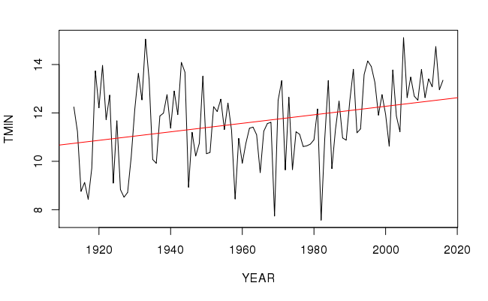

JUNE MIN VALUES p-value = 0.0009536

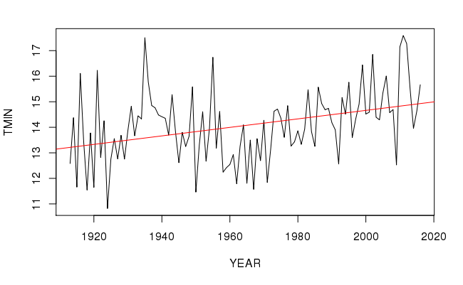

JULY MIN VALUES p-value = 0.000183

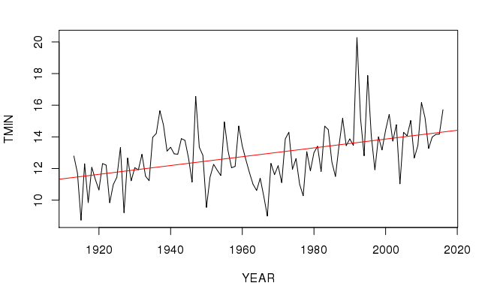

AUGUST MIN VALUES p-value = 0.000001043 🡪 1.043X10-6

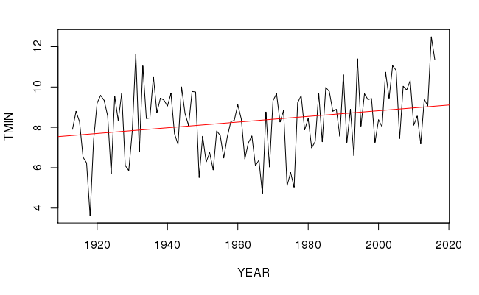

SEPTEMBER MIN VALUES p-value = 0.008791

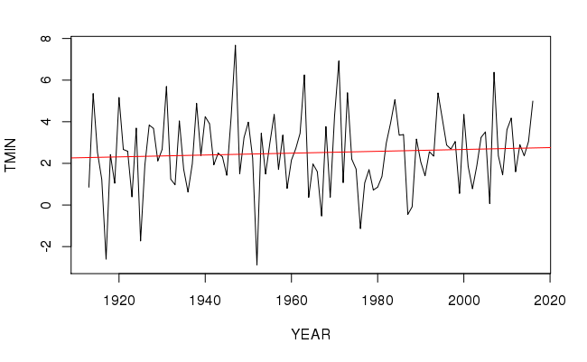

OCTOBER MIN VALUES p-value = 0.467

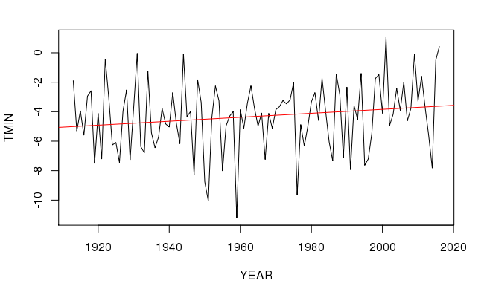

NOVEMBER MIN VALUES p-value = 0.07995

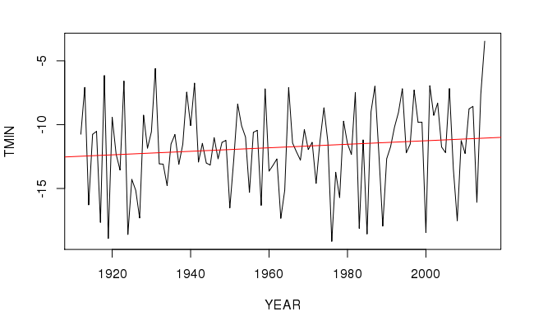

DECEMBER MIN VALUES p-value = 0.2131

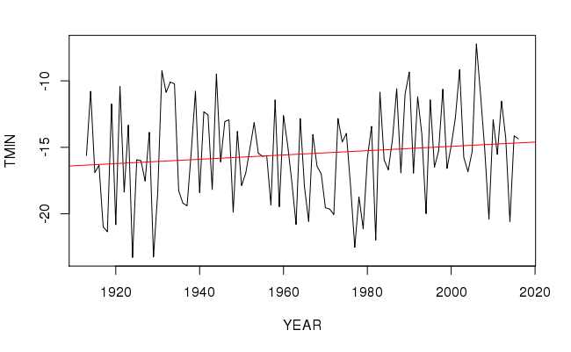

JANUARY MIN VALUES p-value = 0.1718

