Griffith Fires

Anam Mehta

10/8/2018

## Griffith Park as a WUI (Wildlife Urban Interface)

Home to the Hollywood Sign and the famous observatory, Griffith Park is one of the most well known parks in the US. Colloquially known as the Central Park of LA, Griffith Park is one of the largest urban parks in the country located in the Los Feliz neighbodhood. Contrary to the manicured image of central park, however, Griffith is much more rugged and undeveloped. If you live anywhere near Los Angeles, odds are you have walked up the path in the park to the observatory to see the city lights or watch the sunset. Griffith Park also marks the Eastern end of the Santa Monica Mountains. Due to its proximity to urban areas, Griffith Park is designated as a Wildland Urban Interface, or WUI, where human developed areas are next to or overlap with undeveloped areas. This WUI classification in California is notably important because of fire risk in the state and the shear number of homes that are built in WUIs. Since 1990, more than 60% of the homes built in California are in WUI zones (Hammer et al. 2007). These homes are more at risk of wildfire due to their poximity to unmanaged land. Homes in WUIs are also farther away from fire safety like fire stations rescourses that are in more developed areas. In addition to the risk of being closer to forest areas, more human created forestfires occur in WUIs due to the very prsence of people and closeness of flammable material. An overwhelming majority of fires in the state are human started (Balch et al. 2017). As California's population and need for new housing increases, communites expand more and more into WUIs, opening people up to more risk (Cambell, 2010).

## Fire Management

So what do we do to reduce this risk? One way is to reduce the area of WUIs by changing zoning laws and where developers can build homes. However, many established WUIs are at risk of fire right now; what about those? Take Griffith Park for example. Even being so close to very populated area of LA, major fires still burn in the park, and the California Department of Forestry and Fire Protection designated the area as a place with a “very high” fire hazard (California, n.d). This means that there is greater than one percent chance of experiencing fires per year. This may seem like a small number, but fires in Griffith Park occur relatively frequently. How can these fires be managed such that the least damage is done to homes, infrastructure, flora, fauna, and aesthetics? The method of prescribed burns is clearly harmful in this area, so what actually works?

The responsibility of Griffith Park falls to more than one stakeholder, and so the management of fire is not a singular problem. The park is owned by the City of Los Angeles, and within the city, the Department of Parks and Recreation have control over the park. Since Griffith Park is also has an important social and emotional value for many people, the recovery of the park after a fire is a collective effort between community organizations and the government agencies. In a wildfire situations, however, the park must rely on the City of Los Angeles Fire Department to contain and suppress the fire. This means that the relationship between the internal agencies that are in charge of the safety of the park is incredibly important in order to make effective management policies. The policies created must also be specific to Griffith Park because of the vegetation and landscape of park. Much of Griffith Park has very variable elevations. Canyons, hills, and mountains dominate the landscape. Wind has the potential to channel canyon fires very destructively and it the elevation changes make it hard for firefighters to access and keep up with the fire. Griffith Park is also mostly vegetated by chaparral plants. These plants are small, woody, and hug the ground, so fires completeley burn them. They are fire adapted to a point. The natural fire return interval is 30 to 150 years, and having fires more frequently than 20 years can completely eliminate the native chaparral plants and allow invasive grasses to populate the area. Large, high intensity fires are nothing new to the chaparral landscape. The frequency of these fires is the problem.

Fire management of forests is very different from the fire management of these chaparral scrublands. The key in Griffith Park is suppression, suppression, suppression. Due to the high population densities near the park, the consequences of a large fire that escapes the bounds of the park on human life could be monumentally horrific. So far, fires in Griffith Park have been dealt with relatively quickly because of its locality and danger, but fires in Griffith are far from over. While, on the map, the last fire logged is from 2007, more than 10 years ago, a 25 acre fire burned in Griffith just a few months ago. This brush fire flared up about half a mile from the observatory. It prompted evacuations and road closures but was dealt with very quickly due to the weather and position of the fire.

Since almost all of the fires in Griffith Park have been started by humans, prevention can be targeted at human behaviors. Even something as small as a few sparks from skimming some piece of metal on a rock can start a huge blaze, especially if the climate conditions are right. So education and banning behaviors that could inadvertently start fires should be a major way to prevent human caused fires in the future.

## Griffith Park's Tragedy

84 years ago in Griffith Park, more than 3,700 workers were clearing trails, pulling weeds, and building roads that visitor use today. In the mid-afternoon, a small fire that could have been started by a lit cigarette ignited on a pile of leaves near the golf course parking lot. The workers nearby in the park were ordered to go fight the fire. These people had little to no experience fighting fires and didn't really know what they were doing, but still they beat at the blaze with their shovels and dirt. Some even started backfires in the wrong places. The professional firefighters that soon showed up could not control the workers that there fighting the fire in the canyon, which was the most dangerous place to be. As the wind shifted to roar down the canyon, the workers were caught in the towering blaze and many did not make it out. 29 people died that day in the fire, and even though the fire in Griffith was only 47 acres large, its impact is felt far beyond its size (Staff, 2018).

The fire called into question the role of firefighters and civilians in supressing fires. Now, due to the sheer scale of fires in this state, firefighting is a multibillion dollar opperation. While people who fight fires are overall safer in modern times, California still takes advantage of available manpower by having inmates join the firefighting force. These people who are incarcerated earn just two dollars a day and an additional one dollar for every hour fighting an active fire, every hour risking their lives. And then, as ex-cons these people are not even able to get jobs as firefighers (Zaveri, 2018).

The Griffith Park fire was the deadliest fire in California history until November 2018. The Camp Fire in Butte County recently took the lives of 85 civilians while burning 153,336 acres of land and destroying 18,793 structures, making it not just the deadliest but also the most destructive wildfire ever in California (Egel, 2018).

## Maps to Explore

Using geospatial data of Griffith Park and Camp fires, I created a story map. Link to storymap: <http://arcg.is/1ybOOn>

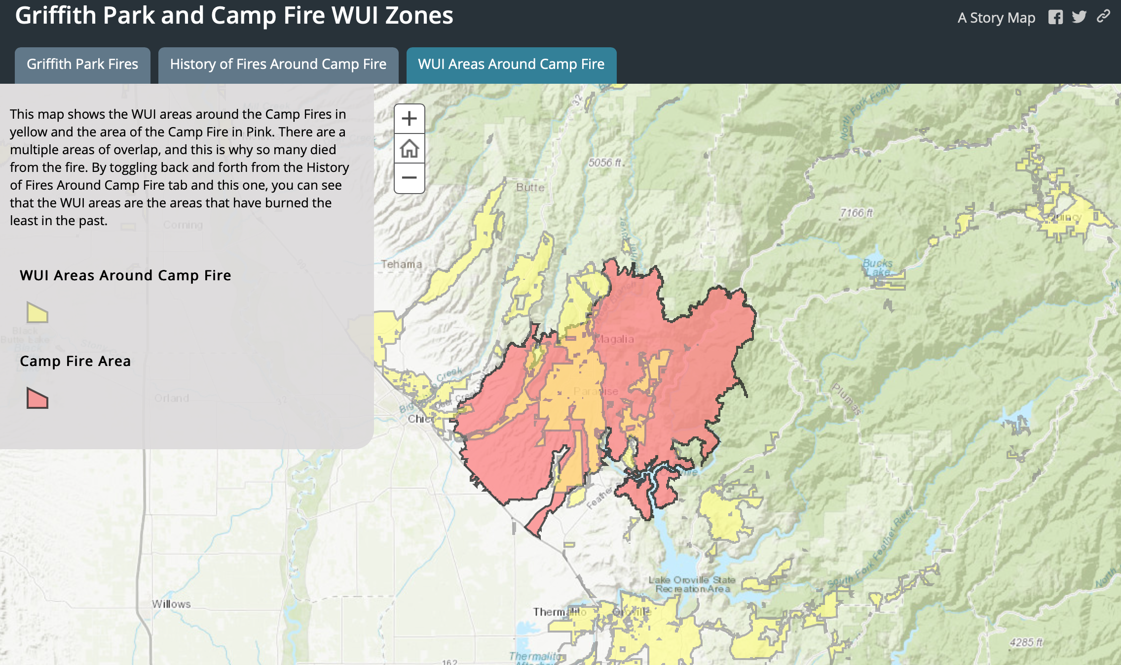

One of the maps from the storymap.

This story map shows the history of Griffith Park fires and the WUI areas that intersect with the fires. This map shows just how many WUI areas are situated very close to Griffith Park. Other tabs in the storymap show the WUI areas and fires that historically interesect with the Camp Fire.

## Conclusions

The map of Griffith Park Fires and WUIs shows that WUI areas actually intersect with very fire prone areas, especially in North West corner of the park. If a fire were to burn in that area today, it would have great potential to destroy many lives and buildings. On the other sides of the park, the fires seem to be kept within the park, but WUI areas are still right next door. If not being directly burned, the risk of living near such a fire prone area is still major. If a fire burns in Griffith Park, the people who live in these WUIs would be the first to feel the negative affects of smoke or particulates in the air.

The maps of the Camp Fire show something very different from the Griffith Park Fires map. First, they show that much of the area that the Camp Fire burned has burned historically multiple times. It seems that the only area that hasn't burned before is the WUI areas. Thus, the Camp Fire would have a much higher toll on human life than the past fires. This growing area of where fires burn is troubling. If the Camp Fire is inidacative of the changing nature of how fires burn in California, we are in for many more fires that extend into WUI areas, exacerbating loss of life and damage to human dwellings.

When those 29 people died in Griffith Park in 1939, of course it was a tragedy, but in one way it was coindcidental because of all the workers already in the park. The Camp Fire, however, is much more scary. It invaded homes and burned down a whole town. There was no coincidence there.

## Bibliography

Balch, Jennifer K., et al. "Human-started wildfires expand the fire niche across the United States." Proceedings of the National Academy of Sciences 114.11 (2017): 2946-2951.

Hammer, Roger & Radeloff, Volker & Fried, Jeremy & Stewart, Susan. (2007). Wildland–urban interface housing growth during the 1990 in California, Oregon, and Washington. International Journal of Wildland Fire. 16. 255-265. 10.1071/WF05077.

California, S. O. (n.d.). California Fire Hazard Severity Zone Map Update Project. Retrieved from <http://www.fire.ca.gov/fire_prevention/fire_prevention_wildland_zones_maps>

Campbell, Paul R. "State Population Projections." Methodology 301 (2010): 457-2422.

Cooper, Daniel S., and Paul Mathewson. "GRIFFITH PARK WILDLIFE MANAGEMENT PLAN DRAFT." (2008).

Staff, Times. “Griffith Park Was the Scene of the Deadliest Fire in State History. The Butte County Disaster Has Surpassed It.” Los Angeles Times, Los Angeles Times, 13 Nov. 2018, www.latimes.com/local/lanow/la-me-griffith-park-fire-20181113-story.html.

Zaveri, Mihir. “As Inmates, They Fight California's Fires. As Ex-Convicts, Their Firefighting Prospects Wilt.” The New York Times, The New York Times, 15 Nov. 2018, www.nytimes.com/2018/11/15/us/california-paying-inmates-fight-fires.html.

Egel, B. (2018). California wildfires start in the woods. Why do cities keep burning?. sacbee. <https://www.sacbee.com/news/state/california/fires/article221385910.html>.

Razo Santoyo, Laura. Fire prevention in Los Angeles County: a survey of the methods and stategies used in the wildland-urban interface. Diss. California State Polytechnic University, Pomona, 2015.

Syphard, Alexandra D., Keith C. Clarke, and Janet Franklin. "Simulating fire frequency and urban growth in southern California coastal shrublands, USA." Landscape ecology22.3 (2007): 431-445.

Fitzmorris, Patricia Kayt. "Wildfire Management in Los Angeles’ Wildland-Urban Interface." (2010).

Serna, J., & Karlamangla, S. (2018, July 10). Brush fire near Griffith Park prompts evacuation of observatory. Retrieved from <http://www.latimes.com/local/lanow/la-me-ln-griffith-brush-fire-20180710-story.html>

Note that the echo = FALSE parameter was added to the code chunk to prevent printing of the R code that generated the plot.