From Fire to Floods: How is Climate Whiplash Affecting Los Angeles County?

Toni Anderson

3/1/2019

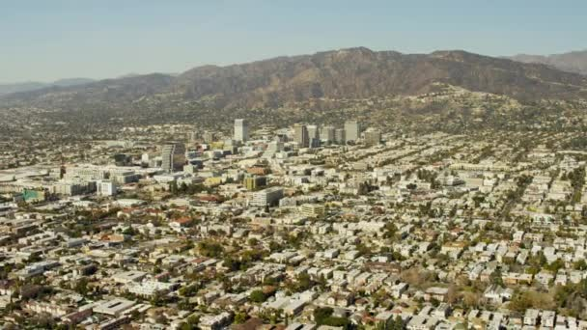

The picturesque Burbank sklyline. Source: Gettyimages

# Climate Whiplash: Where, Why, and How?

Southern California, thanks to its temperate climate and sunny beaches, has a reputation as one of the most idyllic climates in America. The heart of Southern California, Los Angeles County, is the most populous county in the United States with over 10 million residents (US Census Bureau 2018). However, LA county's warm climate hides a much more sinister environmental concern: the phenomenon known colloquially as “climate whiplash.” Put simply, this term denotes frequent transitions from very wet to very dry weather (Hall et al. 2018). This phenomenon is becoming more prevalent worldwide, but is easily identifiable in Southern California: at the end of 2018, for example, the hills of Burbank went from a raging fire to deadly mudslides in just a few weeks, causing massive property damage (Hammer et al. 2007). and prolonged evacuations of both people and livestock (Carroll et al. 2006). But how does precipitation variation create this ongoing from the wet and dry seasons? And what kind of effects will it have on extreme events in the region? How will this, in turn, effect LA county’s population? Observed climate and precipitation trends support the hypothesis precipitation rates are not only increasing but becoming more varied over time. This blog examines the observed trends of climate whiplash in Southern California. Using both scientific studies and raw climate data from the National Oceanic and Atmospheric Administration (NOAA), I will analyze evidence to support the existence of the above hypothesis in the Los Angeles County Region. From this data, I will then discuss the effects of this whiplash on the community itself; including flooding, fires, and water supply contamination. Climate whiplash will increase the frequency of these extreme weather events, which in turn will cause infrastructure and agricultural damage, as well as public unrest and unease due to unorganized evacuations. The effects of climate whiplash are still being unraveled from those attributed solely to global warming; this blog intends to demystify some of these misguided conclusions and bring awareness to the Los Angeles’ new reality of climate whiplash.

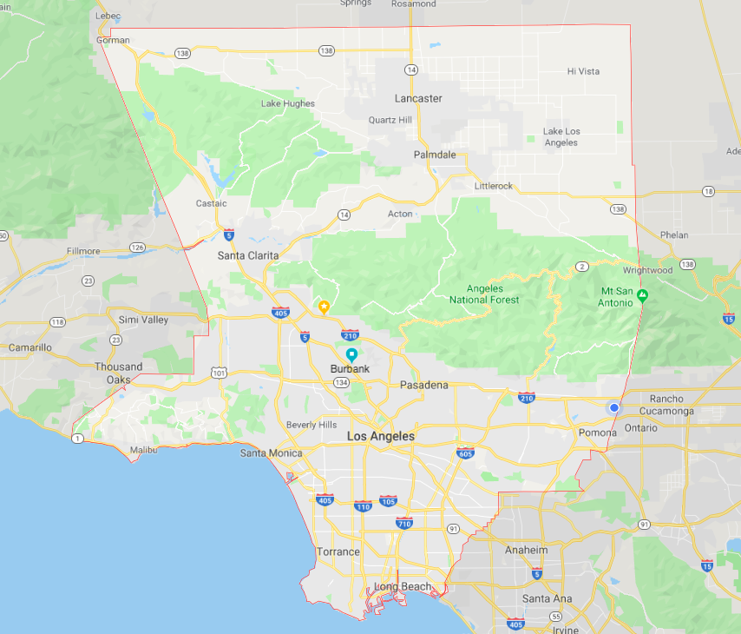

LA County. Source: Google Maps

# Methods

For this analysis, I obtained daily summaries of temperature and precipitation data for Burbank. Then, using the program R-Studio, I graphed the data in order to assess relationships between time and precipitation. In order to confirm or deny a relationship between the two variables I used the null hypothesis method. The relationship is codified in the data as the ‘p-value.’ If the p-value (calculated in R-Studio) is less than .05, then the null hypothesis may be rejected; this means that there is without question a relationship between the two variables. However, if the p-value is greater than .05, there is still a possibility that the relationship does not exist.

### The Data

My climate data came from the National Oceanic and Atmospheric Administration (NOAA), which keeps an extensive climate database compiled from weather stations across the United States. Using their Climate Data Online program, I downloaded daily summaries of precipitation data from the Burbank Valley Pump Plant (Station GHCND:USC00041194). This specific dataset covered all the way from 1939 to the present day, and had a 99% coverage rate, meaning that only 1% of data was left unaccounted for in the form of a gap or lapse in the data.

### Drawbacks

There are certain restrictions to only using one dataset and location for my analysis. Because I am using just one location and then applying trends I see there to the entirety of LA county, there is the potential for misgeneralizations to be made to locations with different microclimates than Burbank. However, a singular dataset simplified the analysis process, and, since this particular set has a very long and consistent set of results, I can use it to reliably track trends without the fear of missing data or gaps skewing the results. The station has moved only slightly in its time of recording, though it has existed for the most part in a parking lot. The asphalt can create a ‘heat island’ effect where heat is trapped in a small area an subsequently makes it warmer than the climate itself. While this could artificially inflate temperature data, the urban location of the weather station do not have a large impact on my data, because I am looking solely at precipitation, not temperature. Furthermore, thanks to Burbank's central location, it is a reasonable assumption that trends collected here will be similar enough to trends observed throughout the county that basic generalizations can be made (with the understanding that exact precipitation totals will be slightly different depending on the area.) All precipitation is in the form of rain, as Burbank’s climate does not allow for snow, so there are no inconsistencies in measured volume of precipitation.

# Preciptation Rates and Whiplash Evidence

### Precipitation Annual Data

This graph displays the sum of all precipitation data from each month from 1940 to the present day (the entirety of the dataset). What is important to note here is high variation in total precipitation. With a p-value of 0.755, there is certainly no way we can reject the null hypothesis. As shown in the graph, precipitation does not increase or decrease over time; rather there is a series of sharp spikes and large dips. Historically, much of California’s precipitation occurs in short, intense bursts during the stormy season (Hall et al. 2018), which is shown by the constant spikes and valleys in the graphs. However as the temperature begins to vary more, these storms can become more intense and less frequent, contributing to the rapid shifts from wet to dry that characterize climate whiplash. The conclusion to draw from this graph that the precipitation rates are becoming more varied over time, with taller spikes and wider valleys.

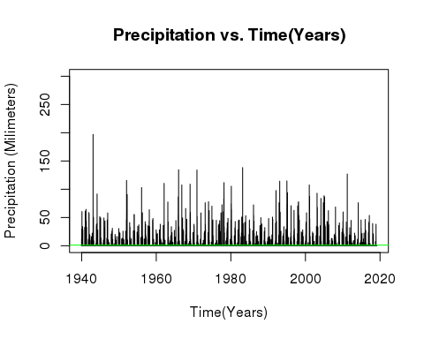

### Precipitation Fall Season Data (Sum)

This variation becomes even more apparent when looking at just a few months at a time. The fall season, shown through the three months of October, November, and December, is particularly significant for climate whiplash because it is the annual transitional period between the wet and dry season. Over time, as shown in these three graphs it has amassed a very volatile climate pattern as the fire season extends into the traditionally short and intense rainy season (Hall et al. 2018). While October is increasing precipitation and temperature, November is significantly decreasing after a series of giant spikes in the mid-1900s. December’s trend line remains stagnant, however, the plotted data points showcase a huge variation in precipitation year to year, with significant valleys and spikes all over the graph. Each month has incredible variation in their precipitation totals; however, what stands out to me is that precipitation spikes are not consistent month to month. For example, October has a precipitation spike in the early 2000s, November suffers a distinct valley in the same year. This shows that the wet and dry seasons in LA County are constantly changing places, both year to year and month to month. This is the trademark sign of climate whiplash; and according to the graphs, this discord in rain schedule is only becoming more pronounced as the maximum and minimum temperatures change around it. Historically, this has been demonstrated through a series of multi-year droughts interrupted by very wet seasons (Hall et al. 2018). If these trends continue, the possibility for dangerous flooding, fires, and other disasters increases exponentially (Abatzoglou et al. 2017).

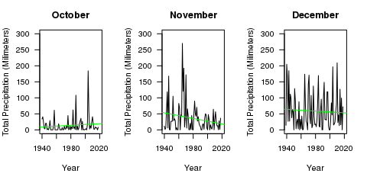

# Discussion

The presence of climate whiplash is clear, based on temperature and precipitation data. However, the changing precipitation patterns and subsequent dry and wet extremes have potentially severe consequences for LA County, some of which we are already beginning to experience. Fires, floods, droughts, and water contamination are all very real problems facing the community as climate whiplash stands poised on the horizon.

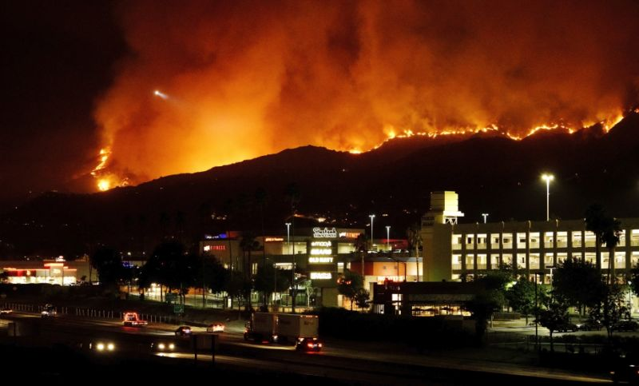

Fire in the Burbank hills. Source:The LA Times

### Fire Danger

As climate patterns continue on their path of whiplash, short, intense droughts will become more common, interspersed by occasional very wet seasons (Hall et al. 2018). Before the wet season of 2017, California experienced one of the most extreme four-year droughts in over a millennium (Abatzoglou et al. 2017). According to projections, events like these will become even more frequent as variation in precipitation patterns continue to grow (Hall et al. 2018).

However, it is not just the dry years that indicate a fire threat. Several of the most recent Southern California fires actually occurred following the wettest modern winters (Hall et al. 2018). The high contrast between the dry years and the suddenly wet winter causes the landscape to produce more underbrush and grasses which quickly dries out because the varied precipitation cannot support the high concentration of plant life (Hall et al. 2018). While wilderness management tasks, such as controlled burns and manual clearing of underbrush can help mitigate some fire hazards, as the climate continues its back-and-forth trajectory, both urban and rural areas will become even more at risk.

As fires become more prevalent in urban areas, however, the danger of evacuations come with them. Very few municipalities have set evacuation plans in place, resulting in confusion, traffic jams, and dangerous situations for residents unable to escape (Carroll et al. 2006). This presents a social justice issue: low-income communities are far less likely to have evacuation plans in place, and are often higher at risk from wildfires because of high population concentration in these areas (Brennan et al. 2012). Additionally, people living in more rural areas are at an even high risk; in a 2012 study, scientists found that areas with housing interspersed with wild vegetation had the highest rate of property loss in Southern California (Brennan et al. 2012). Communities like this exist all over Los Angeles County including the livestock cities of Sylmar, Sunland, and La Tuna Canyon; most are low-income and primarily comprised of non-white populations (US Census Bureau 2010). As fire danger increases thanks to climate whiplash, low-income communities are put at a disproportionately higher risk for property loss and damage than higher income communities.

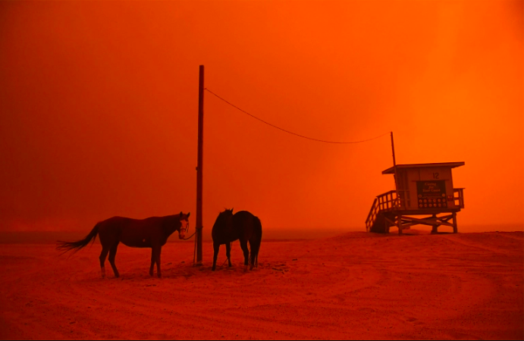

Evacuated horses wait on the beach during Woolsely fires in Malibu. Source: People Magazine

### From Floods to Drought

As climate patterns continue on their path of whiplash, short, intense droughts will become more common, interspersed by occasional very wet seasons (Hall et al. 2018). The drought, in addition to raising prices of water, will exacerbate the fire dangers discussed above. Before the wet season of 2017, California experienced one of the most extreme four-year droughts in over a millennium, in conjunction with the highest recorded temperatures in history (Abatzoglou et al. 2017). According to projections, events like these will become even more frequent as variation in precipitation patterns continue to grow (Hall et al. 2018).

What characterizes climate whiplash, however, is not the presence of just drought and flood, but rather the existence of both in one region over a short period of time. The factors that allow the Los Angeles climate to be so temperate are the same ones that enable these rapid swings between drought and floods, especially during the fall season (Hall et al. 2018). The Los Angeles example of the Woosley fire in Malibu turning quickly into the Malibu floods and mudslides is a preface of what will soon become the norm in Los Angeles (Hall et al. 2018). A study conducted at the University of California, Los Angeles in 2018 discovered strong evidence for heavy increases in seasonal precipitation, projecting that all of California would experience a 100% to 200% total increase in precipitation over the next few decades (Hall et al. 2018).

However, whiplash not only contributes to a more intense rainy season; it also predisposes the region to heavy storms outside of the typical timeframe (similar to the drastic swings between October and November shown on my graphs). Regional flooding, such as the mudslides in Malibu, is linked closely to these severe and longer lasting storms outside of the rainy season (Hall et al. 2018) that contribute a large part of the annual precipitation over a short time period. As many parts of California do not have the infrastructure to redirect that amount of water, it quickly oversaturated the soil, the spews outwards creating flash floods and mudslides across the county.

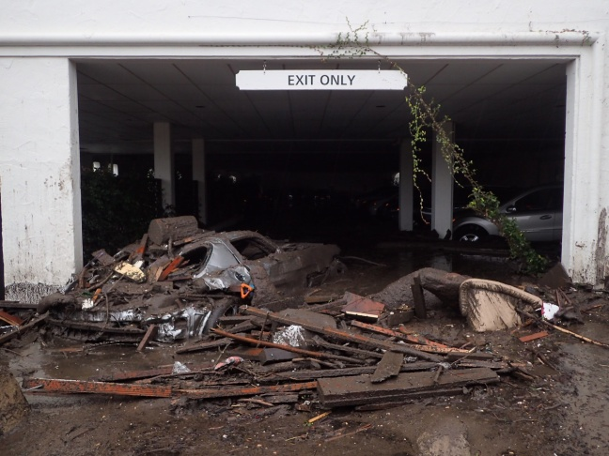

Mudslides envelop a parking garage in Montecito. Source:ABC7 News

While both the flooding and drought are dangerous on their own, it is the dramatic swings between the two sides that are truly devastating. The UCLA study describes a serious whiplash event in 2016 when a four-year drought came to close with several months of extremely heavy rainfall. Roads and bridges throughout California were damaged due to flooding and mudslides. A few months later, the cumulative runoff from this precipitation was a major factor in the failure of the Oroville Dam’s primary spillway. This crisis was utterly unexpected, and forced a quarter of a million people to evacuate the area (Hall et al. 2018). Further impacts on Los Angeles include damage to dams thanks to an increased amount of sediment in the water (Barnard et al. 2018), as well as reduced agriculture production as fields are ruined, or crops simply cannot adapt to the sudden temperature and precipitation changes (Cahill et al. 2007). The humans themselves may have problems adapting to these new changes, as the rapid changes from flood to drought disturb the careful balance between flood control and water storage that is already set off kilter by the beginning of climate whiplash patterns.

# Conclusion

Climate whiplash is a very real problem that is occurring right now in Los Angeles County. The data shows the characteristic variations in precipitation, while numerous other studies, most prominently Swain at UCLA, have confirmed it through other means. The future ramifications of climate whiplash are concerning; the constant pendulum swing between severe drought and extreme flooding leaves the door open for natural disasters and health hazards across the county. Humans can do little to stop the climate whiplash itself from happening; however, they have several optional next steps in order to mitigate the damage this whiplash will cause. Setting more decisive policies about the storage of water and use of water, both to regulate it in a drought and have a place to send it in flood time, would help to keep the political balance between drought and flood (Hall et al. 2018). Furthermore, as LA county exists in a perpetual state of high fire danger, raising awareness about urban fire safety as well as the creation of municipal evacuation plans, either through a local government or neighborhood organization is a necessary endeavor (Carroll et al. 2006). Raised awareness in low-income areas would help to bridge the property damage gap, as would organized evacuation plans that ensure all residents can get themselves and hopefully some valuables out of their home safely. California and Los Angeles country are in for a rough ride as they adjust to the new normal of climate whiplash. However, armed with knowledge of climate trends, disaster preparedness, and strong infrastructure, Los Angeles County will be ready to tackle this challenge head-on.

# Citations

Abatzoglou JT, Marsh PT, Nauslar NJ. 2017. The 2017 North Bay and Southern California Fires: A Case Study. Fire. 1(1):18.

Barnard PL, Campbell‐Swarzenski P, Collins BD, and Conaway CH, East AE, Ritchie AC, Stevens AW. 2018. A regime shift in sediment export from a coastal watershed during a record wet winter, California: Implications for landscape response to hydroclimatic extremes. Earth Surf Process Landforms. 43: 2562–2577.

Brennan TJ, Keeley JE, Massada AB, Radeloff VC, Syphard AD. 2012. Housing Arrangement and Location Determine the Likelihood of Housing Loss Due to Wildfire. PLOS ONE. 7(3): e33954.

Burgin AJ, Loecke TD, Riveros-Iregui DA, Ward AS, Thomas SA, Davis CA, St Claire MA. 2017. Weather whiplash in agricultural regions drives deterioration of water quality. Biogeochemistry. 133: 7.

Cahill KN, Field CB, Lobell DB. 2007. Historical effects of temperature and precipitation on California crop yields. Climatic Change. 81: 187.

Carroll MS, Cohn PJ, Kumagai Y. 2006. Evacuation Behavior during Wildfires: Results of Three Case Studies. Western Journal of Applied Forestry. 21(1):39–48,

Hammer RB, Hawbaker TJ, Radeloff VC, Stewart SI. 2007. Defining the Wildland Urban Interface. Journal of Forestry 105:201-207.

Hall A, Langenbrunner B, Neelin JD, Swain DL. 2018. Increasing precipitation volatility in twenty-first-century California. Nature Climate Change. 8:427-433.

Keeley JE, Syphard AD. 2018. Historical patterns of wildfire ignition sources in California ecosystems. International Journal of Wildland Fire. (27):781-799.

US Census Bureau. 2010. United States Census 2010. US Census Bureau.

US Census Bureau. 2017. The 25 largest counties in the United States in 2017, by population (in millions). Statista.