Effects of Rising Temperatures on Urban Communities in Los Angeles, California

Christina Marsh

Saturday, October 10th



Fig. 1 Los Angeles Skyline

## Introduction

Over the last century, the average surface temperature of the Earth has increased by about 1.5-2.0 degrees Celsius (NASA). Each year, more Americans die as a result of heat than all other natural disasters combined. The climate of Los Angeles is a mild-to-hot and mostly dry climate for the year round. The climate is described as a Mediterranean climate, which is a type of dry subtropical climate. And the L.A. neighborhoods that have the least tree canopy are at greatest risk for heat-related hospitalizations and deaths. Climate change is primarily responsible for the warming trend, but it’s not the only force at work (Montanez). Unlike many other Californians, and Americans in general, Angelenos are also contending with an additional layer of heat intensification caused by what’s known as the “urban heat island effect.” It means that cities — with their asphalt streets, dark roofs, sparse vegetation and traffic congested roads — are almost always a few degrees warmer than the more rural areas that surround them (Netburn). I hypothesize that this means that the data will show an average temperature steadily rising from 1906 onward that surpasses the global average temperature rise of a similar time. This blog will examine temperature and records for Los Angeles from 1906 to 2010 and discuss conclusions we can draw from said statistics as they relate to extreme heat’s disproportionate effect on urban and low-income communities.

## Methods

For this blog, I accessed the database on National Oceanic and Atmospheric Administration (NOAA) to collect air temperature data in my region of study, Los Angeles. I collected data from a station in Downtown Los Angeles because it had the most expansive data of the 3 stations in Los Angeles area (NOAA). I chose to use the data from August because it showed the largest variability of months and was one of the hottest months on average. I graphed temperature average maximums and minimums across the 104 year period to show clear temperature increase from both the lowest and highest temperatures.

To analyze the data, I read and interpreted the p and adjusted r2 values to ultimately test this null hypothesis: the air temperature of Los Angeles is increasing in correlation with time and dependent upon time. The significance of the p value and r2 value depends on how high the values are. In an effort to further the scope of my study, I accessed multiple peer review journals for the information about heat mitigation and impact studies. Results are significant if there is at least one * next to the slope value; this means that the p-value is less than .05 and one can reject the null hypothesis. NS means that there is no significance.

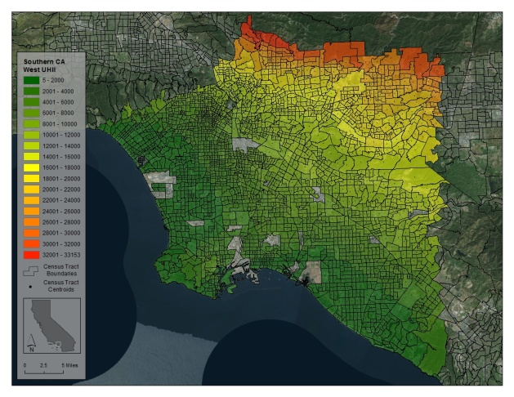

Fig.2 Urban heat island temperatures in the greater Los Angeles area. Image via CalEPA 2015

## Reading Air Temperature Data

Based on my analysis of the monthly temperature trends, there is significant change in temperature in the data collected in all months excluding November and December which showed almost 0 change in average minimum and maximum temperatures. Looking at this summary we see a slightly positive temperature slope (5.835e-05) which is highly significant. (The p-value is 2e-16, which is much less than 0.05). We see lots of variability that is not date driven. Therefore we reject the null hypothesis that there is a slope of 0! While we have determined that the overall trend of TMAX is significantly positive, it could be more revealing of certain trends to break these graphics down into smaller sets of data. Because this represents so much data compressed into one small graphic, its difficult to derive any meaning from this plot aside from a large general upward trend over time

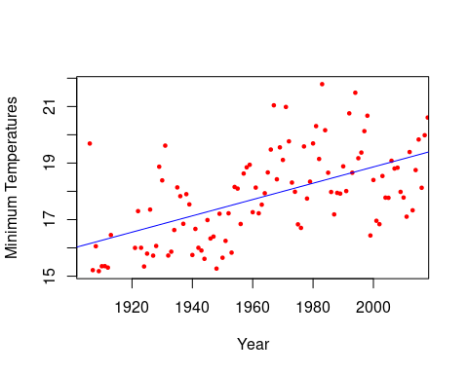

The p-value for this model was 1.762e-07 (which is much less than 0.05) and r-squared value of .228, meaning the trend is statistically significant, and that temperatures are in fact increasing in Los Angeles. Therefore we reject the null hypothesis that there is no association between time and minimum temperature! The overall trend of Minimum Temperature data is significantly positive meaning the trend is statistically significant, and that temperatures are in fact increasing in Los Angeles.

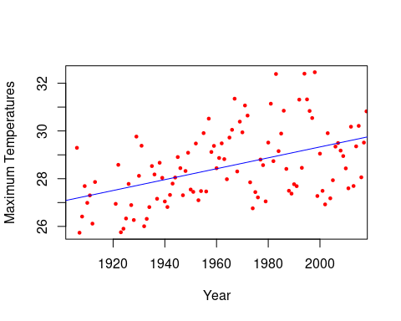

The p-value for this model was 4.201e-11 (which is much less than 0.05) and r-squared value of .0338. We see lots of variability that is not date driven. Therefore we reject the null hypothesis that there is a slope of 0! While we have determined that the overall trend of Maximum Temperature data is significantly positive meaning the trend is statistically significant, and that temperatures are in fact increasing in Los Angeles.

## Discussion

This data can help strengthen existing arguments around the idea that local activists and politicians have raised around the need for better heat mitigation to help the Los Angeles Metropolitan area. Eric Garcetti, Mayor of Los Angeles, has pointed for the need to take actions to fight against climate change through appropriate mitigation efforts (Netburn).The study Characterization of Urban Heat and Exacerbation: Development of a Heat Island Index discusses concerns that heat events may become more common and exacerbate urban populations particularly the elderly. The study helped determine that urban heat is exacerbated during warmer weather and that, in turn, can worsen the health impacts of heat events presently and in the future, for which it is expected that both the frequency and duration of heat waves will increase. This research can help public health agencies in quantify heat stress and make clear where developing mitigation plans or allocating various resources would be most effective (Taha 18). Another study Potential overall heat exposure reduction associated with implementation of heat mitigation strategies in Los Angele gives fascinating insight into heat mitigation that compares a variety of strategies . It explores both the benefits and flaws of analyzing the effects of increasing vegetative cooling the urban environment and its adverse consequences due to the associated potential increase in dew point temperatures (Sailor 5). Additional research must be done to account for monetary costs to implementation. It ignores a key factor of accessibility and general feasibility.

The analysis does not fully account for other factors that effect temperature averages throughout the years. Factors such as wind, existing vegetation, variance in existing architecture, etc. But, rather it points to a trend of large temperature rises that lack the same explanation as the wider look at climate change.

Additionally, there are several weather stations throughout Los Angeles all of which when looked at together will create an even more precise picture of the temperature shifts present then what will come from looking at just one station alone. More exploration needs to be done in determining how widespread these problems are and if the urban heat island phenomenon extends to more major cities (Taha 15).

## Conclusion: A Call to Action

This study points to an uneven distribution of negative effects of rising temperatures even across an area as small as one county. There seems to be shared understanding from the studies that elderly populations are at high risk for heat induced mortality and health issues. Additionally, there is a shared conclusion that it is likely with proper preparedness and mitigation efforts, Los Angeles can reduce the negative effects of heat on the population. More research needs to be done to access cost effective and timely ways in which communities can implement mitigation techniques.

## References

Kalkstein, A.J., Kalkstein, L.S., Vanos, J.K. et al. Heat/mortality sensitivities in Los Angeles during winter: a unique phenomenon in the United States. Environ Health 17, 45 (2018). <https://doi.org/10.1186/s12940-018-0389-7>

Montañez, C., & Fink, D. (2017, February 15). Opinion: L.A. is already trying to reduce the effect of its ‘urban heat island’. Retrieved September 27, 2020, from <https://www.latimes.com/opinion/readersreact/la-ol-le-heat-island-los-angeles-20170215-story.html> Netburn, D. (2017, February 9). L.A.’s mayor wants to lower the city’s temperature. These scientists are figuring out how to do it. Retrieved September 27, 2020, from <https://www.latimes.com/projects/la-sci-cooling-los-angeles/>

Sailor, D.J., Anand, J. Potential overall heat exposure reduction associated with implementation of heat mitigation strategies in Los Angeles. Int J Biometeorol (2020). <https://doi.org/10.1007/s00484-020-01954-5> Southern California Public Radio. (2017, May 31). LA area has highest urban heat island effect in California. Retrieved September 27, 2020, from <https://www.scpr.org/news/2015/09/21/54511/la-area-has-highest-urban-heat-island-effect-in-ca/>

Taha, H. Characterization of Urban Heat and Exacerbation: Development of a Heat Island Index for California. Climate 2017, 5, 59. <https://www.mdpi.com/2225-1154/5/3/59#>

<https://www.epa.gov/climate-indicators/climate-change-indicators-us-and-global-temperature>