Addressing and Communicating Climate Change Risks in Southeast Texas

Katy Swiere

9/29/2020

# Introduction

## About Orange, Texas

The town I grew up in sits along the Gulf of Mexico, at the Southernmost point where Texas and Louisiana meet. The climate is a humid, subtropical one, and has been victim to a significant amount of flooding during my lifetime. The area also suffers from droughts, tornados, hurricanes and occasionally severe winter weather.

Not many people would argue that hurricanes, tropical storms, and other severe weather seem to only be getting worse. Few, however, connect it to our changing climate worldwide.

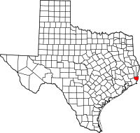

Where is Orange?

## Economics, Politics, and Culture in Southeast Texas

Southeast Texas and Southwest Louisiana are dominated economically by petrochemical industries, like oil refining and natural gas liquification. These jobs often pay well, rarely require more than technical school, and are more or less ubiquitous in our community. Perhaps understandably so, many residents fear that a transition to a clean energy economy and bold action on climate change means lost jobs; they fear that for them, the “cure” will be worse than the “disease.”

# Is the climate of Orange, Texas changing?

When you think of climate change, you may mostly think about changes in temperature. We know, however, that the impacts of climate change are much more than simple increases in temperature.

I conducted a regional analysis using daily data from Orange, Texas weather stations. This data was accessed for free through the National Oceanic and Atmospheric Administration, and you can even download the datayourself here: <https://www.ncdc.noaa.gov/cdo-web/search>

For my analysis, I used both minimum daily temperatures and maximum daily temperatures, averaged them for each month, and determined if there was a statistically significant trend. For most months, there was no disernable trend in temperature. I did find trends in the months of February, March, April, and August for minimum temperature as well as a trend in July for maximum temperature.

Let’s look at what we found:

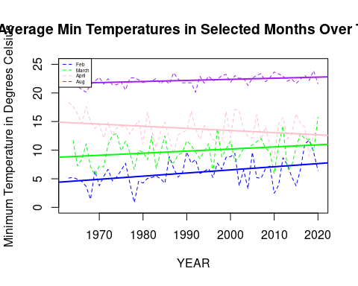 First, for our minimum temperature trends, three months seem to be warming (Feb, March, and Aug) while April appears to be cooling. Additionally, for our maximum temperature trend in July, it seems that daily maximum temperatures are actually decreasing.

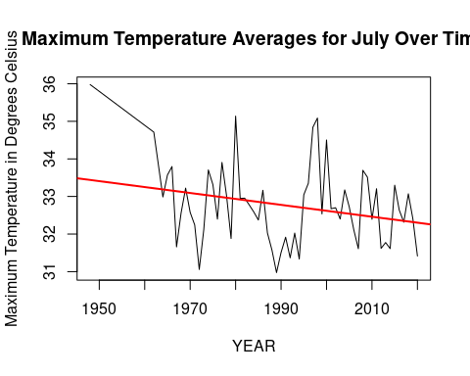

These temperature changes, regardless of whether they are going up or down, will affect weather patterns, agriculture, wildlife, and even human health. This highlights a very important axiom in the climate field: “global warming” does NOT mean that all places are warming all the time. Instead, it means that many places are seeing changes in trends over time. The findings of my analysis do not mean that the global average temperature is not changing, nor does it mean that Southeast Texas will not be affected by these changes.

We can see more worrisome changes much more clearly using precipitation data. For example, let’s take the month of August which is in the middle of the North Atlantic Hurricane Season.

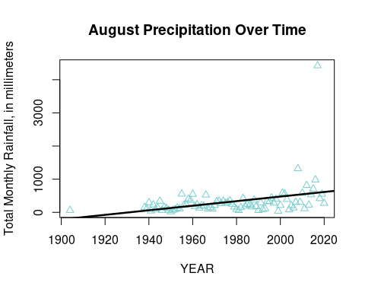 We can see from this graph, which shows data from the month of August, that precipitation has been steadily increasing over time.The black line is the line of best fit, and has a slope of 6.89, meaning that on average rainfall has increased about 6.89 millimeters per year since 1900. We can also see the extreme rainfall associated with Hurricane Harvey, which hit the area in August of 2017. 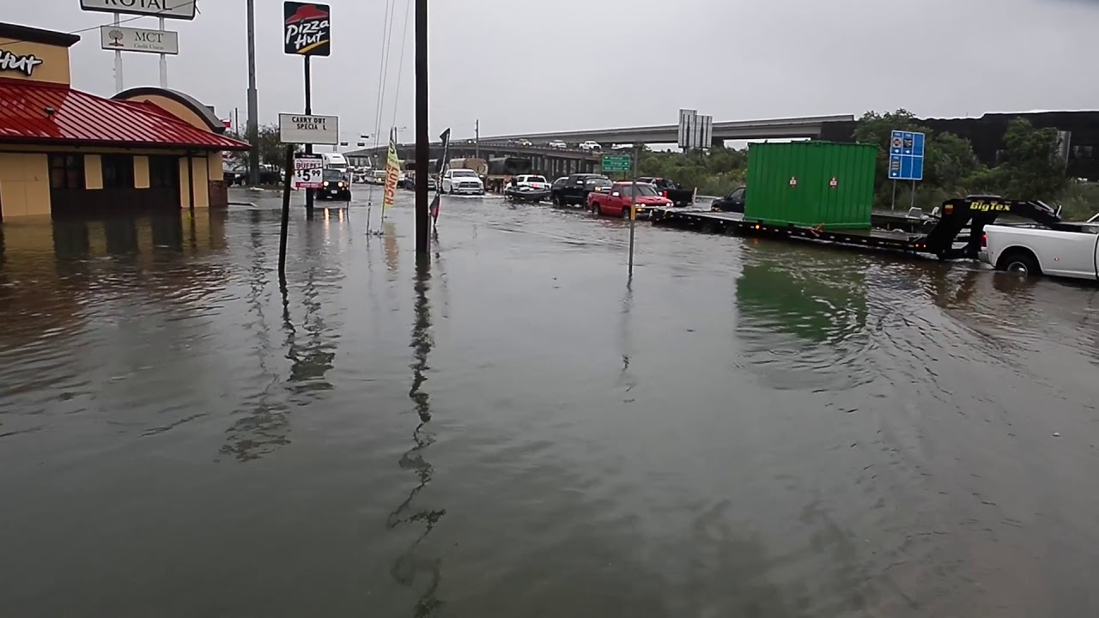

We can also see all months at the same time with this graph, which shows that August is not an exception. In fact, it looks like December has the strongest increase in precipitation over time. My analysis shows that total rainfall has increased overtime, in every month of the year. The R squared, an important metric in statistics which shows how well the observed data matches the line of best fit, is rather large for many months for the precipitation variable, making this conclusion even more compelling (.34 for January, .28 June, and .22 December are some particularly higher examples). This supports the conclusion of Mishra and Singh in “Changes in extreme precipitation in Texas” (2010) who assert that annual precipitation extreme events have increased in Southeast Texas.

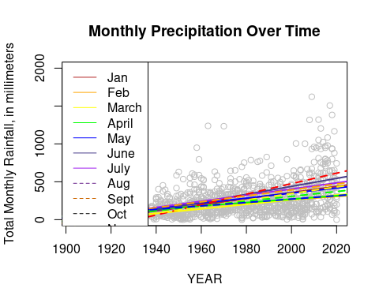 In this graph, the gray dots represent every month’s total precipitation in millimeters. A line of best fit for each month was added to show the differing, but similar, trends in each month.

# Peer-Reviewed Literature and Impacts

How does my analysis compare with peer-reviewed literature? Data analyzing the region of Southeast Texas is rare, since it is a rather small community. However, I can compare findings of literature in the surrounding area to see what other scientists have found. Mishra and Singh (2010) assert that annual precipitation extreme events have changed in mixed ways across the state of Texas, with increases in Southeast Texas.

In “Projected changes of temperature and precipitation in Texas from downscaled global climate models” (2012), Jiang and Yang project steadily increasing temperatures in Southeast Texas and a complicated relationship with precipitation. Based on an emissions scenario of 3.6 degrees Celsius increase by the end of the century, the authors project small increases in temperature and a wetter climate for Southeast Texas, which aligns well with my regional analysis. They note that East and Central Texas “are projected to become drier in winter and wetter in summer” which has not yet begun according to my analysis, which predicts wetter conditions in every month.

These impacts can be severe. According to the project Flood Factor, 1,998,521 properties are already at risk in Texas, and within 30 years, about 2,115,886 will be at risk. Additionally, Marsha, Sain, Heaton, Monaghan, and Wilhelmi (2018) assert that higher emissions will lead to higher levels of heat-related mortality in the region.

# Activists

“Climate activits” as we might normally define the term, are a rare species in Orange, Texas. In fact, I would be hard-pressed to find a single other person in my community who is actively concerned about and regularly takes actions on mitigating or adaptating to climate change.

As one Grist journalist points out, “‘Future-proofing’ is how you say climate change in Texas.”

“Stopping climate change” is political and threatening. “Future-proofing”, on the other hand, is just good practice.

So - how do we answer this question: How are local activists using climate data? In this case, we’ll think about how state and local government is preparing for climate change, even without saying those two little words.

Many Southeast Texas local governments have begun implementing a variety of programs aimed at reducing the costs of floods, storms, and extreme weather events. One easy way to minimize flood risk damages is by limiting development in high-risk areas. This sounds simple enough, but is much more difficult in practice. For one thing, many houses, businesses, and other developments are already built in high-risk areas. Instead of simply kicking these inhabitants out, one option is for the government to subsidize movement into less flood-prone areas. In Jefferson County, this buyout program does exactly that. Harris County has a similar program, which notes that it is not an immediate flood relief program, but aims to prevent flood damage BEFORE it happens. Think of it as eating healthy to prevent disease, instead of eating only junk food and then hoping a treatment helps.

# Conclusion

There is no question that the climate is changing but there is a lot of uncertainty about how exactly these changes will manifest themselves in Southeast Texas. Nevertheless, precipitation has - according to my analysis and that of others - increased over time and will likely continue to worsen due to human-caused climate change. Though some local governments in the area have begun taking action to address the impacts of climate change, perhaps it is time to start addresses the root causes.