Central California Alternative Fire Management Exploration

Teague Scanlon

10/8/2018

# Blodgett Forest Research Station, Central Sierras, CA

## Ecology and Climate

The Central Sierras, specifically around the Blodgett Forest Research Center where quantitative analysis was performed, is categorized as a Mixed Conifer Forest, which is also found in the Southern Rockies, the Southwestern Plateaus and Uplands, and the Southern California Transverse and Peninsular Ranges. Because of selective harvesting and different fire management techniques than in the past, the forest structure is more homogenous than ever before. Mixed-Conifer Forests are generally made up of Pines, Firs, and Cedars, but this area in specific is comprised of more White Fir and Incense Cedar than in times past. This region generally receives about 60cm of precipitation annually, with snow usually falling from December to April (1). Summers are relatively dry, and are expected to get warmer and drier as Climate Change increases in severity over the next century.

## Historical Fire Management

Fire Management in the Central Sierras has been occurring for centuries prior to the creation of Forest Service-led fire management, which began in the early 20th century. Native Americans utilized prescribed burning every 10 to 20 years in this region. However, since the removal of Native Americans and their relatively regular oversight of low-mid severity fires, the forests of the Central Sierras have gotten denser, and the average fuel load has increased. In particular, the forest floor and the understory have increased in mass, which facilitates unpredictable, high severity fires that can easily be transferred to the canopy.

## Fire Treatment Methods and their Costs

Prescribed Fires are very commonly used as a way to manage fuel loads in forests, because if a forest goes untamed for too long, when it does ignite it will burn very intensely and is generally less predictable than low-severity fires. Interestingly, the cost of prescribed fires (both management-ignited and naturally occuring) varies greatly based on geographic region. In the Southeastern United States the average cost of a management-ignited prescribed burn is $78.13 per acre, but varies from $22.80 per acre in the South to $223.38 per acre in the Pacific Northwest. Prescribed Natural Fires prove even more geographically varied, costing $375.75 per acre in the North, but only $2.10 per acre in the south. Specific methods of prescribed fires can also differ, with some management techniques burning only the underbrush and forest floor but attempting to leave the canopy unharmed. Other times, burns are performed around specific tree species to artificially alter the forest structure. Mechanical thinning is another method of fire prevention involving the physical removal of fuel loads using saws and by dragging matter out (and sometimes burning that matter during specific-well planned times). The cost of this fire-regime also varies drastically, but is generally more expensive than prescribed fires because of the labor that goes into this process. In the Sierra Nevadas specifically, this costs between $350 and $3,500 per acre.

'FireBlodgett Image'

## An Analysis of Different Management Techniques

A study led by two Ohio State Professors studied the effects of prescribed fires, mechanical thinning, and a combination of the two on carbon fuel loads in the years following the fire management procedure. A randomized complete block was used in forest environments in each of 12 different locations around the continental United States, and the carbon load that was surveyed in each of these locations was measured in megagrams per acre.

In order to get a better idea of the effects of the different treatment methods across the entire United States, the change in carbon load (Delta) was compared with the specific treatment methods, as can be seen below. The P value, representing the confidence with which differences in delta can be attributed to the different treatment methods, proved to be .000465. This very low number means that the effects of the different treatment methods, prescribed burning, mechanical treatment+prescribed burning, and mechanical treatments, are significant enough to confidently say that they affect the environment in different ways.

## Df Sum Sq Mean Sq F value Pr(>F)   
## Treatment 3 6341 2113.8 7.352 0.000106 ***  
## Residuals 202 58074 287.5   
## ---  
## Signif. codes: 0 '***' 0.001 '**' 0.01 '*' 0.05 '.' 0.1 ' ' 1  
## 35 observations deleted due to missingness

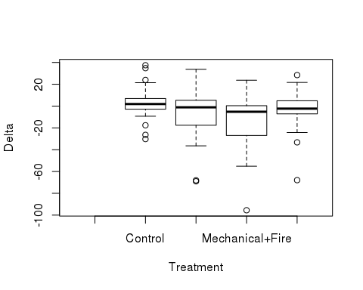

Change in carbon load was also compared to site and treatment together, to see if the treatment methods had different effects across various different locations. The box plot below visualizes this relationship. While some of the datapoints highlight large changes in carbon load due to the different treatment methods performed, the error bars remain relatively wide, likely due to the small datasets that are present within each of these categories (only about 2-4). The P value for this analysis came out to about .43, which is nowhere near the 0.05 that is required to deem a relationship statistically significant. The high confidence value suggests that the effects of the treatment methods across the 12 different sites aren't unique enough to confidently state that change in carbon load can be attributed to both the treatment method as well as the specific location.

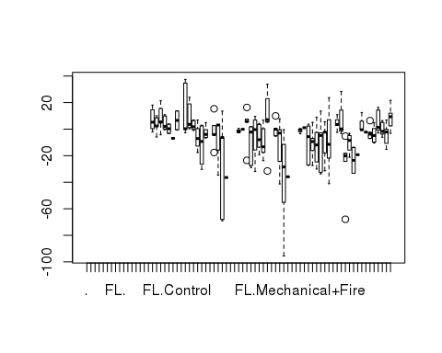

## Df Sum Sq Mean Sq F value Pr(>F)   
## Site 13 9134 702.6 2.797 0.00129 **   
## Treatment 3 7529 2509.8 9.991 4.65e-06 ***  
## Site:Treatment 34 8815 259.3 1.032 0.43056   
## Residuals 155 38938 251.2   
## ---  
## Signif. codes: 0 '***' 0.001 '**' 0.01 '*' 0.05 '.' 0.1 ' ' 1  
## 35 observations deleted due to missingness

# Conclusion

With the lowering budget being allocated to the Forest Service combined with more development in the Wildland-Urban Interface (which is relatively costly to manage) the Forest Service has to weigh the pros and cons of different fire management techniques, taking into account both the effectiveness in lowering the carbon fuel load as well as the cost of facilitating each method. According to the data compiled from the 12 sites around the Continental U.S., a combination of prescribed fire and mechanical thinning is the most effective way to reduce the fuel load in the years following the managament technique. Given the relatively high price associated with mechanical thinning, however, in times of tight budgeting prescribed burns are most likely the most efficient use of monetary resources.