Fire Management Alternatives: Central Sierra Nevada Mountains (California)

Teague Scanlon

12/16/2018

# Introduction To The Site: The Blodgett Forest Research Station

The Blodgett Forest Research Station has been researched and managed by the UC Berkeley School of Forestry since being donated to the University of California system in 1933. The surrounding forest is compartmentalized into 90 different sections of about 33 acres each, which allows for interesting and diverse research on the effects of different forest management techniques. While many of the management methods utilize costly techniques that wouldn’t be feasible statewide, the well-documented and regularly published data measuring succession, biodiversity, and fuel load allow of a comprehensive understanding of forest dynamics within the Central Sierra Nevada Climate.

# Historical Ecology and Climate of the Region

Fire Management in the Central Sierras has been occurring for centuries prior to the creation of Forest Service-led fire management, which began in the early 20th century (Mckelvey). Historically, Native Americans practiced regular burning every 10 to 20 years in this region, but since the removal of Native Americans and their relatively regular oversight of low-mid severity fires, the ecology of the Central Sierras has changed (Mckelvey). Much of the region was used for logging in the late 19th century and on, utilizing selective harvesting and less frequent controlled burns than during Native American Management (University of California). These factors combined with more water stress in the past century have made the Forest Structure of the Central Sierras denser and more homogenous (Mckelvey, McIntyre et al.). Additonally, the average fuel load has increased on the forest floor and in the understory, which facilitates unpredictable, high severity fires that can easily be transferred to the canopy (Weatherspoon). This region generally receives about 166 cm of precipitation annually, with snow usually falling from December to April (University of California). Summers are relatively dry, and are expected to get warmer and drier as Climate Change increases in severity over the next century (Sanders).

# Fire Treatment Methods and their Costs

Prescribed Fires are very commonly used as a way to manage fuel loads in forests, because if a forest goes untamed for too long, when it does ignite it will burn very intensely and is generally less predictable than low-severity fires (Sanders). Interestingly, the cost of prescribed fires (both management-ignited and naturally occurring) varies greatly based on geographic region. In the Southeastern United States the average cost of a management-ignited prescribed burn is $78.13 per acre, but varies from $22.80 per acre in the South to $223.38 per acre in the Pacific Northwest (Cleaves). Prescribed Natural Fires, which are often caused by lighting, prove even more geographically varied, averaging $375.75 per acre in the North, but only $2.10 per acre in the south (Cleaves at al). Specific methods of prescribed fires can also differ based on management objectives, with some agencies burning only the underbrush and forest floor but attempting to leave the canopy unharmed, while other burns are performed around specific tree species to artificially alter the forest structure. Mechanical thinning is another method of fire prevention involving the physical removal of fuel loads using saws and by dragging matter out (and sometimes burning that matter during specific, planned-out times). The cost of this fire-regime also varies drastically, but is generally more expensive than prescribed fires because of the labor that goes into this process. In the Sierra Nevadas specifically, this costs between $350 and $3,500 per acre depending on topography, road access, and proximity to the Wildland-Urban Interface (Carson Range Fuel Reduction and Wildfire Prevention Strategy). Since the relatively intense 2018 fire season, the topic of fire management (and the funding that allows for it) has spent more time than usual in the public limelight. On September 21st, 2018, Governor Jerry Brown “signed bills authorizing a $1 billion, five-year plan to thin forests, including by easing rules on logging.” The Trump administration dedicated a fund for thinning and prescribed burning starting in 2020, with some experts advocating for four times the thinning that is currently occurring (Carlton).

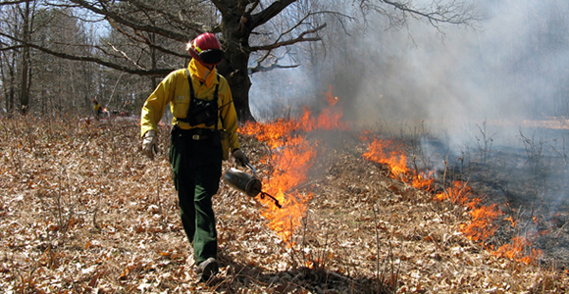

Figure 1. A Wildland Firefighter prepares a prescribed burn to thin a forest

# Statistical Analysis of Different Management Techniques

A study led by two Ohio State Professors researched the effects of prescribed fires, mechanical thinning, and a combination of the two on carbon fuel loads in the years following the fire management procedure, in order to quantify the effectiveness of the different treatment methods. A randomized complete block was used in forest environments in each of 12 different locations around the continental United States, and the carbon load that was surveyed in each of these locations was measured in megagrams per acre (Scott et al.).

In order to get a better idea of the effects of the different treatment methods across the entire United States, the change in carbon load (Delta) was compared with the specific treatment methods. The P value, representing the confidence with which differences in delta can be attributed to the different treatment methods, proved to be < 0.001, suggesting that the fuel load in the following years differs based on the management technique that was previously utilized.

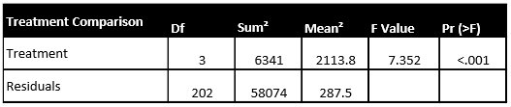  
Table 1. An Analysis of Variance Test highlights the signficance of the treatment method to affect the fuel load 3 years after the treatment occurred.

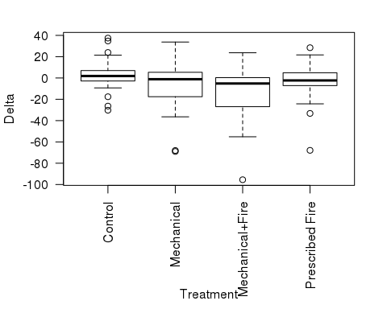 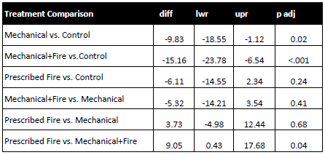  
Table 2. A Tukey Test was performed to analyze the relationships between specific treatment methods. Statistical significance (P<.05) is evident between Mechanical-Control, Mechanical+Fire-Control, and Mechanical+Fire-Prescribed Fire

# Conclusion

With the lowering budget being allocated to the Forest Service combined with more development in the Wildland-Urban Interface (which is relatively costly to manage) the Forest Service has to weigh the pros and cons of different fire management techniques, taking into account both the effectiveness in lowering the carbon fuel load as well as the cost of facilitating each method. According to the data compiled from the 12 sites around the Continental U.S., a combination of prescribed fire and mechanical thinning is the most effective way to reduce the fuel load in the years following the management technique. Given the relatively high price associated with mechanical thinning, however, in times of tight budgeting prescribed burns are most likely the most efficient use of monetary resources.

# Works Cited

Agee, James K., and Carl N. Skinner. “Basic Principles of Forest Fuel Reduction Treatments.” Forest Ecology and Management, vol. 211, no. 1-2, 2005, pp. 83–96., <doi:10.1016/j.foreco.2005.01.034>.

Boerner, Ralph E.j., et al. “Fire, Thinning, and the Carbon Economy: Effects of Fire and Fire Surrogate Treatments on Estimated Carbon Storage and Sequestration Rate.” Forest Ecology and Management, vol. 255, no. 8-9, 2008, pp. 3081–3097., <doi:10.1016/j.foreco.2007.11.021>.

Carlton, Jim. “Facing Deadlier Fires, California Tries Something New: More Logging.” The Wall Street Journal, Dow Jones & Company, 17 Nov. 2018, www.wsj.com/articles/facing-deadlier-fires-california-tries-something-new-more-logging-1542390642.

“Carson Range Fuel Reduction and Wildfire Prevention Strategy.” USDA Forest Service, USDA, www.fs.usda.gov/Internet/FSE_DOCUMENTS/fsm9_025940.pdf.

Cleaves, David A., et al. Prescribed Burning Costs: Trends and - US Forest Service. US Forest Service, www.fs.fed.us/psw/publications/documents/psw_gtr173/psw_gtr173_06_cleaves.pdf.

McIntyre, Patrick J., et al. “Twentieth-Century Shifts in Forest Structure in California: Denser Forests, Smaller Trees, and Increased Dominance of Oaks.” PNAS, National Academy of Sciences, 3 Feb. 2015, www.pnas.org/content/112/5/1458.

McKelvey, K.S., et al. “An Overview of Fire in the Sierra Nevada.” Water-Resources Investigations Report, 1 Jan. 1996, pubs.er.usgs.gov/publication/70006799.

Sanders, Robert. “Warmer, Drier Climate Altering Forests Statewide.” Berkeley News, UC Berkeley, 9 July 2015, news.berkeley.edu/2015/01/20/warmer-drier-climate-altering-forests-statewide/.

Scott L. Stephens, James D. McIver, Ralph E. J. Boerner, Christopher J. Fettig, Joseph B. Fontaine, Bruce R. Hartsough, Patricia L. Kennedy, Dylan W. Schwilk; The Effects of Forest Fuel-Reduction Treatments in the United States, BioScience, Volume 62, Issue 6, 1 June 2012, Pages 549–560,

“Thinning & Improvement Cuttings.” UF-SFRC : 4-H : Common Persimmon, www.sfrc.ufl.edu/Extension/florida_forestry_information/forest_management/thinning.html.

University of California. “Blodgett Forest Research Station.” Extending Orchard IPM Knowledge in California, University of California, Agriculture and Natural Resources, ucanr.edu/sites/cff/Blodgett_Forest_Research_Station/#usage.

Weatherspoon, Phillip C., and Carl N. Skinner. USGS DDS-43, Landscape-Level Strategies for Forest Fuel ... US Forest Service, www.fs.fed.us/psw/publications/skinner/psw_1996_skinner(weatherspoon)004.pdf.