How does proximity to wildfire affect PM2.5 exposure and health risk?

By Baili Zhong, Pomona College EA30, Environmental Analysis

Oct 31, 2018

PM2.5 is a pollutant regulated by the Clean Air Act. According to The American Heart Association, PM2.5 can cause heart and lung problems only after a few hours of exposure (Brook et al. 2010). Longer term exposure over a few years can reduce life expectancy (Brook et al. 2010). PM2.5 is atmospheric particulate matter (PM) with a diameter of less than 2.5 micrometers, about 3% of the diameter of human hair (Miettinen 2018). Wildfires are a major source of PM2.5. In 2017, California ranked third in terms of acres burned (Insurance Information Institute, Inc. 2018). Frequency of large California wildfires have been increasing since the 1970s (Petras et al. 2018). On July 23th, 2018, the Carr Fire became the state's 6th most destructive fire (Insurance Information Institute, Inc. 2018). Four days later, the Mendocino Complex Fire began and grew to become the state's largest fire, burning over 459,000 acres (Insurance Information Institute, Inc. 2018). Not only do wildfires cause significant property damage and loss of life but produces PM2.5 that poses significant health risks (Miettinen 2018).

On December 14, 2014, the EPA strengthened air quality standards to reflect a 12.4 μg/m3 primary annual standard. This standard reflects the normal, safe concentration unusually sensitive individuals can safely tolerate over the course of a year. Sensitive individuals include those with severe asthma and other cardiopulmonary problems. Furthermore, levels above 35.4μg/m3 can cause respiratory problems in the elderly, children, and those affected by less severe cardiopulmonary problems. Levels above 55.4μg/m3 can cause respiratory problems for healthy adults. The 2007 Southern California wildfires had unsafe PM2.5 levels above 35.4μg/m3 (EPA 2012), more than double the primary annual standard.

**Primary Annual PM2.5 Standard (μg/m3)** 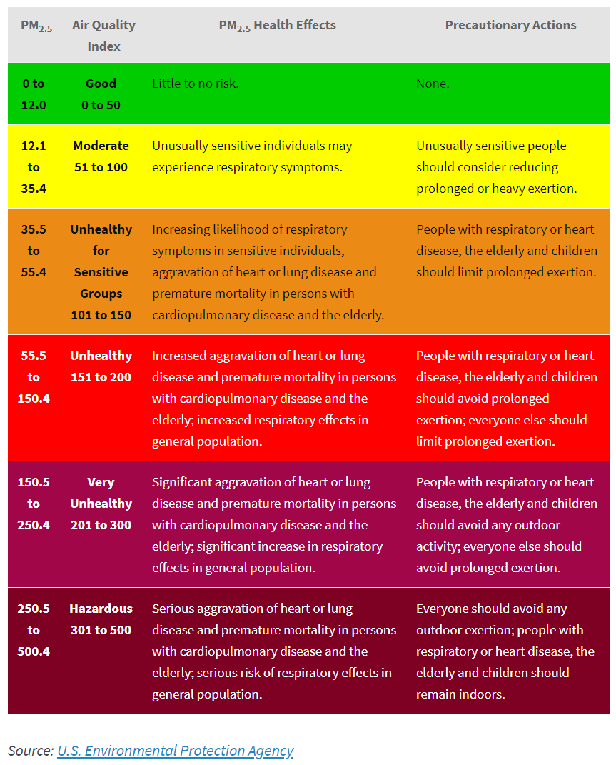

**2007 Southern Californian Wildfires**

The Witch Fire was the second largest wildfire in the 2007 California wildfire season, claiming over 247,000 acres and 1,265 residential buildings (Wikipedia 2018). It lasted from October 21, 2007 to November 13, 2007. It started in Witch Creek Canyon, near Santa Ysabel and spread throughout San Diego County (Wikipedia 2018). The Harris, Witch, McCoy Fire, Coronado Hills Fire, Rice, Poomacha, Ammo (Horno) Fire, and Wilcox Fire also burned in San Diego County during the same wildfire period and could contribute to the increased levels of PM2.5. (Wikipedia 2018). Strong Santa Ana winds pushed the fires west toward the coast, forcing over 500,000 people to evacuate. On Monday, October 22, the Santa Ana winds peaked with sustained wind speeds of 90mph (140km/hr).

To study the effects of PM2.5 in the Witch Fire and surrounding fires, I collected daily summaries from the “AQS Data Mart”. This data contains PM2.5 levels measured by the EPA, state, local, and tribal air pollution control agencies. The data consisted of 5 monitoring stations in San Diego County (EPA 2008). Stations are named by the city where they are located and/or by the EPA's station number. Street names were also provided for the two monitoring stations in the city of San Diego. The pre-fire period was from October 15, 2007 to October 20, 2007. October 21, 2007 to November 13, 2007 was the wildfire period. November 14, 2007 to December 31, 2007 was set as the post-fire period. The 12.4μg/m3 primary annual standard and 35.4μg/m3 safety threshold were used to extrapolate health effects with the understanding that longer exposure to PM2.5 could decrease the PM2.5 levels necessary to cause negative health effects.

**Graph of Daily Mean PM2.5 Concentration for San Diego County from October 15-December 31, 2017** 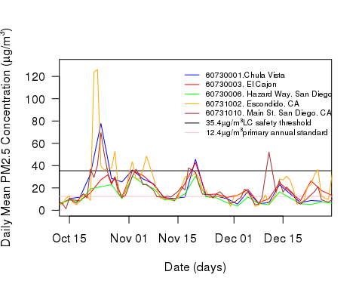

**Analysis: How does proximity to wildfire affect PM2.5 exposure and health risk?**

Escondido, CA had the highest concentration of PM2.5 after Oct 21 until Oct 24, peaking at 126.2μg/m3 on Oct 24 while Main St, San Diego and Chula Vista peaked at 77.8 and 69.62g/m3, respectively on Oct 24.

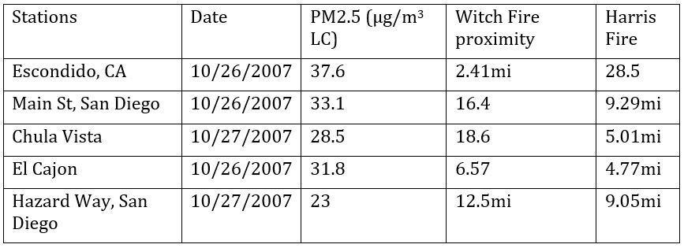

PM2.5 on Oct 26-27 levels

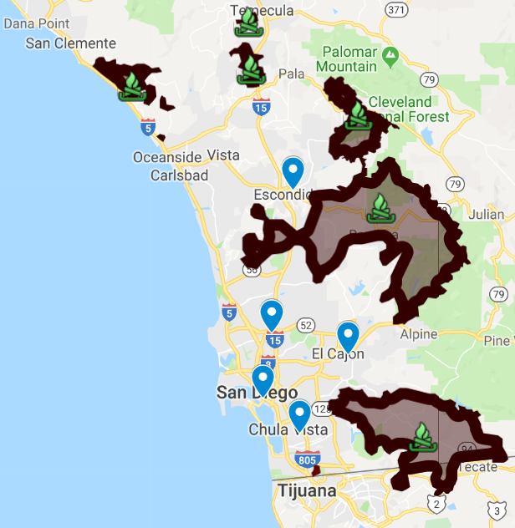

Map of 2007 California wildfires as of Oct 26, 2007. The Harris, Witch, Rice, Poomacha, Horno, Wilcox, and Rosa Fires are also included. Fire labels provided on map [LINK](https://www.google.com/maps/d/u/0/viewer?mid=1iamjtnoH46clRmWGmxgovE_mn_TLmMRE&ll=32.772992998925375%2C-117.0564055829168&z=11) (Ranger Al 2007). Monitoring stations added by Baili Zhong in blue.

###### *Stations are referred to by location and proximity to wildfire as of Oct 26 according to the above map.

Despite the distance from the fires on Oct 26, the PM2.5 levels were relatively similar except for the city of Escondido which had the closest proximity to the fire. It was the only one above the 35.4μg/m3 safety threshold. Thus, proximity does not necessarily dictate PM2.5 levels. Factors such as wind and weather conditions also play a major role. For example, the strong Santa Ana winds pushed the fires west toward the coast.

The Witch Fire perimeter was fully contained by Nov 6. By Nov 11-Nov 12, PM2.5 levels throughout the San Diego County lowered to near 12.4μg/m3 primary annual standard levels, except for El Cajon which still had levels of 35.5μg/m3 on Nov 11. As expected, there were still unsafe PM2.5 levels days after the fire.

PM2.5 levels for all 5 stations started rising after Nov 17 even though the fires were extinguished on Nov 13. PM2.5 levels last much longer than the initial wildfire period and could lead to latent health complications. Furthermore, only by Dec 8 did the last monitoring station, Escondido, reach safe levels under 35.4μg/m3. Only by Dec 20 did PM2.5 levels decrease to 12.4μg/m3 primary annual standard levels that would be safe for unusually sensitive individuals. **PM2.5 levels do not end with the quenching of wildfires but can fluctuate around unsafe levels for at least a month according to the PM2.5 data collected during the 2007 Southern California wildfires.** The public should be aware that respiratory problems months after a fire can still occur. Thus, regular check-ups, or at the very least, decreased outdoor activity can help alleviate potential respiratory problems.

Closer proximity to wildfires usually leads to higher PM2.5 rates even a month after the fire has been put out but weather conditions also play a huge role. A study by Ikuho et al. 2016 estimates the medical costs of the 2007 Southern California wildfires to be $3.4 million. However, the true cost is much higher as the $3.4 million figure does not consider the cost of mortality, symptoms not reported to hospitals, or the costs of avoiding wildfire smoke. Wildfires cause serious health effects and can lead to higher hospital admissions and societal consequences long after and before fire quenching—a topic further explored by the articles by Johnathan Gunasti, Mia Kania, and Mason Asato.

**Limitations and Future Research**

The EPA data set used in this study only measured PM2.5 and did not include other harmful pollutants such as CO, Pb, NO2, Ozone, PM10, and SO2. The combination of multiple pollutants in addition to PM2.5 measurements is a better indicator of health risk and is a topic worth further exploration. Furthermore, the data did not extend further than the 2007 year and thus, PM2.5 concentrations may fluctuate longer than the observed period after a major wildfire, increasing health risk. Wind conditions besides the Santa Ann were not mentioned and could explain the discrepancy between Hazard Way, San Diego and Main St, San Diego PM2.5 levels despite their <0.3mi difference from the wildfire perimeters. Furthermore, the Map of 2007 California wildfires presented only showed the fire perimeters as of Oct 26, 2007. Thus, the effect of wildfire proximity on PM2.5 levels could be further explored with more daily analyses of fire perimeter to monitoring station distance.

**LITERATURE CITED**

Brook, R. et al. 2010. “Particulate matter air pollution and cardiovascular disease: an update to the scientific statement from the American Heart Association.” Circulation: Journal of the American Heart Association. vol. 121, pp. 2331–2378.

Kochi, Ikuho. et al. 2016. “Valuing Morbidity Effects of Wildfire Smoke Exposure from the 2007 Southern California Wildfires.” Journal of Forest Economics, vol. 25, 2016, pp. 29–54, <doi:10.1016/j.jfe.2016.07.002>

Insurance Information Institute, Inc. 2018. “Facts + Statistics: Wildfires.” <https://www.iii.org/fact-statistic/facts-statistics-wildfires>

Miettinen, Ville. 2018. “What is PM2.5 and Why You Should Care.” <https://blissair.com/what-is-pm-2-5.htm>

Petras, George, et al. “California Is Burning.” USA Today, 7 Aug. 2018, www.usatoday.com/pages/interactives/news/california-wildfires-carr-fire-data/

Ranger Al. 2007. “Witch Fire Map Oct 26/07.” <http://www.fireupdate.com/2007/2007maps.htm>

United States Environmental Protection Agency (EPA). 2008. “Outdoor Air Quality Data.” <https://www.epa.gov/outdoor-air-quality-data/download-daily-data>

United States Environmental Protection Agency (EPA). 2012. “REVISED AIR QUALITY STANDARDS FOR PARTICLE POLLUTION AND UPDATES TO THE AIR QUALITY INDEX (AQI).” <https://www.epa.gov/sites/production/files/201604/documents/2012_aqi_factsheet.pdf>

Wikipedia contributors. 2018. "2007 California wildfires." 2018. <https://en.wikipedia.org/wiki/2007_California_wildfires>

Wikipedia contributors. 2018. "Witch Fire." 2018. <https://en.wikipedia.org/wiki/Witch_Fire>