Area and Population Relating to Fires in California Counties

Gabriel Das

10/13/2018

## Introduction

Fuel management is an important strategy in combating wildfires throughout the state of California. Fuel is defined as live or dead brush that has built up over time and assists fires to grow and spread. Brush removal is therefore a common type of fuel management. Given the large size of California, there are different techniques and priorities for each county, with differences being between northern and southern California, where the temperature and soil moisture vary. Some counties are more populated than others, which is a major factor in determining which types of fuel management to use. In the case of more populated counties, prescribed fires may be discouraged in favor of other types of fuel management involving laws and regulations. This is because of the high number of people who live in Wildland Urban Interfaces (WUIs). It would be unwise for prescribed fires to be used in highly populated WUIs since it risks the public's safety. Another factor is the area of each county. This may be related to the acres of land burned in each county.

## Background

I collected data from the Cal Fire website, where I found the total number of acres burned and fires in each county of California that there was data for from March to October of 2018. Also from there, I found links that gave information for a few counties for the acres of prescribed fires and fuel management. I found population data for each county from the World Population Review website, and I found the areas of each county from the California State Association of Counties website. An article from Berkeley University also describes the relationship between fire and fuel management.

## Fuel Management

Fuel Management consists of prescribed burning in addition to brush removal, ensuring space between houses and WUIs, and creating a budget for combating fires when they do arise. The latter methods are more common in counties with a higher population. Fuel management such as brush removal and reducing tree population density. Prescribed fires are used after taking into account weather, climate and topography of the region (Husari, 2006)

## Prescribed Burning

Prescribed burns are designed to control and monitor certain regions to burn biomass which acts as fuel. This is supposed to reduce the risk of a wildfire returning. Below is a graph depicting prescribed fires of six different counties and how they relate to the acres of land burned in each county. Except for one outlier for an exceptionally large amount of burned acres in Shasta County, there is shown to be an exponentially decreasing function for counties that used prescribed fires.

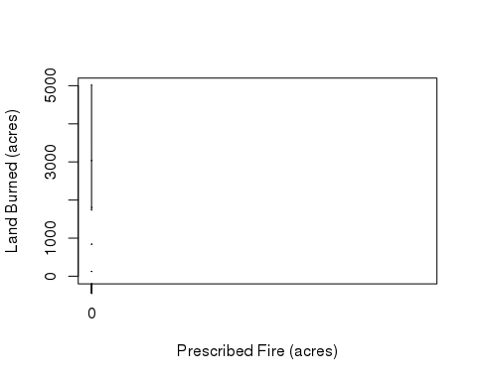

The other graph below shows the relationship between prescribed fires and the number of fires. The more acres affected by prescribed fires in each county, the more fires there are in that same county. While this may seem to disprove the effect of prescribed fire on combating fire regimes, looking closer at the data suggests that while the number of fires increase, they tend to be smaller than in counties without prescribed burning. There are exceptions, of course.

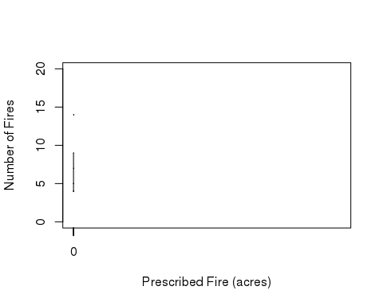

## Area of Counties affected

(Biggest Three CA Counties).

(Biggest Three CA Counties).

Kern and Los Angeles are two of the biggest counties in terms of area, who also have no prescribed fires. They also have among the largest amount of acres used for fuel management.

## Population

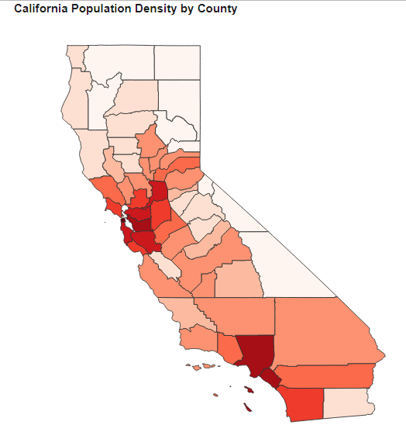

(California population density by county).

The three counties with the highest population are: 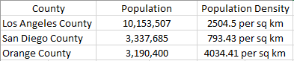

Los Angeles County suffered a total of 1,737 acres burned from 5 different fires San Diego County suffered a total of 713 acres burned with 15 different fires Orange County suffered a total of 330 acres burned from 3 different fires.

The three counties with the lowest population are: 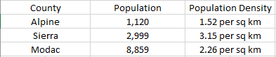

Alpine and Sierra suffered no acres burned, since there have been no fires in these counties in 2018 thus far. Modoc County, on the other hand, suffered 58,569 acres of land burned from only 3 fires. This puts Modoc County among the top of counties in California that experienced the most acres burned.

## Discussion

It seems that size of counties has no real effect on the amount of acres burned in each county. Big counties did not necessarily have bigger or more fires than small counties. Also, population in each county did seem to have a small effect. Counties with more people tended to have less fires than those with less people. In addition, larger counties did not use prescribed fires as much as smaller counties. These counties instead focused more on other types of fuel management which took up a great amount of acres. As a result, big counties with more people saw less fires or acres burned than small counties with a low population. One can compare Los Angeles County to Modoc County to observe this.

## Conclusion

Fuel management is obviously varied among California counties, and rightly so. Different counties have a different landscape and climate. Population and area are also shown to have an impact on determining what types of fuel management to use, as well as how much each county is affected by wildfires. While my analysis isn't conclusive, it shows a slight trend in the relationship between the aforementioned variables. There are many exceptions to observed trends, which tend to be outliers that likely have other causes not mentioned here. What can be said certainly is that bigger, more populated counties are less likely to use precribed fires, focusing more on biomass removal. As a result, these counties are less likely to see wildfires returning and burning as many acres as other California counties.

## Bibliography

<http://www.fire.ca.gov/current_incidents>

<http://worldpopulationreview.com/states/california-population/>

<http://www.counties.org/pod/square-mileage-county>

<https://nature.berkeley.edu/stephenslab/wp-content/uploads/2015/04/Husari-et-al-Stephens-Fuel-Man-AFE-9-06.pdf>