### How Are Warming Autumns Impacting Fall Foliage and the Tourist Economy In New Hampshire?

Susannah Budd  
03/01/2019

#### An Introduction to New Hampshire and Tourism

New Hampshire is a small, primarily rural state, home to 1.3 million people in the middle of Northern New England. Historically, New Hampshire was an industrial state, with major cities centered around paper or textile mills. However, with the advent of globalization and the loss of most of this business, New Hampshire needed to rebrand its economy. Today, the two largest industries in the state are Smart Manufacturing & High Technology (SMHT) and Tourism (“New Hampshire Population 2019,” 2019). The SMHT industry is concentrated in southern New Hampshire, leaving the rest of the state largely dependent on the tourist economy.

Luckily, the state is home to a variety of natural attractions, with mountains, lakes, and seacoast. The most notable feature of New Hampshire tourism is likely the state’s famous fall foliage. Out-of-state “leaf-peepers” pour into the state throughout September and October, hoping to witness the green leaves changing to reds and oranges – and spending nearly three-hundred million dollars in-state in the process (New Hampshire Department of Environmental Services, 2008).

Tourism is most important to the state’s North Country. In the North Country, isolation and a small tax base are significant barriers to economic development (“The Ultimate Guide To The North Country Economy,” n.d.). The northern regions which have successfully been able to rebrand themselves as tourist destinations, most notably Carroll County, are the most economically viable northern regions today. One-fifth of Carroll County’s population is working in the service industry, making tourism an essential lifeline for a vulnerable region (“The Ultimate Guide To The North Country Economy,” n.d.).

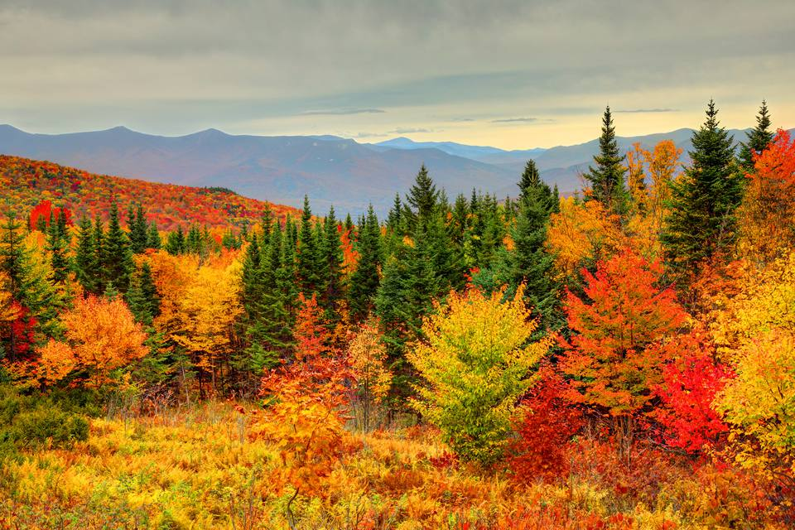

Peak Foliage in New Hampshire's White Mountains. Retrieved from <https://www.tripsavvy.com/see-peak-new-england-fall-foliage-1600409>.

#### An Introduction to Leaf Phenology

Many tourism jobs in New Hampshire’s North Country rely on the fall foliage season. The transition from green summer leaves to the reds and oranges of fall occurs through a process connected to plant photosynthesis. This food-making process of leaves produces chlorophyll, a green-pigmented compound (Lev-Yadun, 2016). Yellow and orange pigments, called carotenes, are also produced, however, carotene pigments are largely masked by the vibrant green color throughout most of the leaf’s lifespan. As days begin to shorten, a signal that winter is arriving, photosynthesis stops, and chlorophyll begins to break down. This exposes the colors of the carotenes which are left behind, forming the beautiful colors of foliage (Lev-Yadun, 2016). Although the onset of fall foliage is triggered largely by changes in daylight, the appearance and duration of such foliage, or “leaf phenology,” is largely dependent on temperatures.

The intensity of the red and purple colors which add beauty and depth to a foliaged landscape is determined by the presence of anthocyanin (Chalker-Scott, 1999). Anthocyanin is formed by plants to protect themselves from overexposure to the sun as they begin to lose their leaves before winter and continue to use the nutrients remaining in the dying leaves as efficiently as possible (Feild, 2001). The production of this compound is facilitated by low temperatures above freezing (Chalker-Scott, 1999). As is outlined in the figure below, an early freeze may shorten the lifespan of fall foliage, while an extended warm period may preserve the landscape for longer. (Gallinat, 2015).

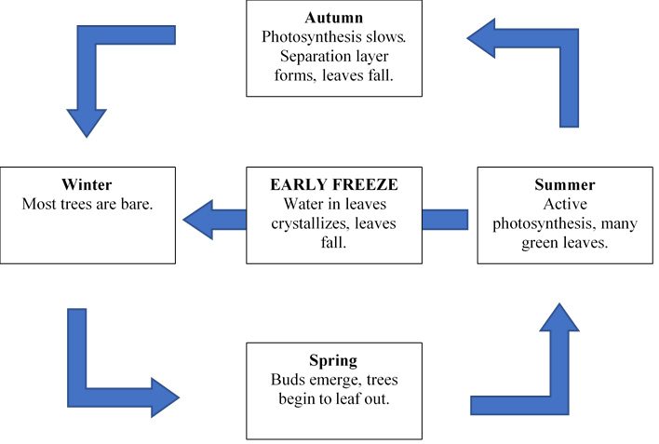

The Life Cycle of Leaf Phenology

Delayed freezes may lengthen the foliage season, however, without some cooler temperatures, less anthocyanin will be produced, and foliage may begin to appear dull colored and less visually appealing. In considering this context of the impact of temperature on foliage, a question arises: how might changes in temperature impact the foliage economy in states like New Hampshire? And how might such changes impact vulnerable populations dependent on these economies?

#### Methods

The National Oceanic and Atmospheric Association, or NOAA, maintains a large database of daily temperature records from surface stations across the world, called the Global Historical Climate Network. This information is available for free on NOAA’s website. To assess the potential impact of New Hampshire temperatures on autumnal leaf phenology, the temperature records from a station in Concord, New Hampshire ranging from April 4, 1939 to January 26, 2019 were obtained and imported into RStudio. In RStudio, the trends for both maximum and minimum temperatures in September, which has historically been the epicenter of foliage season, were analyzed. The null hypothesis which we were investigating states that there is no relationship between temperature and time. In addition, we compared the climate data with a dataset of North Country foliage season lengths since 1975, maintained by the employees of New Hampshire’s historic Polly’s Pancake Parlor. Here, the null hypothesis was that there is no relationship between foliage season length and time. We investigated these null hypotheses using the p-value. If the p-value is less than 0.05, then the findings are considered to be statistically significant, and the null hypothesis may be rejected. We hypothesize that both fall temperatures and the length of the fall foliage season will increase with time.

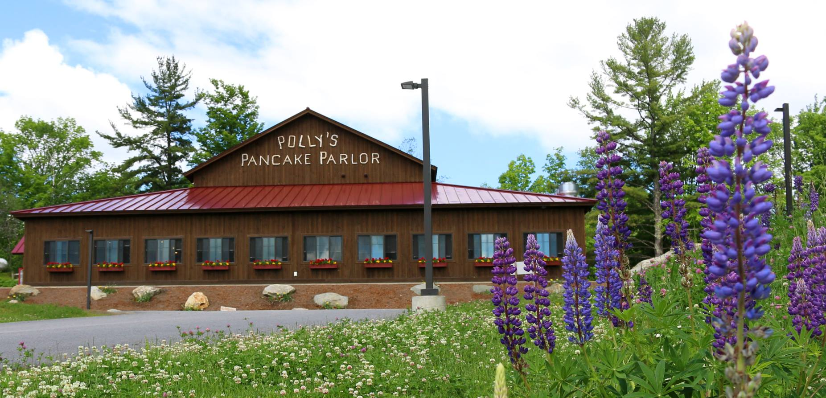

Polly's Pancake Parlor in Sugar Hill, NH. Retrieved from <https://www.onlyinyourstate.com/new-hampshire/pancake-parlor-nh/>.

#### Results

In following these methods, the maximum and minimum September temperatures, as well as the length of foliage seasons, were all found to have statistically significant positive slopes. However, the degree to which the variations could be explained by the linear regression model greatly differed.

The graph of maximum temperatures, as shown below, has a clear positive trend. For the linear regression model of the graph of maximum temperatures in September, the p-value is 0.03, while the r2 is 0.00013. Although we can reject the null hypothesis, the variable “year” does not explain the variation, as the adjusted r2 value is low.

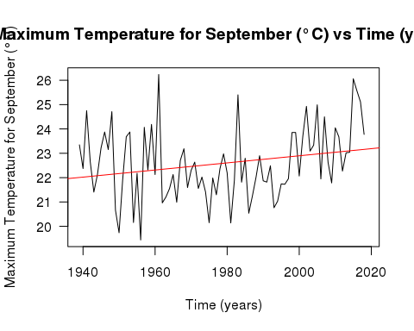

The graph of minimum temperatures, also shown below, also demonstrates a clear positive trend. For the linear regression model of the graph of minimum temperatures in September, the p-value is even more significant, at <.01, while the r2 is still low, at 0.0015. Although we can reject the null hypothesis, the variable “year” still does not explain the variation, as the adjusted r2 value is low.

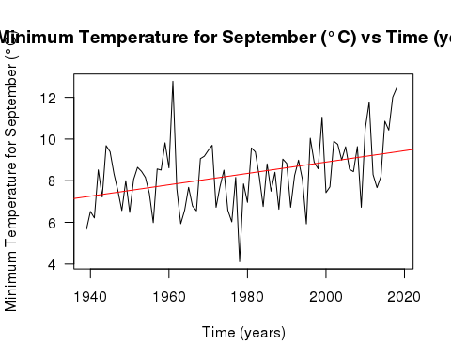

The linear regression model of the graph of foliage season length found below, also found to have a positive slope, fit the linear regression model better than the climate data sets. The p-value for this model was <.01, indicating again that the data is statistically significant. However, the adjusted r2 value was 0.535, indicating that the approximately 54% of the data’s variation may be explained by the variable “year”.

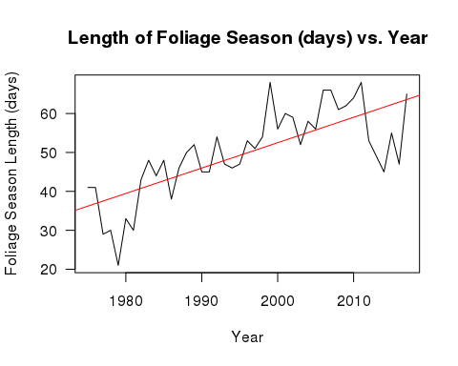

#### What were this study’s limitations? How could further research improve our understanding of this issue?

The null hypotheses were all rejected, however, the r2 values largely indicated that the model used explained low amounts of the variation. This may be contingent on the variable “year,” as it is truly just a proxy for a host of other changes which impact temperature and leaf phenology in more direct and significant ways, which may lead to low correlative values without negating the high probability values. Further investigation into more specific phenology processes may help to more fully explain the variation. Additionally, a changing climate may result in changes in tree habitats, pushing some species further north. As different trees have different foliage seasons, some changes in foliage season length may be attributable to changes in tree composition where the data was collected. Further investigation into tree patterns in Northern New England may also help to shed some light on how this plays a role in foliage season length.

#### What might this mean for New Hampshire's future?

With this understanding, these graphs may provide a powerful understanding of how a statistically significant warming trend is impacting New Hampshire’s foliage economy. Clearly, as the temperature and foliage season graphs demonstrate, as temperatures are warming, the foliage season is getting longer and longer. This correlation may be explained by the leaf phenology principle discussed above, where delayed frost may extend the lifespan of foliaged landscapes. In and of itself, this is not a bad thing – in fact, a longer foliage season is good for New Hampshire. As the peak tourism period lengthens, the opportunity for tourists to spend money in-state lengthens as well. At Polly’s Pancake Parlor, the 2018 foliage season actually broke a record, bringing 800 people into the restaurant between 7 AM and 3 PM in a single day (Margolis 2018).

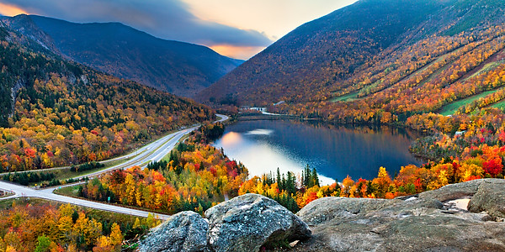

Franconia Notch in Autumn. Retrieved from <http://www.franconianotch.org/things-to-do/great-outdoors/>.

However, the warmth associated with an increased foliage season is not benefitting some of New Hampshire’s other tourist niches. Skiing, another huge tourism industry in New Hampshire, is seeing a reduction in snow days, causing resorts and nearby service businesses to worry about their futures (Margolis 2018). Additionally, the long-term sustainability of increased foliage tourism is uncertain, as warmer autumns may lead to less vibrant foliage (Archetti 2013). Some locals worry that this change is already beginning – as reporter David Brooks said, “It does seem like [warmer autumns are] resulting in less splendid splendor” (Biello 2015).

The long-term implications of a “less splendid splendor” are, thus far, unclear. However, duller leaves aren’t the state’s only concern. As early as 2008, New Hampshire’s state government has expressed concerns regarding how climate change may impact the tourist economy (New Hampshire Department of Environmental Services, 2008). Their worries extend far beyond dulling leaves. Some concerns include the increased pest and pathogen propagation which warming may bring, northward tree movement of species which are important to the New Hampshire economy and identity, and the potential loss of the 3-million-dollar maple syrup industry which disappearance of the maple tree through disease or movement may bring (New Hampshire Department of Environmental Services, 2008).

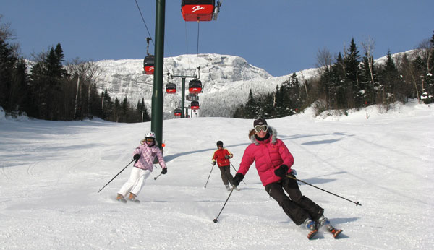

Skiing is an Important Component of the Tourist Economy in New Hampshire. Retrieved from <https://familyskitrips.com/newengland/top-ten-family-ski-resorts-in-new-england/>.

Given that these tourist industries are sustaining large portions of the state’s most vulnerable populations, their gradual disappearance bodes poorly for the long-term health of these economies and begs the question as to how these communities may continue to be supported in an area with very little industry. Coos County, located north of the White Mountains, has struggled to bring in a tourist economy for years – and consequently, has faced the greatest economic challenges in the state (“The Ultimate Guide To The North Country Economy,” n.d.). Millions of governmental dollars have been poured into the county in an attempt to develop transportation and telecommunication industries and ultimately rebuild a firmer economy. However, this has largely been ineffective, with approximately 41% of the county’s residents living in poverty (“The Ultimate Guide To The North Country Economy,” n.d.). The difficulties faced by Coos County today may be similar to what more prosperous areas, such as Carroll County, may face without a strong tourist economy. Although New Hampshire’s foliage tourism economy may continue to flourish and even improve as warmer temperatures lengthen the foliage season, the benefits of this change are not sustainable. Particularly as these tourism industries are not only representative of the very culture and essence of New Hampshire but are sustaining some of the state’s most vulnerable populations, their loss would prove undeniably tragic for New Hampshire’s future.

Not much can be done to prevent these changes at an individual level, however, policy action may be taken to protect the tourist economy in New Hampshire. One powerful example of voter influence protecting tourism in New Hampshire may be found in the near decade-long battle over the Northern Pass, where angry New Hampshirites fought a proposal to have a hydroelectric power line installed to bring power from Canada to Southern New England. The line would have disrupted the ecosystems and pristine beauty of much of Northern New Hampshire, and subsequently, much of its tourist economy (“Understanding the Northern Pass Project in New Hampshire,” 2019). The profound impact which a changing climate and subsequent ecosystem damages may have on the New Hampshire economy makes it critically important for New Hampshirites to pay attention to how their politicians are responding to the climate crisis. Current Governor Chris Sununu was a strong proponent of the damaging Northern Pass, as his campaign received a large donation from Eversource Energy, the company behind the pass (“Understanding the Northern Pass Project in New Hampshire,” 2019). Sununu’s governorship will be up in 2020, and local elections happen every year. The individuals who win these elections have far more control over the future of New Hampshire’s tourist economy than any individual constituent. Pay attention and vote as if the future of your state and livelihood depends on it – it probably does.

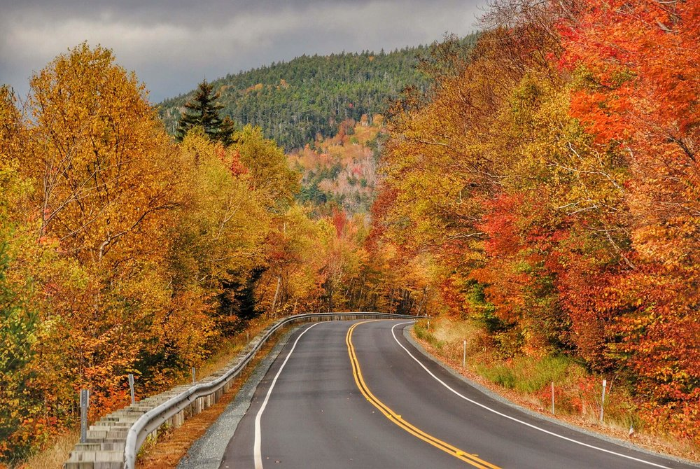

Views from New Hampshire's Kancamagus Highway. Retrieved from <https://www.roamingthenortheast.com/blog/2017/12/3/driving-the-kancamagus-new-englands-best-fall-foliage-drive>.

#### Bibliography

Archetti, M., Richardson, A. D., Okeefe, J., & Delpierre, N. (2013). Predicting Climate Change Impacts on the Amount and Duration of Autumn Colors in a New England Forest. *PLOS ONE*, *8*(3), 1-8. doi: 10.1371/journal.pone.0057373

Biello, P. (2015, October 6). *Granite Geek: Why New Hampshire's Foliage Is Not Quite So Splendid This Year*. Retrieved from <https://www.nhpr.org/post/granite-geek-why-new-hampshires-foliage-not-quite-so-splendid-year#stream/0\>

Burke, G. (n.d.). [Skiing is an Important Component of the Tourist Economy in New Hampshire]. Retrieved from <https://familyskitrips.com/newengland/top-ten-family-ski-resorts-in-new-england/\>

Chalker-Scott, L. (1999). Environmental Significance of Anthocyanins in Plant Stress Responses. *Photochemistry and Photobiology*, *70*(1), 1-9. doi: 10.1562/0031-8655(1999)0702.3.co;2

Feild, T. S., Lee, D. W., & Holbrook, N. M. (2001). Why Leaves Turn Red in Autumn. The Role of Anthocyanins in Senescing Leaves of Red-Osier Dogwood. *Plant Physiology*, *127*(2), 566-574. doi: 10.1104/pp.010063

[Franconia Notch in Autumn]. (n.d.). Retrieved from <http://www.franconianotch.org/things-to-do/great-outdoors/\>

Gallinat, A. S., Primack, R. B., & Wagner, D. L. (2015). Autumn, the neglected season in climate change research. *Trends in Ecology & Evolution*, *30*(3), 169-176. doi: 10.1016/j.tree.2015.03.016

Lev-Yadun, S. (2016). What Do Red and Yellow Autumn Leaves Signal for Sure?. *The Botanical Review*, *73*(4), 279-289. <doi:10.1007/978-3-319-42096-7_47\>

Margolis, J. (2018, October 28). *'Leaf peeping' is huge in New England. Will climate change alter tourism?* Retrieved from <https://www.pri.org/stories/2018-10-19/leaf-peeping-huge-new-england-will-climate-change-alter-tourism\>

*New Hampshire Population 2019*. (2019). Retrieved from <http://worldpopulationreview.com/states/new-hampshire-population/\>

[Polly's Pancake Parlor in Sugar Hill, NH]. (2017, May 22). Retrieved from <https://www.onlyinyourstate.com/new-hampshire/pancake-parlor-nh/\>

R Core Team. (2017). *R: A language and environment for statistical computing*. Retrieved from <https://www.R-project.org/\>

Tangney, D., Jr. (2019, February 6). [Peak Foliage in New Hampshire's White Mountains]. Retrieved from <https://www.tripsavvy.com/see-peak-new-england-fall-foliage-1600409\>

*The Ultimate Guide To The North Country Economy*. (n.d.). Retrieved from <https://stateimpact.npr.org/new-hampshire/tag/north-country/\>

*Understanding the Northern Pass Project in New Hampshire*. (2019, February 27). Retrieved from www.nhmagazine.com/2013/12/16/understanding-northern-pass/

United States, New Hampshire Department of Environmental Services. (2008). *Global Climate Change and Its Impact on New Hampshire's Fall Foliage and Maple Sugar Industry*. Retrieved from <https://www.des.nh.gov/organization/commissioner/pip/factsheets/ard/documents/ard-25.pdf.\>

[Views from New Hampshire's Kancamagus Highway]. (2017, December 4). Retrieved from <https://www.roamingthenortheast.com/blog/2017/12/3/driving-the-kancamagus-new-englands-best-fall-foliage-drive\>