How has climate change impacted fire season in Spokane?

Claire Generous

3/15/2019

## Climate change in Spokane: Extreme events vs. “soft knock” Spokane

Spokane is a mid-sized city located in eastern Washington state. Spokane’s weather, relative to the rest of the United States, appears rather temperate. While tornadoes and severe storms ravage other parts of the United States, Spokane experiences these weather events in what might be termed as a “soft knock” (Loyd and Weiford 2018). For example, in May 2018, a mix of tornadoes, hail, strong winds, and violent thunderstorms occurred in the eastern United States, southern states, and Plains states, but in Spokane, no more than a few mild thunderstorms passed through (Loyd and Weiford 2018). The number of severe thunderstorm warnings issued in Spokane have also declined in the past five years. In 2014, 42 warnings were issues, and in 2017, only five warnings were issued (Noorani 2018).

While Spokane may not have the most severe weather events as mentioned above, nothing about the changes in fire season intensity in and surrounding Spokane resemble a soft knock. Spokane’s wildfire season has become longer, more intense, and less manageable (Figure 1).

## Wildfire Season in Spokane

The number of days smoke from wildfires exceeded health-based air quality standards in Spokane has increased significantly since 2010 (Figure 1).

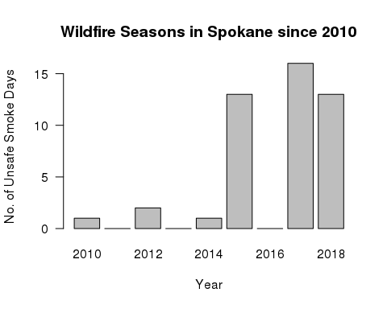

Figure 1. Influenced by the Spokane Clean Air Agency

The trend of fire seasons intensifying in Spokane is consistent with the surrounding Pacific Northwest (PNW) area. Since the early 1970s, area burned by fire in the Northwest by nearly 5,000 percent (Westerling 2016). In Washington alone, an estimated 4.1 acres burned from 2000 to 2017 (Shinn 2018). The 2017 Washington fire season had 40 days at the highest level of preparedness (level 5) which was almost three weeks more than during the severe 2015 fire season (Length of Northwest Forest Fire Season Continues to Grow 2018).

## Does climate change have to do with fire increases?

To evaluate the extent that climate change has on fire intensity, I obtained weather data from the Spokane International Airport station (NWS). Specifically, I used temperature levels and precipitation levels during certain seasons to see if trends in this data impacted Spokane’s fire season intensity.

Anthropogenic climate change accounted for about 55% of observed increases in fuel aridity from 1979 to 2015 across western US forests (Abatzoglou and Williams 2016), thus justifying examining additional trends in the Spokane data since 1980.

## How does precipitation impact fire season ?

On average, Spokane’s average monthly precipitation levels are 34.9 mm (Spokane weather changes [date unknown]). In Washington, in 2017 during the Spring months March through May, precipitation was much above average (National Climate Report for Annual 2017).

An increase in precipitation during the spring months may result in an increase in fire fuels, specifically, more grasses that allow fires to carry (2017 Pacific Northwest Fire Narrative 2017; Wildland Fire Summary and Statistics Annual Report 2017).

Precipitation levels are increasing and are statistically significant (Figure 2; p <0.001 )

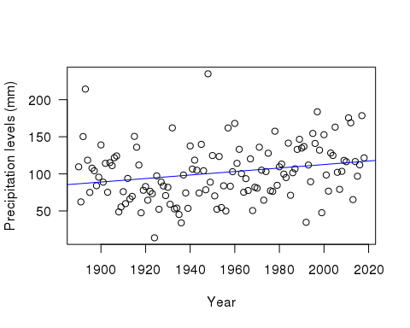

Figure 2. Total precipitation for the months of March - May (1890 to 2019); p value = p<0.001. Slope = 0.24.

Overall, Spokane’s weather is temperature, but the average precipitation total during summer months since 1890 is high with a value of 102 mm compared to the rest of the country.

The increase in precipitation during the spring months results in an increase in fire fuels, specifically, more grasses that allow fires to carry (2017 Pacific Northwest Fire Narrative 2017; Wildland Fire Summary and Statistics Annual Report 2017).

## Is there a relationship between temperature and fire season?

Due to the increases in precipitation during the winter and spring months which result in in an increase in fire fuels, variability in temperatures in summer months exacerbate the effects of these fire fuels on fire season intensity (2017 Pacific Northwest Fire Narrative 2017; Wildland Fire Summary and Statistics Annual Report 2017 2017). In Washington, in 2017 during the summer months June through August, temperature was much above average (National Climate Report for Annual 2017). The NOAA report also displays that the heat extremes which resulted in destructive fires extended throughout the summer and well into autumn.

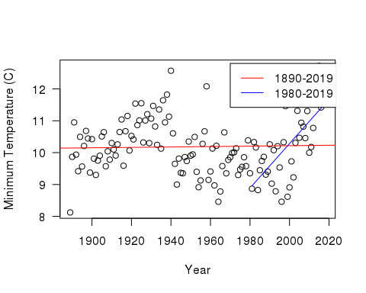

Figure 3. Minimum average temperatures for the months June through August during periods 1890-2017 and 1980-2017. 1890-2017: p = 0.75 and slope < 0.001. 1980-2017: p value = p<0.01 and the slope = 0.07. These values reject the null hypothesis that temperatures have not increased, and thus affected fire season but a significant increase exists between 1980-2019

While the annual average maximum temperature in Spokane since 1890 is relatively temperate with a value of 14.5° C and the average minimum temperature since 1890 is relatively temperate with a value of 3.5° C. The summer months average minimum temperature since 1890 is 10.2° C.The summer months average minimum temperature since 1980 is 10.3° C, 0.1° C warmer than the average since 1980.

The early warm summer temperatures following above average precipitation in the winter and spring result in significant plant growth. Increased plant growth creates an environment more prone to fires (Wildland Fire Summary and Statistics Annual Report 2017).

## Reflections on methods

Some critics have cited problems with the quality of weather stations and that they may generate biases in the data at NOAA’s Land-Based Station Data for the Spokane International Airport station. The station was relocated four times, in 2006, 1979, 1965, and 1941, which may influence the quality of temperature records and trend analyses. Obstructions that were recorded in 2005, 2002, 1997, and 1993 involved wind issues and buildings (Daily Summaries Station Details 2019). Other factors that could create bias in the data could be poor site placement, homogenization of data, instrument changes, and urbanization (Menne et al. 2010 and Land-Based Station Data [date unknown]). However NOAA has several methods to correct for biases that include changes to the time of observation, adjusting for undocumented changes, readjusting sites, and converting to MMTS (Maximum Minimum Temperature System) used to track temperature over a period of time and transmits results electronically because previous measuring methods created more bias (Menne et al. 2009).

The increases in fire season intensity in Spokane are the results of several factors, thus isolating a couple factors fails to encompass the whole story. Other factors besides precipitation and temperature need to be assessed to have a fuller understanding of variability in fire season intensity. Other factors include the main causes of fires starting: humans and lightning as well as different types of fires such as ground fires, surface fires, and crown fires (Forest Fires - An Overview) which are affected differently by temperature and precipitation levels. In the Pacific Northwest, rapid change in temperatures in the summer months combined with decreased precipitation after the heavy rainfall during the spring months created a flash drought potential (2017 Pacific Northwest Fire Narrative 2017) which could have made an impact on fire season intensity.

Adaptation strategies and plans must be in place to combat climate change and its effects on fire (Halofsky et al. 2018). Without mitigation strategies, fires and climate change will continue to become more destructive. Anthropogenic increases in temperature significantly enhanced fuel aridity (for fires) across western US forests over the past several decades (Abatzoglou and Williams 2016). Between 2000 and 2015, the human-caused increases in temperature contributed to 75% more forested area experiencing high fire-season fuel aridity and an average of nine additional days per year of high fire potential (Abatzoglou and Williams 2016). Climate change combined with high intensity fire is leading to increasingly fewer seedlings establishing after wildfires (Davis et al. 2018).

While Spokane’s fire season may not solely be caused by climate change, climate change exacerbates fire intensity. The precipitation and temperature increases in Spokane (NWS) support that precipitation and temperature increases enhance fuel aridity for fires (Abatzoglou and Williams 2016). Spokane’s temperature increases, especially since 1980, have increased significantly (NWS), suggesting a correlation with climate change (Abatzoglou and Williams 2016).

Climate change has been recognized as a contributing factor to exacerbating fire season intensity (Abatzoglou and Williams 2016) which means that not only must fire management efforts improve, but also fire prevention efforts.

## Projected outcomes of increased fires

If Spokane’s wildfire season continues to become longer, more intense, and less manageable, environmental and social degradation will become even more pronounced.

Because of warmer and drier summers, “the typical annual area burned by fire in the Northwest is projected to double by the 2040s and quadruple by the 2080s” (Confronting Climate Change in Washington 2018). As the frequency and intensity of wildfires increases, forestlands and its resources as well as habitats for wildlife will be damaged (Wildfires, air quality & climate change [date unknown]).

Fire season intensifying puts people’s health, safety, and livelihood at risk, especially certain populations. Low income communities “do not have access to “the resources necessary to pay for insurance, rebuilding, or continual investment in fire safety, thereby increasing their vulnerability to wildfire” (Davies et al. 2018, p. 2) Wildfire vulnerability is also experienced unequally across race and ethnicity, with census tracts that were majority Black, Hispanic or Native American experiencing 50% greater vulnerability (Davies et al. 2018).

The US Department of Housing and Urban Development listed Spokane as having one of the highest homeless populations for cities of a similar size (Henry et al. 2018). Without adequate shelter, access to healthcare, and basic resources to live, Spokane’s homeless population is left with little protection against increased fire seasons and effects of degraded air quality. Spokane’s Native American population is also put at high risk during fire seasons. In 2016, Hart Fire burned on the Spokane Indian Reservation, but the Department of Natural Resources did not give equal support to the reservation compared to fires burning in other areas of Spokane, showing that Spokane does not prioritize its indigenous populations as much as the rest of the population (Schwing 2016).

## Looking forward

Although in comparison to other parts of the country, the Pacific Northwest and Spokane are experiencing “soft-knock” climate change, this region must still be given appropriate attention. While the seasonal rises in temperatures and precipitation may not necessarily be solely due to climate change, the impacts are still damning for the PNW and Spokane’s future.

In the early 1900s, state and federal governments began to aggressively fight wildfires, but this caused denser and more fire-prone forests (Meyer 2017). The Natural Resource Defense Council says that “prematurely putting out small fires that could have cleared away undergrowth leaves some forests clogged with highly flammable small trees and shrubs. Unnecessarily suppressing them can increase the risks of subsequent fires being bigger and harder to control” (Where There’s Fire, There’s Smoke, p. 2, 2013).

Finding ways to effectively manage fire seasons will be difficult which is why it is also essential to work on preventative measures. For example, in Oregon, a new Carbon Policy office is considering a “carbon cap and invest” bill similar to California’s Assembly Bill 398 (Shinn 2018). The Washington Department of Natural Resources has developed a 20-Year Forest Health Strategic Plan for eastern Washington through increasing forest and watershed resilience and protecting communities, property, ecosystems, assets and working forests (Franz 2017).

Spokane has done some work with being more equitable regarding fire management for the national Community Risk Reduction priority populations, through programming and free services, (2017 Annual Report) but more work must continue to be done for disadvantaged groups like these because they are the groups most affected by fire seasons.

## Conclusion

Even though weather patterns in Spokane may not be as extreme as other areas and more factors besides precipitation and temperature levels impact fire season intensity, weather patterns that impact Spokane’s fire season still impact the lives of Spokanites and the natural environment, especially those who are less advantaged. Spokane must raise their standard for fire management to mitigate and prevent future increases in fire seasons. By utilizing prevention tactics like the ones described above and by performing more comprehensive studies, Spokane and other PNW cities can change the fire season trend before it becomes irreversible.

## Bibliography

Abatzoglou J, Williams A. 2016. Impact of anthropogenic climate change on wildfire across western US forests. Proceedings of the National Academy of Sciences. 113 (42): 11770-11775.

Confronting Climate Change in Washington (2018). 2018. Union of Concerned Scientists. [cited 2019 Mar 1]. Available from: <http://www.wfpa.org/news-resources/blog/length-northwest-forest-fire-season-continues-grow/>

Daily Summaries Station Details. 2019. NOAA National Centers for Environmental Information: State of the Climate. [cited 2019 Mar 11]. Available from: <https://www.ncdc.noaa.gov/cdo-web/datasets/GHCND/stations/GHCND:USW00024157/detail>

Davies I, Haugo R, Robertson J, Levin P. 2018. The unequal vulnerability of communities of color to wildfire. Proceedings of the National Academy of Sciences. 1-15.

Davis K, Dobrowski S, Higuera P, Holden Z, Veblen T, Rother M, Parks S, Sala A, Maneta M. 2018. Wildfires and climate change push low-elevation forests across a critical climate threshold for tree regeneration. Proceedings of the National Academy of Sciences. 1-6.

Forest Fires - An Overview. [date unknown.] World Boreal Science & Innovation. [cited 2019 Mar 11] Available from: <http://www.borealforest.org/world/innova/forest_fire.htm>

Franz H. 2017. 20-Year Forest Health Strategic Plan. Washington State Dept of Natural Resources.

Henry M, Mahathey A, Morrill T, Robinson A, Shivji A, Watt R. 2018. The 2018 Annual Homeless Assessment Report (AHAR) to Congress. The U.S. Department of Housing and Urban Development: Office of Community Planning and Development. 1-97.

Halofsky J, Conklin D, Donato D, Halofsky E J, Kim J. 2018. Climate change, wildfire, and vegetation shifts in a high-inertia forest landscape: Western Washington, U.S.A. Public Library of Science (PLOS). 1-23.

Land-Based Station Data. [date unknown.] NOAA National Centers for Environmental Information: Data Access. [cited 2019 Mar 14]. Available from: <https://www.ncdc.noaa.gov/data-access/land-based-station-data>

Length of Northwest Forest Fire Season Continues to Grow. 2018. Washington Forest Protection Association. [cited 2019 Mar 1]. Available from: <http://www.wfpa.org/news-resources/blog/length-northwest-forest-fire-season-continues-grow/>

Loyd N, Weiford L. 2018. Weathercatch: Severe weather events — there’s something about May. Washington State University: WSU Insider. [cited 2019 Mar 1]. Available from: <https://news.wsu.edu/2018/05/16/theres-something-about-may/>

Menne M, Williams C, Palecki M. 2010. On the reliability of the U.S. surface temperature record. Journal of Geophysical Research. 115: 1-9.

Menne M, Williams C, Vose R. 2009. U.S. Historical Climatology Network Monthly Temperature Data, Version 2. American Meteorological Society. 993-1007.

Meyer R. 2017. Has Climate Change Intensified 2017’s Western Wildfires?. The Atlantic: Science. [cited 2019 Mar 1]. Available from: <https://www.theatlantic.com/science/archive/2017/09/why-is-2017-so-bad-for-wildfires-climate-change/539130/>

National Climate Report for Annual 2017. 2017. NOAA National Centers for Environmental Information: State of the Climate. [cited 2019 Mar 1]. Available from: <https://www.ncdc.noaa.gov/sotc/national/201713>

Noorani E. 2018. Number of severe thunderstorms decline in Spokane each year, trend may continue. Number of severe thunderstorms decline in Spokane each year, trend may continue. KREM2 News. [cited 2019 Mar 13]. Available from: <https://www.krem.com/article/weather/number-of-severe-thunderstorms-decline-in-spokane-each-year-trend-may-continue/293-561777112>

[NWS] National Weather Service (US). 2019. Current conditions at Spokane International Airport, WA (GHCND). Silver Spring (MD): National Oceanic And Atmospheric Administration

Schwing E. 2016. Resources Come Slow As Wildfire Ravages Spokane Reservation. KNKX. [cited 2019 Mar 11]. Available from: <https://www.knkx.org/post/resources-come-slow-wildfire-ravages-spokane-reservation>

Shinn L. 2018. In the Pacific Northwest, Testing Out New WIldfire Defenses on the Front Lines. Natural Resources Defense Council. [cited 2019 Mar 1]. Available from: <https://www.nrdc.org/stories/pacific-northwest-testing-out-new-wildfire-defenses-front-lines>

Westerling A. 2016. Wildfires in West have gotten bigger, more frequent and longer since the 1980s. The Conversation. [cited 2019 Mar 1]. Available from: <https://theconversation.com/wildfires-in-west-have-gotten-bigger-more-frequent-and-longer-since-the-1980s-42993>

Where There’s Fire, There’s Smoke: Wildfire Smoke Affects Communities Distant from Deadly Flames. 2013. Natural Resources Defense Council.

Wildfire Smoke. [date unknown]. Spokane Regional Clean Air Agency. [cited 2019 Mar 1]. Available from: <https://www.spokanecleanair.org/wildfire-smoke>

Wildfires, air quality & climate change. [date unknown]. Department of Ecology State of Washington. [cited 2019 Mar 1]. Available from: <https://ecology.wa.gov/Air-Climate/Climate-change/About-climate-change/Wildfire-risks>

Wildland Fire Summary and Statistics Annual Report 2017. 2017. Predictive Services; National Interagency Coordination Center.

2017 Annual Report. Spokane Fire Department. 2017. Spokane City.

2017 Pacific Northwest Fire Narrative. 2017. USDA Forest Service and DOI Bureau of Land Management.