Will Climate Change Convert Rainy Seattle to Smokey Seattle?

Ella Meyer

March 22, 2019

## Grey Skies in Seattle

When it’s a nice day in Seattle, you might hear the phrase “The mountain is out,” a.k.a. the sky is clear enough that you can see Mount Rainier behind the cityscape. For a period of time during the last two summers in Seattle, however, the mountain was hidden by something other than rain clouds. Wildfire smoke had engulfed the city. Historically, Seattle has been unaffected by wildfires (Sistek 2018). The air quality has generally improved in Seattle, but since 2013 there have been spikes of poor quality during wildfire smoke events [Figure 1].

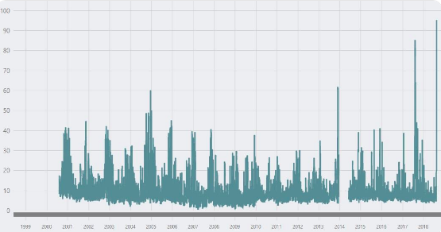

Figure 1. Air quality Index in Seattle (Puget Sound Clean Air Agency 2018).

With an average of 152 days of rain per year, and a close proximity to the Puget Sound, Seattle might be the last place expected to be influenced so extremely by wildfires. The smoke from wildfires in surrounding forests gets trapped in Seattle because of wind patterns and the geography of the region, making air quality especially bad (Sistek 2018). Vox reports, “Breathing Seattle’s air right now is like smoking 7 cigarettes. Blame wildfires” (Irfan 2018). Vox and other news outlets have taken advantage of the smoky situation to create stories, and reports often point to climate change as the cause. Studies using attribution science conclude that, while a warming climate may put us at higher risk for more frequent and intense wildfires, climate change by itself is not to blame (Wimberly and Liu 2014).

To evaluate if the climate is having a multiplying effect on wildfires surrounding Seattle, we first need to determine if climate change has occurred in this region. The Intergovernmental Panel on Climate Change (IPCC) identified a warming trend of 1.5 degrees in the 20th century in the Pacific Northwest (Mote and Salathe 2010). In this blog, I analyze Seattle's climate data. If there is a warming trend, then climate change may have a multiplying effect on the region’s wildfires and air quality.



Figure 2. Photo by Sigma Sreedharan of wildfire smoke turning the sun over the Space Needle a shade of red. August 20th. 2018

## Obtaining and Analyzing the Weather at SeaTac Airport

To tackle the question of whether Seattle has experienced climate change, I used climate data from the National Oceanic and Atmospheric Association (NOAA). NOAA has access to an archive of weather and climate data from various stations worldwide. Using data from the Seattle-Tacoma International Airport, I obtained weather records from 1948 to early 2019 (25,959 days). I used these data assuming that they represent the region.

A Bias Removal Process by NOAA adjusted for biases that may affect the data such as the observation time, instrument change, or urban heat island effect (Meane 2010). While the SeaTac station remained on airport grounds, it changed in elevation and location several times, which may contribute to unadjusted for bias.

I conducted statistical analysis and created a linear regression model using R (CRAN 2019) in an Rmd file for the entire data set of the minimum and maximum temperatures, as well as for selected monthly means. The statistically significant months included are July, August, and September. Using the p-value, I determined whether or not we are able to reject the null hypothesis that temperature change and time have no relationship.

## Modeling Seattle’s Temperature Trends

Although there was a positive trend in maximum temperatures with time, the slope was not significantly different than zero. On the other hand, the minimum temperatures have slightly increased with time ( <0.01 °C/100 years; p< 0.01, r2=0.012).

However, climate change signals differ by season. For example, mean July maximum temperatures have increased 0.03 °C (p < 0.001) and minimum temperatures increased 0.04 °C per year from 1948 to 2019 (p < 0.001) [Figure 3].

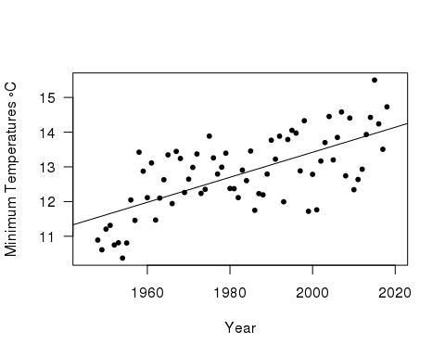

Figure 3. Mean July Minimum Temperatures (°C)

Both the mean maximum and minimum temperatures in August increased by 0.04 °C, or around 0.07 °F per year (p < 0.001) [Figure 4].

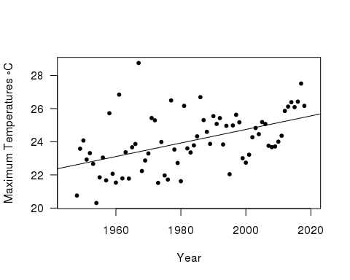

Figure 4. Mean August Maximum Temperatures (°C)

Mean September maximum temperatures increased 0.02 °C and the minimum temperatures increased slightly more by 0.03 °C per year (p = 0.02) [Figure 5].

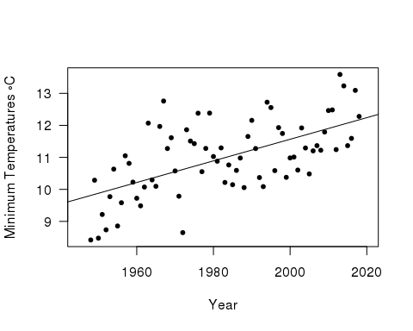

Figure 4. Mean September Minimum Temperatures (°C)

At SeaTac, the statistical analysis for all three summer months rejects the null hypothesis by demonstrating significant warming trends for both maximum and minimum temperatures.

## Connection of Wildfires to Climate Change, Social Injustice, and Environmental Next Steps

The temperature trend shown by the data and the amount of wildfires are both increasing in the region, but warming temperatures are only one part of the equation that creates forest fires. Ignition, dryness, fuel, and wind all have the potential to exacerbate fires. However, a warming climate may cause dryness and change wind. Thus, temperatures will have both a direct and indirect multiplying effect on wildfires (Abatzoglou and Williams 2016).

### Differential Access to Cleaner Air

The lives of Seattle’s residents have been unjustly affected by wildfire smoke. On August 20th, 2018, a joint press release alerted citizens of unhealthy air quality and listed irritated sinuses, asthma attack, and fast heartbeat as just a few of the health risks. By advising everyone to stay indoors with windows closed and air conditioning or air filter on and to refrain from driving, the press release highlights the unequal vulnerabilities of different people. For example, approximately 85% of Seattle’s population do not have air conditioning in their homes. Many people also have long commutes to work and school, and tolls showed that 60% of bikers still commuted across the Fremont Bridge in the smoke (Fritz and Turnbull 2018).

Further, Seattle’s growing homeless population is at extremely high risk of health implications from the smoke. The city has around 12,000 homeless individuals - the largest third largest in the country - and over half of them are unsheltered (Mulvihill 2018). The homeless population generally has little access to healthcare, yet they are faced with more health concerns. Wildfire smoke is a social justice issue because of the difference in individual’s health responses and options to avoid and medicate smoke exposure (Liu 2017).

The impact is not only on humans. At the Seattle Aquarium, a sea otter diagnosed with pollution-induced asthma was treated with an inhaler during the latest smoke episode. Although this example might seem whimsical to some, it demonstrates that the region’s wildlife will also take a hit health-wise, and they do not have access to any of the protective measures that we do.

### Reducing Emissions

The warming climate is likely due to human-caused greenhouse gas emissions. In 2016, Seattle had an emission rate of 4.3 metric tons CO2 per capita (Coven et al. 2016), which is fairly low compared to other big U.S. cities, such as San Francisco with 6.4 metric tons of CO2 per capita (Goodfried et al. 2018). While Seattle’s greenhouse gas emissions are on the low end, they are still able to contribute to climate change. Although globally caused climate change affects this region as well, Seattle still must reduce their own emissions if they wish to decrease wildfire smoke.

Last year, a Washington ballot initiative attempted to cut emissions with carbon fee. The revenue from the fee would have funded the clean energy industry, forest conservation, public transit, and compensated the indigenous and working-class coal communities. Unfortunately, this initiative did not pass. Although the policy would have been a big step towards mitigating climate change, Seattleites should celebrate the fact that the initiative was even represented on the ballot. Hopefully, policies like this one will reappear on future Washington ballots, and other state ballots too.

## August: The Month of Wildfires and Warming Temperatures

Temperature has increased in Seattle over the last 71 years, but the trend is most pronounced in August. With the peak fire season being from mid to late August, wildfires may be further exacerbated by the rising temperatures.

Whether or not the trend of wildfires will continue to affect Seattle in future summers, there is a need for more studies assessing the long-term health effects of wildfire smoke. Additionally, attribution science studies on climate change and the wildfires surrounding Seattle could further our understanding and assist production of scientifically-backed policy.

The bottom line is that climate change is imminent and we should expect changes, such as smokey summer skies, in the places we call home. If we would like to prevent the social-environment impact of wildfires, we will need to reduce CO2 emissions and mitigate impacts of already occurring climate change.

## Sources

Abatzoglou, JT and Williams, AP. 2016. Impact of anthropogenic climate change on wildfire across western US forests. Proceedings of the National Academy of Sciences. 113(42):11770-5.

Coven JF, Krishnan A, and Morgenstern T. 2016. 2016 Seattle Community Greenhouse Gas Emissions Inventory. Seattle Office of Sustainability and Environment.

Fritz A and Turnbull L. 2018. Wildfire smoke is choking Seattle, obscuring the view and blocking out the sun. The Washington Post.

Goodfriend W, Reyes B, and Pac S. 2018. 2016 San Francisco Geographic Greenhouse Gas Emissions Inventory at a Glance. San Francisco Department of Environment, Climate Program.

Irfan U. 2018. Breathing Seattle’s air right now is like smoking 7 cigarettes. Blame wildfires. Vox.

Liu JC, Wilson A, Mickley L, Ebisu K, Sulprizio M, Wang Y, Peng R, Yue X, Dominici F, and Bell M. 2017. Who Among the Elderly Is Most Vulnerable to Exposure to and Health Risks of Fine Particulate Matter From Wildfire Smoke? American Journal of Epidemiology. 186(6):730–5.

Meane M, Williams C, and Palecki M. 2010. On the reliability of the U.S. surface temperature record. Journal of Geophysical Research. 115.

Mote PW and Salathe EP. 2010. Future climate in the Pacific Northwest. Climatic change. 102(1-2):29-50.

Mulvihill G. 2018. Report: Seattle has nation's largest homeless population outside of New York, Los Angeles. KOMO News.

R Core Team. 2017. R: A language and environment for statistical computing. R Foundation for Statistical Computing, Vienna, Austria. URL <https://www.R-project.org/>.

Sistek S. 2018. Smoky 'unhealthy' air is now worst in Seattle this century. How'd it get so bad? KOMO News.

Wimberly MC and Liu Z. 2014. Interactions of climate, fire, and management in future forests of the Pacific Northwest. Forest Ecology and Management. 327:270-9.