Why Are Recent Droughts In New Mexico So Severe?

Siddharth Namachivayam

2/28/2019

## Background

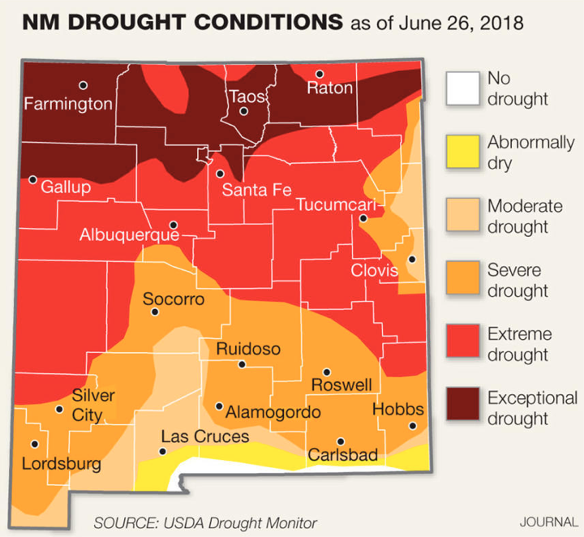

The above map displays varying drought conditions across the state of New Mexico in late June during an intense Southwest drought which began in 2018. For the vast majority of that year, the USDA drought monitor categorized around 70% of the state as consistently experiencing 'at least severe drought.' Unsurprisingly, this drought has had considerable impacts on the state of New Mexico with long-term consequences continuing into 2019. For example, exceedingly dry conditions increased the number of wildfires and exacerbated water scarcity issues across the state. Specifically in the city of Albuquerque, the drought caused numerous issues with regards to urban water supply, leading to uncertainty around the reliability of reservoirs (Hayden 2018).

Clearly, extreme events like the recent drought in the Southwest have pressing and important implications for the city of Albuquerque and the state of New Mexico. Understanding how such events occur and what factors amplify/facilitate them will be of crucial importance in planning and preparing against the negative impacts of severe drought. Thus, while creating this blog, I was interested in the following question: given the above severity of New Mexico's ongoing drought, what climatic trends in temperature facilitated and amplified the observed extreme weather behavior?

To begin, I hypothesized that rising temperatures during the summer intensified the severity of drought in New Mexico. In order to reduce the scope of my analysis, I decided to strictly look at temperature trends within the city of Albuquerque. The station at Albuquerque International Airport provided all the raw data analyzed and presented in the section below.

## Analyzing Albuquerque Data

In order to analyze temperature trends, I initially created 12 sets of data (January, February, March, etc.), each looking at the monthly averages of Albuquerque minimum temperatures (TMIN). I then plotted the data from 1931 to 2019 and then added a best fit line for each plot:

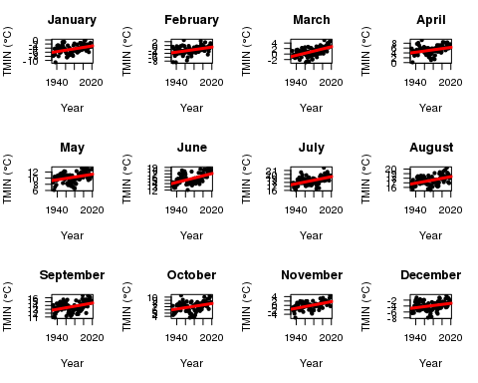

Note each best fit line has a clear positive (or increasing) slope. To determine whether these positive trends are statistically significant (i.e. fit the data well), statisticians look at a measure known as the 'p-value.' Essentially, p-values indicate the probability of a certain observed result occuring. So, the lower the p-value, the higher the significance of a result. There are a lot of calculations that go into finding this p-value, but if it is less than 0.05, then statisticians consider the corresponding result to be statistically significant.

In all of the above graphs for Albuquerque minimum temperatures, each best fit line had p-values less than 0.05. Since our positive trend lines fit the data well, we thus have strong evidence that Albuquerque minimum temperatures have been increasing since 1931 *for all 12 months* (not only during the summer as I had initially hypothesized).

## How Can We Trust The Data?

Many climate skeptics forward the argument that measurements from places like Albuquerque International Airport are unreliable due to a phenomenon called the 'urban heat island effect.' To an extent, the skeptics aren't wrong in that urban areas tend to produce more heat than surrounding rural or unpopulated regions. However, scientists account for this disparity by removing the effect through a process known as 'homogenization.' Simply put, homogenization compares data from urban stations to surrounding stations in order to make appropriate adjustments for proper climate measurement.

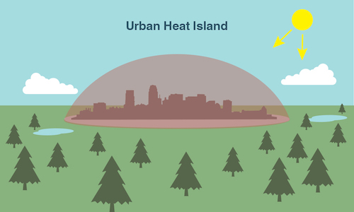

Illustration of Urban Heat Island Effect

Unfortunately, some climate skeptics accuse the homogenization process itself of containing a 'warm' bias. Still, thorough studies on the reliability of the U.S. Surface Temperature Record indicate that such adjustments are both appropriate and necessary (Menne et al. 2010). Furthermore, they suggest any potential 'warm' biases towards daily minimum temperatures are essentially negligible. In light of these studies, along with the increasing trends observed in our above data analysis, there should be no doubt that Albuquerque is indeed warming.

## What Do Rising Temperatures Have To Do With Drought?

**There are two main reasons that rising temperatures in Albuquerque could potentially amplify/facilitate severe drought:**

**1) Mountain snowpack-** Discharge in the Rio Grande river, a crucial source for New Mexico's water supply, directly relates to snowpack in the Jemez Mountains (UCS 2016). Temperatures in the Jemez Mountains will be lower than those measured at Albuquerque due to higher altitudes. However, the *trend* of those temperatures will be increasing similar to what we saw in the Albuquerque data, i.e. we can expect the mountains to be warming. Warmer winter temperatures in the mountains will cause more precipitation in the form of rain rather than snow, decreasing the total amount of snowfall. In addition, warmer spring temperatures will melt snowpack earlier, ultimately extending the duration and intensity of summer drought.

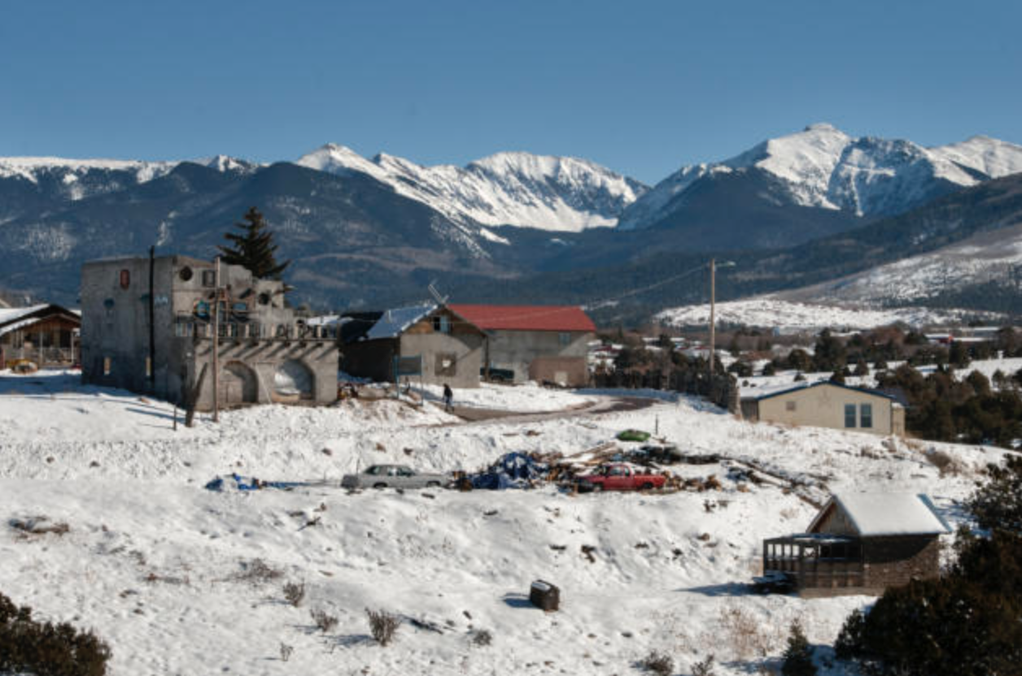

Snowpack in Northern New Mexico

**2) Evapotranspiration-** Evapotranspiration is the combined effect of evaporation (when liquid turns to vapor) and transpiration (when plants release vapor through the stomata on their leaves). Regions with warming trends similar to Albuquerque will convert more liquid water into gas and encourage plants to open up their stomata, increasing evapotranspiration. Since increasing evapotranspiration decreases the amount of water available for allocation by transferring vapor into the atmosphere, we can expect the severity of drought conditions to intensify across New Mexico.

As a brief side note, transpiration in New Mexico is slightly mitigated by the presence of drought-resilient plants in the desert. However, the overall trend of diminishing water resources ends up staying about the same.

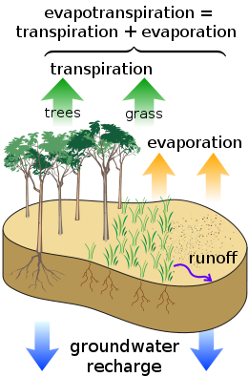

Illustration of Evapotranspiration

## What Does This Mean For New Mexicans?

Warmer temperatures across New Mexico increase the frequency, intensity, and duration of drought conditions. These increasingly severe conditions have major consequences for both farmers and agriculture. For example, since drought reduces water allocations for crop irrigation, farmers become more dependent on pumping groundwater from wells. As these wells deepen over time, their water starts to contain higher amounts of salt, damaging crop production and threatening the livelihood of farmers throughout the state (Frisvold et al. 2013).

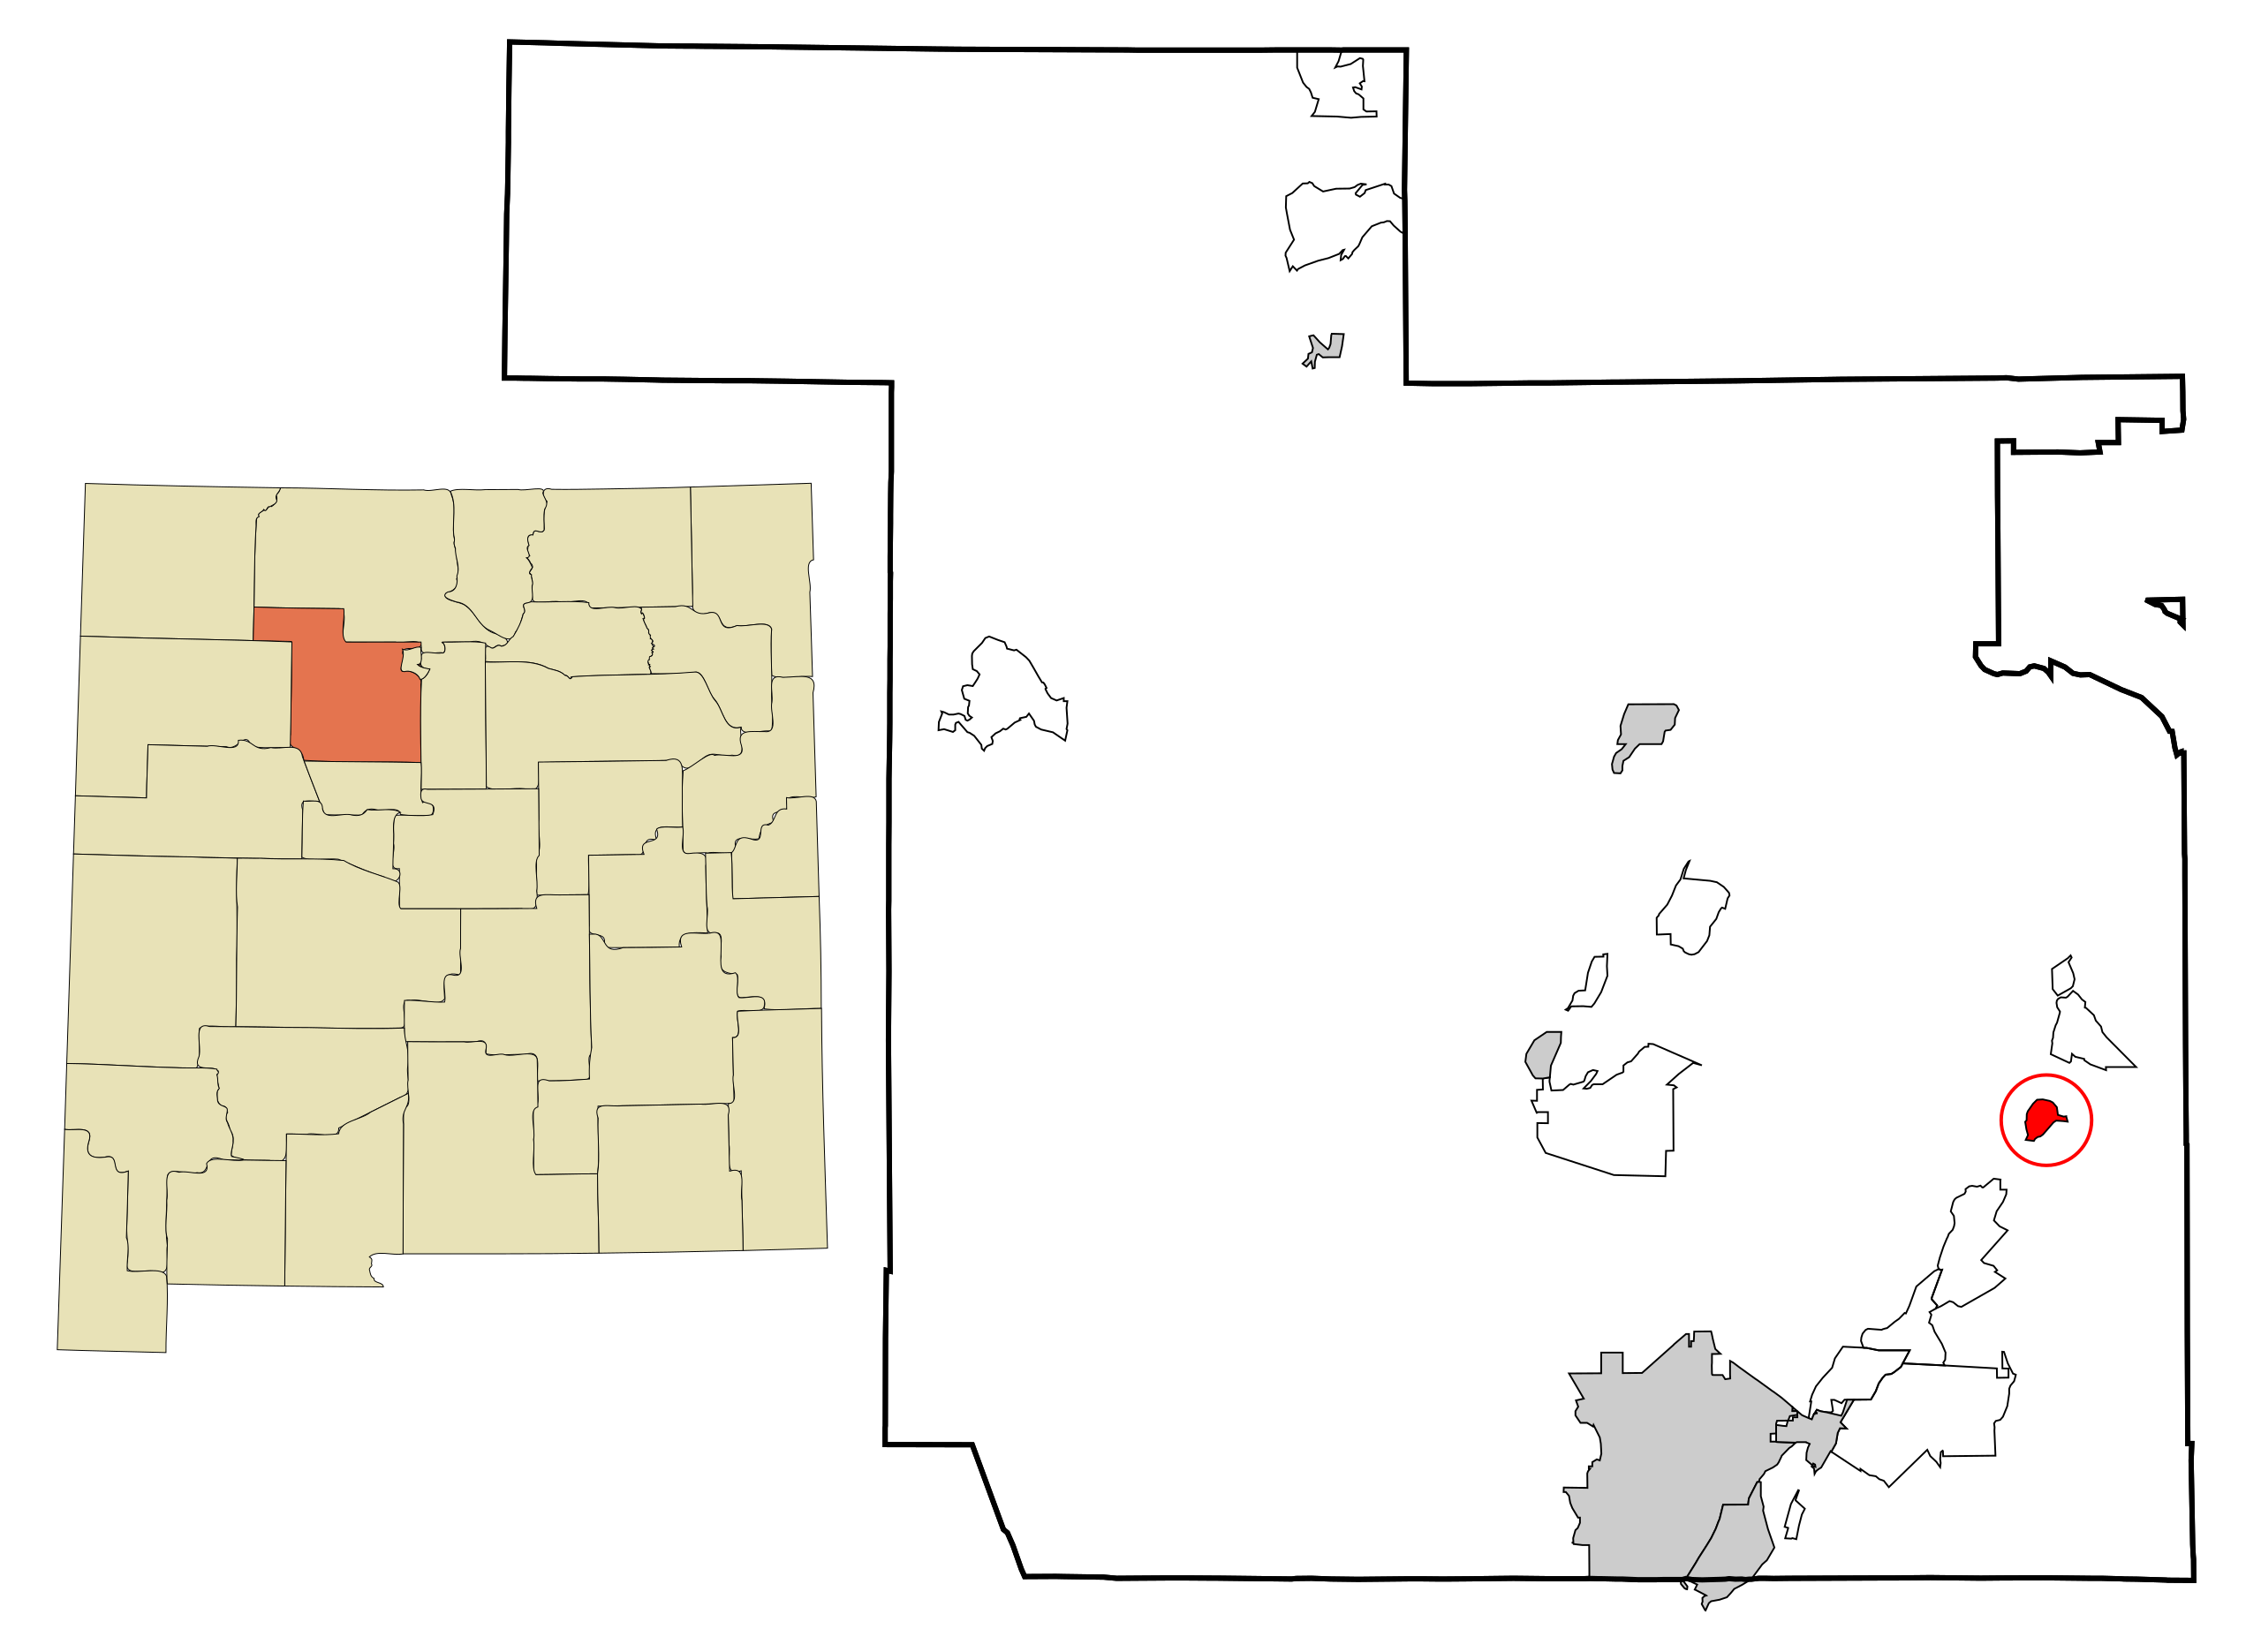

Location of Kewa Pueblo between Albuquerque and Santa Fe

In addition, droughts also exacerbate existing social inequalities through a whole host of environmental justice issues. For example, one study in California indicates that domestic water supply shortages and rising water costs affect low-income families and people of color the most (Feinstein et al. 2017). Decreasing the affordability of water during shortages increases the precarity of poorer households' living conditions at a time when they already have little to no disposable income. Indigenous people in New Mexico will also be disproportionately impacted by intensifying drought. In 2014, drought forced the people of the Kewa tribe to cease traditional farming practices in order to adapt to changing climate conditions (Jung 2014). As the duration and severity of drought increases with warming in New Mexico, more Indigenous people will have to fight to maintain their traditions and way of life.

## Conclusion

Strong warming trends in regions like Albuquerque are likely exacerbating drought in New Mexico. Higher temperatures in the Jemez Mountains decrease snowpack during winters and lead to earlier snowmelt in the spring. Along with increasing evapotranspiration, these factors cause longer and drier periods of drought during the summer. As these droughts become more and more severe, their impacts will disproportionately affect greater numbers of farmers, low-income families, people of color, and Indigenous tribes. Preparing against rising temperatures will be crucial to mitigating the severity of drought in New Mexico. Moving into the future, New Mexico should view its water problems as pertaining to not only drought, but rather, more general climatic shifts and trends which faciilitate and amplify severe drought.

## Citations

Hayden M. 2018. No end in sight for drought. Online at <https://www.abqjournal.com/1190697/no-end-in-sight-for-states-drought-conditions.html>

Menne MJ, Williams CN, Palecki MA. 2010. On the reliability of the U.S. surface temperature record. Journal of Geophysical Research. Online at       <https://onlinelibrary.wiley.com/resolve/doi?DOI=10.1029/2009JD013094>

[UCS] Union of Concerned Scientists (USA). 2016. Confronting Climate Change in New Mexico. Online at       <https://www.ucsusa.org/sites/default/files/attach/2016/04/Climate-Change-New-Mexico-fact-sheet.pdf>

Frisvold GB, Jackson LE, Pritchett JG, Ritten JP. 2013. Agriculture and Ranching. In Assessment of climate change in the Southwest United       States: A report prepared for the National Climate Assessment. Online at <https://www.climas.arizona.edu/sites/default/files/pdf2013sw-nca->       color-finalweb.pdf

Feinstein L, Phurisamban R, Ford A, Tyler C, Crawford A. 2017. Drought and Equity in California. Online at <https://pacinst.org/wp->       content/uploads/2017/01/PI_DroughtAndEquityInCA_Jan_2017.pdf

Jung C. 2014. Drought forces some Native Americans to choose which tradition to save. Online at       <http://america.aljazeera.com/articles/2014/3/20/drought-forces-someinindiancountrytochoosewhichtraditiontosave.html>