Why Should Alabamians be Concerned About Climate Change if Temperature isn't Rising?

Cheyenne Vance

3/16/2019

## The Political Divide

According to a 2018 survey done by National Surveys on Energy and Environment, 60% of Americans believe that global warming is happening, and that “humans are at least partially responsible for the rising temperatures.” However, only 35% of Republicans believe that climate change is partially a result of human actions, while 50% of Republicans do not believe climate change at all (National Surveys on Energy and Environment 2018).

In the case of my hometown Alabama, a Republican stronghold, we might expect skepticism to be even higher than the national average. Several politicians who are also climate skeptics hail from the south which is quite ironic considering the south is predicted to bear the brunt of climate change impacts. By the year 2080 Alabama will suffer the fifth highest economic loss, behind only Florida, Mississippi, Louisiana and Arkansas, all of which tend to have conservative leanings (Figure 1; Brookings Institute 2017, Hsiang et al. 2017). Aside from economic loss, the south will most likely see an increase in mortality, loss of coastal lands and homes, and decreased agricultural production. Part of this skepticism is the lack of understanding of climate change. The idea that climate change does not pose a threat because we experience cold winters is a common held belief. However, when deciding if climate change is a threat or not, we must observe climate trends over a long period of time, rather than on a case to case basis. 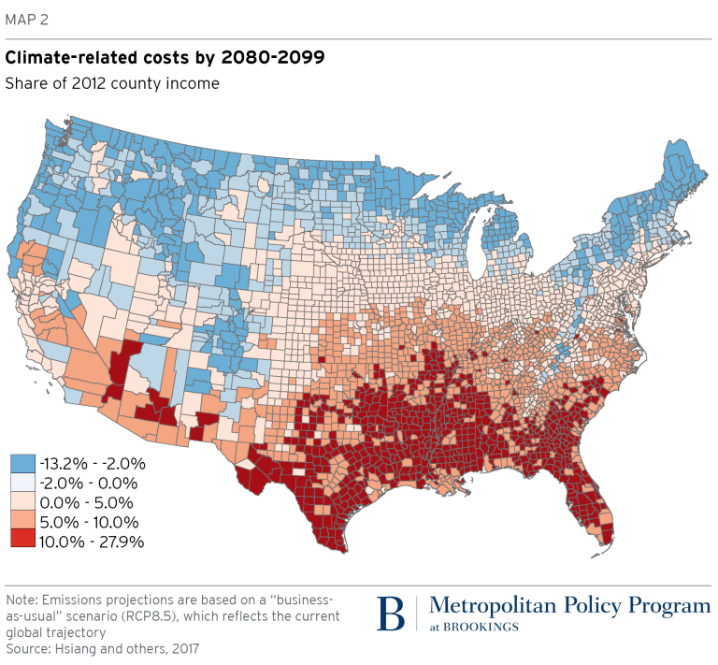

Figure 1: Percentage of economic losses caused by climate change (Hsiang et. al. 2017)

In this blog I will be exploring whether temperature is increasing or not in Huntsville, Alabama. If I am able to reject my null hypothesis which states that temperature is not increasing, then Huntsville, Alabama is experiencing climate change. I will first analyze climate trends in Northern Alabama, and then provide some detailed information on the impacts of these trends and climate change in general, including sea level rise, economic damage, and health risks.

## Roots of Skepticism in the South

So why is there skepticism surrounding climate change despite the copious amounts of evidence? Many skeptics deny “global warming,” justifying their position with the record breaking winters we’ve been experiencing. For this reason I would like to avoid using the phrase global warming, and instead use climate change. In his book A Global Warming Primer, Jeffrey Bennett provides a detailed explanation of how global warming actually works. He states that global warming is an increase in energy in the atmosphere and oceans, which causes extreme weather events. With this newfound knowledge, we can quickly point out the logical fallacy present in the following tweets from President Trump.

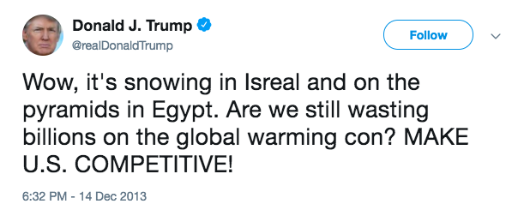

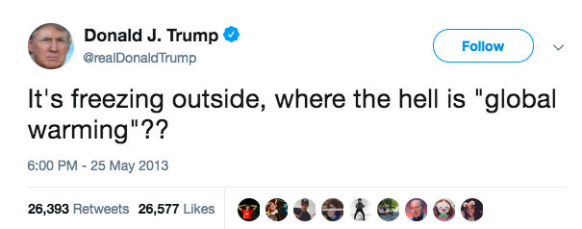  
In fact, with our understanding that global warming causes extreme weather events, President Trump’s tweets support the fact that the climate is changing drastically in all parts of the world. However, some people believe that global warming only leads to warmer temperatures; this assumption may not hold in the south.

After acquiring Alabama NOAA temperature records from over a 60 year period, I analyzed the climate trends in Huntsville, AL. The data had a standard deviation of 9.9 degrees, an average temperature of 7 degree celsius, and 99% variance. I then created a graph of average max temperature trend in the hottest month, July, over a 60 year time period. The data showed an increase of .0128 degrees per year. Ideally we would want to analyze a longer record, which would probably show a stronger trend, but a 60 year timeframe is about what most humans today might be able to remember. To make predictions on a longer time frame we could create a model to show possible trends. The trend I observed in maximum temperatures was not statistically significant, and if shown to Alabamians it probably wouldn't raise any concerns.

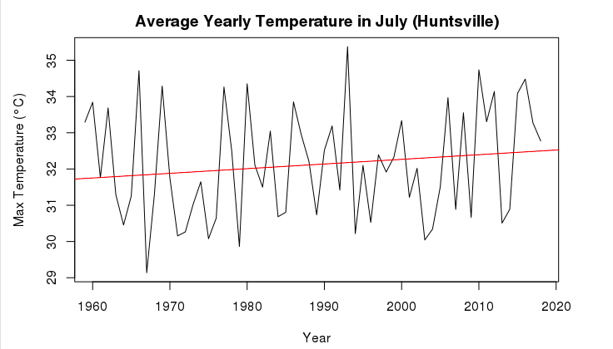

Figure 2: Average max temperatures recorded in July from 1958 to 2019 in Huntsville, AL (slope: 0.0128 degree/year; p = 0.263, r-squared = .004)

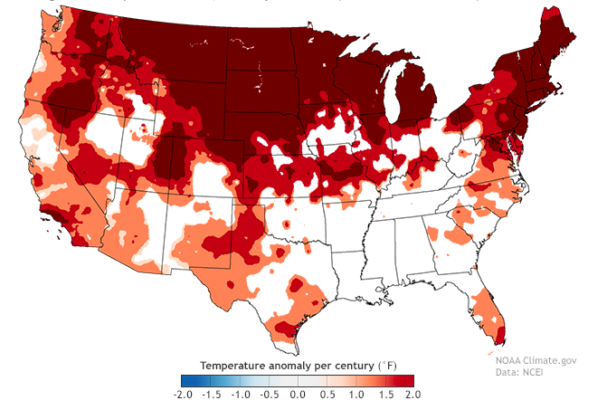

Figure 4: Statistically significant (95% confidence level) temperature anomalies recorded in February from 1895-2016 (NOAA Climate 2017)

It's important to note that NOAA suggests that the south is one of the few places in the U.S. that has not seen significant changes in temperatures (Figure 4). Based off of these data, it makes sense why southerners may object to climate change or simply not care about it. If it doesn’t affect them, should they care? Some researchers have even discovered localized cooling in the Southeast, which could further fuel the skepticism surrounding climate change in these regions.

## The “Warming Hole”

The third National Climate Assessment reported that there was unusual cooling happening in the Southeast between 1991 and 2012. They stated that this was “unusual compared to the rest of the U.S. and the globe.” This phenomenon has been dubbed the “global warming hole” (National Geographic 2014). Intrigued by this cooling phenomenon, I decided to explore whether Huntsville had experienced an increase in minimum temperatures or not.

When analyzing mean monthly minimum temperatures in Huntsville, Alabama, I observed a much more striking heating trend with an increase of .04 degrees. From the data, the "warming hole" seems to be represented by the sharp dips and lack of high temperature extremes that occurs between 1990 and 2020 (Figure 5). However, there is a sharp increase around 2018 suggesting that the warming hole is probably no longer occurring.

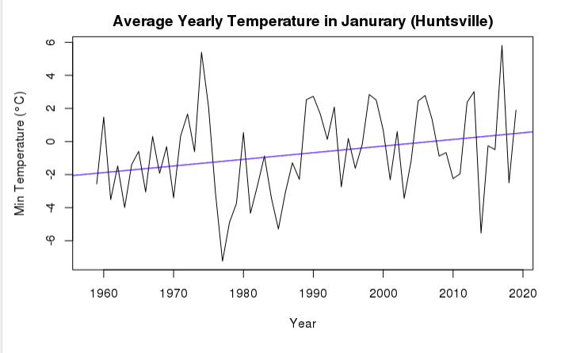

Figure 5: Average minimum temperatures recorded in January from 1958 to 2019 in Huntsville

The p-value for this model was .039 with a slope of 0.04 and r-squared value of .05, meaning the trend is statistically significant, and that temperatures are in fact increasing in Huntsville, Alabama.

## Do Small Temperature Trends Matter?

In short, yes Alabamians should be concerned about climate change, even if the increases in temperature are small. A one degree increase in temperature can cause a huge increase in extreme weather events, such as droughts, hurricanes, and flash floods. While the causes of the warming hole are debated, a team of researchers have done an attribution study to figure out this mystery.

The team concluded that aerosols, which are naturally occurring and man made particulates, were most likely the cause of the warming hole. They also discuss the complexity of the cooling and warming role aerosols play. Airborne absorbing aerosols have been reported to raise regional temperature by reducing the local large-scale cloud cover (Yu et. al 2014), but an increase in particulates in the air could also cause cooling. A 2012 study found that particulate pollution from factories was responsible for delaying expected warming (Leibensperger 2012).

## What else might influence temperature trends?

In spite of the limited temperature records used there are other confounding factors that could affect temperature trends, such as the siting conditions of the measuring station. One study points out that poor siting conditions, such as around heaters or shaded areas, can impact the reliability of stations (Menne 2010). In a future research project I would like to extrapolate climate data from other stations in the region to correct for variability. Despite some uncertainty around climate change and its causes it is certain that anthropogenic activities play a large role in climate trends.

## What is at Stake?

Alabama, along with the other southern states, will face some of the largest economic and ecological impacts if they continue business as usual. A very likely cause of increased temperatures is the burning of coal, which southern economies are heavily reliant on. The south is already experiencing rising sea-levels, an increase in severe storms such as hurricanes, and heat spells (National Climate Assessment). Several teams of scientists have conducted studies documenting sea level rise along the Gulf Coast and its impacts which include the loss of coastal forests, salt‐marshes, coral reefs, and marine communities. In 1990, rates of relative sea‐level rise along the Gulf of Mexico were documented as high as 11.9 mm yr−1 in Louisiana (Penland et. al., 1990), and have since been going up.

Properties and economies along the Gulf of Mexico, which contributes over $2.2 trillion to the U.S. Gross Domestic Product (NOAA-NOS 2008), will be threatened by hurricanes and sea level rise. As I mentioned before, southern states will suffer the most severe economic losses as a result of nation-wide climate change impacts if they do not convert to more sustainable forms of energy.

These extreme weather events are also particularly dangerous for vulnerable groups of people. Climate change has been associated with increased deaths, disease and injury due to heat waves, floods, storms, fires and droughts, and the increased frequency of cardio-respiratory diseases due to higher concentrations of ground level ozone (IPOC 2007). The elderly, children, and those with health conditions will especially be affected by these impacts. African Americans were only second, after individuals aged 65+, of the largest demographics affected by heat-related deaths and comprise over 27% of Alabama's population. While these conditions may not pose a significant problem for the wealthy, those with lower incomes will have a hard time adapting, and will disproportionately suffer the impacts of climate change, while reaping very few of the benefits.

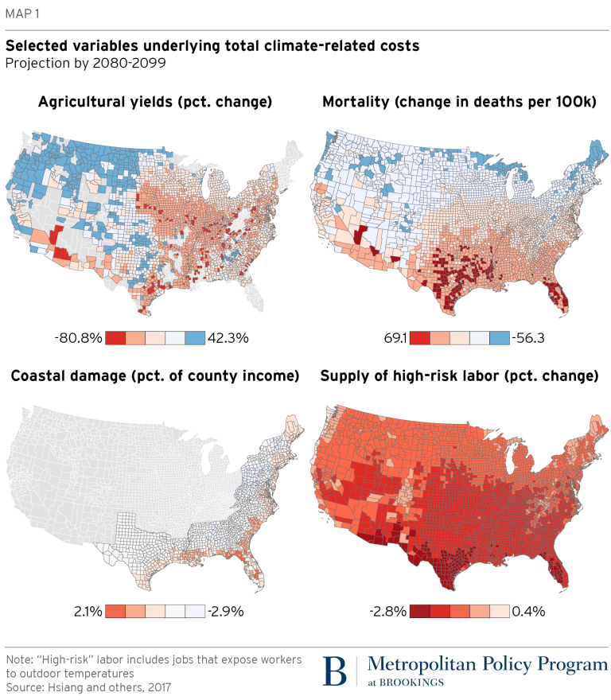

Figure 7: Total percent change in climate-related attribution costs, (Hsiang et. al. 2017)

## Conclusion

Roughly 95% of scientists across the country are in agreement that climate change is occurring and have the data to show it. As mentioned earlier, my data confirms that yes, Alabamians should be concerned, but what else can we do? A few major steps that the south can take is adopting cleaner energy sources, and reducing energy usage overall. However, a major step is first admitting that climate change is occurring and educating ourselves on the matter. Climate change should not be a partisan issue because it affects all of us and will affect future generations. I hope that a major take away from this blog is that climate change is not simply warming temperatures, but an increase in extreme weather events overall. Finally while part of climate change is due to natural processes, human activity is playing a significant role in exacerbating the issue.

## Works Cited

Leibensperger, E. M., Mickley, L. J., Jacob, D. J., Chen, W.-T., Seinfeld, J. H., Nenes, A., Adams, P. J., Streets, D. G., Kumar, N., and Rind, D. 2012. Climatic effects of 1950–2050 changes in US anthropogenic aerosols – Part 2: Climate response, Atmos. Chem. Phys., 12: 3349-3362. <https://doi.org/10.5194/acp-12-3349-2012>

Penland S, Ramsey KE 1990. Relative sea‐level rise in Louisiana and the Gulf of Mexico: 1908–1988. Journal of Coastal Research. 6: 323–342.

Yu Shaocai, Alapaty Kiran, Mathur Rohit, Pleim Jonathan, Zhang Yuanhang, Nolte Chris, Eder Brian, Foley Kristen, Nagashima Tatsuya. 2014. Attribution of the United States “warming hole”: Aerosol indirect effect and precipitable water vapor. Scientific reports 4: 6929.

Genebra Suíça. 2001. "Climate change 2007: Impacts, adaptation and vulnerability." Intergovernmental Panel On Climate Change.

Ellis Jean T., Joseph P., Spruce Roberta A., Swann James C., Smoot Kent, W. Hilbert. 2011 "An assessment of coastal land-use and land-cover change from 1974–2008 in the vicinity of Mobile Bay, Alabama." Journal of Coastal Conservation 15.1: 139-149.

Desantis Larisa RG, Bhotika Smriti, Williams Kimberlyn, Putz Francis E. 2007. "Sea‐level rise and drought interactions accelerate forest decline on the Gulf Coast of Florida, USA." Global Change Biology 13.11: 2349-2360.

Bennett Jeffrey O. 2016. A Global Warming Primer : Answering Your Questions About the Science, the Consequences, and the Solutions. Big Kid Science.

Crouch Jake. 2017. Mapping U.S. climate trends. NOAA. <https://www.climate.gov/news-features/blogs/beyond-data/mapping-us-climate-trends>

Menne Matthew J., Williams Jr. Claude N., A. Palecki Michael. 2010. “On the reliability of the U.S. surface temperature record.” Journal of Geophysical Research, 115, D11108.

## Further Reading

Wise, Justin. "Poll: Record number of Americans believe in man-made climate change." The Hill, July 2018 <https://thehill.com/policy/energy-environment/396487-poll-record-number-of-americans-believe-in-man-made-climate-change>

National Surveys on Energy and Environment."As Americans Experienced the Warmest May on Record Their Acceptance of Global Warming Reaches a New High." July, 2018 <http://closup.umich.edu/files/ieep-nsee-2018-spring-climate-belief.pdf>

Howard, Brian. "As the World Warms, Part of the American Southeast Cools." National Geographic, May 2014. <https://news.nationalgeographic.com/news/2014/05/140509-global-warming-hole-southeast-climate-change-science/>

Howard, Brian. "Climate Report Provides Opportunity for Bridging Political Divide" National Geographic, May 2014. <https://news.nationalgeographic.com/news/2014/05/140506-national-climate-assessment-global-warming-policy-politics/>

"Atmospheric Aerosols: What Are They, and Why Are They So Important?" Nasa, August 1996. <https://www.nasa.gov/centers/langley/news/factsheets/Aerosols.html>

Hill, Taylor."Climate Change Wallops Alabama, but the State Climatologist Is a Climate Skeptic." TakePart, November 2016. <http://www.takepart.com/article/2016/11/01/alabama-drought-shows-state-mind-climate-change>

“Climate Change Indicators in the United States: Heat-Related Deaths.” Environmental Protection Agency, August 2016.