Rising Temperatures to Blame for Extreme Weather Events in the Nation's Capital?

Chris Clark

3/11/2019

## Blizzards and Hurricanes, Are They Increasing?

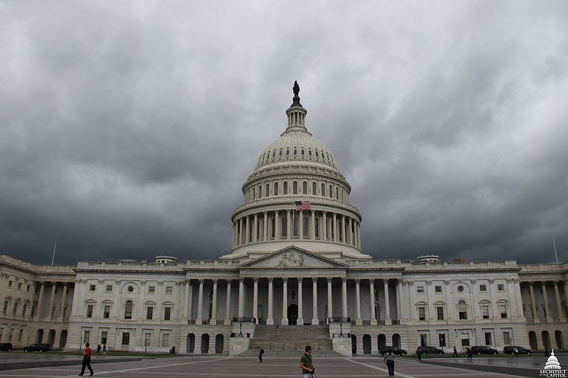

[***Figure 1.*** *Picture of the US Capitol Building with a Storm Looming from USCapitol Flickr* ]

Washington, DC is a hub of government and culture for the United States. It is built on a drained swamp, making the climate humid with blistering summers and cold winters. The city has not been historically known for its extreme weather, but growing up there, I saw that events such as hurricanes and blizzards have been increasing in frequency and intensity throughout the past century. To explain extreme events, I evaluate literature and temperture data for summer and winter weather patterns, then address some of the socioeconomic impats they have on vulnerable populations.

I hypothesize that these increases in extreme weather have corresponded with atmospheric warming in DC during summer and winter months. This is troubling from a humanitarian perspective because of the rampant homelessness and income inequality in the nation’s capital. Changes in temperature that can influence these events may be very destructive and deadly to communities of lower income, and something must be done to mitigate these impacts.

## Analyzing Temperature Trends with NOAA Data

Using The National Oceanic and Atmospheric Association (NOAA) data base, I downloaded weather data from 1936-2019 taken from Reagan National Airport in Arlington, Virginia (3 miles south of Washington, DC). This airport has had construction in recent years, but the station is not in the same area as the construction has been, leaving me with no reason to assume inaccuracy in this station's data. The relationship between temperatures and times was analyzed over this 83 year span using the open source statistical analysis program R to determine whether I could reject the null hypothesis of no relationship between temperature change and time. Data with α= 0.05 are statistically significant and allow me to reject the null hypothesis.

## How do Increased Temperatures Relate to Blizzards?

Washington, DC is a quintessentially mid-atlantic area, straddling the line between the snow-prone north and storm-prone south. This zone between snow and storm has not historically been known for its blizzards. However, according to local news outlet WUSA9, 11 of the 15 worst winter storms in the DC metropolitan area since 1800 have occurred between the months of January and March from 1966 to the present.

What could be contributing to this increase in extreme weather? One hypothesis is that warming temperatures in the winter can cause increased evaporation from plants as well as the nearby Potomac river and Chesapeake bay, leading to more water vapor in the air and thus larger snowfall once the temperatures dip and the precipitation falls (Wallace et al. 2014). Maximum December temperatures in DC have actually increased significantly since 1945 with a slope of .03 degrees Celcius (.05 degrees Fahrenheit) per year and p-value of .03. December high temperatures in DC have historically ranged from -3 to 7 degrees C (26-44 F). Evapotranspiration has also been increasing all throughout the coterminous United States (Walter et al. 2004), possibly due to rising temperatures. Temperatures in January and February (DCs heaviest snowfall months) have not significantly decreased, but since the temperatures in December have increased, evaporation and evapotranspration and increases may be contributing to increases in major snowfall events in the region. 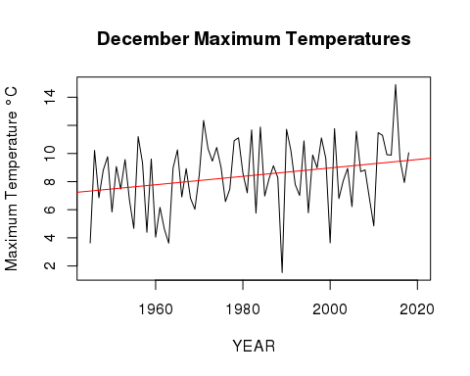

[***Figure 2.*** *Plot of December Maximum Temperatures Over Time*]

## Have Maximum Temperatures increased Hurricanes?

Atlantic hurricane season as designated by NOAA starts on June 1 and goes all the way through November 30. As shown in figure 3, maximum temperatures in August have increased with a slope of .02 degrees C (.04 degrees F) per year with a p-value< 0.01. August high temperatures historically have ranged from 20 to 34 degrees C (68-93 F). This p-value shows a significant correlation between year and temperature, meaning that there has been significant warming in the Washington, DC area. This increased surface/atmospheric temperature supports hurricane landfall, where previously cooler land and atmospheric conditions could not support the storms. This is supported by the above graph, as well as data that shows that between 1970 and 1998 east coast hurricane frequency was increasing (Smith 1999). Figure 4 also shows an upward trend through time of North Atlantic Tropical Cyclone activity. Additionally, hurricane data from the National Weather Service (2012) shows that through time, DC experienced hurricanes with more frequency than in the previous 150 years, which may be partially explained by the increases in temperature.

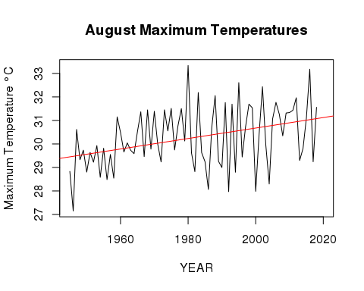

[***Figure 3.*** *Plot of August Maximum Temperatures Over Time*]

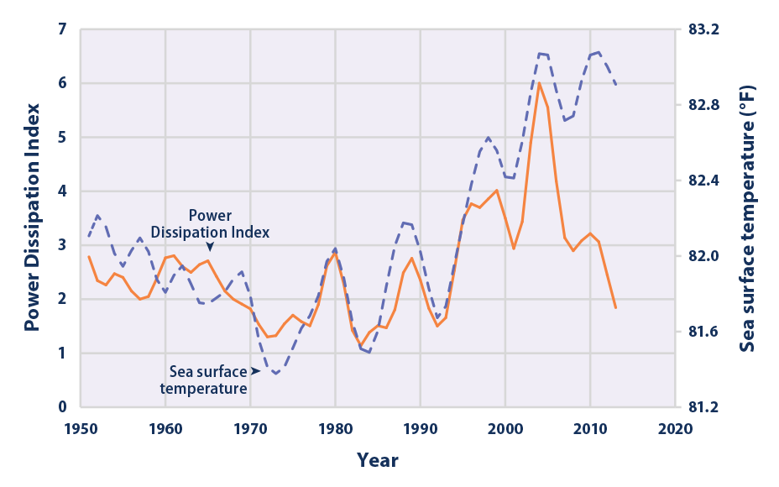

[_**Figure 4.** North Atlantic Tropical Cyclone Activity According to the Power Dissipation Index, 1949–2015 Source: EPA <https://www.epa.gov/climate-indicators/climate-change-indicators-tropical-cyclone-activity_>]

## Limitations & Future Research Directions

Much of the literature I have employed is very broad in scope and admittedly, it is unlikely that warming-caused evaporation is the sole cause of increases in extreme weather. However, based on existing literature and my own analyses I believe that they are at the very least significant contributors. To prove this, long-term studies looking at various atmospheric factors and storm behaviors would be needed, but I believe this is a good start.

## Societal Implications: Poverty & Homelessness

Extreme weather events disproportionately affect people who are homeless or live in poverty (shown in Figure 5). These events likely magnify physical and mental health issues as well as substance use disorders in the impoverished and homeless (Pendrey et al. 2014). This has wide implications in DC, which has a 19% poverty rate with more than 15,000 of the city’s 700,000 residents experiencing homelessness over the course of a typical year (as of 2018). Additionally, it has been shown that climatic disasters are more destructive to places of lower income (Kahn 2005).

With this data as well as social data on weather's impact on different communities, increases in frequency and intensity of extreme weather events will likely continue to wreak havoc on the vulnerable, lower income communities. This needs to be considered in planning for extreme weather events so that mass displacement and casualties can be avoided as extreme weather comes more and more often. This may come in the form of increased shelter space and more proactive campaigns to get vulnerable people into shelters before storms hit. Though this has been done in some neighborhoods, there is a long way to go to protect most of the city's vulnerable.

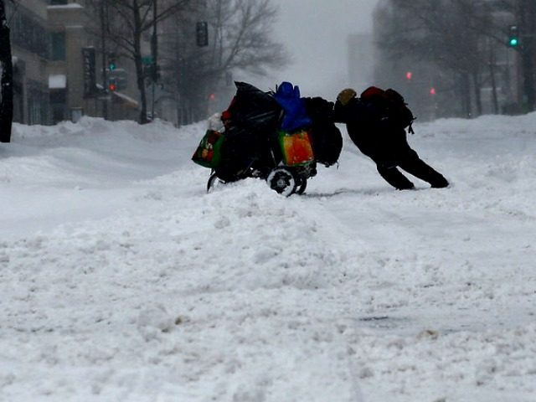

[***Figure 5.*** *Picture of a Homeless Person During a Winter Storm from WUSA9*]

## Sources

Kahn M. 2005. The Death Toll from Natural Disasters: The Role of Income, Geography, and Institutions. Rev. Econ. Stat. 87(2):271-284

[NWS] National Weather Service (US). 2012. Hurricane History for the Washington and Baltimore Region. Silver Spring (MD): National Oceanic and Atmospheric Administration

Pendrey C, Carey M, Stanley J. 2013. Impacts of extreme weather on the health and well-being of people who are homeless. Aust. J. Prim. Health 20:2-3.

R Core Team (2017). R: A language and environment for statistical computing. R Foundation for Statistical Computing, Vienna, Austria. URL <https://www.R-project.org/>

Smith E. 1999. Atlantic and East Coast hurricanes 1900–98: a frequency and intensity study for the twenty‐first century. Bull. Amer. Meteor. Soc. 80:2717–2720.

The Washington Legal Clinic for the Homeless. 2018. Fact Sheet on Homelessness and Housing Instability in DC [PDF]. Washington (DC): The Washington Legal Clinic for the Homeless.

Wallace JM, Held IM, Thompson D, Trenberth KE, Walsh JE. 2014. Global warming and winter weather. Sci 343:729–730.

Walter MT, Wilks DS, Parlange J-Y, Schneider RL (2004) Increasing evapotranspiration from the conterminous United States. J Hydrometeorol 5(3):405–408.

WUSA (US). 2018. DC's 15 worst winter storms. Washington (DC): CBS