Has Climate Change Contributed to More Frequent and Severe Wildfires in Santa Barbara County?

By: Emily

2/11/2019

# Why I Chose this Topic

After witnessing firsthand the incredible destruction that the Thomas Fire brought to my hometown, I became determined to bring awareness to the correlation between climate change, extreme weather, and natural disasters. The Santa Barbara County Multi-Jurisdictional Hazard Mitigation Plan (Hazard Mitigation Plan) categorizes Wildfire as a “high probability/medium impact hazard.” In this blog, I will compare climate data from the National Oceanic and Atmospheric Administration (NOAA) with wildfire data from the Hazard Mitigation Plan to asses whether climate change is exacerbating natural hazards such as wildfire. I will attempt to prove my hypothesis that climate change is causing wildfires in Santa Barbara to become more frequent and intense.

# 

Santa Barbara is a coastal city in California that is vulnerable to a number of natural hazards that could be exacerbated by climate change. Some of the most impactful and likely of these events include drought/water shortage, flooding/sea level rise, and wildfires (Hazard Mitigation Plan).

Although I didn't have enough time to thoroughly show a correlation between some of these threats and climate change, I will briefly discuss the inferences that I have made based on my research.

## SB April Climate since 1893

The first step that I took towards proving my hypothesis about wildfires was graphing Santa Barbara climate data that had been recorded from 1820 to the present.

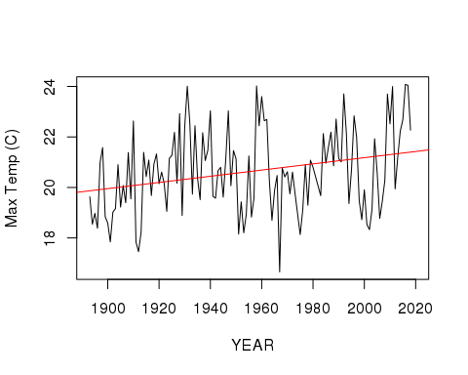

This graph shows the average temperature change in Santa Barbara during the month of April. The positive slope of 0.012 indicates that average temperature is increasing at a rate of about 1 degree per every century. We know that this is significant data because the P-value is less than 5%

# Wildfire Acres Burned

Next, I wanted to see if over time there would be an indication of increased intensity in Santa Barbara wildfires. So I used the wildfire data (Hazard Mitigation Plan) to graph the number of acres burned in the major fires recorded since 1920.

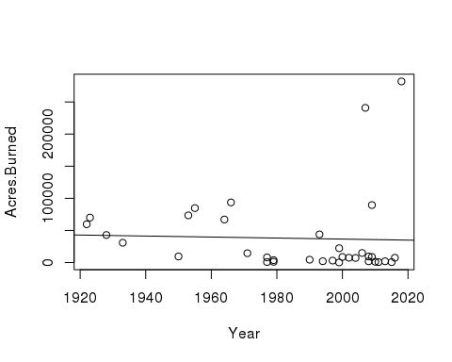

Unfortunately, the data had so much variance in the number of acres burned per year that there was no real relationship found.

However, I did notice that there seemed to be more fires in recent years, so I decided to graph the instances of major wildfires to see if they would show a significant increase since 1920.

# Wildfire Instances

This data did indeed indicate a significant relationship and a stark increase in the the number of fires that ocurred each year. The slope of 0.083 indicates that in the 2000s there is estimated to be thirteen times the number of wildfires that ocurred in 1920. The R squared value (0.6421) indicates that about 64% of the variance in the data is explained by the line and the P-value of 0.0094 indicates that the data is significant.

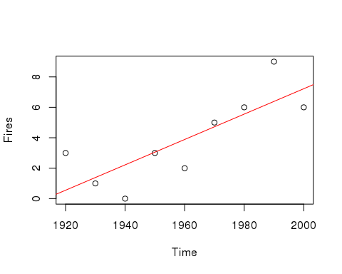

# Conclusion

The Thomas fire burned a total of 281,893 acres (CalFire.calgov), making it the largest fire in Califorinia's recorded history. This came on the heels of the 2012–2014 California drought which was cumulatively the worst unbroken drought of the last millennium (Hazard Mitigation Plan, 2019). Though the state of California declared the drought over in 2014, Santa Barbara remained in drought conditions until 2017 with its two main water sources at 14.9% capacity 0.2% capacity in 2016 (Hazard Mitigation Plan, 2019). Although I was not able to find comprehensive research on whether the drought contributed to the severity of the Thomas Fire, I presume that the link between hotter temperatures and increased wildfire instances is the extended drought conidtions. I suspect that drought caused an accumulation of dry vegetation that acted as fuel for the fire. To further the damaging positive feedback loop that a warming climate has imposed on Santa Barbara county, post fire landscapes in the Chapparal biome are subject to significantly increased erosion rates capable of producing large destructive debris flows (Natural History of Fire & Flood Cycles, 1995). This became evident when the post Thomas fire storms were immediately followed by devastating floods in Monteciteo.

Globally we’ve seen roughly a 330% increase in hurricanes, droughts, wildfires and extreme storms since 1980 (Drought, Fire, and Flood: Climate Change and Our New Normal 2018) The consequences of these extreme weather events have disastrous impacts on the communities where they take place and can often trigger a positive feedback loop of disasters as we have seen with Santa Barbara County.

If I had more time, I would've found and graphed more data that could corroborate my positive feedback loop theory of disaster further and strenghten my claim that a warming climate in Santa Barbara has contributed to more frequent and severe wildfires.

# Sources

Ainsworth J, Doss TA. 1995. Natural History of Fire & Flood Cycles.

1. National Oceanic and Atmospheric Administration.

Santa Barbara County Office of Emergency Management. 2017. Santa Barbara County Multi-Jurisdictional Hazard Mitigation Plan.

UCSB Bren School of Environmental Science & Management, the Community Environmental Council, the Santa Barbara Foundation, and the Santa Barbara Museum of Natural History. 2018. Drought, Fire, and Flood: Climate Change and Our New Normal.