The 2013 Boulder Flood: Can We Attribute Specific Extreme Weather Events to Climate Change?

Bailey Lai

15 March 2019

## Introduction

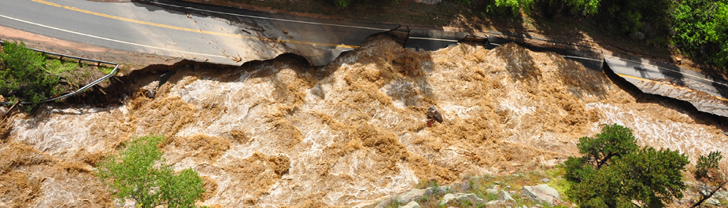

***Figure 1.*** *A road washed out by an overflowing stream in the foothills of Boulder, September 2013. Image obtained from City of Boulder website.*

For decades, climate scientists have warned the public of the effects of historic and present anthropogenic greenhouse gas emissions on global climate patterns. Yet the scientific community continues to struggle to pinpoint with statistical certainty how climate change leads to an increase in regional natural disasters. Along with the politicized nature of climate science in America, the media in the United States has therefore been quick to conflate or dismiss any relationships between short-term weather-induced natural disasters with long-term global climatic patterns.

This jump to conclusions was seen in the devastating September 2013 rainstorm and floods in Colorado. The rainstorm hit Boulder County particularly hard. In the span of one week in September 2013, Boulder received one of the largest sustained precipitation levels in a one-week period since the start of historic records. From Monday 09 September to Monday 16 September received 17.15 inches of rain, just shy of the 20 inches of precipitation the county receives on average annually (Brennan and Aguilar 2013, "Colorado Flood 2013", n.d.). On Thursday 12 September, the county received over 10 inches in just one day, the highest in recorded history (*ibid.*). Ensuing floods killed 4 people in the county, injured dozens and caused the evacuation of nearly 2,000 residents by road and helicopter (Brennan and Aguilar 2013). Overflowing waters in the region's waterways also destroyed 345 homes and damaged 557 homes, and caused over a billion dollars in property and economic damage (ibid., Figures 1 & 2). In the aftermath, FEMA declared the entire county a disaster zone, and public and private reconstruction efforts around the county continued for years.

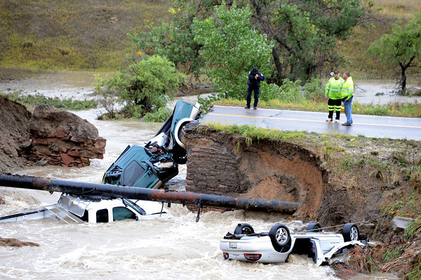

***Figure 2.*** *A bridge collapse in Lafayette, CO causes three cars to fall into a creek on 13 September 2013. Image obtained from Cliff Grassmick of Daily Camera.*

A year after the floods, local newspaper Daily Camera declared “2013’s flood-triggering rains not caused by climate change” (Brennan 2014). This bold claim was based on a local study modeling the probability of increased precipitation in Northeast Colorado as a result of anthropogenic-induced warming (Hoerling et al. 2014). However, even the article noted other scientists’ criticism of the paper’s suspect methodology. For example, Hoerling et al. (2014) developed a model to predict the likelihood of five-day flood event in just the month of September, presumably to measure and compare models that could determine specifically how likely the September 2013 floods. Though this model could analyze September flood events, the authors fail to mention how their model can account for the change in flood probability throughout the whole year or other months of the year. The study also focuses on two thirty-year periods, the years 1871-1900 and 1984-2013, presumably to model before and after worldwide anthropogenic emissions increased exponentially in the 20th century. The authors do not explain why they decided to pick two thirty-year periods specifically. Therefore, looking at one month in two 30-year periods prevents the model used in Hoerling et al. (2014) from making general conclusions on how climate change has affected the overall likelihood of floods across Northeast Colorado in the past century.

However, a multitude of other local and national researchers on the September 2013 Boulder floods have disputed this initial study. In a field known as attribution science, climatologists and meteorologists attempt to pinpoint direct causal relationships between global and regional climate change with the probability of specific extreme weather events like the Boulder floods. What researchers focused on was the fact that much of the humid air causing the floods came from the convergence of two concurrent hurricanes on Mexico's east and west coasts. In mid-September 2013, Hurricane Manuel on the Pacific and Hurricane Ingrid on the Gulf of Mexico killed hundreds along the Mexican coast. At the same time, the sea surface temperature around Mexico were the highest globally and likely increased from anthropogenic warming (Trenberth *et al.* 2015). As the two storms' combined warm monsoonal air met up and headed north into the United States, huge amounts of moisture built up above the Southwest (*ibid.*). Meteorologists at the time also noted a front of cold, dry air had stalled along the Front Range Urban Corridor (Brennan and Aguilar 2013), Northeast Colorado's relatively flat and heavily populated area just east of the Rocky Mountains. This combination of exceptionally warm, humid air and cold, dry air created the conditions for what the *Daily Camera* called a "1000-year rain and 100-year flood" (Brennan and Aguilar 2013, Brennan 2014). Years later, *Daily Camera* followed up on the initial study with new studies claiming the opposite of Hoerling *et al.* (2013). According to researchers like Kevin Trenberth, the model in Hoerling *et al.* (2013) did not take into account the abnormal hurricane conditions south of Colorado that led to massive rainstorms. One later attribution study created models combining global climate change with local trends, taking into account how much the hurricanes' abnormally warm conditions had been enhanced by human-caused climate change (Pall *et al.* 2017). Their results showed anthropogenic climate change had increase rainfall up to 30% in the 2013 storms compared to regional climate models with anthropogenic variables removed (Pall *et al.* 2017, Brennan 2017).

Though the overwhelming majority of scientists agree on anthropogenic climate change, the attribution of climate change to any single extreme weather event continues to incite scientific debate. Using the 2013 Boulder floods as a case study, I wanted to test whether larger regional climate change in Colorado and climate change around the world could be obscured by highly variable, short-term conditions like daily temperatures and precipitation in the Boulder area. I hypothesized the six climate stations increase in daily max temperatures over time, and increase in daily precipitation over time. To test the plausibility of this alternative hypothesis, I test whether the null hypothesis (that daily max temperature and/or precipitation will not increase) can be rejected.

## Methodology

For this study, I chose six sites based on their location within the Boulder Creek watershed (Table 1, Figure 3, "Boulder Area" 2013, USGS n.d.). I looked at three climate stations around Boulder obtained from the National Oceanic and Atmospheric Administration's online database of daily summaries from the Global Historical Climate Network (NOAA GHCN). One is located in the city of Boulder, and two are located in the Rocky Mountains just west of Boulder (Figure 3). I also look at three climate stations from the site of the Niwot Ridge Long Term Ecological Research program (NWT LTER), up in the Rocky Mountains to the west of Boulder and close to the headwaters of the Boulder Creek watershed (Table 1, Figures 3 and 4).

***Table 1:*** *Climate stations analyzed for daily maximum temperatures and daily precipitation*

|  |  |  |  |  |
| --- | --- | --- | --- | --- |
| Climate Station | Latitude | Longitude | Altitude (m) | Agency/Program |
| 1. [D-1](http://niwot.colorado.edu/data/climate/d1-meteorological-data) | 40.0598 | -105.6165 | 3739 | NWT LTER |
| 2. [Saddle](http://niwot.colorado.edu/data/climate/saddle-meteorological-data) | 40.0547 | -105.5892 | 3528 | NWT LTER |
| 3. [C-1](http://niwot.colorado.edu/data/climate/c1-meteorological-data) | 40.0362 | -105.5440 | 3022 | NWT LTER |
| 4. [USW00094075 - Boulder 14 W](https://www.ncdc.noaa.gov/cdo-web/datasets/GHCND/stations/GHCND:USW00094075/detail) | 40.0354 | -105.5409 | 2996 | NOAA GHCN |
| 5. [USC00051681 - Coal Creek Canyon](https://www.ncdc.noaa.gov/cdo-web/datasets/GHCND/stations/GHCND:USC00051681/detail) | 39.8958 | -105.3847 | 2728 | NOAA GHCN |
| 6. [USC00050848 - Boulder](https://www.ncdc.noaa.gov/cdo-web/datasets/GHCND/stations/GHCND:USC00050848/detail) | 39.9919 | -105.2667 | 1672 | NOAA GHCN |

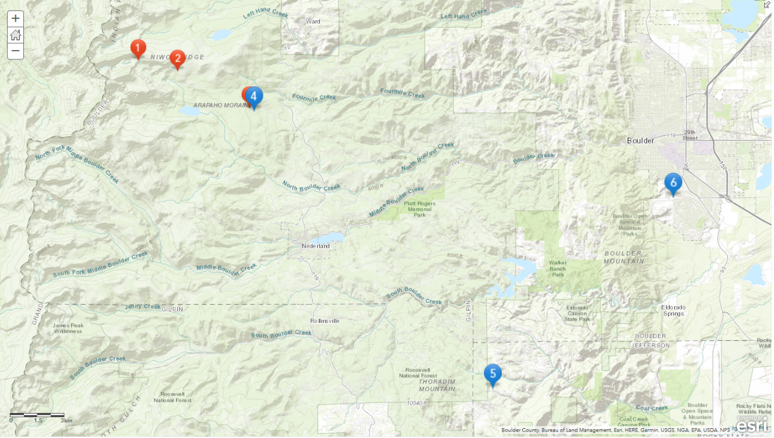

***Figure 3.*** *Topographic of climate station locations with corresponding numbers (#3 hidden behind #4). Map created via ArcGIS Online.*

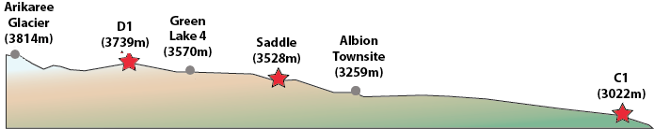

***Figure 4.*** *North-facing side elevation of NWT climate station locations (Numbers 1-3 in Figure 3). Image obtained from NWT LTER website.*

On the statistical software R, I used a linear regression model for the daily max temperature and precipitation of each site to test whether the historical data has an increase or decrease, how much of the variability in the data can be explained by the model, and whether such results are statistically significant.

## Results

Two of the three NWT stations, Saddle and C-1, and two of the three NOAA climate stations, Boulder 14 W and Boulder, had statistically significant increases in daily maximum temperature over time (Table 2). One station, D-1, had a statistically significant decrease in daily maximum temperature over time. One station, Coal Creek Canyon, had a non-significant increase over time.

***Table 2:*** *Linear regression of daily maximum temperatures*

|  |  |  |  |  |
| --- | --- | --- | --- | --- |
| Climate Station | change in daily TMAX | Adjusted R-squared | p-value | Statistical significance? |
| 1. D-1 | -3.69e-05 | 0.000630 | 7.08e-05 | yes |
| 2. Saddle | +1.25e-04 | 0.00248 | 1.15e-08 | yes |
| 3. C-1 | +9.23e-05 | 0.00438 | < 2e-16 | yes |
| 4. Boulder 14 W | +2.39e-04 | 0.00146 | 0.00247 | yes |
| 5. Coal Creek Canyon | +3.65e-05 | 0.000109 | 0.124 | no |
| 6. Boulder | +4.74e-05 | 0.00366 | < 2e-16 | yes |

Two of the six stations, D-1 and Saddle, had a statistically significant increase in daily precipitation over time (Table 3). One station, C-1, had a statistically significant decrease in precipitation over time. D-1, Boulder 14 W, Coal Creek Canyon, and Boulder, had a non-significant increase over time.

***Table 3:*** *Linear regression of daily precipitation*

|  |  |  |  |  |
| --- | --- | --- | --- | --- |
| Climate Station | change in daily PRCP | Adjusted R-squared | p-value | Statistical significance? |
| 1. D-1 | +2.24e-05 | 0.000262 | 0.0164 | yes |
| 2. Saddle | +2.57e-04 | 0.00725 | <2e-16 | yes |
| 3. C-1 | -8.74e-05 | 0.00954 | <2e-16 | yes |
| 4. Boulder 14 W | +8.30e-05 | 0.000492 | 0.0531 | no |
| 5. Coal Creek Canyon | +5.15e-06 | -6.66e-05 | 0.688 | no |
| 6. Boulder | +1.62e-06 | -5.28e-06 | 0.379 | no |

Only Saddle shows a statistically significant increase in daily temperature and precipitation over time, thereby rejecting the null hypothesis for that station. D-1 has a statistically significant changes for both as well, but for temperature it is decreasing. As a reference, I provide the linear regression graphs for daily maximum temperature over time (Figure 5) and daily precipitation over time (Figure 6) I created for D-1 station below. The height of the 2013 floods is clearly visible as the tallest spike on the right side of Figure 6. I purposely omit the graphs of the other stations to prevent cluttering up the results section.

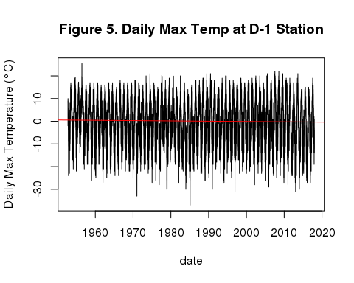

## logical(0)

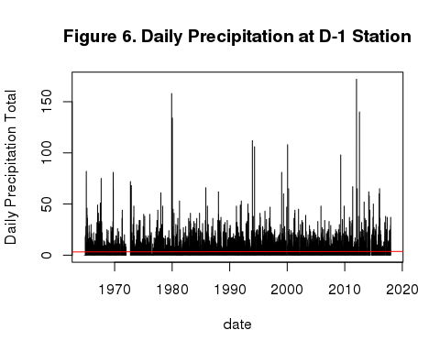

## logical(0)

## Discussion

I found the six stations' varying results intriguing, since I chose all six based on their geographic proximity and location around the Boulder watershed. Rather than the expected consistent trend among all stations, each station's daily temperatures and precipitation seemed to trend in different directions. The adjusted R-squared for all sites' daily temperature and precipitation are below 0.01, meaning even the statistically significant linear models explained less than 1% of the variability in the data. For example, D-1 has a statistically significant linear model for precipitation, but much of the variation in the data appears as "noise" (Figure 6) as reflected in the very low adjusted R-squared value of 0.000262 (Table 3). One noteworthy comparison is between the C-1 weather station data from Niwot Ridge LTER and Boulder 14 W data from NOAA and GHCN. As the two stations are within 100 meters of each other (Figure 3), I find it surprising that C-1 has a statistically significant decrease in daily precipitation, yet Boulder 14 W has a close to significant increase (Table 3). Although this study cannot conclude that daily temperature and precipitation are correlated or are increasing in the Boulder Creek watershed, my results highlight how wide variations in local, short-term collection of weather data can obscure larger global trends of warming climate and increased precipitation. Daily weather does not full encapsulate changes in seasons over years and decades. A future study should create monthly and seasonal means to better analyze climatic trends over time.

I ran into a couple limitations when creating this study. The time range of available data from GHCN on NOAA's website vary widely. For example, daily summaries from Boulder (USC00050848) began October 1893, whereas daily summaries from Coal Creek Canyon (USC00051681) began July 1984. Because of such huge variances in time records, I cannot draw concrete direct comparisons between the daily data of each station. the In the Niwot Ridge LTER data, "various circumstances" required the data compilers to estimate daily summaries for missing values stretching many consecutive days in each station's daily summaries. Researchers should focus on maintaining accurate data to avoid estimating daily summaries. In the future monthly summaries may be more appropriate in looking at seasonal fluctuations of temperature and precipitation over time.

Future studies could model predicted future water flow of streams converging downstream into urbanized areas. For example, Yochum and Moore (2013) estimated peak water flow in 15 streams affected by the 2013 Boulder floods instead of focusing on long-term precipitation or air temperature data. Local geographic conditions also greatly affect the likelihood of flooding and should be accounted for. Multiple streams running down the Front Range mountain valleys converge into Boulder Creek, heading east into the city of Boulder and concentrating flooding along areas closest to the waterways. Features of urbanization, such as impervious surfaces, waterway channelling, and damming, will have an impact on which areas will be predisposed to flood events. In addition, variations in how global climate trends affect communities and at the local and regional level should neither be ignored nor dismissed. In Gustafson, Joehl, & Hartman (2018), the International Union for the Conservation of Nature and USAID conducted community workshops in a village in the Lower Mekong Basin to incorporate locals' experiences of expected climate change in the region. They found villagers felt more vulnerable to short-term changes such as unreliable seasonal rainfall and drought affecting their agricultural livelihoods, rather than the researchers' initial focus on long-term, multi-year temperature increase and shifting precipitation. Given our current trajectory for anthropogenic climate change, we must incorporate community voices into attribution science so we can best adapt for increasing "natural" disasters in the future.

## Conclusion

Looking at daily temperature and precipitation changes in the Boulder Creek watershed limited the scope and applicability of my study. However, by doing so I show how the range of data within a local area can vary considerably, despite close proximity. This narrow focus on daily weather can obscure the larger trends of regional climate over long periods of time. Arguments in the climate debate that rely exclusively on daily weather conditions should be taken with high caution due to its inability to accurately reflect larger trends. At the same time, local accounts of how long-term climate change affect short-term conditions in weather should be taken into account rather than dismissed.

The unusual September 2013 rainstorm across Colorado created once-in-a-lifetime floods across the highly populated foothills of Boulder County. Some people may try to claim that such specific extreme events can be explained away with weather variability. However, with global anthropogenic climate change scientists warn such unusual regional events may become increasingly common. Attribution science will continue to play a prominent role in attempting to find relationships between long-term climate change models with short-term extreme weather events. Establishing a relationship between global precipitation patterns and the future likelihood of floods like the one afflicting Colorado in September 2013 will help us predict and prepare for potential future disasters.

## References

* 2013 Flood Maps. (n.d.). [Government]. Retrieved from <https://bouldercolorado.gov/flood/flood-maps>
* Boulder Area Sustainability Information Network: Watershed. (2013, December 18). Retrieved February 25, 2019, from <http://bcn.boulder.co.us/basin/watershed/> Boulder Creek Watershed. (n.d.).
* Brennan, C. (2014, September 29). Boulder researcher: 2013’s flood-triggering rains not caused by climate change [News]. Retrieved February 25, 2019, from <http://www.dailycamera.com/news/boulder-flood/ci_26626817/boulder-researcher-2013s-flood-triggering-rains-not-caused>
* Brennan, C. (2015, June 22). Boulder scientist ties severity of Colorado’s 2013 flood to climate change [News]. Retrieved February 18, 2019, from <http://www.dailycamera.com/news/boulder-flood/ci_28360775/boulder-scientist-ties-severity-colorados-2013-flood-climate>
* Brennan, C. (2017, July 31). Study promotes link between climate change, intensity of Boulder rains in 2013 flood [News]. Retrieved February 25, 2019, from <http://www.dailycamera.com/boulder-county-news/ci_31177629/study-promotes-link-between-climate-change-intensity-boulder>
* Brennan, C., & Aguilar, J. (2013, September 22). Eight days, 1,000-year rain, 100-year flood [News]. Retrieved February 18, 2019, from <http://www.dailycamera.com/news/boulder-flood/ci_24148258/boulder-county-colorado-flood-2013-survival-100-rain-100-year-flood>
* Hoerling, M., Wolter, K., Perlwitz, J., Quan, X., Eischeid, J., Wang, H., … Dole, R. (2014). Northeast Colorado Extreme Rains Interpreted in a Climate Change Context, 15–18. *<http://coflood2013.colostate.edu/meteo.html>. (n.d.).
* Gustafson, S., Cadena, A. J., & Hartman, P. (2018). Adaptation planning in the Lower Mekong Basin: merging scientific data with local perspective to improve community resilience to climate change. Climate and Development, 10(2), 152–166. <https://doi.org/10.1080/17565529.2016.1223593>
* Nash, L. L., & Gleick, P. H. (1991). Sensitivity of streamflow in the Colorado Basin to climatic changes. Journal of Hydrology, 125(3), 221–241. <https://doi.org/10.1016/0022-1694(91)90030-L>
* Niwot Ridge Long Term Ecological Research. (n.d.). [Academic]. Retrieved from <http://niwot.colorado.edu/data>
* Niwot Ridge LTER. (n.d.). [Academic]. Retrieved from <http://niwot.colorado.edu/location>
* Pall, P., Patricola, C. M., Wehner, M. F., Stone, D. A., Paciorek, C. J., & Collins, W. D. (2017). Diagnosing conditional anthropogenic contributions to heavy Colorado rainfall in September 2013. Weather and Climate Extremes, 17, 1–6. <https://doi.org/10.1016/j.wace.2017.03.004> Trenberth, K. E., Fasullo, J. T., & Shepherd, T. G. (2015). Attribution of climate extreme events. Nature Climate Change, 5(8), 725–730. <https://doi.org/10.1038/nclimate2657>
* USGS Links for HUC 10190005 - St. Vrain. (n.d.). Retrieved February 25, 2019, from <https://water.usgs.gov/lookup/getwatershed?10190005/www/cgi-bin/lookup/getwatershed>
* Yochum, S. E., & Moore, D. S. (2013). Colorado Front Range Flood of 2013: Peak Flow Estimates at Selected Mountain Stream Locations (Technical Report). Colorado: USDA NRCS. Retrieved from <https://www.researchgate.net/publication/267213172_Colorado_Front_Range_Flood_of_2013_Peak_Flow_Estimates_at_Selected_Mountain_Stream_Locations>