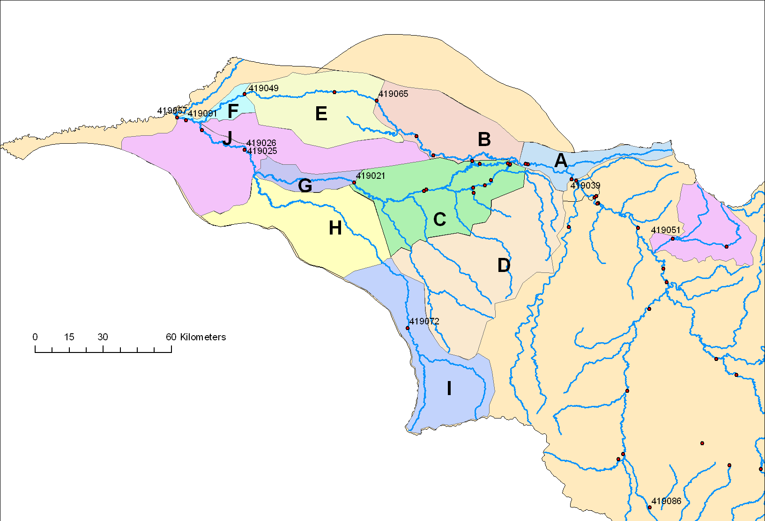

K

|  |  |
| --- | --- |
| **Catchment Name** | **Spreadsheet label** |
| A | 419065_Upper |
| B | 419065_Lower |
| C | 419021_Lower |
| D | 419021_Upper |
| E | 419049 |
| F | Out_Piancreek |
| G | 419026_Namoi |
| H | 419026_Barrad |
| I | 419072 |
| J | Out_Namoi |
| K | 419051 |
| Not shown (Above A) | 419039_Upper |