# Creating PDF document in .NET Core Web API

Let’s imagine that we have a .NET Core Web API project in which we need to generate a PDF report. Even though it shouldn’t suppose to be too hard to do something like that, we could end up in loosing to much time if we don’t know how to do it properly.

In this article, we are going to show you how to use DinkToPDF library to easily generate PDF documents while working on the .NET Core Web API project.

So, without further ado, let’s dive right into the fun part.

## Basic Project Preparations

Let’s start from the very beginning, by creating a new .NET Core Web Api project named PDF_Generator:

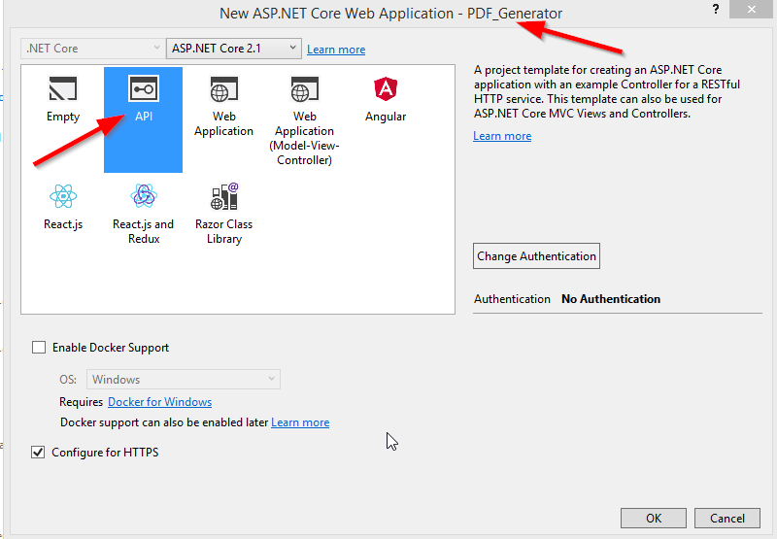

After the project creation, let’s modify the launchSettings.json file to disable our browser to start automatically and to change the applicationUrl property to localhost:5000:

{

"$schema": "http://json.schemastore.org/launchsettings.json",

"iisSettings": {

"windowsAuthentication": false,

"anonymousAuthentication": true,

"iisExpress": {

"applicationUrl": "http://[::]:5000",

"sslPort": 44320

}

},

"profiles": {

"IIS Express": {

"commandName": "IISExpress",

"launchBrowser": false,

"environmentVariables": {

"ASPNETCORE_ENVIRONMENT": "Development"

}

},

"PDF_Generator": {

"commandName": "Project",

"launchBrowser": false,

"applicationUrl": "http://[::]:5000",

"environmentVariables": {

"ASPNETCORE_ENVIRONMENT": "Development"

}

}

}

}

## DinkToPdf Library Configuration

DinkToPdf is a cross-platform oriented library which is the wrapper for the Webkit HTML to PDF library. It uses WebKit engine to convert HTML to PDF.

It will allow us to create a PDF document from our HTML string that we generate in the .NET Core project, or to create a PDF document form existing HTML page. Furthermore, we can download created PDF document or save it on a certain location or return a new HTML page with the PDF content.

We are going to cover all these features in this article.

So, let’s first install the DinkToPdf library:

PM> Install-Package DinkToPdf

Or search for DinkToPdf inside the Nuget Package Window:

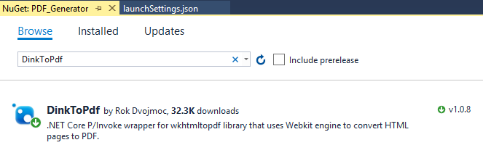

After the installation completes, we need to import native library files to our root project. We can find those files in our source project in the NativeLibrary folder. Inside we will find two folders 32bit and 64bit, so we need to choose the appropriate library for our OS. We are going to choose the files from the 64bit folder:

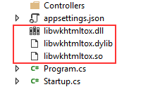

Finally, we need to register this library with our IoC container in the StartUp class:

public void ConfigureServices(IServiceCollection services)

{

services.AddMvc().SetCompatibilityVersion(CompatibilityVersion.Version_2_1);

services.AddSingleton(typeof(IConverter), new SynchronizedConverter(new PdfTools()));

}

Excellent.

We have everything in place and we are ready for the coding part.

## Preparing Data for the PDF Document

In a real-world project, we can collect data from the database or receive it from other API. But for the sake of simplicity, we are going to collect data for our PDF document from the local storage. Then we are going to create an HTML template and store it in the PDF document.

So let’s first create a new folder Models and inside it the Employee.cs file. We are going to modify it:

namespace PDF_Generator.Models

{

public class Employee

{

public string Name { get; set; }

public string LastName { get; set; }

public int Age { get; set; }

public string Gender { get; set; }

}

}

To continue, we are going to create a new folder Utility and two class files inside it DataStoage.cs and TemplateGenerator.cs. Complete structure should look like this:

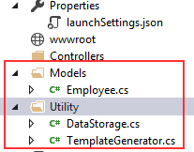

Now, let’s modify the DataStorage.cs file:

using PDF_Generator.Models;

using System.Collections.Generic;

namespace PDF_Generator.Utility

{

public static class DataStorage

{

public static List<Employee> GetAllEmployess()

{

return new List<Employee>

{

new Employee { Name="Mike", LastName="Turner", Age=35, Gender="Male"},

new Employee { Name="Sonja", LastName="Markus", Age=22, Gender="Female"},

new Employee { Name="Luck", LastName="Martins", Age=40, Gender="Male"},

new Employee { Name="Sofia", LastName="Packner", Age=30, Gender="Female"},

new Employee { Name="John", LastName="Doe", Age=45, Gender="Male"}

};

}

}

}

In the code avobe we just return a list of employees which will be displayed inside the HTML template.

### HTML Template Generation

We want to generate the HTML template, so we need to modify the TemplateGenerator.cs file:

using System.Text;

namespace PDF_Generator.Utility

{

public static class TemplateGenerator

{

public static string GetHTMLString()

{

var employees = DataStorage.GetAllEmployess();

var sb = new StringBuilder();

sb.Append(@"

<html>

<head>

</head>

<body>

<div class='header'><h1>This is the generated PDF report!!!</h1></div>

<table align='center'>

<tr>

<th>Name</th>

<th>LastName</th>

<th>Age</th>

<th>Gender</th>

</tr>");

foreach (var emp in employees)

{

sb.AppendFormat(@"<tr>

<td>{0}</td>

<td>{1}</td>

<td>{2}</td>

<td>{3}</td>

</tr>", emp.Name, emp.LastName, emp.Age, emp.Gender);

}

sb.Append(@"

</table>

</body>

</html>");

return sb.ToString();

}

}

}

In the code above we are fetching data from our static DataStorage class and fill our template with it. The HTML template is nothing more than a pure HTML code.

But we want to style our table and h1 tag, so let’s create new folder assets and inside it a new styles.css file and modify it:

.header {

text-align: center;

color: green;

padding-bottom: 35px;

}

table {

width: 80%;

border-collapse: collapse;

}

td, th {

border: 1px solid gray;

padding: 15px;

font-size: 22px;

text-align: center;

}

table th {

background-color: green;

color: white;

}

This css file is going to be loaded later in the Controller class.

That is it, we have our HTML template to use in PDF creation and we can continue to the Controller logic.

## Saving the PDF Document on the Local Storage

In the Controllers folder, we are going to create a new empty API controller PdfCreatorController:

namespace PDF_Generator.Controllers

{

[Route("api/[controller]")]

[ApiController]

public class PdfCreatorController : ControllerBase

{

}

}

Let’s now modify the PdfCreatorController to support creating of PDF document and its saving to local drive:

using DinkToPdf;

using DinkToPdf.Contracts;

using Microsoft.AspNetCore.Mvc;

using PDF_Generator.Utility;

using System.IO;

namespace PDF_Generator.Controllers

{

[Route("api/[controller]")]

[ApiController]

public class PdfCreatorController : ControllerBase

{

private IConverter _converter;

public PdfCreatorController(IConverter converter)

{

_converter = converter;

}

[HttpGet]

public IActionResult CreatePDF()

{

var globalSettings = new GlobalSettings

{

ColorMode = ColorMode.Color,

Orientation = Orientation.Portrait,

PaperSize = PaperKind.A4,

Margins = new MarginSettings { Top = 10 },

DocumentTitle = "PDF Report",

Out = @"D:\PDFCreator\Employee_Report.pdf"

};

var objectSettings = new ObjectSettings

{

PagesCount = true,

HtmlContent = TemplateGenerator.GetHTMLString(),

WebSettings = { DefaultEncoding = "utf-8", UserStyleSheet = Path.Combine(Directory.GetCurrentDirectory(), "assets", "styles.css") },

HeaderSettings = { FontName = "Arial", FontSize = 9, Right = "Page [page] of [toPage]", Line = true },

FooterSettings = { FontName = "Arial", FontSize = 9, Line = true, Center = "Report Footer" }

};

var pdf = new HtmlToPdfDocument()

{

GlobalSettings = globalSettings,

Objects = { objectSettings }

};

_converter.Convert(pdf);

return Ok("Successfully created PDF document.");

}

}

}